Name………………………………………………………………... Index No :……………………………...
Candidate’s Signature …………………………
Date: ………………………………...
312/1
GEOGRAPHY
THEORY
PAPER 1
JULY/AUGUST 2014
TIME: 2³/₄ HOURS

Kenya Certificate of Secondary Education (K.C.S.E)

312/1
Geography
Paper 1
2³/₄ hours

INSTRUCTIONS TO CANDIDATES
- This paper consists of sections A and B
- Answer all questions in section A.
- In section B, answer question 6 and any other two questions
- All answers must be written in the answer sheets provided.

This paper consists of 4 printed pages. Candidates should check to ascertain that all pages are indicated and that no question are missing
SECTION A: 25 MKS
Answer all questions in this section
1. (a) Differentiate between rotation and revolution of the earth (2mks)
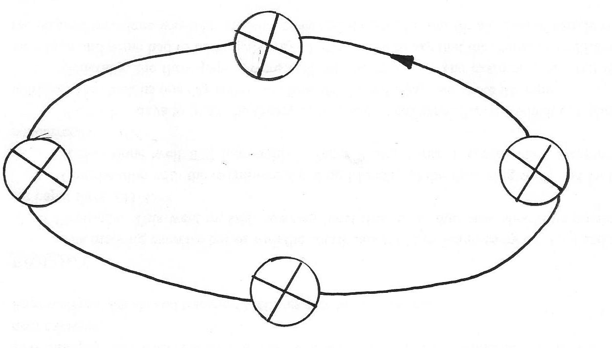
(b) Study the diagram below and answer the questions that follow
Date B
0º
0º
S
N
N
S
0º
June 21st
N
S
0º
Date A
Dec 22nd
0º
S
N

Identify
(i) The season marked X (1mk)
(ii) The date marked by A (1mk)
(c) State one characteristic of the summer solistice (1mk)

2. The diagram below shows same types of folds. Use it to answer question (a)

Anticline
Syncline
E
F
G
Fault
Increasing stress
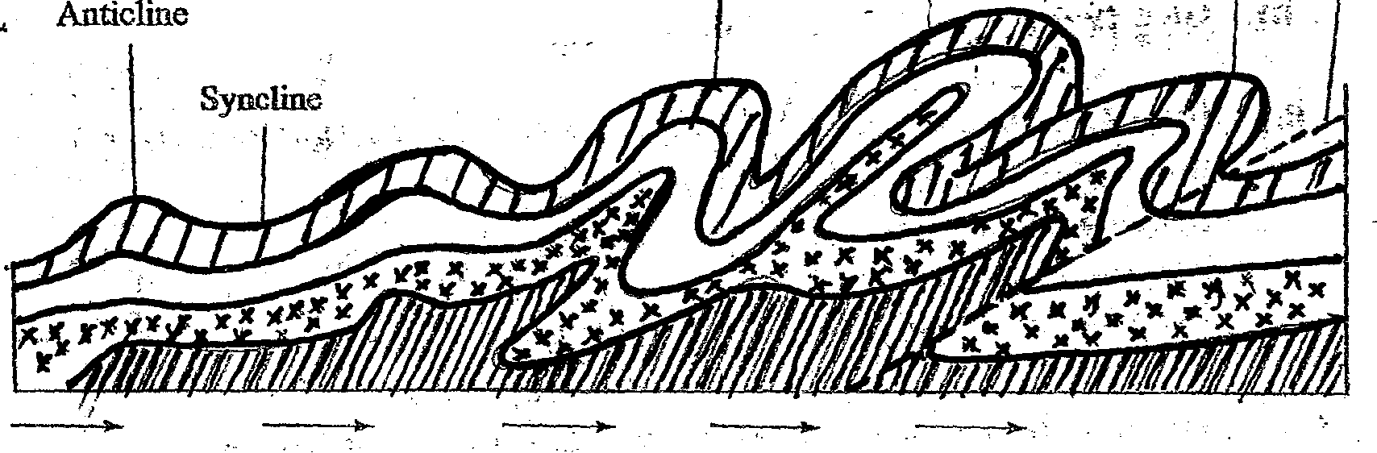

(a)Name the type of folds marked E,F and G (3mks)
(b) State two causes of folding (2mks)
3. (a) State three ways in which wind transports its load (3mks)
(b) Identify two features produced by water in arid areas (3mks)
4. (a) Describe how Lake Victoria was formed (3mks)
(b) State the economic importance of lake Naivasha (2mks)
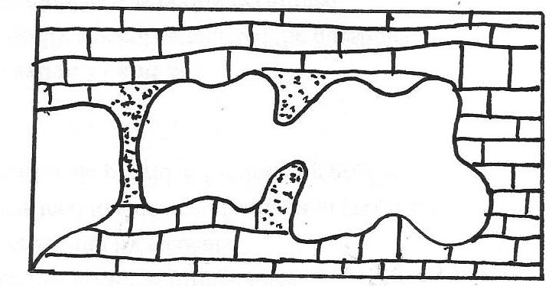
5. The diagram below represents underground features in a limestone area. Use it to answer question (a)

Y
X
Cavern
V

(a) Name the features marked X and Y (2mks)
(b) Describe how the feature marked V is formed (3mks)
SECTION B
Answer question 6 and Any other two questions from this section
6. (a) (i) Identify two physical features found in grid square 0450 (2mks)
(ii) What is the position of Airport principal point +13A/97 5047 in grid square 9354
using latitudes and longitudes (2mks)
(iii) Measure the length of the all weather road loose surface E1706 from the junction at
the market grid square 867576. Give your answer in metres (2mks)
(b)(i) Draw a cross section along Northing 51 between Eastings 82 and 88 . Use a scale 1cm rep
50ft. On the section mark and name
River Sagana
Loose surface road
Hill
River Rathithi (7mks)
(ii) Calculate the vertical exaggeration of the section (2mks)
(c) Citing evidence from the map, state four economic activities of the area covered by the map (4mks)
(d) Explain how relief has influenced the distribution of settlement in the area covered by the
Map (4mks)
7. (a) State three characteristics of Inter-Tropical convergence zone (3mks)
(b) Describe the characteristics of Equitorial climate (6mks)
(c)(i) State three different ways by which air condences to form rainfall may be made to rise(3mks)
(ii) With the aid of a well –labelled diagram, describe how relief rainfall is formed (6mks)
(d) Form 4 students of Rabwao secondary school is planning to conduct a field study in a
weather station near their school.
(i) State three ways in which they will prepare for the study (3mks)
(ii) Describe how they would use a rain gauge to collect their data (4mks)
8. (a) What is the different between mass wasting and weathering (2mks)
(b) (i) Apart from soil creep, name two other processes of slow mass movement (2mks)
(ii) Explain three causes of soil creep (6mks)
(iii) Explain three physical conditions that influence landslides (3mks)
(c) Describe the following processes of mass wasting
(i) Rock fall (2mks)
(ii) Subsidence (2mks)
(iii) Mud flows (2mks)
(d) Explain the effect of weathering in the following
(i) Tourism (2mks)
(ii) Agriculture (2mks)
(iii) Pottery (2mks)
9. (a) (i) What are tides? (2mks)
(ii) Give four causes of ocean currents (4mks)
(b) State four factors that influence the development of coasts (4mks)
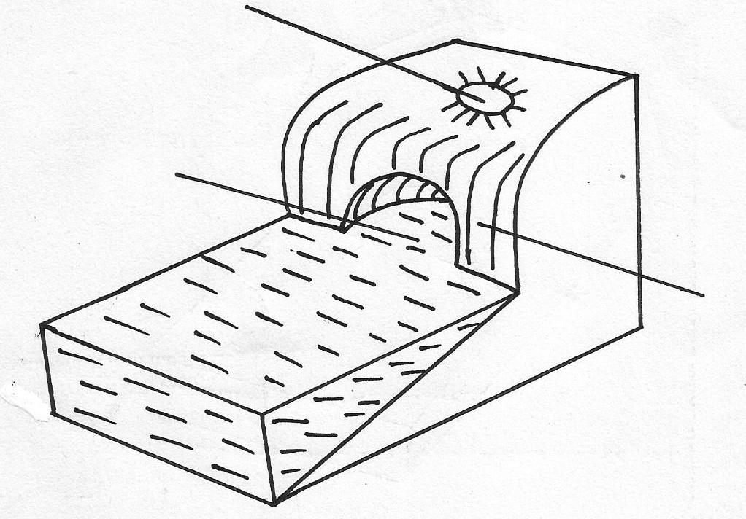
(c) The diagram below represents some coastal features. Use it to answer the questions below
R
P
Q
SEA
LAND

(i) Name the features marked Q and R (2mks)
(ii) Describe how the feature marked P is formed (5mks)
(d) Explain four ways in which coastal landforms is significant to the economy of Kenya (8mks)
10. (a) (i) What is a glacier? (2mks)
(ii) Name two mountains in E. Africa where glaciers are found (2mks)
(b) (i) Describe plucking as a process in glacial erosion (4mks)
(ii) State three factors that influence glacial erosion (3mks)
(c) Describe how the following features are formed
(i) Pyramidal peak (4mks)
(ii) Hanging valley (4mks)
(d) Explain three negative effects of glaciations (6mks)

