NAME……………………………………………….….ADM. NO………………
DATE……………………….CLASS……………………………………

MWAKICAN FORM 1 JOINT EXAMINATION TERM 1-2019

GEOGRAPHY FORM 1
TIME: 2 HOURS

INSTRUCTIONS TO CANDIDATES
Answer ALL questions in all sections

SECTION A:

Answer all questions from this section in the spaces provided.

1. a). Define the term environment (2mks)

b) Explain three importance of studying geography (3mks

c) Highlight 2 types of environment studied in geography (2mks)

d) Define the term Geography (2mks)

2. (a) Give three heavenly bodies. (3mks)

(b) Define the term Equinox. (2mks)

3. a) Differentiate between rotation and revolution of the earth (2mks)

(b) State two effects of the rotation of the earth (2mks)

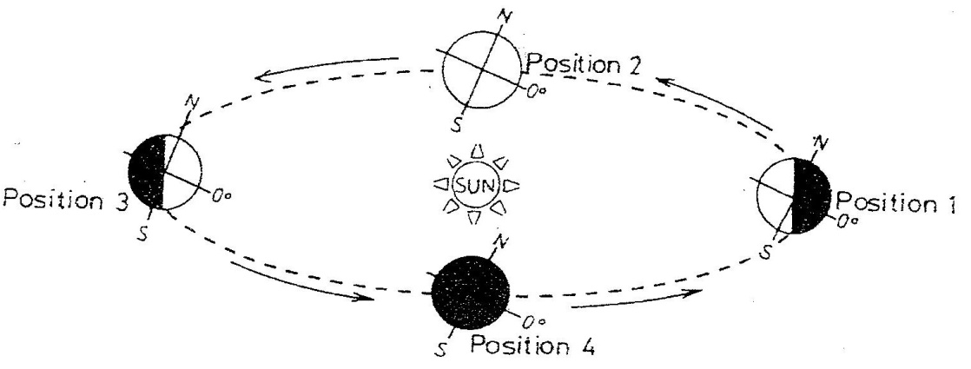
- Study the diagram below and answer the questions that follow

(i) Which movement of the earth is represented by the diagram? (1mk)

(ii) Give two effects of the movement represented by the diagram (2mks)

4. a) What is the solar system. (1mk)

b) State two theories that explain the origin of the solar system. (2mks)

c) What is a natural satellite? (1mks)

d) List three examples of natural satellites (3mks)

e) Give three characteristics of the sun (3mks)

f) What is an orbit (1mk)

5) a) What an eclipse? (1mk)

b) Use the diagram below to answer the questions that follow.
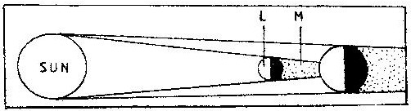

i) What type of eclipse is represented by the diagram? (1mk)

ii) Name the features marked L and M (2mks)

6. (a) what is a geoid (2mks)

. (b) State three proofs that the earth is spherical. (3mks)

7. (a) what is a breeze (2mks)

- The diagram below shows a type of wind.
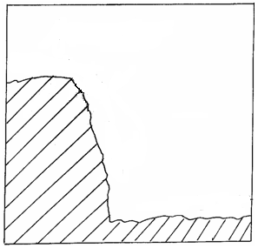
Terrestrial
radiation
High
pressure
HILL TOP
Low pressure
warm air
W
W

(i) Identify the type of wind marked W. (1mk)

(ii) List two characteristics of the type of the wind marked W. (2mks)

8. (a)Give three forces that are responsible for the spherical shape of the earth. (3mks)

(b) Give three reasons why the interior of the earth is very hot. (3mks)

9. The diagram below represents the structure of the earth. Use it to answer question
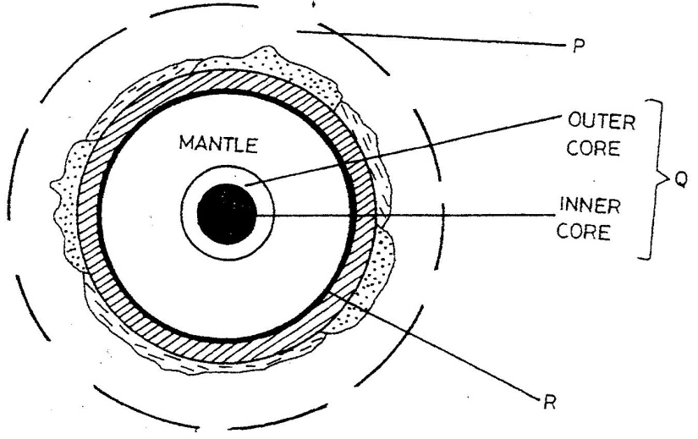

- Name
(i) The parts marked P and Q (2mks)

(ii) Give two minerals of the outer core. (2mks)

b. State three characteristics of the crust. (3mks)

10. (a) What is an air mass? (2 mks)

(b) Give three benefits of humidity in the atmosphere. (3 mks)

c) Name two forms of precipitation. (2mks)

- If the local time in Nairobi on longitude 37°E time is 10 p.m. What will the time be at Buchanan Liberia on longitude 10°W.? (4mks)

.12 Name four layers of the earth’s atmosphere (4 mks)

13. (a) State two conditions that are necessary for the formation of fog. (2 mks)

(b) Give reasons why a Stevenson’s screen is:
(i) Painted White (2 mks)

. (c) What is weather forecasting? (2mks)

(d) State four ways in which weather forecasting is important to the human activities. (4mks)

- A pupil was requested to pick out fourteen numbers randomly from a set of numbers. She picked 20, 37, 1, 66, 42, 12, 6, 15, 12, 42, 100, 3 , 82, 42.
Calculate :
- The mean of the data (2mks)

- The mode of the data (2mks)

- The median of the data (2mks)

- The data below shows rainfall and temperature distribution of Nakuru town use it to answer the questions below
Month | J | F | M | A | M | J | J | A | S | O | N | D
Rainfall in mm | 18 | 38 | 66 | 127 | 114 | 84 | 112 | 104 | 69 | 56 | 38 | 31
Temp in °C | 19 | 20 | 20 | 18 | 20 | 19 | 19 | 18 | 18 | 18 | 18 | 18

- Draw a simple line graph to represent the temperatures (5mks)

b) Define the term statistics. (1mk)

c) Differentiate between primary data and secondary data. (2mks)

d) Highlight two disadvantages of observation as a method of collecting data. (2mks)

