NAME:………………………………………………….. INDEX NO:………………………………

CANDIDATE’S SIGNATURE:…………………………DATE…………………………………….

312/1
GEOGRAPHY
November, 2021
PAPER 1
TIME: 2 ¾ HOURS
ACK DIOCECE OF NAMBALE
Kenya Certificate of Secondary Education
GEOGRAPHY 312/1
2 ¾ Hours

Instruction:
- Answer ALL the questions in section A.
- In Section B answer question 6 and any other two.

SECTION A:

1. a) Name two branches of geography. (2mks)

b) Give three reasons why it is important to study geography. (3mks)

2. a) What is solar insolation? (2mks)
b) Outline three importance of moisture in the atmosphere. (3mks)
3. a) State two effects of the rotation of the earth on its axis. (2mks)
b) The local time at manual 60⁰W is 11.30 am. What is the time in Nairobi
37⁰E? (3mks)
4. a) What is an ice sheet? (2mks)
b) State three ways in which ice moves (3mks)
5. a) Name the two types of waves experienced in the coastal area. (2mks)
b) List three coastal features which result from wave deposition. (3mks)

SECTION B:

Answer question 6 and any other two questions.

6. Study the map of Kijabe 1 : 50,000 (sheet 134/3) provided and answer the following questions.

a) i) Give the longitudinal extent of the area covered by the map. (2mks)

ii) Identify the two human made features found at grid square 3301 (2mks)
iii) what is the bearing of the cattle dip at Ewaso kedong valley from grid reference 3195( 2mrks

b) i) calculate the area covered by thicket vegetation in the area covered by the map (3mks)
ii) measure the length of all weather road bound surface C68 and give your answer in km. (2 maks)
c) i) Give three evidences showing that the area receives high rainfall (3marks)
ii) Citing evidence from the map, identify three economic activities practiced in the area covered by the map (6maks)

d) Describe the drainage of the area covered by the map. (5mks)

7. a) State two factors which influence the occurrence of underground water (2mks)
b) Differentiate between a well and spring. (2mks)
c) The diagram below represent an artesian basin. Use it to answer question C (i) and (ii) .

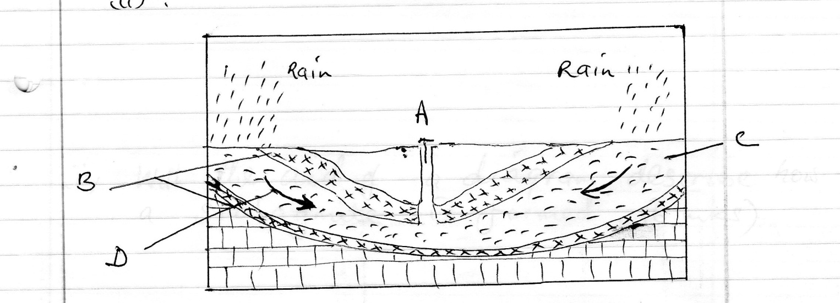

i) Name the parts marked A, B, C (3mks)
ii) Identify the process marked D. (1mk)
iii) State three factors which favour the location of an artesian well (3mks)
d) i) Apart from stalagmites name three other underground features formed in limestone areas. (3mks)

ii) With the aid of a diagram describe how a stalagmite is formed (6mks)
e) i) State three reasons why there are few settlements in Karst Landscapes. (3mks)
ii) Name two surface features found in limestone areas. (2mks)
8.(a) With the aid of well labelled diagrams describe the processes involved in the formation of a corrie lake. (8mks
(b) Explain four ways in which a glaciated landscape is of significance to human activities. (8mks
(c) Explain three conditions that may lead to glacial deposition in lowlands. (3mks)
(d) Suppose students were to carry out a field study on glaciation on Mt.Kenya
(i) Name two types of morains they are likely to study. (2mks)
(ii) State two problems they are likely to experience during the field study. (2mks)
(iii) Why was it important for the learners to conduct a pre-visit (2mks)
9. a) Describe podzolization as a process of leaching. (4mks)
b) State three ways in which mulching helps in soil conservation. (3mks)

c) Explain how the following factors influences the formation of soils.

i) Climate (4m
ii) Topography (4mks

d) i) What is soil catena? (2mks)

ii) Draw a well labelled diagram to show a well – developed soil profile. (3mks)

e) Explain five causes of soil degeneration. (5mks)
10. i) Define the term faulting. (2mks)
ii) Name 2 types of faults. (2mks)
iii) Use the diagram below to answer the question that follows:-
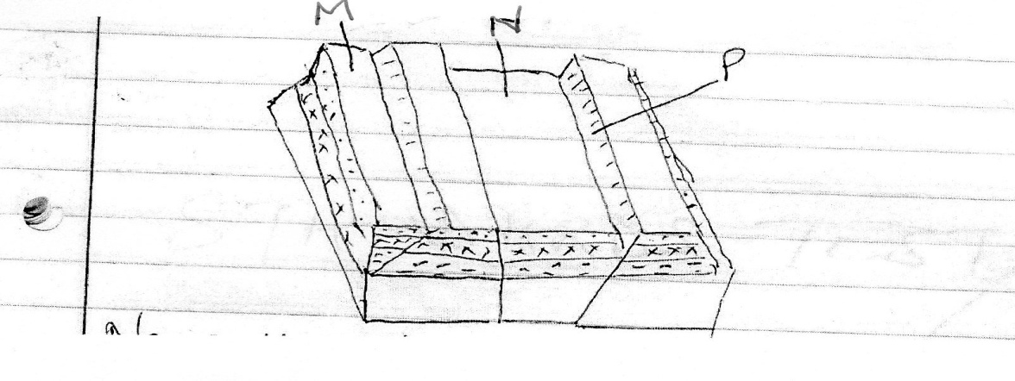
a) Name the features marked M, N and P (3mks)
b) With well labelled diagrams explain the formation of the Rift valley through tensional forces. (8mks

c) Explain five positive effects of faulting. (10mks)

