312/1GEOGRAPHY
FORM FOUR
END OF TERM II 2019: JULY/AUGUST 2019
2019
GEOGRAPHY
PAPER 312/1.
Time 2.³/₄Hours.
Name------------------------------------------------class----------------------- Adm. No. --------------------
Date-------------------------------------------------Signature--------------------------------------------
Instructions to candidates.
This paper consists of two sections: A and B.
Answer all questions in section A. In section B, answer question 6 and any other two. Candidates should check the question paper to ascertain that all the pages are printed as indicated and that no questions are missing. Candidates should answer the questions in English.
Section A: Answer all questions in this section. 25 marks.
For Official use only
Section A.
Question | 1 | 2 | 3 | 4 | 5 | Total
Score
Section B
Question | 6 | 7 | 8 | 9 | 10 | Total
Score

Total A
Total B
Total

Section. A. Answer all questions in this section.
1. (a). What is faulting? (2 marks)
_______________________________________________________________________________________________________________________________________________________________________________________________________________________________________
(b). Name three features formed through faulting. (3 marks)
_______________________________________________________________________________________________________________________________________________________________________________________________________________________________________
2. (a). Differentiate between the processes of the formation of plutonic rocks and volcanic rocks. (2 marks)
_______________________________________________________________________________________________________________________________________________________________________________________________________________________________________
(b). For each of the following sedimentary rocks, name the resultant rock that forms after metamorphism. (3 marks).
(i) Sandstone. ____________________________________________________

(ii) Limestone. ____________________________________________________

(iii) Clay. ____________________________________________________

3. (a) Name two types of soil according to texture. (2 marks)
__________________________________________________________________________________________________________________________________________________________
(b). Give three factors that determine the color of soil. (3 marks)
_______________________________________________________________________________________________________________________________________________________________________________________________________________________________________
4.a) State two ways in which springs are formed. (2marks)
____________________________________________________________________________________________________________________________________________________________

b) The diagram below represents an artesian basin. Name the parts marked. K.L.M.
(3marrks)

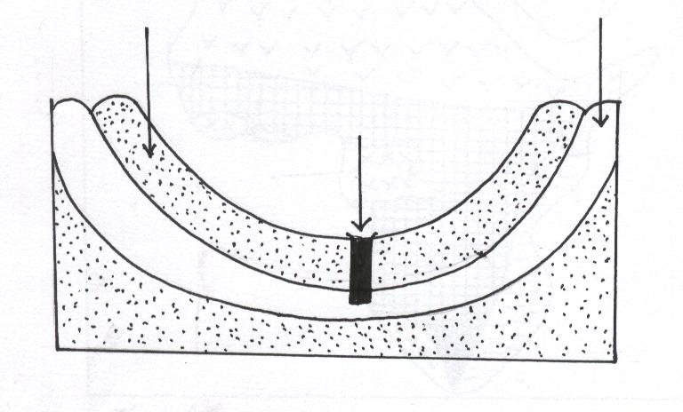
K
M

L

K-------------------------------------------

L------------------------------------------

M------------------------------------------

5. a). Differentiate between the long profile and cross profile of a river. (2 marks)
____________________________________________________________________________________________________________________________________________________________________________________________________________________________________

b). State three factors that influence river discharge. (3 marks)
______________________________________________________________________________________________________________________________________________________________________________________________________________________________________________________
Section B. Answer Question Six and any other two.
Study the Map of Taita Hills 1: 50,000 Kenya provided to answer the questions that follow.
6. (a) (i). State two methods used to show relief in the extract map of Taita Hills.
(2 marks).
____________________________________________________________________________________________________________________________________________________________________ (ii). Identify three man made features found in the grid square 4127. (3 marks)
________________________________________________________________________________________________________________________________________________________________________________________________________________________________________________________________________________________________________________________________________

(b). (i) What is the highest point of the area covered by the map. Give your answer in centimeters. (2 marks).
____________________________________________________________________________________________________________________________________________________________________

(ii). Find the bearing of the peak of Mwatunga hill in grid square 3214 from water tank at grid square 2619. (2 marks)
____________________________________________________________________________________________________________________________________________________________________

(iii) What is the Teita Sisal Estates land registration number. (1 mark).
____________________________________________________________________________________________________________________________________________________________________

c). Draw a rectangle 16cm by 12 cm to represent the area enclosed by Easting 24 and 40 and Northing 20 and 30. (1 mark).

On the rectangle mark and name the following features.

- Mgange Hills
- All weather road bound surface.
- Ronge forest
- A rock out crop
- River Ruhia. (5 marks.)

(provide a graph paper)

d)(i) Describe the distribution of settlements in the area covered by the Map. (5 marks)
____________________________________________________________________________________________________________________________________________________________________________________________________________________________________________________________________________________________________________________________________________________________________________________________________________________________________________________________________________________________________________
__________________________________________________________________________________________________________________________________________________________________________________________________________________________________________________________________________________________________________________________________________________________________________________________________________________________

(ii). Citing evidence from the map give two economic activities carried out in the area covered by the map other than sisal farming. (4 marks).
____________________________________________________________________________________________________________________________________________________________________________________________________________________________________________________________________________________________________________________________________________________________________________________________________________________________________________________________________________________________________________

7.(a). (i). State two conditions for the submergence of the coast. (2 marks) ______________________________________________________________________________________________________________________________________________________________________________________________________________________________________________________
(ii). Name two features that form as a result of submergence of the coast. (2 marks).
______________________________________________________________________________________________________________________________________________________________________________________________________________________________________________________
(b). The diagram below represents coastal features. Use it to answer the questions that follow.
H
G
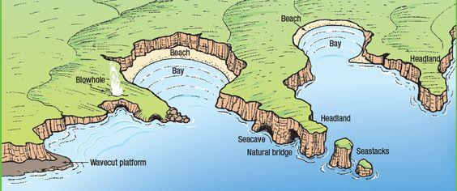

E
F

- Name the parts marked E, F, G, H. (4 marks)
E___________________________________

F ___________________________________
G___________________________________

H___________________________________
(ii). Explain the formation of Wave cut platform. (6 marks)

____________________________________________________________________________________________________________________________________________________________________________________________________________________________________________________________________________________________________________________________________________________________________________________________________________________________________________________________________________________________________________________________________________________________________________________________________________________________________________________________________________________________________________________________________________________________________________________________________________________________________________________________________________________________________________________________________
The diagram below represents a limestone land scape area. Use it to answer the questions that follow.
P
Q

R

c) (i). Name the features marked P, Q, and R. (3 marks)
P_____________________________

Q______________________________

R. _____________________________

(ii). Describe the how swallow hole is formed in limestone area. (4 marks)
____________________________________________________________________________________________________________________________________________________________________________________________________________________________________________________________________________________________________________________________________________________________________________________________________________________________________________________________________________________________________________

d) Students of Sharp Rise secondary school took a field study in a Karst scenery area.
(i) State four ways the students would have evaded the problems they encountered while they were in the field. (4 marks)
_______________________________________________________________________________________________________________________________________________________________________________________________________________________________________________________________________________________________________________________________________________________________________________________________________________________________

8.a) Explain how the following factors influence climate.
    - Latitudes. (2marks)
____________________________________________________________________________________________________________________________________________________________________________________________________________________________________________________________________________________________________________________________________________

(ii). Distance from the sea. (2marks)
____________________________________________________________________________________________________________________________________________________________________________________________________________________________________________________________________________________________________________________________________________

b) The table below shows temperatures reading at a weather station.

Day | MON. | TUE. | WED. | THUR. | FRI. | SAT. | SUN
Max ºc | 26 | 25 | 26 | 24 | 27 | 27 | 24
Min. ºc | 15 | 17 | 17 | 13 | 19 | 18 | 17

Calculate:
(i) The daily range of temperature for Monday. (2marks)
______________________________________________________________________________________________________________________________________________________

(ii) The mean temperature for Friday. (2marks)
______________________________________________________________________________________________________________________________________________________

c) Study the climate map of Africa below and answer the questions that follow.

P

Equatorial
Climate
R
Q
P
(i) Name the climatic regions marked P, Q and R. (3marks)

P----------------------------------------------------------

Q______________________________________

R______________________________________

(ii) Describe the characteristics of equatorial climate. (8marks)
________________________________________________________________________________________________________________________________________________________________________________________________________________________________________________________________________________________________________________________________________________________________________________________________________________________________________________________________________________________________________________________________________________________________________________________________________________________________________________________________________________________________________________________________________________________________________________________________________________________________________________________________________________________________________________________________________________________________________________________________________________________

(iii) Explain three ways in which vegetation adapts to the climatic region marked R. (6marks)
_______________________________________________________________________________________ ____________________________________________________________________________________________________________________________________________________________________________________________________________________________________________________________________________________________________________________________________________________________________________________________________________________________________________________________________________________________________________________________________________________________________________________________________________________________________________________________________________________________________________________________________________________________________________________________________________________________________________________________________________________________________________________________________

9. a) (i) What is piedmont glacier? (2mark)
______________________________________________________________________________________________________________________________________________________________________________________________________________________________________________________(ii) State two conditions that favour formation of glaciers. (2marks)
______________________________________________________________________________________________________________________________________________________________________________________________________________________________________________________

b) Explain the following ways of ice movement.
(i) Basal slip. (2marks)
______________________________________________________________________________________________________________________________________________________________________________________________________________________________________________________

(ii) Plastic flowage. (2marks)
______________________________________________________________________________________________________________________________________________________________________________________________________________________________________________________

c) Explain two factors that determine the speed of ice movement. (4marks)
______________________________________________________________________________________________________________________________________________________________________________________________________________________________________________________
__________________________________________________________________________________________________________________________________________________________________________________________________________________________________________________________________________________________________________________________________________________________________________________________________________________________

d) The feature below is from a glaciated landscape. Use it to answer the following question.

B

A

(i) Name the parts marked A and B. (2marks)
A__________________________________________________________________________
B__________________________________________________________________________

(ii) State THREE characteristics of the feature above. (3marks)
____________________________________________________________________________________________________________________________________________________________________________________________________________________________________________________________________________________________________________________________________________________________________________________________________________________________________________________________________________________________________________

(iii) Give three features of glacial deposition. (3marks)
________________________________________________________________________________________________________________________________________________________________________________________________________________________________________________________________________________________________________________________________________
____________________________________________________________________________________________________________________________________________________________________

(iv) State five positive effects of glaciation. (5marks)
____________________________________________________________________________________________________________________________________________________________________________________________________________________________________________________________________________________________________________________________________________________________________________________________________________________________________________________________________________________________________________
______________________________________________________________________________________________________________________________________________________________________________________________________________________________________________________

10. (a) (i) Name three conditions necessary for wind deposition to take place in hot desert. (3marks)
______________________________________________________________________________________________________________________________________________________________________________________________________________________________________________________
(ii) State three mechanisms of wind transportation in hot deserts. (3marks)
______________________________________________________________________________________________________________________________________________________________________________________________________________________________________________________
(b) With the aid of labelled diagrams describe how the following features are formed.
- Rock pedestal. (6marks)
______________________________________________________________________________________________________________________________________________________________________________________________________________________________________________________________________________________________________________________________________________________________________________________________________________________________________________________________________________________________________________________________________________________________________________________________________________________________________________________________________________________________________________________________

- Zeugen. (6marks)
____________________________________________________________________________________________________________________________________________________________________________________________________________________________________________________________________________________________________________________________________________________________________________________________________________________________________________________________________________________________________________________________________________________________________________________________________________________________________________________________________________________________________________________________________________________________________________________________________________________________________________________
(c) You are supposed to carry out a field study of a semi- arid area in Kenya:
    - Name two Counties which you would visit for your study. (2marks)
______________________________________________________________________________________________________________________________________________________________________________________________________________________________________________________
    - What information would you collect through observation that would indicate that the area is turning into a desert? (2marks)
______________________________________________________________________________________________________________________________________________________________________________________________________________________________________________________
    - State three measures you would recommend to combat desertification in the area. (3marks)
______________________________________________________________________________________________________________________________________________________________________________________________________________________________________________________

This is the last Printed page. @ 312 GP1/2019

