3KNT FRETARNITY EXAMINATION
GEOGRAPHY PAPER 1 MARKING SCHEME
SECTION A : (25 MKS)
1.a) What is a latitude ? (2mks)
It is an imaginary parallel line drawn from west to east and measured in degrees north or south of the equators.

b)What is the time of Hola on 400 E when the time at Tema o 00 longitude is 12 noon. (3mks)
10 – 4 minutes
40 x 4 = 160 minutes = $\frac{160}{60}$ hours = 2 hours 40 minutes
12:00 + 2 hours 40 minutes
= 2:40 pm at Hola
2a) State 2 conditions which may influence the occurrence of land slides. (2mks)
- Nature of materials
- Extent of saturation / amount of rainfall
- The angle of the slope / gradient of the land.
- Human activities eg mining
- Occurrence of earthquakes / volcanic
b)i)type of mass movement shown. (1mk)
- Rockfall
ii) Feature marked P and Q. (2mks)
P: cliff face / steep slope
Q: tams / Talus creep/Scree
3a) State 3 conditions necessary for the development of Karst scenery. (3mks)
- An area of limestone
- Thick layers of calcium carbonate rocks
- Moderate to abundant rainfall
- A low water table to allow formation of conspicuous features
- The rock should be well jointed.
b) Give 2 reasons why there are few settlement in Karst land scapes. (2mks)
- The areas are rocky.
- They have thin soils.
- They have poor vegetation.
- There is inadequate water supply.
4a) Give 2 features of deposition that results from action of water in arid areas. (2mks)
- Bajada
- Alluvial pans
- Playas
- Salinas
b) State 3 positive effects of desert features to human beings. (3mks)
- Sand harvested from desert features used in building and construction.
- Water from oases and pans provide water for irrigation and domestic use.
- Desert landscapes are ideal for military training and testing of weapons.
- Desert surfaces can be used for recreation eg Dakar Rally in Senegal.
- Some features attract tourists eg Yordangs , rock pedestal.
- Loess/ alluvial deposition are fertile soils for crop farming.
5a) Name three types of soils according to texture. (3mks)
- Loamy
- Clay
- Silty
- Sandy
- Gravel
b) Name 2 ways in which humus improves the quality of soil. (2mks)
- Helps soil to retain moisture.
- Aerates the soil.
- It provides essential minerals to the soil.
- It improves soil texture/ structure.

SECTION B (75 MKS)
6Ai)Identify the two human made features found in the grid square 2320. (2mks)
- Bridge or Mc call’s bridge
- All weather road loose surface.
ii)What is the altitude of the highest point in the area covered by the map. (3mks)
2362 metres
bi)What is the bearing of the Air Photo Princiapl Point at grid square 3426 from the Air Photo Principal point at grid square 2931? (2mks)
132⁰ +1⁰
-
ii)Measure the distance of the dry weather road(c 640) from the junction at point M (345142) to the junction at point N (416201) . give your answer in kilometers.(2mks)
12.2 km + 0.2 km
-

ci) a cross section , let the students clearly mark a dry weather road, river kaptarit , a ridge on the cross section
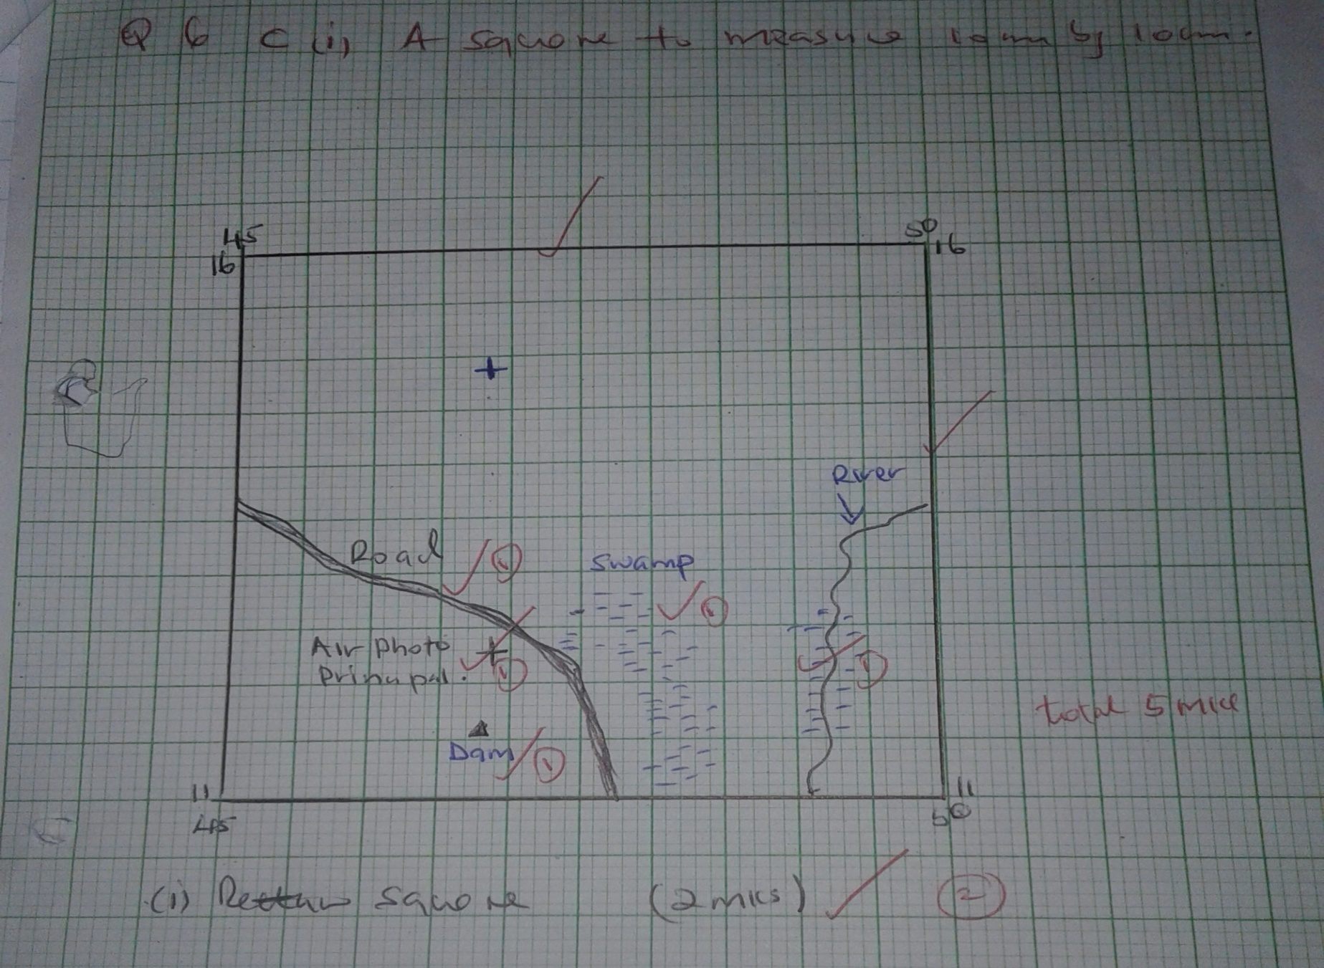
ii) Name two methods when to show relief on the map. (2mks)
- Contour
- Trigonometrical station
iii) Citing evidence from the map, identify five social services offered in kitale municipality. (5mks)
- Health / medical services – pressure of hospitals.
- Recreational services – sports clubs/ kitale club.
- Religious services – church.
- Security services – police stations.
- Housing – built up areas / huts.
- Water supply – water tower / tank.
- Burial service – cemetery.
7a)For each of the station, calculate the mean annual range of temperature. (2mks)
X : 31⁰ – 28⁰ = 3 ⁰c
Y: 21⁰ – 12⁰ = 9⁰c
bi)Calculate the annual rainfall for station Y. (2mks)
12+12+15+50+90+110+87+50+35+20+15= 583mm
ii)On the graph paper provided, draw a bar graph to represent the rainfall for station X. use a vertical scale of 1cm to represent 50 mm. (5mks)
NB: drawn to scale
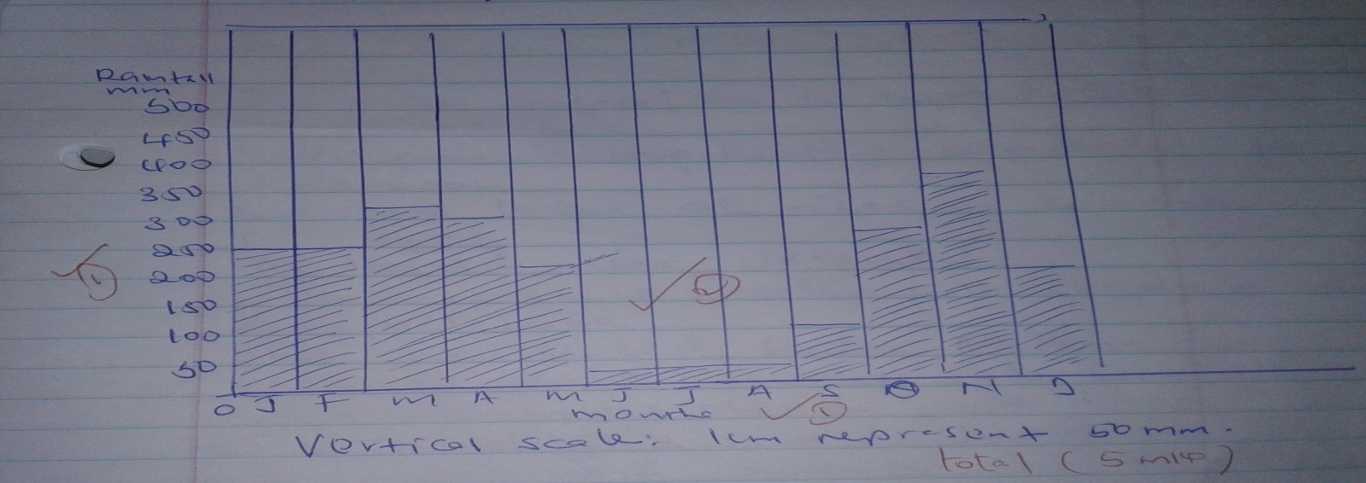

c) Describe the climate characteristics of station Y. (6mks)
- The station received low rainfall.
- Rainfall occurs throughout the year.
- The wettest month is June and the driest month is February.
- Summers are relatively dry while winter is relatively wet.
- Most rain falls between May and august.
- The station experience warm summers and cool winters.
- The temperatures are moderate throughout the year.
di)Describe how convectional rainfall is formed. (6mks)
- The water surface /sea is heated intensity by conduction.
- Maximum heating occurs in the afternoon.
- Moisture laden air rises in convectional currents.
- As the warm air rises, it is cooled.
- The moisture laden air condenses at high attitude.
- The condensed water vapour form clouds which develop into cumulonimbus clouds with time.
- The cloud give rise to heavy/ torrential rain accompanied by thickens and lighting and sometimes hail stones.
ii) Explain two problems associated with convectional rainfall in the lake region of Kenya.
- The torrential rain causes floods which displace people.
- The hailstones destroy crops.
- The strong wind blow off roofs of houses/ uproots trees.
- Lighting strikes causing deaths of people and animals. 2 well explained = 4 mks
8ai)What is a mineral? (2mks)
A mineral is an inorganic substance with a definite chemical composition found at or benefit the surface of the earth.
ii)Describe the following characteristics of minerals :
- Luster (2mks)
- Minerals differ in their brightness depending of the nature of their reflecting surface (smooth surfaces are shiny whereas rough surfaces are dull)
- Colour (2mks)
- Different minerals displays different colours (minerals that have iron or magnesium have dark colour)
- Density (2mks)
- Minerals have different weight per unit volume. Minerals have different specific gravity – some minerals are heavy. Other are light.
Bi) Name two examples of extrusive igneous rocks. (2mks)
- Basalt
- Pumice
- Obsidian
- Trychite
- Rhyolite
- Tephra
- Scoria
- Andesite
- Phonocite
ii) Describe three ways in while sedimentary rocks are formed. (9mks)
Mechanically formed sedimentary rocks.
- Are formed from rock fragments.
- The fragments are transported by wind or water or ice.
- The particles are deposited in layers.
- Over a long period of time, they are compacted into a hard rock.
- The hard rock is sedimentary rock which is mechanically formed sedimentary rock. (3 mks)
Organically formed sedimentary rocks.
- They are formed from the remains of plants or animals.
- They accumulate in layers.
- Over a long period of time the remains are compacted into a hard rock.
- The hard rock is sedimentary rock which is organically formed sedimentary rock. (3mks)
Chemically formed sedimentary rocks
- Dissolved minerals are transported into water bodies.
- They are then precipitated or evaporated over a long period of time.
- The precipitate or evaporates are then compacted to form a hard rock.
- The hard rock is a sedimentary rock which is chemically formed sedimentary rock. (3mks)
c) Explain the significance of rocks to the economy of Kenya under the following subheadings:
i)Tourism
- Some rocks form unique features that attract tourists earning the country foreign exchange or income. (2mks)
ii) Energy
- Some sedimentary rocks contain fossil fuels which are sources of energy for domestic or industrial use of coal. (2mks)
iii)Water
- Some rocks act as storage for water which can be supplied for domestic or industrial or agricultural use. (2mks)
9. Ai) Name the vegetation zones marked W,X Y (3mks)
- W: rainforest
- X : bamboo forest
- Y : heath and moorland
ii) Describe six characteristics of savannah vegetation. (6mks)
- Savannah vegetation consists of trees and grass.
- In wetter areas near the forests, the vegetation consists of tall scattered trees similar to those found in forest.
- The wetter areas have tall thick grass.
- The most common tree species are acacia and other thorny trees.
- There are scattered baobab trees and other drought resistant trees.
- Along river valleys there are tall trees or riverine trees and thick bushes.
iii) Name the temperate grasslands found in the following countries (3mks)
- Canada : prairies
- Russia : steppe
- Australia : downs
b) Explain 3 causes of the decline of the areas under forests in Kenya. (6mks)
- Destruction by fire either accidentally or intentionally.
- Diseases and pests attack mainly the planted forest.
- Human activities such as charcoal burning or farming in forested areas.
- Over-exploitation leading to depletion of certain uses such as meru oak, camphor.
- Degazzetment by the government reducing the areas under forests.
- Prolonged droughts leading to degeneration of forests some of which take long to recover. 3 well explained x 2=6
c) i) State 3 reasons why it would be necessary to visit the area before the study. (3mks)
- To familiarize with the area in order to design the appropriate research method.
- To prepare the working schedule.
- To be able to formulate the appropriate objectives and hypothesis.
- To be able to identify relevant equipment for data collection.
- To seek permission from one relevant authorities.
ii) Give 4 uses of vegetation you are likely to identify during the study. (4mks)
- As fodder
- For providing food eg vegetables
- For providing wood fuel or charcoal wood.
- For controlling soil erosion.
- For cultural or worship.
- For production of building or construction materials.
- For ornamental or beauty or aesthetics
10ai) Outline 2 factors that influence the development of drainage pattern. (2mks)
- Difference in rock resistance or hardness
- The arrangement of rock layers or the rock structure.
- Faulting or fault glinded.
- The nature of the slope.
ii) Outline 5 characteristics of a river in its youthful stage. (5mks)
- The river has a steep river gradient.
- River channel is narrow and deep.
- The river steep-sided or v-shaped valley or gorges.
- The river flows at a high speed or high stream velocity.
- The vertical erosion or down-cutting is dominant.
- The river channel is generally winding.
- A river in its youthful stage has rapid on water falls or cataracts on cascades.
- The river has interlocking spurs, potholes and the type of flow is horizontal.
- The river has a small volume of water and has a small load.
b) Describe the following processes of river erosion:
i) Attrition (2mks)
- As rock materials are transported downstream, they constantly collide against each other. The materials gradually wear or reduce in size.
ii)Corrosion (4mks)
- As solid materials are transported down stream, they are hurled against the banks and dragged along the river bed. The rock materials chips off pieces of rock from the channel and the river bed. The rock materials scour or smoothen or grid the river bank or bed. Eddy current rotate pieces of the rock around the hollows breaking or grinding the river bed.
c) Explain 3 negative effects of rivers to the human environment. (6mks)
- When a river flood, they destroy a lot of property on crops and may displace people leading to loss of human life.
- Some rivers are habitat to dangerous animals which may attack human being or destroy crops.
- A Wide or deep rivers are barriers to transport especially where bridges have not been constructed.
- River water can b a medium or spreading water borne diseases since flood waters may spread chemicals from farms or human waste which contaminate sources of water. 3 well explained x 2= 6mks
d) A field study of a river in its old stage
i) State three reasons why it would be necessary to pre-visit the area of study. (3mks)
- Help to assess the suitability of the study area.
- Help to draw up objective on hypothesis for the study.
- Help to prepare a route map.
- Help to design a working schedule.
- Help to identify the probable problems or how solve problems.
- Help to estimate the cost of the study.
- Help identify suitable data collecting method.
- Help to identify appropriate equipment to be used.
ii) State 3 activities you would carry out to determine why deposition occurs at this stage. (3mks)
- Measuring of the gradient.
- Finding out the nature of the bed.
- Finding out the amount of the load.
- Establishing the velocity of the river.
- Observing obstacles in the stream channel on distributaries.
- Measuring the width or depth of the river.

