CASPA JOINT EVALUATION
Kenya Certificate of Secondary Education
Geography (312/2)
Paper Two Form 4

Time: 2 hours 45 minutes
Name: ………………….………………………. School: …………………………………
Reg. No: .…………………………… Signature: .……………………………
INSTRUCTIONS TO CANDIDATES:
- This paper consists of two sections, A and B.
- Answer all the questions in section A.
- Answer question 6 and any other two questions from section B
- All answers MUST be written on separate answer sheets provided.
- This paper consist of 4 printed pages , students to confirm this and ensure all the questions printed as indicated

FOR EXAMINER’S USE ONLY

SECTION  A | 1 | 2 | 3 | 4 | 5

SECTION  B | 6 | 7 | 8 | 9

TOTAL

SECTION A (25 marks) Answer All the Questions in this Section
- a) Define the term mining. (2 marks) b) State three forms in which minerals occur. (3 marks)
- a) Distinguish between forest and forestry. (2 marks)
b) Show three factors that influence the distribution of forests. (3 marks)
- a) What is horticulture? (2 marks) b) Give three economic factors that influence agricultural activities. (3 marks)
- a) Name two places where limestone are found in Kenya. (2 marks) b) List three uses of soda ash. (3 marks)
- a) What is a dead ground? (2 marks) b) Mention three uses of a photograph. (3 marks)

SECTION B (75 marks)

Answer question 6 and any other two questions
- Study the photograph below and use it to answer question (a).
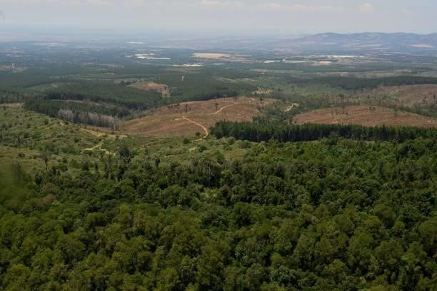

(a) (i) Identify the type of photograph shown above. (1 mark)
      - Describe the characteristics of the forest shown on the photograph.(4 marks)
      - Draw a rectangle measuring 15 cm by 10 cm. On it, sketch and label five main features shown on the photograph. (5 marks) (b) (i) Name two indigenous softwood tree species in Kenya. (2 marks)
      - Explain three problems facing forestry in Kenya. (6 marks)
      - State three factors favouring the development of softwood forests in Canada.
(3 marks)
(c) Give four differences between softwood forests in Kenya and Canada. (4 marks)

- Study the table below and answer the questions that follow
Oil consumption in Kenya in the year 2010
Economic sector | Percentage of oil consumed
Agriculture | 4
Aviation | 21
Commercial and Industry | 22
Power | 7
Rail | 6
Road | 30
Shipping | 6
Others | 4
Total | 100
a) i) Draw a simple pie chart to represent the information above. (6 marks) ii) What is the percentage of oil used in transport in the year 2010? (2 marks) iii) Mention two demerits of using the method above to represent data. (2 marks) b) i) List three countries where oil is produced in the Middle East. (3 marks) ii) Explain three contributions of oil in the economy of the countries in the Middle East
(6 marks) c) Describe how petroleum oil is formed. (6 marks)
- a) Name two wheat growing counties in Kenya (2 marks) b) State five conditions favouring wheat farming in Kenya. (5 marks)
  - Describe wheat farming from planting to harvesting stage. (8 marks)
  - Give two selling points of wheat in Kenya. (2 marks)
  - Compare wheat farming in Kenya and Canada. (8 marks)
- a) Discuss nomadic pastoralism in Kenya under the following sub-headings
i) The cattle breeds kept | (2 marks)
ii) The pattern of movement | (2 marks)
iii) Marketing of the animals | (3 marks)
b) i) Give three reasons why nomadic pastoralists keep large heads of animals. (3 marks)
ii) Explain four measures taken by the government of Kenya to improve beef cattle farming. (8 marks) c) Give four challenges facing nomadic pastoralism in Kenya (4 marks)
d) Name three indigenous breeds of dairy cattle reared in Kenya. (3 marks)

THIS IS THE LAST PRINTED PAGE.

