NAME…………………………………………………………………ADM………………………..CLASS………………….
312/2
GEOGRAPHY
Paper 2
Time: 2¾ hours

MOMALICHE 2 CYCLE 6 EXAMINATION
Kenya Certificate of Secondary Education
FORM 4 TERM 1 2019

INSTRUCTIONS TO CANDIDATES
- This paper has two sections A and B.
- Answer all the questions in section A.
- Answer question 6 and any other two questions from section B.
- All answers must be written in separate answer sheets.

SCORE SHEET

SECTION A 1-5
QUESTIONS 6
QUESTION 7
QUESTION 8
QUESTION 9
QUESTION 10
TOTAL

SECTION A.
Answer all the questions in the section.

1a)Define the term animal sanctuary. (2mks)
b)Name any three marine parks in Kenya. (3mks)

2a)Differentiate between horticulture and market gardening. (2 mks)
b)Mention three factors that have favoured horticulture industry in Kenya. (3 marks)

3(a)Statethree physical factors that influenced location of Perkerra irrigation scheme.
(3 mks)
(b)State two problems that face farmers in (a) above. (2mks)
4. a) Name two dairy cattle breeds reared in Kenya. (2mks)
b) State three differences between beef farming in Argentina and Kenya. (3mks)
5(a) Give two examples of softwood trees found in Kenya (2mks)
(b) State three problems facing forestry in Canada (3mks)
SECTION B

Answer question 6 and any other two questions from this section

6. The table below shows crops production in Kenya for a period of five years in 1000 kilograms. Use it to answer question (a)
CROP/YEAR | 2005 | 2006 | 2007 | 2008 | 2009
Coffee | 1000 | 900 | 800 | 700 | 800
Tea | 700 | 700 | 600 | 680 | 600
Cotton | 500 | 400 | 300 | 600 | 350
pyrethrum | 300 | 200 | 300 | 440 | 450

(a) (i) Using a scale of 1 cm represent 200 kilograms present the above data using a compound bar graph.(9 marks)
(ii) List two advantages of using a compound bar graph to represent statistical data.(2 mks)
(b)(i)Other than Ghana, name other two counties West Africa where cocoa is grown
(2 mks)
(ii) State three physical conditions that favor the growth of cocoa in Ghana.(3 mks)
(c) Describe how cocoa is processed in Ghana (6 mks)
(d)Give three importance of cocoa production to the economy of Ghana. (3 mks)

7a) i) identifytwo types of open cast mining. (2mks)
ii) Describe the stages involved in deep-shaft mining. (6mks)
b) State three negative effects of mining on the environment. (3mks)
c) Give two reasons why Kenya import her oil in crude form. (2mks)
d) Explain four ways in which mining contributes to the economy of Kenya. (8mks)
e) Explain how the following factors influence exploitation of minerals.
- Technology (2mks)
- Quality of the ore. (2mks)

8. Use the map of North America to answer the questions below.
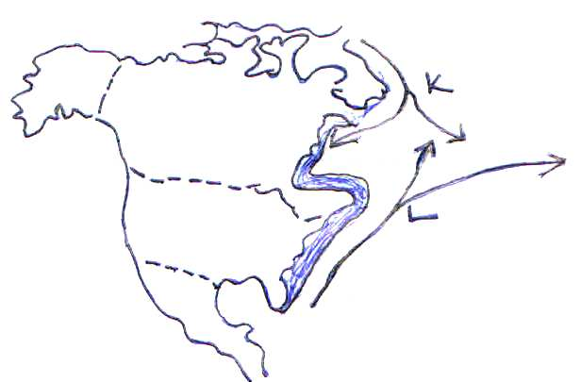

- (i) Name the ocean currents named K and L (2 mks)
(ii) Name two methods of fishing used in the shaded area. (2 mks)

(b) Explain how the following factors favour fishing in the shaded area.
(i) Indented coastline (2 mks)
(ii) Ocean currents (2 mks)
(c) Explain four ways in which marine fisheries in Kenya can be conserved (8 mks)
(d) (i) Give three methods used to preserve fish in Kenya (3 mks)
(ii) Explain three problems experienced by fishermen in Lake Victoria (6 mks)

9(a)(i) Name two geothermal power stations in Kenya (2mks)
(i)Explain three physical factors that influence the location of geothermal power stations (6mks)
(b)(i)State three negative effects of energy crisis (3mks)
(ii)Explain four measures taken by the Kenyan Government to manage and conserve energy (8mks)
(c)(i)State three challenges facing energy management in Kenya (3mks)
(ii)State three disadvantages of natural gas (3mks)

10(a)(i) Differentiate between industry and industrialization. (2mks)
(ii)Name a town in Kenya where each of the following industries is located.
- Oil Refining (1mk)
- Paper manufacturing (1mk)
- Motor vehicle assembly (1mk)
(b)Study the map of the Ruhr industrial region and use it to answer the question below.
River x

River Y
Q
R

Name;
(i)The rivers marked X and Y (2mks)
(ii)Towns marked Q and R (2mks)
(iii)A part from iron and steel industry, name two other industries in the region (2mks)
(c)Explain five factors which influenced the location of iron and steel industry in the Ruhr region of Germany (10mks)
(d)State four problems facing cottage industry in India (4mks)

