END OF TERM 1I EXAMINATION, 2019
Kenya Certificate of Secondary Education (KCSE)

GEOGRAPHYFORM FOUR

312/2
GEOGRAPHY

PAPER 2

TIME: 2¾ HOURS

INSTRUCTIONS TO CANDIDATES:
- This paper has two Sections A and B.
- Answer all the questions in Section A.
- In Section B, answer question 6 and any other two questions from Section B.
- All answers must be written in the answer booklet provided.

312/2
GEOGRAPHY

PAPER 2

TIME: 2¾ HOURS

SECTION A (25 MARKS)
Answer ALL the questions in this section.

1. a) Differentiate between afforestation and agro-forestry. (2 marks)
b) Give three reasons why afforestation is being undertaken in Kenya. (3 marks)

2. (a) Name three modes of transport in Kenya. (3 marks)
(b) Give two ways in which cell phones contribute to Kenya’s economic development. (2 marks)

3. (a) Define the term “mining” (2 marks.)
(b) List three challenges Kenya faces in exploitation of her minerals. (3 marks)

4. (a) State two advantages of using solar energy. (2 marks)
(b) Identify three non-renewable sources of energy used in Kenya. (3 marks)

5. (a) Define the term pollution. (2 marks.)
(b) State four causes of water pollution. (4 marks.)

SECTION B:
Answer question 6 and any other two questions from this section.

6. Study the photograph below and answer the following questions.
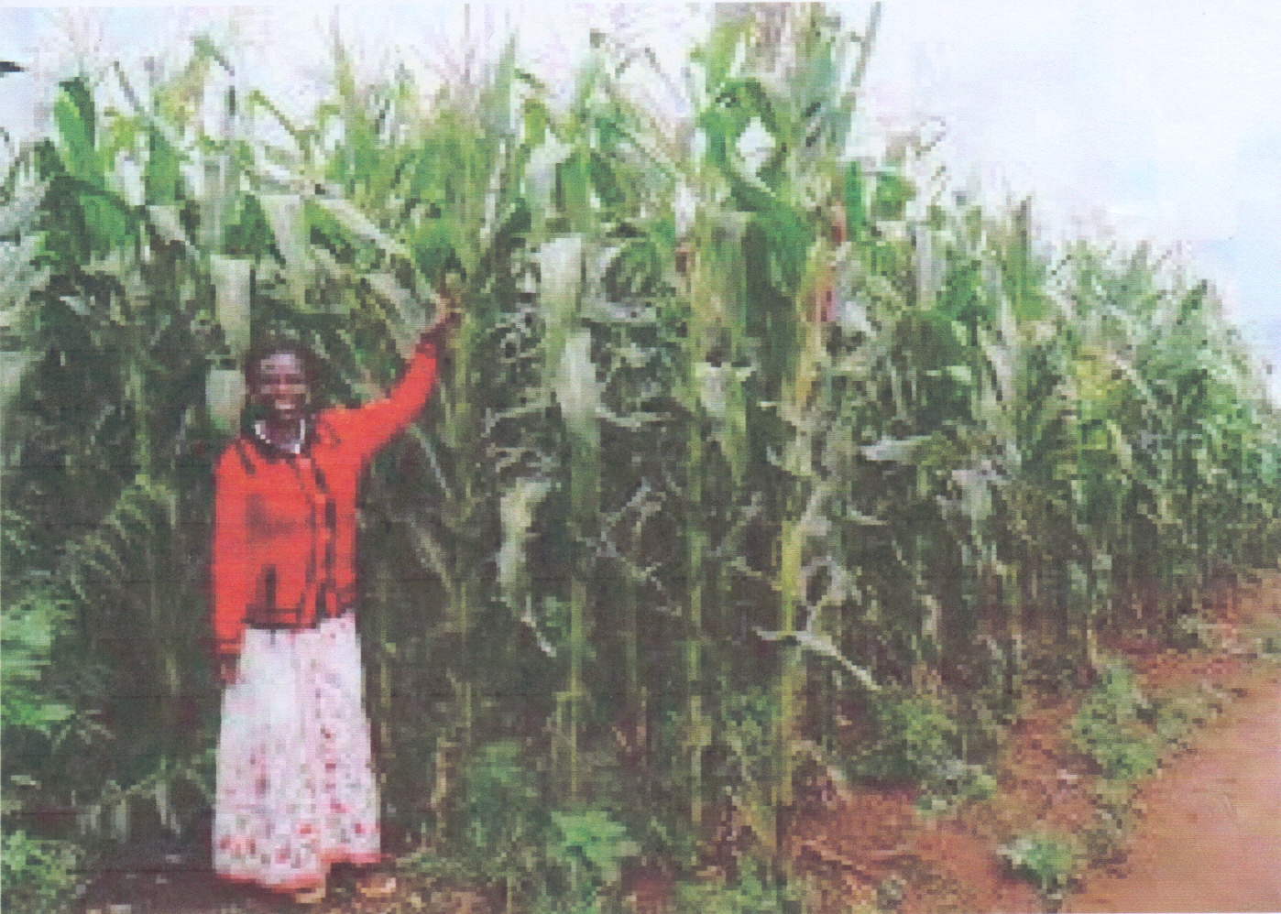

(i) Identify the type of photograph shown above. (1 mark)
(ii) Give one reason for your answer in a(i) above. (1 mark)
(iii) Draw a rectangle measuring 15cm by 10cm to represent the area of the photograph. On it sketch and label the main features shown on the photograph. (4 marks)
(b) (i) Name three countries in Kenya where maize is grown on large scale. (3 marks)
(ii) Explain three physical conditions that favour maize cultivation in UasinGishu County in Kenya. (6 marks)
(iii) Describe the stages involved in the cultivation of maize from land preparation to harvesting. (6 marks)
(iv) Outlinefour ways in which the government assist maize farmers. (4 marks)

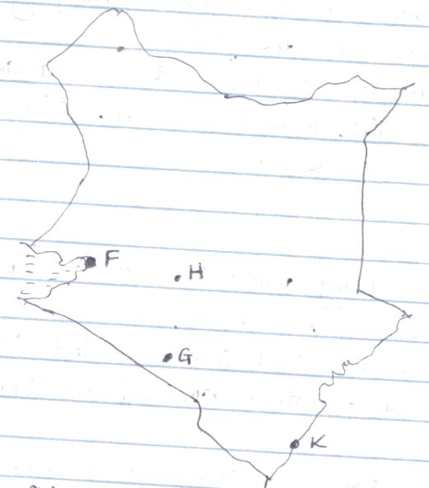
7. The map of Kenya below shows some industrial towns.

F
H

G

K

a) Name the industrial towns marked;

i) F (1 mark)
ii) G (1 mark)
iii) H (1 mark)
iv) K (1 mark)

b) i) Differentiate between an industry and industrialization. (2 marks)
ii) State four similarities between the Jua kali industry in Kenya and the Cottage industry in India. (4 marks)
c) i) Give four reasons why most industries are located in Nairobi. (4 marks)
ii) Explain four problems caused by industrialization. (8 marks)
d) State three methods used by the government of Kenya to decentralize industries. (3 marks)
8. The map of East Africa below shows some fishing grounds. Use it to answer questions (a) and (b).
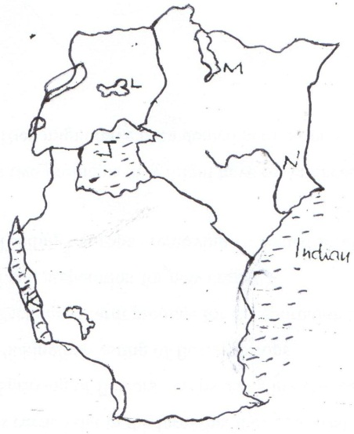

K
J
L
Indian Ocean
N
M
a) Name the fishing grounds marked:(5mks)

J
K
L
M
N

b) i) Explain three factors that have favoured fishing in the area marked J. (6 marks)
ii) Name three fish species caught in the area marked J. (3 marks)
c) Give four reasons why inland fishing is more widespread in East Africa than fishing in the Indian Ocean. (8 marks)
d) Name three traditional fishing methods used by fishermen in East Africa. (3 marks)

9.(a) (i) Define the term wildlife. (2 marks)
(ii)Differentiate between a Game Reserve and a National park. (2 marks)
(iii)Name three game parks in Uganda. (3marks)
(iv)What is Wildlife Management? (2 marks)
(b) Explain the measures being taken to manage Wildlife in East Africa. (8 marks)
(c) Explain four physical factors that influence the distribution of Wildlife in East Africa.
(8 marks

10. (a) (i) Differentiate between horticulture and market gardening.(2mks)
(ii) Name two horticulture flowers grown in Kenya. (2mks)
(iii) State three problems facing horticultural farming in Kenya. 2mks)
(b) (i) Give four characteristics of horticulture and market gardening (4mks)
(ii) State three measures that have been taken by the Kenya government to promote horticultural farming. (3mks)
(c) Explain three conditions that favour horticultural farming in the Netherlands (6mks)
(d) Students from Kiong’ongi secondary school conducted a field study of a flower farm in the neighbouring Rift valley region.
(i) Give two ways of planting flowers used in recording their findings from the field of study. (3mks)

