1996 GEOGRAPHY PAPER 1 MARKING SCHEME:
SECTION A:
1. a) Two features resulting from extrusive volcanic activity
Composite volcano Lava plateau/lava plains/tuff plateau
Caldera/crater Ash and cinder cones
Spine/volcanic plugs Hot spring (any 2 x 1 =2 mks)
b) Four ways in which volcanicity has influenced human activities in Kenya
i) The Volcanic rocks of the Kenya highlands have been weathered to produce fertile soil for agriculture.
ii) Landforms resulting from activity are tourist attraction /scenic beauty e.g Mt Kenya.
iii) Trachyte and phonolites/volcanic rocks are used for building
iv) steams jets/gerious at Olkaria are used for generating geothermal power.
v) Gases associated with volcanic activities are mined in Kenya e.g CO2 at Kereita and at Esageri in Baringo
vi) steep slopes formed through volcanic activity discourages settlement/farming/development of transport. (4mks)
2. The block diagram below represents part of the earth’s crust which has been subjected to tensional forces.
a) (i) The slope marked A-Heave/Escarpment
(ii) The angle marked B-hade (2mks)
b) Three ways in which faulting can influence drainage system
    - Vertical faulting across a river may cause waterfall
    - Rift faulting in an enclosed area may lead to formation of a lake if rivers drain into the basin/inland drainage
    - Some rivers flow along fault lines/fault guided drainage
    - Uplifting of landscape which leads to faulting may cause rivers to their direction of flow. (Any 2x1= 2mks)
3 a) What is an isobar?
    - It is an imaginary line connecting places with the same air pressure.
    - It is a line an a map connecting places with the same atmospheric pressure. (2mks)
b) Four characteristics of Modified equatorial climate (Lake V. Basic)
- Rainfall throughout the year
- Rainfall total between 1000mm-1600mm/heavy/high/high rainfall
- Rainfalls mainly in the afternoons
- Rain is accompanied by thunder
- Temperature range between 200-60c/moderate a temperatures
- There is high humidity
- Double maximum rainfall (any 4x1=4 mks)
3 c) Convectional type of rainfall
  - Small annual range of temperature (only if the answer on rainfall
award marks)
4.a) If the local time in Nairobi at longitude 37o E is 10.00a.m. What will the
time be at Buchanan in Liberia at longitude 10ºW
1º = 4 Mins
47º x 4 = 188 mins
= 3hrs 8 mins
Buchanani is 3 hrs. 8 mins behind Nairobi its time will be 6.52 am (2mks)
b) The effect of the international date line on time
On crossing this longitude while going to west, a day is lost while
a day is gained while crossing to the East. (2mks)
5. a) Three examples of mechanically formed sedimentary rocks
- Sandstone - Clay stone, siltstone -shale -Mudstone
b) Changes that occur in sedimentary rocks when they are subjected
to intense heat and pressure.
  - New Minerals are formed
  - Minerals recrystallize further
  - Rock particles become compacted
  - The physical appearance of the rock changes
  - Metamorphism without any details(Any 2x 1 = 2 marks)

SECTION B:
1. Study the map of Ithanga (1:50,000 Sheet 135/4) provided and answer
the following questions.
a) i) The six – figured grid reference for the trigonometrical station
to the south – east of the area covered by the map – 300906 (1mk)
ii) The bearing of the school at Kamwiendei village from the
church at Riakanau? 029º + 1o (022 – 030º) (2mks)Accept this
iii) The length of the dry weather road (E 625 ), from the
junction at karaba shops to where it ends at Riakanau
village in kms.
- 10.7 km + 0.1 km (10c- - 10.8) (2mks)
iv) The area of Tebere B in the northern part of the map.
-13.5 ± 1 km² (1.25 – 14.5 ) km² (2 mks)
b) Student from one of the schools in the area covered by the map
carried out a field study on the physical features and economic
activities found in the area.
i) Two types of natural vegetation they are likely to
have identification.
- Scrub - Scattered trees -Woodland
ii) Citing evidence from the map, name three economic
activities the students are likely to have identified during
their study.(3mks)
Activity: Evidence
Agriculture / farming Sisal estate / coffee plantation / coffee factory
Commerce / trading Shop / markets
Mining / quarrying Processing
Posho mills / coffee factory Transportation
Roads / ferry * No evidence no marks Any 3 x 1 = 3 mks
(iii) Citing evidence from the map, name two methods the students are likely
to have used to cross River Tana.
Method Evidence
Ferries Ferries
Barrage Merila river Barrage
Bridge points New Tana Bridge
* No evidence no marks Any 2 x 1 = (2 mks)
(c) The drainage of the area covered by the map is as follows
- River Tana and its tributaries from the main drainage system in the area
- The area has numerous, permanent, surface streams/ rivers
- Most parts of the area covered by the map are well drained
- There are some seasonal swamps found mainly along the valley of river Tana.
- The main drainage pattern is dendritic with radia pattern noticeable in the South East.
- There are man – made water features including dams water troughs and in the area covered by the map (4 x 1 = 4 Mks)
* If you get a specific point find the evidence from the river.
(d) The distribution of settlement in the area covered by the map is as follows:
- There are few settlements/labour lines within Ithanga estate and
Kiamutunguru hills.
- There are scattered settlements in the South West and the area
immediately to the North of river Tana
- There is nucleated settlements mainly in the market/shopping centres/
villages in the North and South Western part of the area covered by the map.
- Some areas such as Mbondoni and the area between Kamwendei and
Karabal have no settlements.
(e) A rectangle 15cm by 10cm representing the area west of Easting 20 and south of Northing 00.on the rectangle the following are marked and named.
i) The provincial boundary ii) Ithanga hills
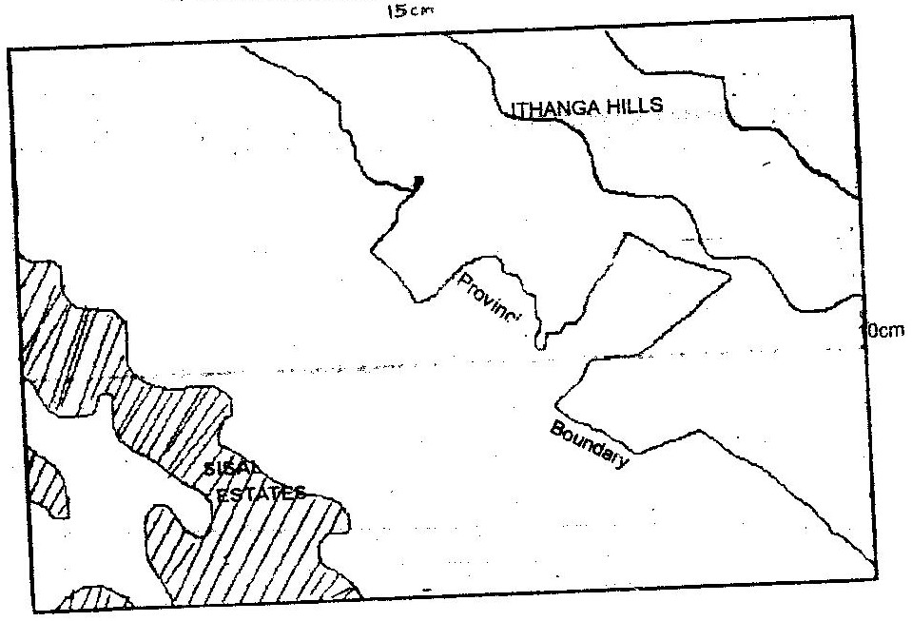
iii) The sisal plantation to the south west of the area.

2. a) i) A river dived
- It is a ridge / high ground that separates two or more rivers basins
- The highest line of an interflose (1mks)
ii) Describe three ways by which a river transports its load
- Traction process / rolling / sliding – The large and heavy particles of the river load are rolled / dragged along the river bed.
- Saltation process – particles that are not too heavy but cannot remain suspended in water are momentarily lifted by the water turbulence and at times dropped onto the river bed.
- Solution – soluble minerals are dissolved in the river water and carried away in solution.
- Suspension – light particles of the load are carried and maintained within the turbulence of flowing water. (any 3 x2 = (6 mks)
NB: Correct description can earn marks without process.
b) The characteristics of a river in its old stage
- The widening of the valley through lateral erosion creates an extensive area where the river deposits its load, the gradient of the plain is low.
- The speed of flow is low, the gradient of the plain is low.
- Due to the slow speed and the high rate of deposition, the river forms pronounced meanders.
- Due to the slow speed, the main work of the river is deposition
- Meanders become more pronounced with narrow neck which are eventually blocked by deposits to form meander cut off / ox –bow lakes.
- Increased deposition along the channel raises the river bed may eventually form small islands / braided channel / river braids
- Deposition along the banks of the river channel leads to formation of leaves.
- The reduced speed and increased deposition blocks the river mouth forcing the river to form distributaries / delta.(any 7 points = 7 marks)
c) Description of drainage patterns / systems.
Superimposed
- The drainage system develops on a rock structure that overlay
a totally different one.
- The river valley cuts through the surface rock layer onto the underlying rocks.
- Gradually the surface rocks are removed ad the underlying rocks now become exposed.
- The superimposed drainage system bears on relationship to the existing rock structure / discordant with the rock structure (3mks)
ii) Centripetal
- The pattern develops in an area with a central basin
- River drain into the depression from different directions(2mks)
d) You have planned to carry out a study of a river in its youthful stage preparation for the study.
- Carry out reconnaissance survey
- Read from reference books / seek permission from the authority
- Prepare a sketch map
- Formulate objectives from the study /Hypothesis of the study
- Prepare relevant stationery (Any 2 x 1 =(2 mks)
ii) Two features you are likely to study
- Interlocking spurs
- Gorges
- Water falls / rapids / cataracts
- Potholes, plunge, slope river , slope pools(Any 2Mks)2 x 1
iii) Two problems you are likely to experience during the study
- Steep slopes
- Thick vegetation
- Rocky contours
- Poor communication / bad roads
- Hostile weather conditions (to be specified)
- Wild animals crossing river valley (Any 2 x 1 = 2 mks)
3.a) The four process things which are
- By hydraulic action
- Abrasion / currasion
- Solution / Currasion

QUESTION 3:
b) i) Formation of a spit.
- It forms on a shallow shore at a point where there is a change in the
angle of the coastline.
- Sand or shingle is deposited by long shore drift / oblique waves
- Deposition continues and materials accumulates seawards
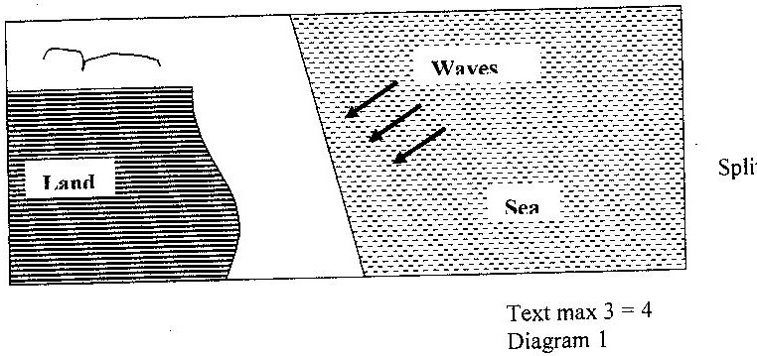
- With time, an elongated feature with one end attached to the mainland projects into the sea and it called a split.

FORMATION OF BLOWHOLES
- Wave erosion acts on a line of weakness at the back part of the roof of a sea cave
- At the same time weathering especially by solution acts on the line of weakness from the surface downwards.
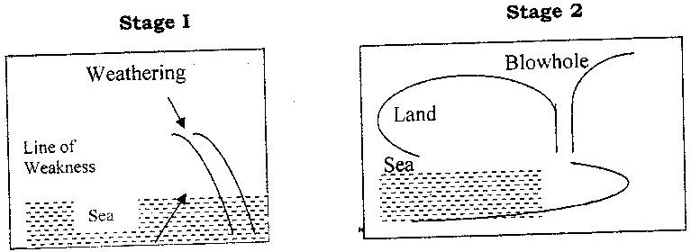
- Eventually, a vertical shaft / hole, which connects the surface to the cave below, is formed and is called a blowhole.

Wave action
NB** Point must be mentioned to score full marks for text.
Wave action at the base of a cliff attacks the zone of weaknesses.
The cave develops and gradually enlarge following the lines of weaknesses.
The cave eventually opens up further inland through a vertical shaft/line of weakness to form a blowhole group. (2x1= 2mks) Diagram 2 marks.)
An atoll
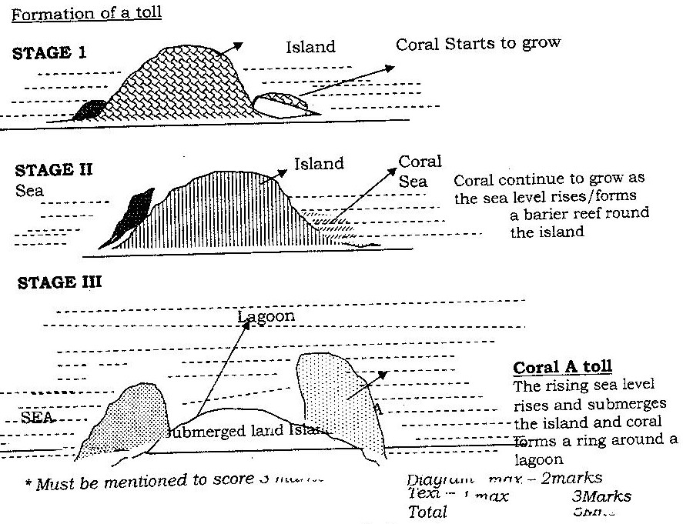
Stage 1

3 a) (iii) Formation of an Atoll(Hurray’s theory)
- Coral grow on submarine hills or plateaus.
- These hills/plateaus consist of either volcanic material or accumulated pelagic material
- They rise/accumulate to within 60 meters of depth.
- Coral grows more vigorously outwards
- The coral on the inner side is slowly dissolved to form a deep lagoon.
b) (iii) formulation of an Atoll (Dely’s theory)
- During the last ice age, coral islands in the ocean were flattened by marine erosion.
- At the end or the ice age, the meltoutous caused a global rise in sea level.
- The warmer temperature encouraged growth of coral reefs, which kept pace with the rising sea level
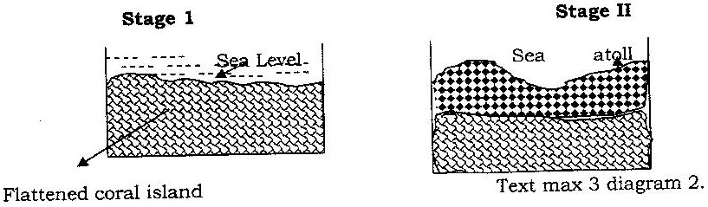
- Coral grew more vigorously outwards than inwards.

c) Some student carried out a field study on the coastal features found along the coast of Kenya.
(i) Thee features formed as a result of coastal emergence that they are likely to have studied
- Raised beaches
- Raised wave-cut platforms
- Raised coral/exposed coral rocks
- Cliffs
- Mud flats (any 3x1 = 3mks)
(ii) Three methods the student may have used to record their data
- Taking photographs
- Drawing sketches/maps/ Diagrams
- Tabulating/tallying
- Labels samples
- Making notes/taking notes (Any 3x1 = 3mks)
(iii) Two ways in which features resulting from coastal emergence are of significance of Kenya
- Some are tourist attraction
- Coral provides raw materials for cement manufacturing
- Coral rocks are used as building materials
- They provide an environment for education/research activities
(2x1= 2mks)

4 a) (i) Four characteristics of desert soil
- They are thin/shallow
- They are stony/sandy
- They are saline
- They are loose in texture
- They are rich in calcium
- Low moisture content (4x1=4 marks)
(ii) Two factors that contribute to soil leaching
Nature of the soil / Solubility of the minerals
Topography
b) How each of the following factors influences the formation of soil;
(i) Parent rock
- The nature of the rock influences the rate of weathering/hard rock weather slowly while soft rock weathers fast
- The rock determine the soil texture/large grained soils.
- The type of minerals in the parent rock are transferred to the soil during formation. (2x1= 2mks)
ii) Living organisms
- They assist in the breaking down of rocks through burrowing / ploughing / root penetration.
- They influence the chemical composition of soil by adding / removing organic acid solution / minerals.
- Burrowing / digging influences soil aeration. (2 x 1 = 2 mks)
Topography
- It determines the rate of weathering / steep slopes encourage high rate of weathering and removal of soil particles.
- It influences soil depth / gentle slopes have deep soil while steep slopes have thin soils
- It influences soil drainage / where land is flat, soil are poorly drained.
(2 x 1 = 2 mks)
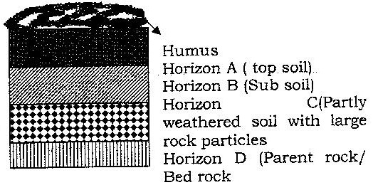
c) Draw a well – labeled profile of mature soil
A soil profile

d) Four ways in which human activities contribute to soil erosion
- Monocultural / farming activities leads to soil exhaustion thus making the soil vulnerable to erosion.
- Overstocking reduces vegetation cover, exposing soil to agents of erosion.
- Ploughing up and down a slope provides channels for surface run off.
These are enlarged to become gullies.
- Deforestation / clearing of vegetation cover exposes soil to agent of erosion.
- Mining / quarrying / road construction loosen / exposes the soil making it susceptible to erosion.
- Human settlement and cultivation on steep slope / river frontage increases soil erosion processes.
- Continues cultivation without replenishment of soil exhaustion making the soil vulnerable to erosion.
- Shifting cultivation / bush fallowing leaves land unprotected against erosion.
(Ant 4 x 2 = 8 mks)
NB: Double tick at the end of the whole explanation = (25)
GEOGRAPHY PAPER 2 1996 MARKING SCHEME
SECTION A
1. a) Vegetable / tomatoes / onions / carrots.(allow any correct vegetable)
(max 1mk)
Fruits / oranges , pineapples, plums, mangoes (allow any correct fruit)
flowers, roses (max 1 mk)
b) Netherlands has a higher urban population than Kenya / there is
high demand both local and foreign for horticultural crops products in Netherlands than in Kenya.
- Farmers in Netherlands have more access to the capital needed for horticultural farming than in Kenya.
- There is more advanced and appropriate technology in Netherlands which has enhanced horticulture farming than in Kenya.
- Netherlands unlike Kenya has highly skilled labour for production and handling of agricultural products.
- There is more advanced horticultural farming related research in the Netherlands than in Kenya.
- Netherlands unlike Kenya has well organized marketing procedures / co-operatives / auction markets which are conducive for horticultural farming. (any 3 well compared points 3x1(3mks)
2. To create employment opportunities / solve unemployment problem make
use of locally available materials.
- To produce cheap consumer goods / to substitute the expensive imported goods.
- To reduce importation / save foreign exchange
- To cater for local needs.
- To diversify the export goods
- Jua kali industries requires little capital investment.
- Establishment for jua kali industries is a way decentralizing industries which reduces rural – urban migration
3. a) X – Amboseli N.P Y – Marsabit G.R
Z – malindi / watamu marine Reserve
b) Setting up the Kenya wildlife services which is responsible for
conserving wildlife.
- Banning of game hunting
- Banning of game hunting
- Banning of trade in wildlife products
- Establishing the Kenya rangelands ecological monitoring Unit (KRMU)
- Creating public awareness through mass media, wildlife clubs and wildlife education centres. (Any 2x 1 = 3mks)
4. a) Ndola, Kitwa, Mafulira Luashya, Chililabombwe, Chemezi
b) Mining of copper has created employment opportunities.
- It has led to development of manufacturing industries
- It has facilitated the development of transport network.
- It has promotes agricultural production near the mining areas.
- It has facilitated local and foreign trade.
- It has led to expansion of hydro- electric power production.
(Any 3x1 = 3mks)
5. a) High demand for hard wood has led to over – exploitation.
- Population pressure on land has led to increased cutting of trees to provide land for farming and settlement.
- The time taken for the hardwood trees to mature does not match the rate at which they are being exploited.
- Softwood forest in Canada are more extensive than those in Kenya
- Softwood trees species in Kenya are Exotic while those in Canada are indigenous.
- There is a wider variety of softwood tree species in Canada than is in Kenya. (Any 2 x 1 = 2 mks)

SECTION B.
Country | Passengers in millions
 | 1996 | 1997
Canada  U.S.A  Argentina  India  Japan | 4,200  27,700  14,100  96,800  258,400 | 3,000  16,600  12,000  163,800  311,900
1. a) i) Using a scale 1cm to represent 20,000 millions passengers,
draw comparative bar graphs based on the data above (9mks)
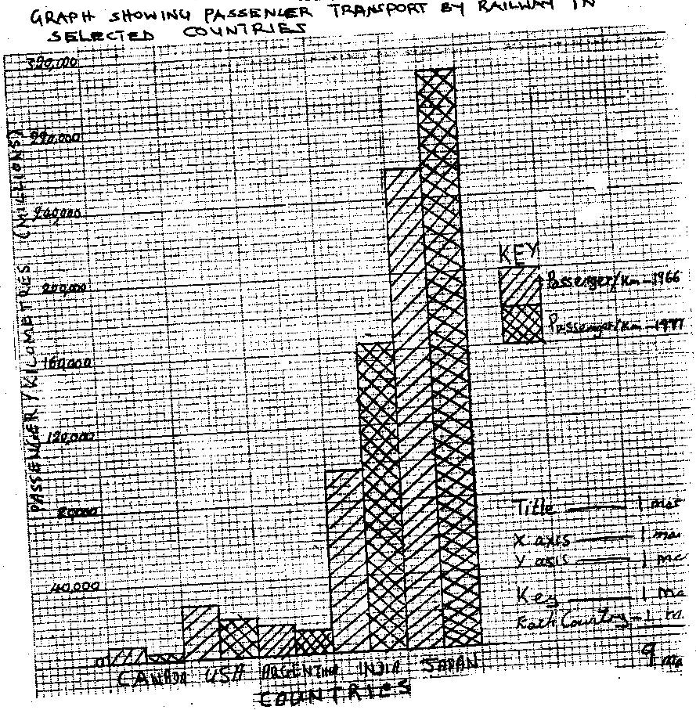

ii) They are easy to construct
- They are easy to compare
- They depict data more accurately
- They give clear visual impression
- They are easy to interpret
- Easy to reach (Any 2 x 1 = 2mks)_
b) 4,200 1,200 x 100
3,000 4,200
1,200 = 28.5% (2mks)
c) Africa countries were administered by different colonial government
who constructed rail lines only with the areas of their jurisdiction.
- Many African countries have political differences, which lead to mistrust and hostility. This works against any efforts undertaken railway construction jointly.
- African countries have railways of different gauges, which makes it difficult for them to be connected.
- There is little inter- state trade among African countries. This does not warrant construction of railways to transport bulky goods.
- African countries lack sufficient capital to establish railways which rely mainly of imported raw materials / mountains landscape / swampy terrain have hindered the development of rails to link the countries.
d) Establishment of airport has created employment opportunities thus solving the problem of unemployment/ improving the standards of the employees.
- It has promoted tourism by providing direct links with the countries of origin.
- It has promoted Horticultural products by providing efficient means of transport to the foreign markets.
- It helps generate revenue through taxation of goods and passengers at the airport./ foreign exchange earning.
- It has promoted international understanding by enabling Kenyans to interact with people from other part of the world.
2. a) Kisumu grew as the terminus of Uganda railways.
- It grew as large port handling the regional lake trade.
- The high population in the surrounding areas provided the required labour force.
- Early Asian settlement in the area led to commercial development
- It was a regional headquarters for colonial administration.
- Water for domestic and industrial use was readily available in the area.
- It has rich agricultural hinterland providing food and industrial raw material.
- The development of industries has attracted people to the tow.(Fishing industry) (Any 4 x1 mk 9max 4 mks)
b) Banking / Financial center.
Industrial center
Fashion center
Transport and communication center
Headquarters of U.N
Leading trade center/stock exchange center
Educational center
Cultural center (Max. 5mks)
c) The rapid growth of population has led acute shortage of houses.
- There is serious traffic congestion during rush hours especially in Nairobi. This leads to lose of time congestion
- The heaps of uncollected garbage cause a health hazard as they can lead to epidemics.
- The town a large unemployed population which is idle and encourages crime and immoral practices.
- The urban centers suffer from perennial water shortages due to increased
- Number of consumers
- There is poor sewage system in some parts of the towns. This causes a health hazard.
- The rapid growth of population has lead to inadequate provision of health hazard.
- The rapid growth of population has lead to inadequate provision of health, education services and social services.
- Pollution of the air sound pollution caused by vehicles causes health hazard.
d) Urbanization encourages national unity as people of all nationalities/ethnic background comes together.
- It promotes links between countries as communication network tends to focus into urban centres.
- It creates employment opportunities through the establishment of commercial and industrial activities.
- It leads to development of infrastructure both within the urban centres and the surrounding rural areas.
- It provide market for agricultural and industrial goods produced in the country.
- Urban centers attract large population that labour for manufacturing industries and the other commercial activities. Any 3x2=6mks)
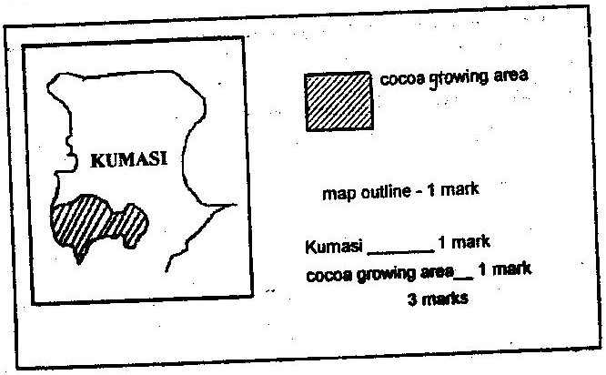
Map of Ghana

b)Pods are harvested using long knives
- Pods are collected and piled at a central place.
- Pods are split open with a sharp knife and beans scooped out by hands.
- Beans are put in heaps on mat and covered with banana leave
- Beans are allowed to ferment for 5-6 days during which the juicy pulp drains away.
- Fermented beans are washed and cleaned
- Beans are spread on tables covered with mats to dry in the hot sun.
- Beans are turned frequently as they dry and slowly turns brown.
- Dry beans are put in sacks and sent to the harvest-buying center.
- At the center, the dry beans are weighted and graded ready for export
NB: Sequence should be used some activities may be omitted.
(ii) Pest and disease which destroy the crop
- Fluctuation of prices in the world market which discouraged the farmers.
- Low prices paid to the crop discourage the farmers.
- The strong Hamattan wind destroys the crop.
- Inadequate labour during harvest.
- Poor means of transport make it difficult for farmers to deliver their crop in time. (4mks)
c) High temperature throughout the years average temperature must be over 21⁰-30⁰
- High rainfall and evenly distributed throughout the year (1000-21000 mm per year.
- Deep fertile well drained soils/can withstands a wide variety of soils.
- Low altitude of up to 700m sea level.
- Seedling must be sheltered from strong winds.
- High relative humidity Any 4x2 =8mks)
d) The leaves are used for roofing
- The shells and fiber are used for fuel
- The leaves are used for making baskets and brooms.
- The sap from the stem is used for making wine
- The fruit is used for making oil/ cosmetics/soap.
- Crushed nuts are used a animal feeds
4 a) It is suited where the number of people living in a country or region exceed the
available resources.
b) The population has lower life expectancy than that of Sweden has an ageing population..
- Most people live in urban centers
- Kenya has a high population birth rate while in Sweden it is low
- Kenya has high population death rate than Sweden.
- Kenya’s fertility rate is higher than that of Sweden. (Any 4x 1= 4mrks)
c) Most people live in the central highlands and lake Victoria basins because these areas have suitable climate for human settlement and for agricultural production. Areas with fertile soil such as the central Highlands have dense population because the soil support agricultural production/ areas with poor soil have sparse population e.g most parts of Nyika plateau.
- Gently sloping and flats lands facilitate settlement and transportation while rugged slopes/steep landscapes have sparse population or nil higher and steeper slopes of Mt. Kenya a nd Elgon.
- Transport and communication facilities have encouraged settlements. There are many market centres along the Kenya roads and centres such as Nairobi and Thika, which are, accommodate large population.
- Development of industries is a major factor influencing population distribution in Kenya. There are many people in the industrial centers such as Nairobi, Nakuru, Mombasa and Eldoret.
- Disease and pest discourages or discourages settlement in given areas. In Kenya, the government discourages population settlement schemes such as Mwea.
Any 4 x 2 = 8mks)
d) (i) Rural-urban urban-Urban
Urban-Rural International
(ii) Population pressure which leads to landlessness in areas such as central province lead to migration of people to settlement schemes and to less populated rural areas in search of land.
Insecurity in areas such as North-Eastern and Northern Kenya which have frequent attacks from bandits and cattle rustler shapes made some people to migrate to more secure areas.
Establishment of large plantation near Thika town and rice irrigation schemes in Mwea and Ahero attract people from neighboring areas as they search for employment /mining/Lumbering/fishing.
Natural catastrophes such as floods in Kano plains and lower Tana Valley cause people to move to more secure higher grounds.
Pastoral communities such as the Maasai, Samburu and Boran migrate from one rural area to another in search of pasture and water for their livestock.
Drought and famine sometimes cause people to migrate in search of food e.g some people who live in semi-arid areas of Kenya temporarily migrate to those districts where they can get food during the time of droughts)
d) Explain four factors that influenced population distribution in Kenya.
- Rainfall amount and distribution
- Soil fertility
- Colonial administration
- Government policy
- Vegetation
- Transport and communication network/social amenities
- Pests and diseases
- Development of industries
- Availability of water
- Drainage
- Temperature
- Relief
NB: Explanation should be attached

