GEOGRAPHY 312/2
END TERM
FORM THREE
TERM ONE 2020

NAME: ……………………………….. ADM NO: …….……….. CLASS: ……………..

SECTION A
Answer ALL the questions in this section.
- (a) Distinguish between forest and forestry. (2mks)

(b) State three problems facing forestry in Kenya. (3mks)

- (a) Define economic Geography. (2mks)
(b) Give three natural economic factors of production exploited by man. (3mks)

- (a) Give two hardwood species in Kenya (2mks)
(b) Give three characteristics of softwood in Canada. (3mks)

- The diagram below shows the occurrence of petroleum in the earths crust. Use it to answer questions (a) and (b)
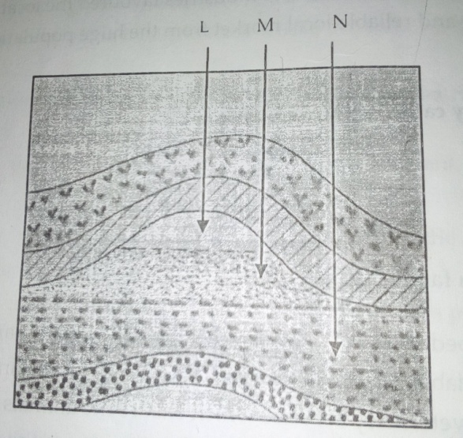
(a) Name the substances in the area labeled L, M and N. (3 mks)

(b) Give two by –products obtained from the refining of crude oil (2 mks)

- (a) Name two areas in South Africa where diamonds are mined. (2mks)
(b) Identify three methods used in diamond mining in South Africa. (3 mks)

SECTION B
Answer questions six and any other two.
- The table below gives the figures for the 1999 population census per district for central province of Kenya.
District | Population
Nyandarua  Nyeri  Kirinyaga  Muranga  Kiambu  Thika  Maragua | 479902  661156  457105  348304  744010  645713  387969
(a)(i) Beside bar graphs, name three other methods that can be used to represent the data above. (3mks)

(ii) Draw a simple bar graph to represent the data in the table above. Use a scale of 1cm to represent 100,000 people. (6mks)

(iii) State four advantages of using bar graphs to represent statistical of three densely populated districts. (4mks)

(b) Calculate the total population of three densely populated districts. (2mks)

(c) Explain three types of ground photograph (6mks)

(d) State four advantages of a comparative line graph. (4mks)

7. (a) (i) Distinguish between indigenous and exotic forests. (2mks)

(ii) Show how natural forest differ from planted forests (8mks)

(b) Explain three factors that influence the distribution of softwood forests in Kenya (6mks)
(c) (i) State three measures that are being taken in Kenya to conserve forests. (3mks)

(ii) Explain three factors favouring the exploitation of softwood in Canada. (6mks)

8. (a) Explain five factors to consider before undertaking mining. (10mks)

(b) Give three problems facing soda ash mining in Magadi (6mks)

(c) (i) State three methods of placer/alluvial mining. (3mks)

(ii) Explain three negative effects of open cast mining. (6mks)

9. (a) Explain three reasons why only a small part of Kenya is forested (6mks)

(b) Explain five ways in which diamond contributes to the economy of South Africa. (10mks)
(c) (i) Name three leading minerals which are exploited in Kenya. (3mks)

(d) Form four students conducted a field, study in mining in their local area.
(i) State three methods of data presentation they were likely to use. (3mks)
(ii) State three importance of work schedule during their fieldwork. (3mks)

10. (a) Differentiate between human geography and economic geography. (2mks)
(b ) Name at least FIVE human activities in Kenya. (5mks)
(c) Your Geography class organized a field study on wildlife at Lake Nakuru National Park.
(i) Apart from preparing a route map, identify other ways in which the class prepared for the
study. (5mks)
(ii) Why was it necessary to prepare a route map?(4mks)
(i) Identify the activities the class was involved in during the study.(6mks)
(ii) Give THREE methods the class used to record data.(3mks)

