MWAKICAN FORM 1 GEOGRAPHY EXAM
MARKING SCHEME TERM 3 2019

  - Define the term Geography (2mks)
Geography is the description of the earth/ It is the study of earth as home of man/ it is the description of the distribution of natural features on the earth and their interrelationship.
  - The diagram below represents the interior structure of the earth, use it to answer the questions (i) and (ii)
sima
Continental crust
x
    - What is the other term for continental crust? (1mk)
sial
    - What do we call the boundary marked x? (1mk)
Gutenburg discontinuity
  - Name four theories of the origin of the earth. (4mks)
- Passing star theory
- Nebula cloud theory
- Collision theory
- Supernova theory

- Draw a circle to represent the earth/globe, on it draw and name the five main lines of latitudes giving their degrees (10mks)
Award a tick for correct stated line
Award tick for given degrees
Arctic Circle 66 ½°N
Tropic of Cancer 23 ½°N
Equator 0°
Tropic of Capricorn 23 ½°S
Antarctic Circle 66 ½°S

  - State 4 effects of the rotation of the earth (4mks)
- It causes deflection of ocean currents and winds
- It causes day and night
- It causes rising and falling of ocean tides
- It causes the variation of the speed of air masses
- It causes 1hour difference in time between longitudes(meridians) that are 15° apart

  - What do you call the time of the year when the lengths of day and night are equal and the sun is also over head at the equator? (1mk)
Equinox

  - Give reasons why the interior of the earth is hot (3mks)
- The earth still retains the original heat which it had before it started cooling. The outer part cooled faster than the interior.
- Due to radioactivity going on inside the earth which causes occasional explosions, releasing a lot of heat.
- The crustal rocks exerts a lot of pressure on the rock materials beneath it. The intense pressure generates a lot of heat inside the earth.
  - Calculate the following
    - If at place X (longitude 10°E) is 2:00pm, what will be the time at Y (longitude 11°E)? Show calculations (3mks)
- Difference in longitude = 11°E - 10°E = 1°
- 1° x 4 = 4mins
Time at 10°E is 2:00pm
Time at 11°E is 2:00pm + 4mins
- 2:04pm (Answer)

    - The time at place Q (longitude 25°W) is 1:00am, what will the time be at P (longitude 30°W)? (3mks)
- Difference in longitudes = 30°W - 25°W = 5°
- 5° X 4 = 20min
Time at 25°W is 1:00am
Time at 30°W is 20mins earlier = 1:00am – 20mins
- =12:40am (answer)

- The diagram below represents the lunar eclipse. Use it to answer the questions below
Y
X
SUN
Z
Penumbra
Name X- Earth (3mks)
Y- Moon
Z- Umbra

  - State three forces that contribute to the shape of the earth (3mks)
- Force of gravity- it attracts objects on the earth surface towards the center of the earth
- Centripetal force- it pulls the north pole and south pole towards each other
- Centrifugal force- it creates the bulging at the equater

  - Explain four proofs that the shape of the earth is spherical (8mks)
- Circumnavigation of the earth- if you move along a straight path following the same direction, you will come back to the same starting point from the opposite direction.
- The rising and setting of the sun- as a result of the earth’s rotation, places in the east receive sunlight earlier than places to the west. If the earth was flat, all places would receive sunlight at the same time.
- The earth’s horizon is curved when viewed from outer space showing that the earth is spherical.
- When a ship is approaching a port, an observer standing on a raised ground will not see the whole ship. First one sees the smoke, then the other parts appear gradually.
- During the lunar eclipse, the earth casts a spherical shaped shadow on the moon. Only spherical bodies form spherical shadows
- Photographs of the earth taken by the satellites from outer space show that the earth is spherical.
- All planets in the solar system are spherical and therefore the earth being one of the planets is also spherical.

  - Define the term weather (2mks)
The condition of the atmosphere for a short period of time.

  - Give reasons why the Stevenson’s screen has the following characteristics
    - It has louvers. (1mk)
To allow free air movement.
    - It has metallic legs (1mk)
To prevent termites from destroying it.
    - It is 1.2meters high (1mk)
To prevent contact with direct radiation from the earth’s surface
  - Give the correct instruments used to measure the following elements of weather (5mks)
Maximum Temperature – maximum thermometer

Wind direction – wind vane/wind sock

Rainfall – rain gauge

Atmospheric pressure – barometer

Humidity – Hygrometer/ dry and wet dry bulb thermometer

- The diagram below represents a weather measuring instrument
30cm
Ground
x
Metallic cylinder
Collecting jar
  - Label part X (1mk)
-funnel
  - Describe how the above instrument is used (3mks)
- When it rains, water enters the collection jar through the funnel
- When the rain stops, the collection jar is removed
- Water is poured into a measuring can/cylinder where it is measured and recorded
- Explain the formation of convectional type of rainfall (4mks)
- A water body is heated by the sun during the day.
- Convectional currents are formed
- The currents rise, cool and condense to form clouds
- When the clouds are heavy enough, they fall as convectional rainfall

- Use the table below representing temperature and rainfall readings for station X to answer the questions that follow
 | Jan | Feb | March | April | May | Jun | July | Aug | Sept | Oct | Nov | Dec
Temp °C | 20 | 22 | 21 | 19 | 17 | 15 | 13 | 15 | 17 | 18 | 22 | 24
Rainfall mm | 310 | 290 | 170 | 140 | 143 | 110 | 90 | - | - | 50 | 75 | 200

  - Looking at the rainfall data which is the wettest month (1mk)
January
  - Which is the hottest month (1mk)
December
  - Calculate the mean annual temperature (2mk)
20+22+21+19+17+15+13+15+17+18+22+24 = 223
223÷12 = 18.58°C or 18.6°C
  - Calculate the rainfall total for station X (2mk)
310+290+170+140+143+110+90+50+75+200 = 1578mm
  - Calculate the annual temperature range (2mk)
24 – 13 = 11°C
  - On the graph paper provided draw a simple line graph to represent the temperatures figures for station X. (Use the scale: 1cm rep 5°C) (6mks)
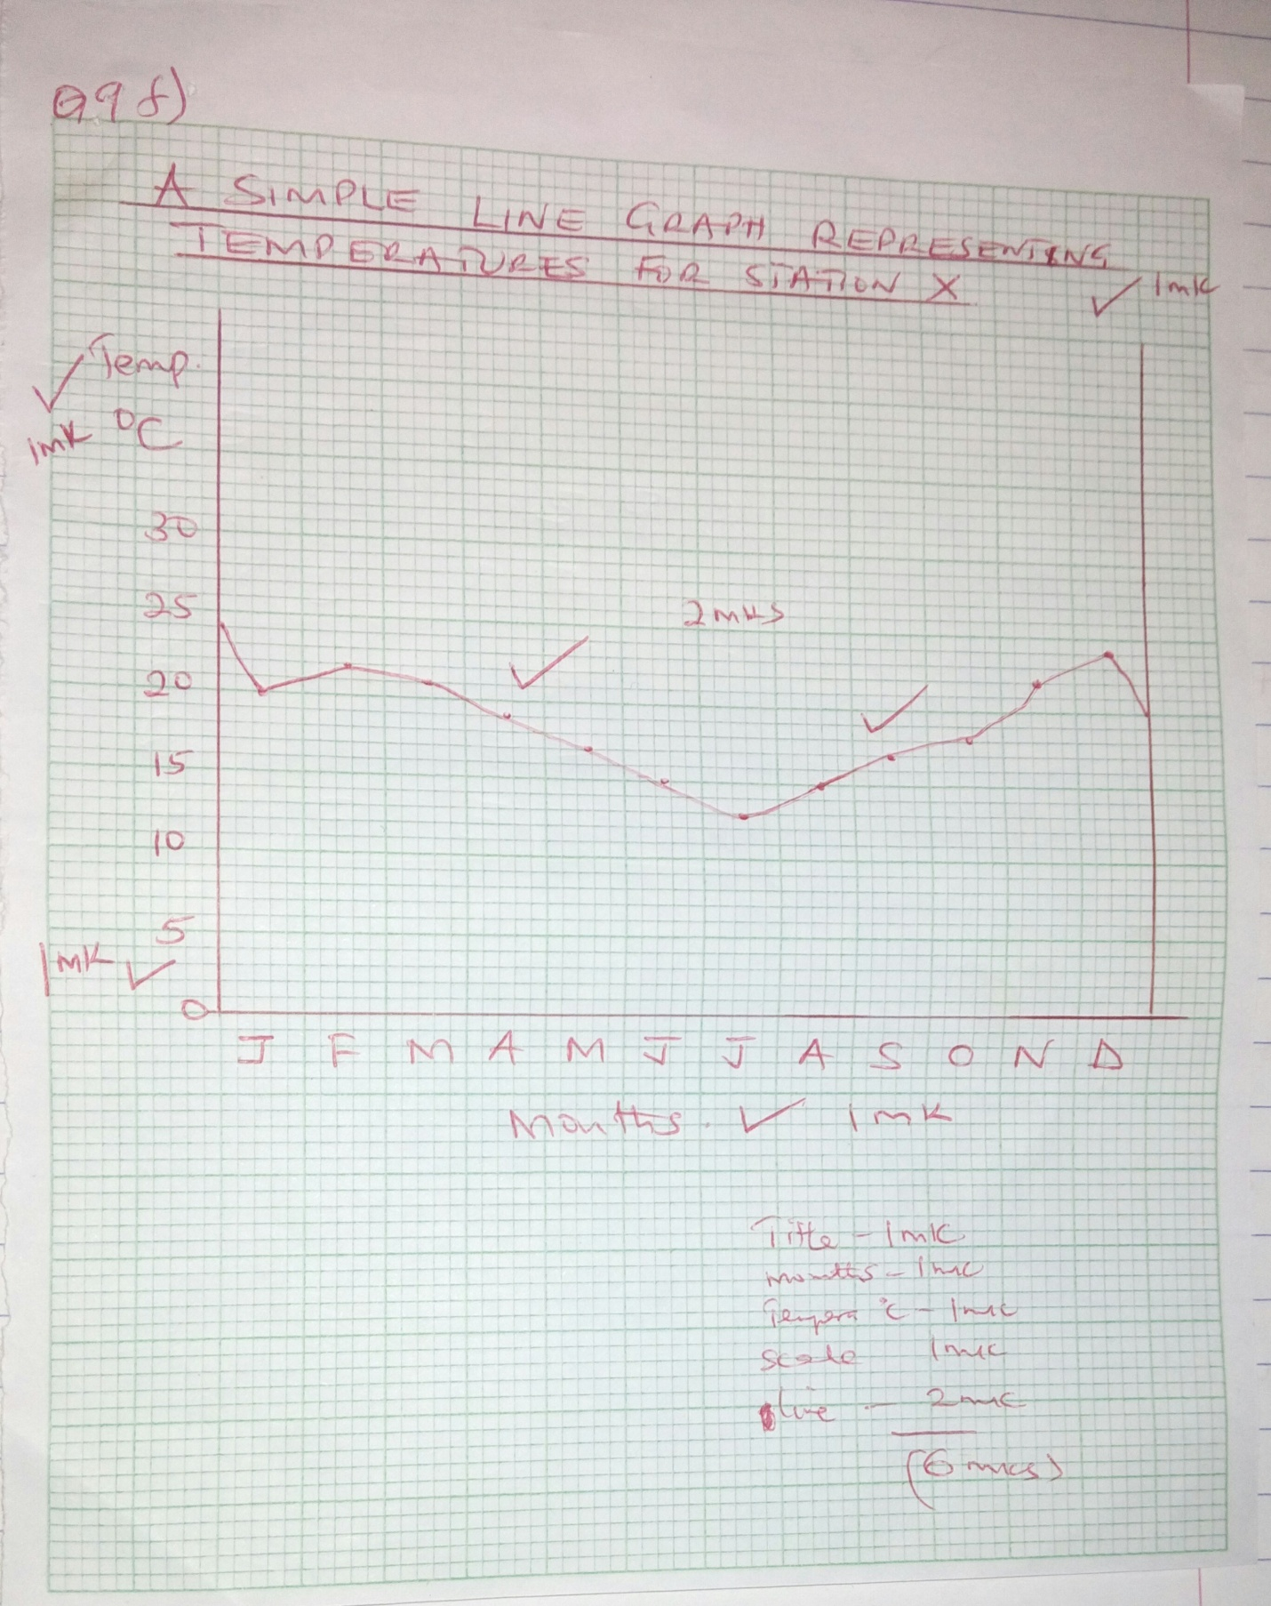

  - Name three types of field work. (3mks)
- Field study or field teaching
- Excursion
- Fieldwork research
  - Give three methods you would use to collect data (3mks)
- Observation
- Interviewing
- Taking photographs
- Administering questionnaire

  - What is a rock? (2mks)
It is a solid substance made up of a combination of minerals that form the solid part of the earth crust

  - Name the three types of sedimentary rocks (3mks)
- Mechanically formed sedimentary rocks
- Organically formed sedimentary rocks
- chemically formed sedimentary rocks
  - Name the metamorphic rock that resulted from the following sedimentary rocks (2mks)
Sandstone – Quartzite
Clay – Slate

  - Minerals occur in 4 ways. Name them. (4mks)
- Veins and lodes
- Beds and seams
- Weathering products
- Alluvial or placer deposits
  - State 5 factors that influence mining activities (5mks)
- Value of minerals
- Size of mineral deposits
- The quality of ore
- Method of mining
- Technology
- Capital
- Market
- Transport cost

