TERM 3 -2016 MJET MARKING SCHEME FORM 1 GEOGRAPHY
1a) Define the term Geography. (1mk)
Description of the distribution of the natural features on the earth and their interrelationship OR Description of the distribution of the features due to human activities on earth
b) State any four reasons why we study Geography. (4mks)
Geography is a career subject; it provides a firm foundation for advanced studies in specialized fields like surveying, remote sensing, urban planning etc.
-Geography creates awareness in the people on the significance of management and conservation of the environment.
- One is able to acquire basic skills and knowledge which contribute to local, regional& national development.
-Through the study of fieldwork, geography teaches one on how to manage time properly by drawing a time schedule and adhering to it. ( any other acceptable answer
c) Geography as a subject relates widely with other subjects. Explain how Geography relates with mathematics. (2mks)
-Mathematics principles or formulae are used in Geography to calculate distance or area or population density etc.
-Geographical information can be analyzed or presented accurately through the application of mathematical techniques.
- Geographical concepts are applied in calculating certain concepts in mathematics.
d) The diagram below shows the relationship between geography and other disciplines.
Name the disciplines marked U,V,W and X. (4mks)
U - History
V - Demography
W - Climatology
X – Geomorphology
2a) What is the solar system? (1mk)
The solar system is the sun heavenly bodies and the planets orbiting around it
b) Name two planets without natural satellites in the solar system. (2mks)
- Mercury
- Venus
c) Give three forces that are responsible for the spherical shape of the earth. (3mks)
i) Centripetal force
ii) Centrifugal force
ii) Gravitational force
d) Highlight three proofs that the earth is spherical. (3mks)
–The gradual emergence of a ship approaching the shore.
- Circumnavigation of the earth along straight path leads one to the starting point from the opposite direction.
- The different time during which the sun rises and set in different parts of the world.
- The earth is a planet and all planets are spherical.
- The circular shadow cast by the earth during a lunar eclipse.
- The circular shape of the earth as seen on photographs taken form satellites. ( any other acceptable answer )
ei) What is a solstice? (1mk)
i) Solstice is when the sun’s overhead position is over the tropical of cancer and Capricorn
ii) State three effects of the revolution of the earth. (3mks)
-Causes seasons; summer, autumn, winter, spring.
-Causes changes in the position of the mid-day sun.
-Causes varying lengths of day & night at difference times of the year.
- Causes changes in the position of the mid- day sun at different times of the year.
-Causes lunar eclipse.
fi) State the effect of crossing the international dateline from West to East. (1mk)
A day is gained

ii) If the local time in town A at longitude 20⁰E is 10am, What will be the time at town B at longtidue 10⁰W? B 0 A 20⁰E (3mks)
10⁰W

Difference in longitude 10+ 20 = 30⁰
1⁰ = 4min
30⁰ = 30 x 4 = 120min
= 2hrs
Time at B is; 1000
- -200
8.00am
g i) Give three reasons why the interior of the earth is very hot. (3mks)
- The weight of the overlying burden or materials exerts pressure on the core, resulting into high temperatures .
- Radioactivity
- In the process of cooling, after breaking away from the sun, the interior of the earth cooled at slower rate than the outer part
ii) The diagram below shows the internal structure of the earth. Use it to answer the question below.
Name the parts marked X and Y. (2mks)
X – Crust
Y- Gutenberg Discontinuity
3a) Define the term weather. (1mk)
This is the condition of the atmosphere of a given place at a specific time or over short period of time.
b) Name two forms of precipitation. (2mks)
- Dew
-Frost
-Snow
-Mist and fog
- Rainfall
c) The amount of solar radiation which reaches the earths surface depends on a number of factors. Name three factors. (3mks)
- The area and nature of the surface on which the rays fall.
-The inclination or angle of the surface on which the sun’s rays fall.
-The position of the earth on its orbit which produces different seasons.
-The intensity of the sun’s radiation in space and the earth’s average distance form the sun. (each 1mk)
d) What is a weather station? (1mk)
-This is a place where the elements of weather are observed, measured and recorded.
e) Outline three factors to consider when siting a weather station. (3mks)
- Should be located in an open space where there is free flow of air.
-Should not be near objects such as buildings, vegetation or other structures that might cause obstruction.
-Secure
-The site should be relatively flat and free form flooding ( each 1mk)
f i) What is weather forecasting. (1mk)
-The prediction of the weather situation for a given place within a short period of time like an hour, a day, a week, a month or a gear.
ii) Give three reasons why recording of data at a school weather station may be inaccurate. (3mks)
- Inadequate personnel who also lack skills due to limited training facilities.
- -Use of defective and absolute equipment .
- Vagaries of nature such as storms and earthquakes
- Variation in temperatures at different areas due to nature of vegetation, slope, soil moisture etc.
g) The following table shows rainfall and temperature of town X.
Months | J | F | M | A | M | J | J | A | S | O | N | D
Temp(⁰C) | 23 | 24 | 26 | 28 | 29 | 28 | 26 | 26 | 26 | 30 | 28 | 25
Rainfall (mm) | 3 | 0 | 3 | 1 | 18 | 500 | 720 | 408 | 300 | 70 | 15 | 0
Using the figures given find;
i) The total annual rainfall (2mks)

3+0+3+1+18+500+720+408+300+70+15+0 = 2038mm

ii) The wettest month. (1mk)

ii) Wettest month – July 720mm( Indicate the amount of rainfall).

iii) The mean monthly rainfall. (2mks)

Total rainfall
No. of months = 2038
12 = 169.83 ≈170mm
iv) The annual range of temperature. (1mk)
30 -24 = 6⁰c
v) The hottest month. (1mk)

October 30⁰c
4a) What is a map? (1mk)
- A map is a representation of a part of the earth or the whole earth on a flat surface drawn to scale
b) State three types of maps. (3mks)
- Topographical
-Atlas
-Sketch
c) Give four uses of maps. (4mks)
-They show direction and locating of place and phenomena on the surface of the earth.
- They show human and economic activities eg settlement patterns, forestry etc.
-They indicate physical features such as relief, drainage patterns etc.
-They show weather trends eg rainfall distribution, temperature and climatic regions.
-They show political and administrative boundaries ( any other acceptable point)
d) Name three types of marginal information you would find on a map sheet. (3mks)
- Sheet name title
-Sheet index number
-Grid systems
-Compass direction
-Magnetic variation
-Scale
-Key
-Edition, publisher and copyright ( ANY THREE 1MK)
e) State two types of scales used in a map (2mks)
i) Statement scale
ii) Linear scale
iii) Representative fraction or linear scale
5a) Define the term statistics. (1mk)
- An art or science which is concerned with the interpretation of numerical information.
b) Differentiate between primary data and secondary data. (2mks)
Primary data is first hand data that has not be documented while secondary data are facts and figures collected and documented in textbooks, journals and other written materials.
c) Highlight three disadvantages of observation as a method of collecting data. (3mks)
- Visual impairment may limit the effectiveness of this method.
-Expensive since it requires a lot of travelling.
-The observer may be biased and hence may not record observation carefully.
-Difficult to use this method when the weather is harsh eg rainy days.
-May not be possible to collect data on past activities.
d) The table below shows the amount of rainfall of station A. Use a bar graph to represent the data(5mks)
Months | J | F | M | A | M | J | J | A | S | O | N | D
Rainfall (mm) | 260 | 200 | 300 | 450 | 500 | 180 | 200 | 200 | 350 | 400 | 150 | 100

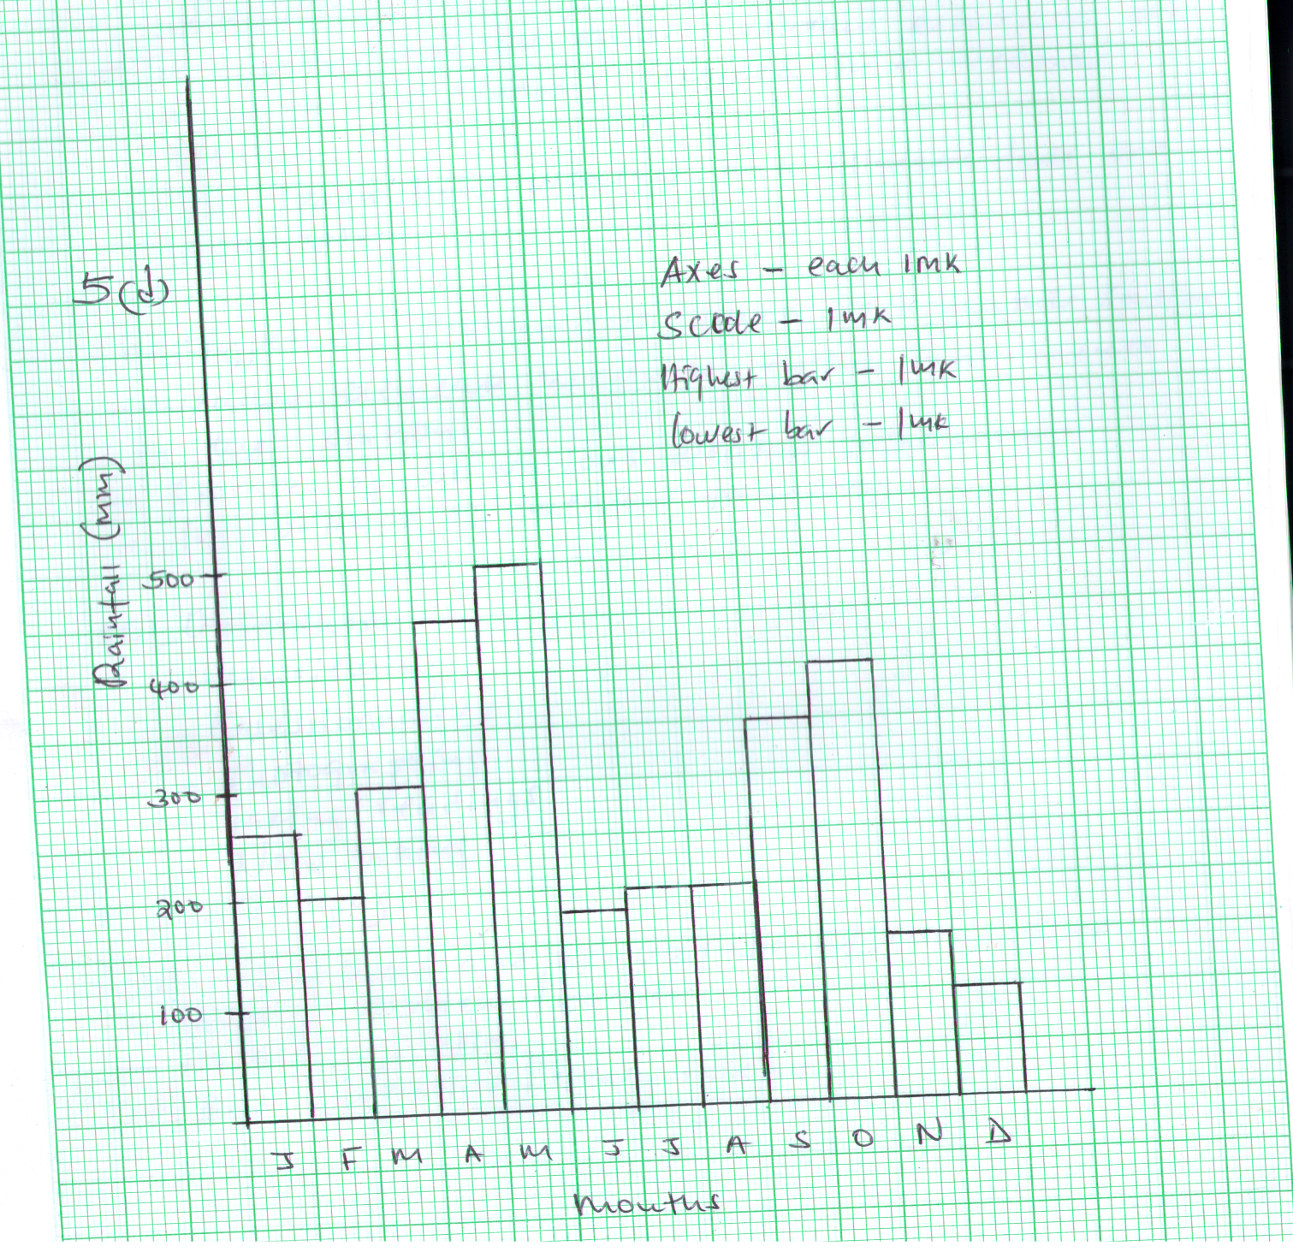

e) State one advantage of using a bar graph. (1mk)
They are easy to draw
-They give a clear visual impression of the definite quantities of data.
-They clearly show the individual amount and clear comparisons of different quantities
6. Form one students from a certain school planned to visit a weather station for field study.
a) State four objectives for their study. (4mks)
- To find out the different instruments found in a weather station
-To clarify the factors necessary for siting a weather station.
-To examine how the various weather elements are observed and readings recorded in a weather station.
-To learn how weather and climatic date are analyzed.
b) Name the various data to be collected. (4mks)
- Types of instruments found in a weather station.
- Weather elements measured by the instruments in the station.
-Storage of the various weather instruments
-Importance of weather forecasting.
c) State the methods they would use to collect data. (5mks)
-Observation
-Interviewing
-Questionnaires
-Photographing
-Taking readings
-Note taking
-Tallying

d) What are the likely problems they are likely to encounter during the field study. (4mks)
- Outdated and un – operational instruments
- Language problem/ barrier
-Hostile people
- Bad weather/heavy rainfall
e) Suggest the possible solutions to be problems highlighted in (d) above) (4mks)

- Visit a modern and well – equipped weather station
- Engage services of an interpreter
- Explain the purpose of the study before the visit.
- Carry umbrellas and gum boots to take care of bad weather/ heavy rainfall.

