Name: ………………………………………………. Adm. No …………….

GEOGRAPHY TERM II 2016
TIME : 2 HOURS

MWAKICAN JOINT EXAM (MJET)
FORM 2 END TERM II 2016

INSTRUCTIONS TO CANDIDATES
- Write your Name, Admission Number and Class in the space provided above.

- Answer all the questions in the spaces provided.

- Candidates should check the question paper to ascertain that all the pages are printed and no questions are missing.

- Candidates should answer questions in English

ANSWER ALL QUESTIONS ON SPACE PROVIDED
- (a) State four reasons why its important to study geography (4mks)

(b) Mention branches of geography (2mks)

- (a) Describe the solar system (2mks)

(b) State the characteristics of the sun (3mks)

(c) The local time at station x 60⁰w is 11.30a.m what is the time at station Y 37⁰E
(2mks)

(d) With aid of well labeled diagram describe the occurrence of solar eclipse (6mks)

- (a) Name the layers of the atmosphere (4mks)

(b) State the characteristics of the troposphere (3mks)

- (a) Name three forms of precipitation that commonly occur in Kenya (3mks)

(b) What’s Stevenson’s Screen (2mks)

(c) Mention instruments found in the stevenson’s screen (2mks)

- (a) Apart from water vapour, name other three substances that are suspended in the
atmosphere (3mks)

(b) Give two factors that are considered when classifying clouds (2mks)

(c) State four proofs that the earth is Spherical (4mks)

- (a) Define statistics (2mks)

(b) State four methods used to collect statistical data (4mks)

- (a) Name types of field work (2mks)

(b) Why is it necessary to carry a pre-visit in field work (4mks)

- (a) Define earth movement (2mks)

(b) Identify two causes of earth movement (2mks)

(c) Name fold mountains found in the following countries (3mks)

Asici

North America

South America

(d) Other than Fold Mountains name other result and features of folding (2mks)

- Through aid of diagrams explain how the rift valley was formed through tensional
forces (5mks)

- (a) Define climate (2mks)

(b) State factors influencing climate of a place (4mks)

(c) The Map below shows climate regions of Kenya . use it to answer questions below c(i) and (ii)

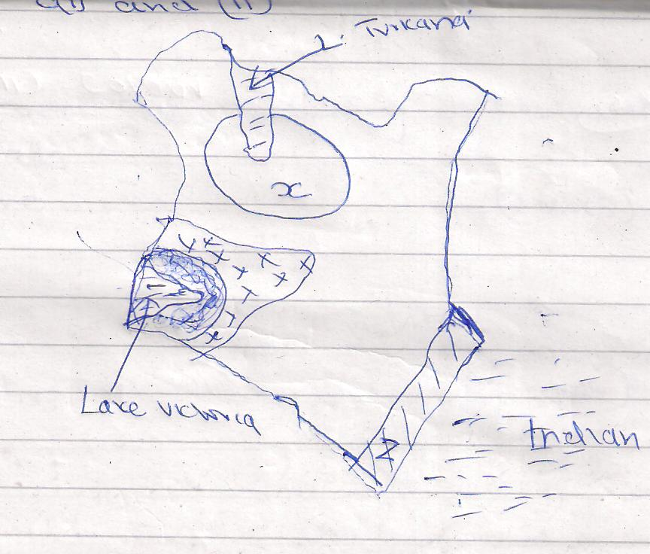

(c) (i) Name the climatic regions marked x and y (2mks)

(ii) State four characteristics of the climatic region marked 2 (4mks)

- (a) What is a mineral (2mks)

(b) Describe the following characteristics of minerals
(i) Lustre (2mks)

(ii) Colour (2mks)

(c) Name two examples of extrusive igneous (2mks)
11. (a) Differentiate between Magma and Lava (2mks)

(b) Name intrusive features of volcanicity (3mks)

(c) Explain three ways in which volcanic features influence human activities (6mks)

