MWAKICAN JOINT EXAMINATION
FORM 2 GEOGRAPHY
MAKING SCHEME
TERM III 2016
- (a) Reasons for studying geography.
- It helps develop skills e.g observation.
- It enables learners to understand/appreciate different environmental influences
- It encourages international awareness/cooperation
- It helps learners to appreciate important social valves
- It promotes positive attitudes towards conservation of the environment
- It leads to development of career opportunities
- It helps learners to manage time properly
- It enables learners to explain the origin and formation of the earth/the land forms
Any first 4 x 1 = 4mks

(b) Branches of geography
(i) human geography
(ii) Physical geography
Any first 2 x 1 = 2mks

- (a) Describe the solar system 2mks
- It is the sun, planets and other celestial bodies held together by the Forces of gravity.
- The celestial bodies revolve around the sun.
- Most celestial bodies are spherical in shape

(b) Characteristics of the sun
- It radiates solar energy which enables life on earth.
- It’s made up of hot gases/gases at very high temperatures
- It provides light which other heavenly bodies reflect
- A star with heavenly bodies or biting around it.
- It rotates on its own axis in anticlockwise direction

Any first 3 x 1 = 3mks

(c) The local time at station x 60⁰w is 11.30a.m what is the time at station Y 37⁰E
The difference in longitude is 60 + 37 = 97⁰
1⁰ = 4 minutes
97⁰ = 97 x 4 hrs
60
Time = 6hrs 28 minuts
= 5.58pm 2mks
(d) With the aid of well labeled diagram describe the occurrence of solar eclipse
- It occurs when the moon lies between the earth and the sun. when the sun are
blocked by the moon form reaching earth’s surface.
- The shadow of the moon is cast on the earth’s surface
- The shadow is the solar eclipse
- The shadow has two parts
- The umbra and penumbra
- The umbra shadow causes total solar eclipse
- The penumbra causes partial solar eclipse
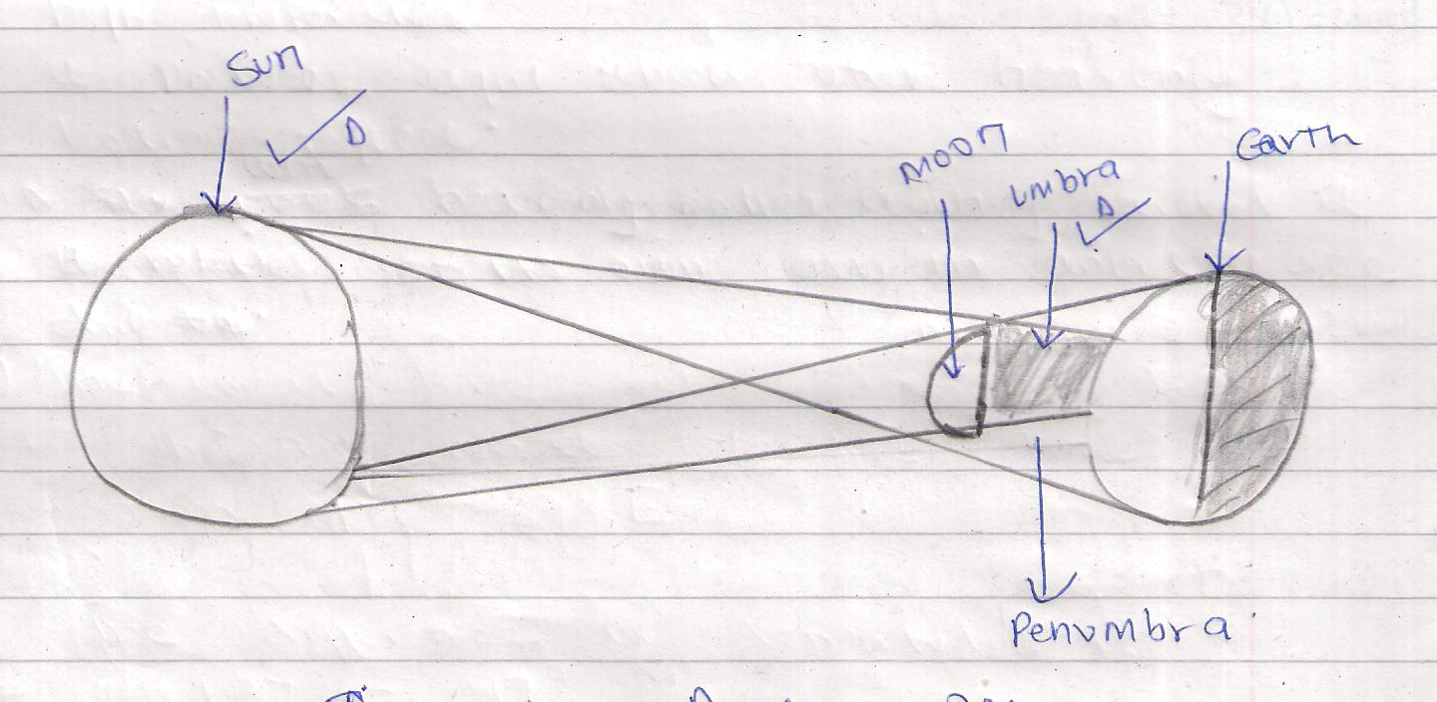
Distribution Diagram 2 marks
Explanation 4 marks
Total = 6 marks
3(a) Name the layers of the atmosphere
- Troposphere
- Stratosphere
- Mesosphere
- Thermosphere/ionosphere
4 x 1 = 4mks

(b) Characteristics of the troposphere
- Temperature decrease with increase in height/normal lapse rate
- Pressure falls with increase in height
- The speed of wind increases with increase in height
- It contains most of the atmospheric water vapour/cloud
Any first 3 x 1 = 3mks

4(a) Forms of precipitation that commonly occur in Kenya
- Rain
- Hail
- Dew
- Fog/mist
Any first 3 x 1 = 3mks
(b) What’s Stevenson’s Screen
It’s a white wooden box in which meteorological instruments are kept at a weather station 2mks

(c) Instruments found in the stevenson’s screen
- Maximum thermometer
- Minimum thermometer
- Six’s thermometer
- Hydrometer
Any first 2 x 1 = 2mks
5(a) Apart from water vapour, name other three substances that are suspended in the
atmosphere (3mks)
- Dust particles - gases
- Pollen grains - salt particles
- Smoke
Any first 3 x 1 = 3mks

(b) Factors considered when classifying clouds
- Height
- Shape/form
- Appearance (colour)
Any first 2 x 1 = 2mks
(c) Proofs that the earth is Spherical
- Circumnavigation of the earth along a straight path leads one to the starting point from the opposite direction.
- The circular shadow cast by the earth during a Lunar eclipse
- The earth is a planet and all planets are spheres
- The circular shape of the earth seen on photographs taken for satellites
- The gradual emergence of a ship approaching the shore
- The different times during when the sun rises and sets in different parts of the world
- The appearance of the middle pole to be relatively higher than other poles placed along a straight line or a level ground at equal distances
- The earths horizon is circular.

Any first 4 x 1 = 4mks

6(a) Define statistics 2mks
- Exact numerical facts or figures collected systematically and arranged for a particular purpose

(b) Methods used to collect statistical data (4mks)
- Observation
- Interviewing
- Administering questionnaires
- Taking measurements
- Carring out experiments
- counting
- Content analysis
Any first 4 x 1 = 4mks

7(a) Types of field work 2mks
- Field study or field teaching
- Excursions
- Field research
Any first 2 x 1 = 2mks

(b) Why is it necessary to carry a pre-visit in field study is necessary (4mks)
- To help in identifying methods of data collection
- To help in formulating the hypothesis objectives of the study
- To help in assembling appropriate apparatus / equipments / instruments for the study
- To help in estimating the cost of the study
- To get in contact with the relevant authorities / seek permission for the visit.
- To help in preparing the work schedule timing the study
- To identify problems to be experienced
- To determine the appropriate route to be taken
- To identify the location of the geographical phenomena to be studied before the actual day
Any first 4 x 1 = 4mks
8(a) Define earth movement 2mks
Refers to the movements of the crustal rocks caused by forces originating and operating in the interior of the earth known as tectonic forces

(b) Causes of earth movement
- Magma movement within the earths crust
- Gravitational pull / gravitational pressure
- Convectional current in the mantle
- Isostatic adjustment
Any first 2 x 1 = 2mks
(c) Fold mountains found in the continets (3mks)
Asia - Himalayas
North America - Rockles
South America - Andes

(d) Other resultant features of folding apart from fold mountains
- rolling plains
- intermontane plateaus
- intermontane basiss
- Valley and ridge landscape
- Escarpments
Any first 2 x 1 = 2mks

- Through aid of diagrams explain how the rift valley was formed through tensional
forces (5mks)
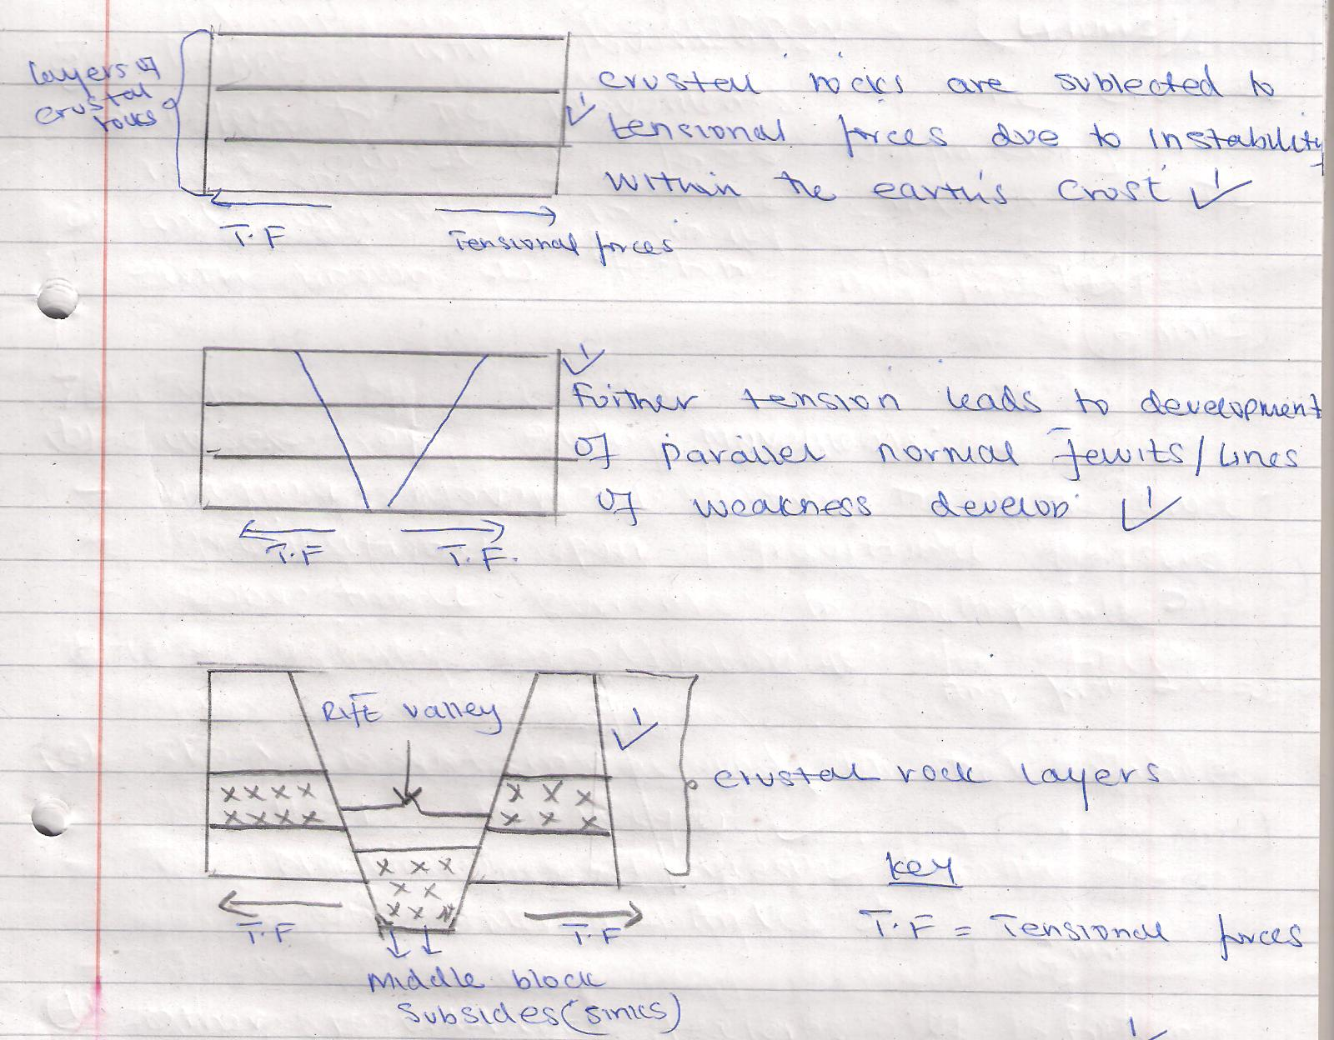

- The middle block gradually subsides or sinks
- The depression so created by the sunken middle part is the rift valley
Map allocation - Diagrams - 3mks
Explanation - 3 mks
Total - 6mks

9(a) Define climate 2mks
Climate refers to the average weather conditions of a given place over a long period of time usually 30-35 years

(b) factors influencing climate of a place
- Latitude
- Altitude
- Distance
- Configuration of the coasture
- Ocean currents
- Aspect
- Air masses
Any first 4 x 1 = 4mks

(c) (i) Name the climatic regions marked x and y
X - Desert climate
Y - Modified tropical climate of the highlands
2 x 1 = 2mks
(ii) Characteristics of the climatic region marked 2 (4mks)
- Has small divinal temperature range
- Has a small annual temperature range of 3⁰C - 5⁰C
- Has mean annual temperature of between 20ºC and 32°C / experiences high temperatures throughout the year / 750mm and 1300mm per year / No distinct dry month.
- High relative humidity / 80%
- Double rainfall maxima regime
- Receives convectional rainfall
- Experiences low pressure
- Has thick cloud cover
Any first 4 x 1 = 4mks
10(a) What is a mineral (2mks)
It’s an inorganic substance with a definite chemical composition at/beneath the earth’s surface

(b) Describe the following characteristics of minerals
(i) Lustre (2mks)
Minerals differ in their brightness depending on the nature of their reflective surfaces (smooth surfaces are shinning whereas rough surfaces are dull

(ii) Colour (2mks)
Different minerals display different colours e.g gold is yellow, copper is blue.

(c) Name two examples of extrusive igneous (2mks)
- Basalt - Obsician - Scoria
- Pumice - Andesite
- Tuff - Phonoute
- Rhyolite - Trachite

Any first 2 x 1 = 2mks

11. (a) Differentiate between Magma and Lava (2mks)
- Magma is the molten rock material which originates from the interior of the earth/cools while below the earths surface and has large crystals while lava is the molten rock materials that has reached in surface

(b) Name intrusive features of volcanicity
- Dykes / Dikes
Laccouth / Laccolite
Batholiths / Batheyute
Lapolith
Phacouth / phacolite

Any first 3 x 1 = 3mks

(c) Explain ways in which volcanic features influence human activities (6mks)
- Volcanic mountains are sources of rivers which provide water for domestic /
industrial uses.
- Volcanic rocks weather down to form volcanic soils which support agriculture.
- Volcanic rocks weather down to form fertile volcanic soils which support agriculture
- Volcanic rocks are important building materials in the construction industry
- Volcanic features are tourist attractions which promote tourism
- Volcanic mountains have forests which provide valuable timber used in building and construction industries.
- Volcanic mountains influence formation of relief rainfall which encourages agricultural activities.
- Volcanic mountains modify temperatures making them attractive to human settlements
- Volcanic features such as steam jets and gysers provide suitable sites for geothermal power generation.
- Some volcanic pipes are embedded with valuable minerals which are mined.

