GEOGRAPHY EXAMS
FORM 2, TERM2, 2019
TIME: 2HOURS
INSTRUCTIONS: THE PAPER HAS SECTION A & B ANSWER ALL QUESTIONS

- a. Name the layers of the atmosphere with temperature inversion. (2marks)

b. Identify one layer of the atmosphere which is isothermal. (1mark)

- a. Apart from photograph work ,identify two others areas of study in practice geography
(2marks)

b. Give two types of ground photograph (2marks)

- (a)What is an earthquake? (1mark)

(b) Name two types of earthquake waves. (2marks)

- (a)Define the term rotation of the earth.(1mark)

(b) State three effects of the rotation of the earth. (3 marks)

- (a) The diagram below shows the world pressure belts of the Northern hemisphere.
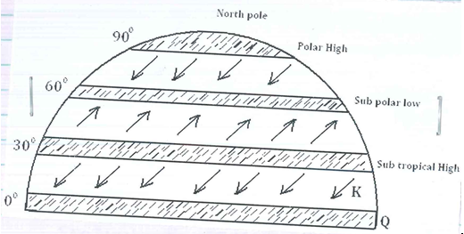

- Name the pressure belt marked Q (1mark)

- Name the planetary wind marked K (1 mark)

- State three characteristics of the zone marked Q . (3marks )

(b). The table below represents rainfall and temperature for a town in Kenya .Use it to answer the questions below

Month | J | F | M | A | M | J | J | A | S | O | N | D
Temp ^{oC} | 27 | 28 | 28 | 28 | 27 | 25 | 25 | 24 | 25 | 26 | 27 | 26
Rainfall | 25 | 38 | 99 | 140 | 277 | 439 | 277 | 69 | 142 | 201 | 71 | 25
- Calculate the annual range of temperature for the town. (1mark)

- Calculate the total annual rainfall for the town. (2marks)

- State three characteristics of the climate experienced in the town. (3marks)

SECTION B : 75 MARKS
- (a) (i) What is isostacy? (2marks )

(ii) State three causes of earth movements. (3marks)

(ii)why is an extension boundary also referred to as constructive boundary?

(2marks)
b. (i) using a well labeled diagram ,explain how a geosyncline leads to the formation of fold mountains . (8marks)

(ii) Name the young fold mountains in the following continents.
- Africa.

-Europe

-Asia

-North America (4 marks)

c. Explain three ways in which fold mountains influence climate. (6 marks)

- (i) Apart from the sill ,name the other features ,resulting from intrusive volcanic activity (4Mks)

(ii) Explain how a sill is formed. (4marks)

b. (i) Describe the characteristics of a composite volcano (5 marks)

(ii)Name two examples of composite volcanoes found in Kenya (2marks)

c. Explain five negative effects of volcanicity in Kenya . (10 marks)

8. (a)(i) Differentiate between a mineral and a rock. (2marks)

(ii) Give two modes of occurrence of minerals. (2marks)

(b)(i). Describe how trona is mined in Lake Magadi. ( 6marks)

(ii) State three uses of soda ash . (3marks)

(c) Explain three benefits of rocks to the economy of a country. (6marks)

(d) (i) You intend to carry out a field study on rocks near your school.
(ii) Give three reasons why it is necessary to collect rock samples (3marks)

(ii) Identify three items that you would carry during the study. (3marks)

END

MARKING SCHEME
SECTION A :25 MARKS
- (a) layers with temperature inversion
- Stratosphere
- Thermosphere 2×1=2marks
(b) Isothermal layer in the atmosphere
- Tropopause
- Stratopause
- Mesopause 1×1=1
- (a) Areas of study in practicals geography other than photograph work.
- Mapwork
- Fieldwork
- Statistics 2×1=2
(b) Type of ground photographs
- Ground general view
- Ground particular view
- Ground obliques 2×1=2
- (a) Earthquakes
- Sudden /rapid/abrupt movement or vibration of the cristae rocks caused by seismic waves 1×1=1
(b) Types of earthquake waves
- Primary waves
- Secondary waves
- Love waves
- Rayleigh waves 2×1=2
- (a) What is rotation of the earth?
- The movement of the earth on its own axis once in 24 hours from west to east . 1×1=1
(b) State three effects of the rotation of the earth.
- The occurrence of day and night.
- A difference of 1 hour between longitudes 15º apart.
- The deflection of wind and ocean currents
- The variation of the speed of air masses. 3×1=3
- (a) word pressure belt from the map and the planetary wind
- Q- equatorial low pressure belt /doldrum
- K- N.E trade winds. 2×1=2
(b) Characteristics of the zone marked Q
- Forms between latitude 231/2ºN and 231/2⁰S
- has low atmosphere pressure/doldrums
- convergence point of the North East and South East trade winds.
- It is associated with convectional rainfall usually accompanied by thunder and lighting.
- Characterized by high temperatures. 3×1=3
(c) annual range of temperature for the town
- 28^{O}c – 24⁰C =4⁰C
- Total annual rainfall of the town.
25+38+99+140+277+439+277+69+142+201+71+25=1808mm 1×2=2
- Three characteristics of the climate experienced in the town .
- Experiences high temperatures throughout the year
- The annual range of temperature is small 4ºC
- Rainfall throughout the year /there is no marked dry season.
- There is double maxima rainfall.
- The wettest month is June /Driest months are December and January
- Experiences high rainfall/1803 mm per year.3×1=3i

SECTION B (75 MARKS)
6(i) Isostacy
I is the state of balance that always exists between sial and sima layers.
Sial and sima layers
(ii)Causes of earth movements.
-Magma movement within the crust.
Gravitative force or pressure.
Convection currents in the mantle
Isotactic adjustment of the crustal rocks
3 x 1=3mks
(iii)Why Extension boundary is called a constructive boundary.
When tectonic plates move away from each other ,a fault forms between the, followed by outflow of magma forming new volcanic features rocks.
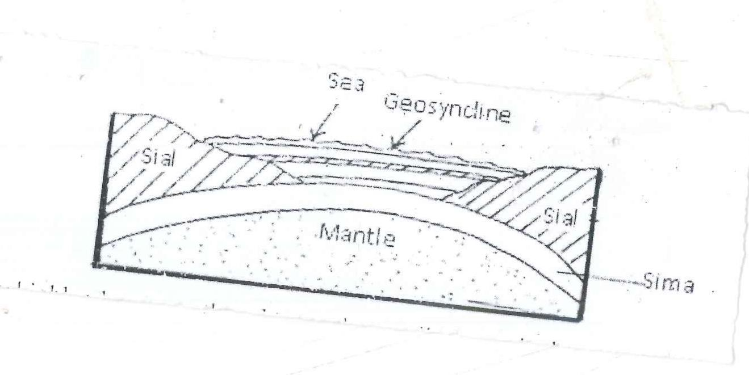
b. Formation of fold mountains
Tectonic movements formed a wide depression on the earth’s crust; a geosyncline.

-Sorrounding highlands area weathered to produce sediments which are transported and deposited in the geosyncline to form thick layers.
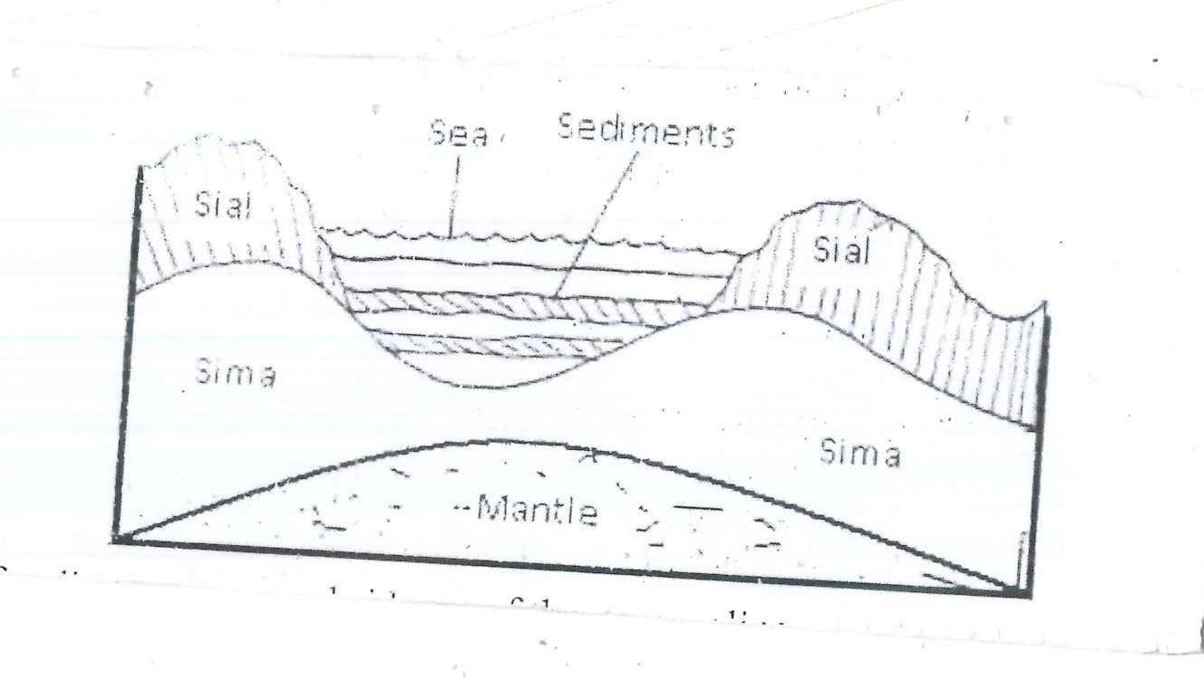
-The weight of the sediments cause subsidence of the geosyncline.
More sedimentation in the geosyncline causes further subsidence which trigger compressional forces that draw the higher grounds towards each other.
He layers of sediments are compressed at the edges to form folds leading to fold mountains.

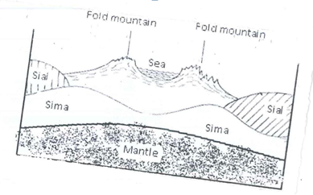

Text 5 mks
Diagram 1x3= 3mks
Total 8mks
b(i) Africa:Atlas,
Europe: Alps,
Asia:Himalayas,
N.America:Rockies
4x1= 4mks
c.Fold mountains influence on climate.
-Some of the mountains that face the sun in the high latitude areas(Aspect) are warmer than those not facing the sun.
Windward slopes of the fold mountains have high precipitation while the lee ward sides have low rainfall due to the rain shadow effect.
-Orographic effect of the fold mountains leads to temperatures decrease with increasing altitude hence lower temperatures on the high mountain slopes forming snow/ice.
-Atmospheric pressure decreases with increasing altitude.
-Local winds are common blowing up the fold mountains during the day.(Anabatic ) and down the mountain slopes at night (Katabatic).
-Moisture content in the air on the mountain slopes decreases as the altitude increases as air becomes colder and rarefied.
-The valley bottoms between the fold mountains are characterized by temperature inversion making the higher slopes to be warmer and the lower slopes cooler.
3x2=6mks
7 a (i) Features resulting from intrusive volcanic activity apart from sill
-Batholiths/Bathylith
Dykes
Lapoliths
Laccoliths/Laccolites
Phacoliths/Phacolites
4x1= 4mks
(ii) Formation of a sill
-Erath movements cause horizontal /fissures in the earth’s crust.
-Magma under high pressure forces itself into the horizontal cracks /fissure .
-Then, the magma cools and solidifies along the bedding plane or in the horizontal cracks.
-This leads to the formation of a solid sheet of igneous rock known as the Sill.
4x1= 4mks.
b(i)Characteristics of a composite volcane
-It has altering layers lava and ash/pyroclasts.
-It has a vertical shaft/pipe.
-Steep/gentle depending on the nature of lava whether acidic or intermediate.
-Has conelets/side cones/parasitic cones/adventure cones on the sides.
-Has a crater at the top.
-Has side vents/Dykes.
5x1= 5mks.
b(ii) Examples of composite volcanoes in Kenya
Mt Kenya
Mt Elgon
Mt Kenya
Mt Suswa.
2x1=2 mks
c. Negative effects of volcanic activity in Kenya.
. –Some features formed through vulcanicity create barriers making construction of communication lines difficult and expensive for example Yatta Plateau.
-The rugged nature of the volcanic mountains like Mt.Longonot makes settlement and agriculture difficult.
-The volcanic mountains create a rain shadow effect on to leeward sides discouraging settlement and crop forming due to aridity.
-Volcanic eruptions in some places produce gases which pollute the unsuitable for agriculture for example on slopes of Mt Longonot.
5x2=10mks
8a(i) Differentiate between a mineral and a rock.
A mineral is an inorganic substance with a definite chemical composition at or beneath the surface of the earth while a rock is a naturally occurring aggregate of mineral particles forming part of the earth’s crust.
2x1=2mks
(ii) Modes of mineral occurrence
-Veins and lodes.
-Seams and beds.
-Weathering products.
-Allurial deposits.
b(i) How Trona is extracted from the surface of the lake by a machine called a dredger.
-The dredger floats on the lake water digging out the trona from the Lake bed upto 3 metres deep.
-Inside the dredger trona is crushed into smaller pieces, then mixed with lake liquor to form a slurry.
-The slurry is pumped into the factory through a pipeline for processing.
3x2=6mks
(ii) Uses of soda ash
-Making glass
-Making dyestuffs
-Making soaps and detergents.
-In processing wood pulp to make paper.
-Softening of water.
-In refining Aluminum.

c. Benefits of rocks to the economy of a country.
-Some rocks weather down to form different soils that are used for agricultural activities.
-Some rocks contain valuable minerals/substances that can be exploited for industries/fuel.
-Some rocks provide building/construction materials.
-Some rocks are used for carvings such as Kisii soaps tone sold to generate income.
-Some rocks form underground water reservoirs to provide water for irrigation/domestic use.
-Some rock outcrops attract tourists such as the granite tors, earning the country foreign exchange.
3x2=6mks
d(i) Importance of collecting rock samples .
-For further analysis in school as there is no laboratory in the field.
-To build a collection of rock samples for future reference.
-To aid in data presentation/displays for more exposure.
-For research purposes.
3x1= 3mks
(ii) Identify three items that you will carry during the study.
Hammer
Note book/Stationery
Geological map.
Jembe
Camera.
3x1=3ks

