312/1
GEOGRAPHY
PAPER 1
NOV. 2016
TIME: 2¾ HOURS

MWAKICAN JOINT EXAM TEAM (MJET)
FORM 3 END TERM 3, 2016
GEOGRAPHY
PAPER 1
TIME: 2¾ HOURS

INSTRUCTIONS TO CANDIDATES:
- This paper has two Sections A and B.
- Answer all the questions in Section A.
- Answer question 6 and any other two questions from Section B.
- All answers must be written in the answer booklet provided.

SECTION A: (25 MARKS) ( ANSWER ALL THE QUESTIONS)
1.a) State two forces that shape the surface of the earth. (2mks)
b) State three characteristics of the crust. (3mks)
2. a) Distinguish between a coast and a shore. (2mks)
b) State three conditions necessary for the formation of a spit. (3mks)
3.a) State three ideal conditions for the formation of an artesian well (3mks)
b) Give two ways in which underground water may reach the earth surface. (2mks)
4.(a) What is a lake (2mks)
(b)Give 3 reasons why most of the Rift Valley lakes are alkaline(3mks)
5.(a)Highlight three natural causes of climate change (3mks)
(b)State two effects of climate change on the physical environment. (2mks)

SECTION B (ANSWER QUESTION 6 AND ANY OTHER TWO)
6. Study the map extract of Busia sheet 101/1 provided and use it to answer following questions.
a)i) Identify two man made features found in grid square3628.(2 marks)
ii)Measure the distance of Provincial boundary from Odiodo Hill to
the bend at grid reference 3429 giving your answer in km . (2 marks)
iii) Give the magnetic declination when the map was taken (1 mk)
b)i) Calculate the bearing and direction of Odiado Hill from Air photo Principal point at
grid square 2539. (2 marks)
ii)Citing evidence from the map give two economic activities carried out in the area covered.
(4 marks)
c )i)Give 3 types of vegetation shown in the map (3mks)
ii) Describe the relief of the area covered by the map. (5 marks)
d)i) Give the Longitudinal extent extent of the area covered by the map ( 2mks)
ii) Give the two types of scales represented by the map ( 2mks)
iii) Give two drainage features shown in the map (2 mks)
7(a)Differentiate between a rock and a mineral (2mks)
(b) i) Describe the formation of mechanically formed sedimentary rocks.(3mks)
ii)State 3 characteristics of igneous rocks. (3mks)
iii)Give 3 examples of metarmophic rocks. (3mks)
(c) State 3 characteristics of minerals. (3mks)
(d) Students from your school carried out a field study on the type of rocks within their locality
(i) identify any 3 tools they would carrry with them to the field (3mks)
(ii) State 3 ways the students would prepare before the field study. (3mks)
(iii) Give 2 problems they are likely to encounter (2mks)
(iv) One of the rock samples they collected is coral. Give 3 uses of this type of rock.
(3mks)

8. (a) (i) What is river rejuvenation (2mks)
(ii) Study the diagram below and answer the questions that follow.

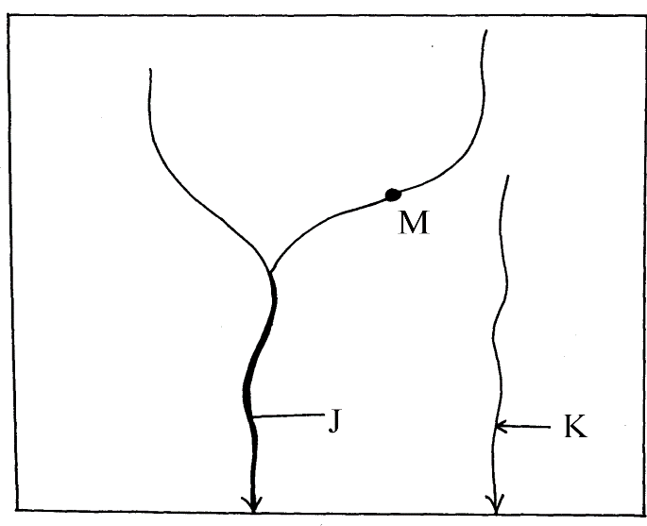
(a) Identify the process represented by the diagram above (1mk)
(b) Label the parts marked J and K (2mks)

(c) Identify the type of erosion that take place at the point marked M (2mks)
(iii) Describe three ways in which a river transport its load (6mks)
(iv) With the aid of a well – labeled diagram, illustrate the hydrological cycle (6mks)
(v) Give the significance of river to human Activities. (6mks)

9.a) (i) Define the term faulting (2 marks)
- Mention three types of features associated with faulting. (3 marks)
- With the help of a diagram explain the formation of the rift valley through the tension process.
- Supposing you were to carry out a field study on the Rift Valley. (7 marks)
b) (i) State any two objectives of the study. (2 marks)
(ii) State three importance of studying faulting through field work. (3 marks)
(iii) Explain four significance of faulting to human activities. (8 marks)
10. (a) What is weathering? (2 marks)
(b) Give five processes involved in physical weathering. (5 marks)
(c) (i) Apart from plants, give four factors that influence the rate of weathering. (4 marks)
(ii) Explain three ways in which plants cause weathering. (6 marks)
(d) Explain four effects of weathering. (8 marks)

