NAME:……………………………………………………………………ADM NO:……………
DATE:………………………

MWAKICAN FORM 3 JOINT EXAMINATION
TERM III 2016
GEOGRAPHY
PAPER 2
FORM 3
NOV. 2016
TIME: 2 ¾ HOURS

INSTRUCTIONS TO CANDIDATES
- THIS PAPER CONSISTS OF TWO SECTONS: A AND B
- ANSWER ALL QUESTIONS IN SECTION A
- IN SECTION B, ANSWER QUESTION 6 AND ANY OTHER TWO

SECTION A: 25 MARKS
1 a) Name two areas where gold is mined in South Africa (2mks)
b) State three ways in which mining create employment in Kenya (3mks)
2 a) Distinguish between a forest and forestry (2mks)
b) List three hard wood tree species in Kenya (3mks)
3 a) Differentiate between statistics and statistical methods (2mks)
b) List three sources of secondary data (3mks)
4 a) Name two oil producing countries in Middle East (2mks)
b) Give three by-products obtained when crude oil is refined (3mks)
5 a) Explain why mining is regarded as a robber industry (2mks)
b) Explain why petroleum, oil and natural gas are not regarded as minerals 2mk)
c) Name one area in Kenya where gold is mined (1mk)

SECTION B: 75 MARKS
ANSWER QUESTION SIX AND ANY OTHER TWO

6 The table below represents the rainfall and temperature data of station Y for one year. Study it and answer the questions that follow:
Month | Jan | Feb | Mar | April | May | June | July | Aug | Sep | Oct | Nov | Dec
Rainfall(mm) | 5 | 10 | 33 | 40 | 60 | 100 | 75 | 40 | 30 | 15 | 5 | 5
Temp | 23 | 24 | 25 | 27 | 27 | 29 | 28 | 27 | 26 | 25 | 24 | 24

- Calculate the following:
- Annual temperature range (2mks)
- Mean monthly temperature (2mks)
- Annual Rainfall (2mks)

b) Draw a combined line and bar graph to represent the data (8mks)
c) Describe the characteristics of the polygraph in b above (6mks)
- Apart from choosing and labeling the vertical scales for rainfall and temperature, state four other steps to be followed in constructing a polygraph (4mks)
- Give one disadvantage of this type of graph (1mk)
7 a) Define the term mineral (2mks)
b) I) Name two areas in South Africa where diamond is mined (2mks)
ii) Give four ways in which minerals occur (4mks)
c) I) Explain Three negative effects of mining on the environment (6mks)
ii) Identify any two methods of mining (2mks)
Iii) Name a port through which minerals in East Africa are exported (1mk)
d) Explain four ways in which soda ash contributes to the economy of Kenya (8mks)

- a) i) Name two provinces where forests are found in Canada 2mks)
ii) Give three tree species that are found in Canada (3mks)
b) Explain three ways in which the transportation of logs in Canada
Differ from Kenya (6mks)
c) Explain four problems that face forestry in Canada (8mks)
d) A form four class conducted a field study in a forested region in the area around their school
i) Identify two main categories of hypothesis that the students would have formulated (2mks)
ii) Identify four activities the students could have been involved in during the study (4mks)

9 a) i) Identify the two types of photographs (2mks)
ii) State three advantages of using photographs as a technique of recording data (3mks)
iii) With reference to ground photographs explain the meaning of
Dead ground (2mks)
Fore ground (2mks)
Back ground (2mks)

B) Study the photograph below and use it to answer the questions that follow

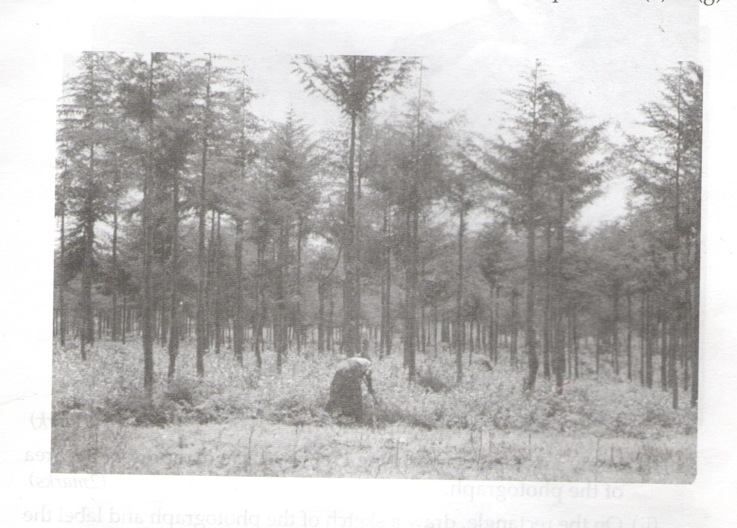

i) Name the type of photograph shown (1mk)
ii) Describe the appearance of the forest shown on the photographs (7mks)
c) Name the kind of farming activity in the photograph (1mk)
d) Name the type of trees shown in the photograph (1mk)
e) Compare tree harvesting in Kenya and Canada (4mks)

10. (a) State 3 factors influencing distribution and types of natural forests in Kenya . (3mks)
(b) List 4 characteristics of coniferous forest. (4mks)
(c)Explain 4 importance of forests in kenya . (8mks)
(d) Students of your school decided to carry out a field study in nearby forest.
(i) Give 3 importance of the previsit. (3mks)
(ii)State 3 reasons why they needed a route map. (3mks)
(iii)State 2 follow-up activities the students will have after the field study. (2mks)
(iv) Give 2 reasons why students required a working schedule. (2mks)

