MWAKICAN JOINT EXAMINATION
GEOGRAPHY FORM 3
PAPER 312/1 PAPER 1
MAKING SCHEME

ANSWERS SECTION A
- (a) Types of environment
- physical environment
- human environment
(2 x 1 = 2mks)
(b) Areas covered in physical geography
- The earth and the solar system
- Earth forming processes – internal and external
- The structure of the earth
- Vegetation
- Drainage
- Weather and climate
(Any 3 x 1 = 3mks)
- (a) Components of the solar system
Sun
Natural statellite
Meteors
Meteorites
Asteroids
Comets
Planets
(Any 3 x 1 = 3mks)
(b) Planets without statellites
Venus
Mercury
(Any 2 x 1 = 2mks)
- (a) Types of Folds
Simple symmetrical fold
Assymetrical fold
Isocinal fold
Recumbent fold
Overthrust fold / Nappe fold
Anticlinorium and syclinorium complex

(Any 3 x 1 = 3mks)
(b) Fold mountains in the following continents
South America - Andes mountains
North Africa - Atlas mountains
(Any 2 x 1 = 3mks)
- (a) define the term earth movements
It’s the displacement or movement of crustal rocks caused by Tectonic forces which originate and spate in the earth interior
( 2 x 1 = 3mks)

(b) Causes of earth movement
Magma movement
Gravitional force
Convectional currents
Isostatic adjustment
(Any 3 x 1 = 3mks)
- (a) Define
- Divide/watershed – ridge line (boundary line) separating drainage basins or river systems (1mk)
- Confluence - a point where tributary river join the main river (1mk)

(b) Ways a rive erodes its channel
Hydraulic action abrasion Attritioin
Solution corrosion
(Any 3 x 1 = 3mks)

SECTION B
- Study the Map of Migwani 1:50000. Sheet 151/1 provided to answer the questions which follows

- Types of Scales used
- Linear scale (1mk)
- Ratio scale/Representative fraction (1mk)
2 x 1 = 2mks

- Man-made feature found East of Easting 00 and North of Northing 80
- Dry weather road (1mk)
- Settlement (1mk)

2 x 1 = 2mks)
- Six figure grid references of Kauma dam
- 902624
2 x 1 = 2mks
(b) (i) The length of the all weather Road Bound surface C94 from the junction with the Dry weather road D502 to Northing 84
- 5.7 Km - + 0.1Km
2 x 1 = 2mks)
(ii) The area enclosed by all weather loose surface road to the North West of the Map Area in sq.Km
Complete squares = 4 Area = 11sq. Km - + 0.5 km²
Incomplete squares 14
2 x 1 = 2mks

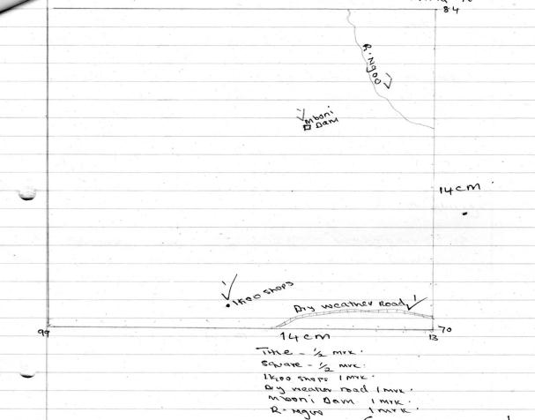
SQUARE ENCLOSING EASTING 99 AND NORTHING 70

(b) (i) Functions of Gwani town citing evidence from the Map
- Administrative - chiefs office
- Trade - shops
- Health services - health centre
- Recreation - rest house
- Religion - church
- Education - school
- Transport - all weather road
(Any 3 x 1 = 3mks)
(c) (i) Types of Vegetation
Scrub
Scattered trees
2 x 1 = 2mks
(d) Drainage of the area covered by the Map extract
- Most of the rivers are permanent
- The main river is Ikoo
- Rivers rises from the West and flow towards East/S. East
- Some rivers are disappearing
- Rivers to the North West form Radial drainage
- River Ikoo forms dendritic drainage pattern
- There are several reservoirs of Dams of Mboni dam, Kisini dam
- There is a spring - eg at 0663
(Any 5 x 1 = 5mks)
- What is a rock?
- A rock is a natural occurring substance made up of one or more elements and forms part of the earths crust (2mks)
- Examples of Intrusive igneous rocks
Granite
Diorite
Syenite
Gabbro
Peridotite
(Any 2 x 1 = 2mks)

- State three characteristics of sedimentary rocks
- They are non crystalline/ do not have crystals
- They are laid down in layers / have stratas
- They have bedding planes
- Some contain fossils
- They are formed through hardening of sediments which are derived from other rocks

(Any 3 x 1 = 3mks)
(b) Metarniophic equivalents
Original Metarmorphic
Granite gneiss
Jandstone Quartzite
Clay Slate
Limestone Marble
( 4 x 1 = 4mks)
(c) Three ways through which original rocks turn into Metarmophic rock.
- Thermal metamorphism . this is whereby original rocks comes into contact with high
temperature especially during vulcanicity. The rock changes in physical characteristics
(2mks)
- Dynamic Metamorphism. The original rocks are subjected to great pressure resulting from earth movements which causes realignment of the minerals leading to physical changes in rock appearance
(2mks)
- Thermal – Dynamic - The original rock is subjected to a combination of great pressure and intense heat. This causes realignment of minerals in the rock causing changes in physical and chemical characteristics (2mks)
(3 x 6 = 6mks)
(d) (i) Methods of data collection
Observation
Experiments
Reading from geological sources
- x 1 = 2mks
(ii) Two objectives of the study
- to identify the types of rocks around the school compound
- to establish the mineral composition of the rocks
- to investigate the relationship between rocks and major landforms found in the area
2 x 1 = 2mks
(iii) Reason of carrying geological hammer
- for breaking the rocks in order to get rock samples (1mk)
(iv) Three problems likely to be encountered
- Danger of being bitten by poisonous snakes/spiders/scorpions/wasps.
- In accessibility of some areas due to thick vegetation/steep slopes
- Adverse weather conditions which may affect the progress of the field study
- Accidents due to slipping/falling

(Any 3 x 1 = 3mks)
- (a) Define physical weathering
Physical weathering is disintegration of rocks without any chemical processes being involved/breaking of rocks without alteration in its chemical composition
(2mks)
(b) Explain processes of physical weathering
- First action, it occurs when water freezes inc racks, its volume increases exerting pressure on the crack breaking it
- slaking occurs when clay rocks receive a lot of water hence the rock expand when they lose the water during dry season the rock shrink and break
- Crystal growth as water moves up cracks through capillary dissolved minerals crystalline within the cracks breaking it.
- Pressure release off loading when underlying rocks are exposed through wide spread erosion the rocks expand and disintegrate
- Block disintegration when a bloc of rock is exposed to intense heat during the day the minerals expand, at night the rock crois hence contract this continuous process leads to disintegration of the rock.
- Exfoliation when the rock surface is exposed to intense heat the minerals on the surface expand while the underneath mineral remains cool. This continuous process eventually causes stress which leads to the peeling of the rock.
Process 3
Explanation 3 = 6mks
(c) (i) Two factors which accelerate the rate of weathering in Equatorial areas.
- High temperatures which increase the rate of chemical decay of rocks
- High rainfall which increase the rate of chemical weathering hence rock minerals are dissolved forming thick soils.
- The rain forests add a lot of organic matter into the soil increasing the chemical and biological weathering
(Any 2 x 2 = 4mks)
(ii) Explain three significance of weathering to human activities
- Weathering form deep fertile soils which aid agriculture
- Weathering leads to formation of beautiful scenery e.g granitic rocks which attracts tourists
- Weathering weakens rocks making it easier for mining activities/produce blocks for building and construction.
- Weathering products such as day and bauxite are used as sources of minerals/ for industries
3 x 2 = 6mks)
(d) You are planning to carry out a field study on weathering in the area around your
school.
- State three ways you would prepare for the study
- Conducting a reconnaissance/pre-visit of the are of study to familiarize yourself before actual field study.
- Seeking permission from relevant authorities
- Assembling the srelvant equipment for the study
- Holding discussions in class about the study.
- Preparing a work schedule
- Dividing into groups
- Reading about the topic from secondary sources
(Any 3 x 1 = 3mks)
- Give three chemical weathering processes you are likely to study
- Solution
- Carbonation
- Hydrolysis
- Hydration
- Oxidation
(Any 3 x 1 = 3mks)
- What follow-up activities you would be involved in after the study
- Writing reports
- Displaying photographs/items collected
- Asking / answering questions
- Discussing with the rest of the class
- Drawing diagrams
- Analyzing / assessing the information against the hypothesis
(Any 2 x 1 = 2mks)

- (a) What is faulting?
Faulting is the process of breaking or fracturing of the rocks of the earth crust due to compressional or tensional forces or process where by crustal rocks of the earth crust cracks or fractures (2mks)
(b) (i) Types of faults
- normal faults
- thrust faults
- Reverse faults
- Anticlinall faults
- Shear/tear faults
(Any 4 x 1 = 4mks)

- Causes of faulting
- Tension forces - causes the rocks to sketch finally breaking them
- Compression forces – cause the rocks to fold and some sections of folded rocks may fracture.
- Shear forces – causes rocks to move along a line of weakness in apposite directions
3 x 1 = 3mks
- Formation of Rift Valley by compressional forces
- Layers of the rocks are subjected to compressional forces
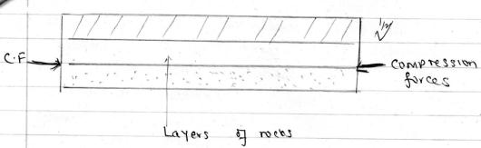

- Lines of weakness deveion on the layers of rocks resulting in the development of two reverse faults

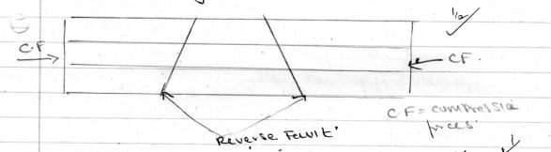

- As compression force push towards each other former the side block slide/slide above the central/middle blocks creating a Rift Valley

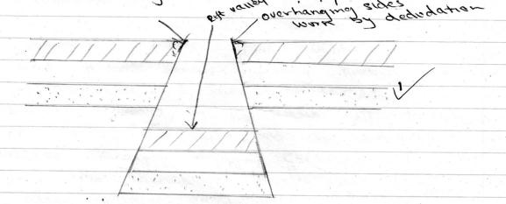

The overhanging sides are eventually worn out by dedudation
Explanation - 4mks
Diagrams - 2 mks
Total - 6 mks
(iii) Other features resulting form faulting apart from Rift Valley
- Escarpments / fault scarps
- Tilt blocks
- Block mts / horst
- Depressions
- Fault steps
(Any 3 x 1 = 3mks)
(c) You intend to carry a field study on faulting the rift Valley.
(i) Sources of data for field preparations.
Topographical Map of the area
- Textbooks
- Photographs
- Recorded video clips
- Internet
(Any 4 x 1 = 4mks)
(ii) Positive effects of faulting
- Lakes formed from faulting provide water for domestic and industrial uses
- Faulting leads to formation of beautiful features e. rift Valley which attracts tourists hence earning foreign exchange
- Valuable minerals are exposed e.g diatomite making mining easy
- Heavy rainfall is received on the windward side of block mountains which support agriculture.
- Springs occur at the foot of the fault scarps creating settlement
- Depressions within the floor when filed with water
- Create lakes important for fishing e.g L. Naivasha
(Any 3 x 1 = 3mks)
- (a) (i) Differentiate between weather and climate
- Weather refers to the daily atmospheric conditions of a certain place, at a specific time correct definition.
- Climate - it’s the average weather condition of a particular place for a long period of time usually 30 – 38 years correct definition
(Any 2 x 1 = 2mks)
(ii) Elements of weather
- Precipitation
- Temperature
- Humidity
- Air pressure
- Wind
- Cloud cover
- Sunshine
(Any 3 x 1 = 3mks)
(b) Apparatus found in Stevenson screen
- Maximum thermometer
- Minimum thermometer
- Six thermometer
- hygrometer (dry and we bulb thermometer)

(Any 3 x 1 = 3mks)
(c) (i) Annual range of Temperature
Maximum Temp - minimum Temperature
29⁰C - 20⁰C = 9⁰C
Annual range = 9⁰C (2mks)
(ii) Annual rainfall
2 + 15 + 60 + 78 + 85 + 40 + 30 + 20 + 85 + 90 + 21 + 2 = 527mm
(2mks)
(iii) Describe the climate of the station
- Mean annual temperature is 24⁰C
- Annual temperature range is moderate 9⁰C
- Annual total rainfall is 527mm
- Lowest rainfall is received in months of January and December.
- Lowest temperatures occur in July and august and highest in December
- Highest rainfall occurs in October.
- The station experiences two rain seasons between March to May and September to October
- There’s no dry month.
- The area experiences low rainfall.
(Any 5 x 1 = 5mks)

(d) (i) Weather forecasting is the prediction of the conditions of the atmosphere over
a short time (2mks)
(ii) Effects of weather on human activities
- Farmers plan their activities
- Prepares people on how to dress
- Helps in transport such as aviation and sailing
- Helps in planning military activities
- Helps in guiding tourist activities e.g in parks
- Helps in warning against natural calamities
(Any 3 x 1 = 3mks)
(iii) Factors influencing temperatures
- Latitude
- Altitude
- Cloud cover
- Length of the day
- Ocean currents
- Distance from the sea
- Aspect/slope direction
(Any 3 x 1 = 3mks)

