MWAKICAN FORM 3 PAPER 1
TERM 1 2015
GEOGRAPHY
MARKING SCHEME

SECTION A

1. (a) (i) Nearest planet to sun mercury (1mk)
(ii) Furthest form the sun - Neptune (1mk)

(b) Effects of rotation of the earth
- day and night
- rise and fall of tides
- deflection of winds and currents
- difference of one hour between meridians 15⁰ apart 3 x 1 mks

2. (a) Name of compressional boundaries (2mks)

- Oceanic to oceanic
- Continental to continental
- Continental to oceanic

(b) Describe how Fold Mountain is formed by geosynclines
- A large depression called geosynclines formed in the surface of the earth.
- it is then filled with water to form a sea.
- the surrounding land masses were intensively eroded.
- the sediments were deposited in the geosynclines to subside even further.
- their accumulation and weight caused the geosynclines to subside even
further.
- subsequent accumulation formed very thick layers.
- the sediments were later sublected to compression forces which may cause
further subsidence of the geosynclines drawing landmasses together
- The layers of sediments in the geosycline then folded benching upwards
to form mountains (4mks)

3. (a) a river is a natural flowing stream of water in a channel from upland area towards the
lowlands.
(b) Ways a river erodes
- hydraulic action/Quarrying process
- corrosion/abrasion
- attrition
- solution/corrosion
4. (a) (i) Divinal range of temperature for Thursday Max - 26⁰C - min. 16⁰C = 10⁰C
(1mk)
(ii) the mean temperature for Monday
Max 28⁰C
Min 18⁰C
46⁰C 46⁰C = 23⁰C (1mk)
2

(b) Apart form water vapour name two other substances that are suspended in the atmosphere
(2mks)
- Gases such as carbon dioxide
- Air (wind)
- Clouds
- Pollen grains
- Misl
- Smoke/dust particles

5. (a) Name two types of seismic waves (2mks)
- primary p waves
- secondary s waves
- longitudinal waves L waves

(b) State three major earthquake zones of the world (5mks)
- circum - pacific belt
- the great rift valley belt
- mid Atlantic ocean belt
- the Tethyan - Mediterranean belt
SECTION B

6. (a) (i) Name two human features found in grid square 8257. (2mks)
- cattle dip
- foot path
- dry weather road
- settlement area

(ii) Magnetic declination of the Map (1mk)
01⁰09’

(iii) Methods of presenting relief
Trigonometrical stations
Use of contours (2mks)

(iv) Area of enclosed by the district boundary and the Northing 53 to the east of area covered by the map
Full squares = 20
Half squares 29/2 = 14.5
Area = 34.5km²
+ 0.5km²

34km²
35km² (2mks)

(b) Two scales used
(i) Linear scale
(ii) Representative fraction/ratio scale

(c) Describe the drainage of the area covered by the map

- The dorminat drainage features are rivers.
- There are several permanent rivers e.g river Sagana
- Most rivers form a dendritic drainage pattern with their tributaries
- There are several dams along the courses of most rivers in the area.
- River Sagana has a meandering source indicating that it is in its mature
stage of development.
- there is a swamp in grid square 0045 3 x 2 (6mks)

(d) Human activities that take place in the area

Activity evidence
(i) Keeping of livestock - cattle dips e.g at grid square 8846

(ii) Growing of cash crops e.g coffee - coffee factories e.g at grid square 8948.

(iii) Transport - numerous all weather roads e.g road A2

(iv) Trade - numerous market centres e. at grid square
9155.

Any 3 x 2 = 6mks
The activity should have evidence to score

(d) (i) means of transport they are likely to have used to travel to Karatina township
- road transport
- railway transport (2mks)

- Adjoining sheet and number to south east of Karatina
Embu sheet No. 135/2 (2mks)

7. (a)(i) Tiit block
Escarpment slope
Block mountain/horsts (2mks)

- Formation of rift valley through tensional forces.
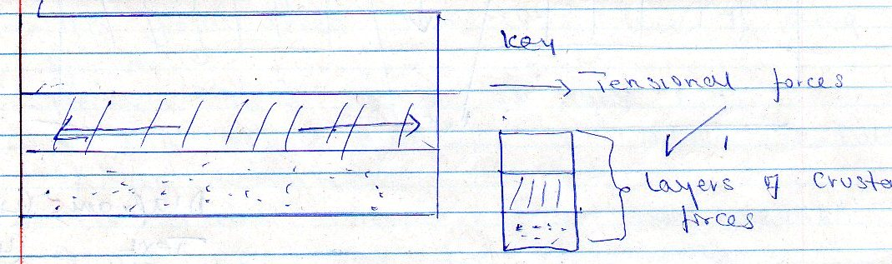

- Layers of rocks are subjected to tensional forces when there is some instability with the earths crust

- Parallel normal faults develop/lines of weakness develop.
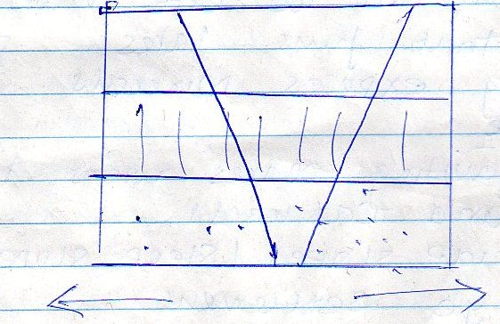

The middle part gradually sinks/subsides

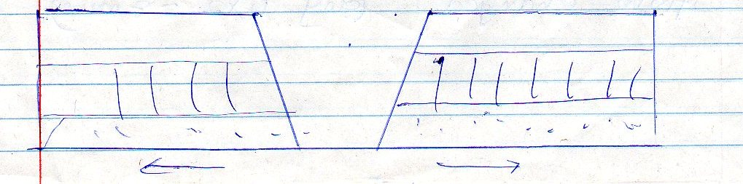

- The sunken part form a depression known as Rift valley

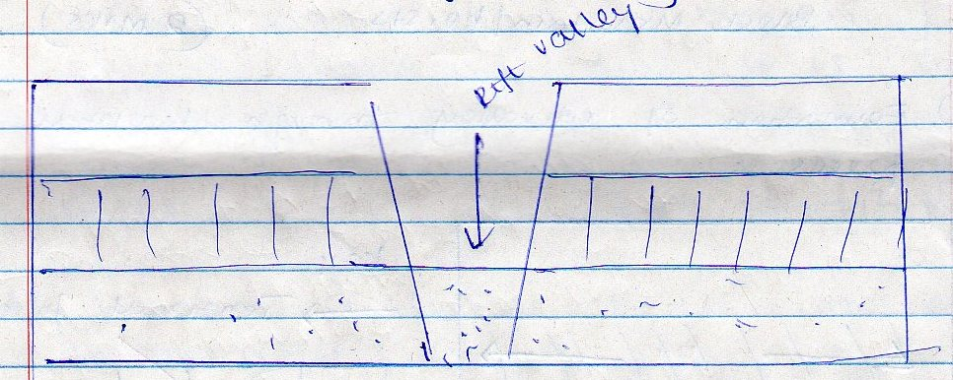

Diagrams (4mks)
Text (4mks)
Total (8mks)

(b) Explain effects of faulting
- Faulting/fault scraps make it difficult to construct roads/railways
- depression in the rift valley contain water that forms lakes
- faulting exposes minerals such as diatomite
- step faulting makes rivers to waterfalls rapids and cataracts
- the scrap slopes/steep slopes tend to discourage settlement
Some rivers such as the Katonga in Uganda have had their directions of flow charged

(any 4 x 2 = 8 mks)

(c) Students are planning to carry out field study in area affected by faulting.
(a) why they need to carry pre-visit
- To enable them draw up study objectives/hypothesis.
- to familiarize themselves with the area of study
- enable them draw a route map
- enable them prepare a work schedule/plan activities.
- to enable identify/sort out relevant tools/equipment for the study.
- to identify suitable methods of data collection.
- to seek permission from the occupants of their site of study.
- to enable them prepare financial

(4 x 1 = 4mks)
(b) Ways to collect data
- observation
- interviews
- questionnaire
- sampling
- extracting from secondary sources (3mks)

8. (a) (i) Weathering is the breakdown and decomposition of solid rocks on the
earth through physical and chemical processes without movement
Mass wasting - down slope movement of weathered material by aid of
gravity 2 x 1 = 2mks

(ii) - Water
- heat/temperature
- chemicals/dissolved substances 3 x 1 = 3mks

- Types of chemical weathering
- Hydrolysis
- Carbonation
- Oxidation
- Hydration
- Solution
4 x 1 = 4mks

(b) (i) Types of mass wasting
- Talus creep/screed creep
- solifluction
2 x 1 = 2mks

(ii) Factors which cause soil creep
- Heating and cooling of soil
- Freezing of soil
- Ploughing down hill
- Shaking by earthquakes/heavy, trucks.
- Alternative drying and wetting of soil
- Tramping and borrowing of the ground

(c) Effects of maswasting on the environment
- leads to loss of fertile soil
- lead to loss of life and property
- it may block the river or stream
- leads to displacements of people
- it may lead to destruction of infrastructure and buildings
- it may lead to formation of lakes
4 x 2 = 8 mks

9. What is climate

- It is the average weather conditions of a place for a long period of time
30 to 35 yrs (2mks)

- Name two instruments found in a Stevenson screen
- Sixs thermometer
- Minimum and maximum thermometer (2mks)

(b) Climatic regions
1. Modified equatorial climate of the coast
2. modified tropical climate of the highlands
5. Tropical climate - Narok/Kwale
7. Desert climate (4mks)

Four climate characteristics of region marked 5
- Rainfall is experienced in the afternoon (convectional type)
- Heavy rainfall 1600 – 1500mm/year.
- Temperatures range between 20⁰C to 26⁰C.
- Has double maxima rainfall.
- Relative humidity is high
- Rainfall comes all year round
1 x 4 = 4mks

(c) Describe the characteristics of desert type of climate
- Has low rainfall less than 250mm
- High temperatures through out the year
- Night temperatures are extremely low
- High temperature range
- Large diurnal range of temperature.
- Sandstorms are common
- The winds are dry - Harmattan
- Occasional floods caused by sporadic rainfall
- The sky is cloudless – clear sky

(d) consequences of climatic change:-
- increase in rainfall
- disruption of natural ecosystem
- affects agriculture which taxed to reduced crop yields
- flooding from rising sea level due to melting of ice
- increases in ultra violet radiation
- leads to shift of climatic and vegetation zones
- affect water use and long term planning
3 x 2 = 6
Consequences should be well explained

(iii) Countries experiencing Tropical monsoon climate outside Africa
- Mexico
- India
- Bangladesh
- Berma
- Vietnam
- Indonesia
- North of Australia
(3mks)

10. (a) (i) The vegetation marked

W - Rain forest (1mk)
X - Bamboo forest (1mk)
Y - Health and moorland (1mk)

(ii) Describe characteristics of Savanna Vegetation
- Savanna vegetation consist of trees and grass
- Near wetter areas the vegetation consists of tall scattered trees
- Wetter areas have tall thick grass.
- In drier areas the trees become fewer and more scattered.
- Some trees are deciduous
- Some trees are umbrella shaped
- There are scattered baobab trees and other drought resistant trees.
- A long river valleys there are tall trees/riveririe trees and thick bushes

- x 1 = 6mks

(iii) Name temperate grassland found in the following countries
- South Africa - Vied (1mk)
- Australia - Downs (1mk)
- Argentina - Pampas (1mk)

(b) Explain three causes of the decline of areas under forest in Kenya
- Fire - often large areas of forests are destroyed by accidental and sometimes intended fire such forests take time to recover.

- Diseases caused by pests and parasites attack mainly planted forest causing trees to die.
- Human activities/settlement, charcoal burning, farming and logging have destroyed many forests areas many of which are transformed into farms of grasslands.
- Over exploitation leads to depletion of certain tree species such as Meru oak burning, farming and logging have destroyed many forests areas many of which are transformed into farms of grasslands.
- Over exploitation leads to depletion of certain tree species such as Meru oak camptor, eigonteak. These trees take long time to mature.
- Government policy of degazetting of some forests made people clear many forested areas.
- Prolonged drought lead to degeneration of forests. Some of which take long to recover.
Any 3 x 2 = 6mks

(c) (i) State three reasons why it would be necessary to visit the area before the
day of study.
- To familiarize in order to design appropriate research methods
- To prepare a working schedule.
- To be able to formulate relevant objectives and hypothesis
- To identify appropriate equipment for data collection
- To seek permission from the owners of the land/authorities
- To identify suitable area of study and to meet the people who will provide information during the study

Any 3 x 2 = 6 mks

(ii) Give four uses of vegetation you are likely to identify during study.
- Used as fodder for animals
- Used for providing fruits/vegetables
- Providing wood, fuel/charcoal
- Controlling soil erosion/protecting catchment areas.
- Production of building/construction materials/timber

4 x 1 = 4mks

