END OF TERM TWO 2019
GEOGRAPHY EXAM
GEOGRAPHY FORM 3
Time: 2¾ Hours
SECTION A (25MKS)
ANSWER AL THE QUESTION IN THIS SECTION
1 .State the effects of the following on the shape of the earth
a. Centripetal force (1mk)

b. Centrifugal force (1mk)

c. Force of gravity (1mk)

2 a) Identify the main characteristics of ocean water (2mks)

b) Outline three factors that influence wave deposition (2mks)

3 a) Differentiate between anabatic winds and katabatic winds (3mks)

b) State three factors that hinder weather forecasting (3mks)

4 a) what is the hydrological cycle (2mks)

b) State three benefits of the hydrological cycle (3mks)

c) Name two sources of water in hydrological cycle (2mks)

5 a) what is longitude (2mks)

b) What is the time in Hola 40⁰ when the time in Accra 0º longitude is 3pm.
(3mks),
SECTION B
Answer question 6 and any other two questions from this section
6.Study the map of Taita hills (1:50,000) sheet 189\1 provided and answer the following question
a) i) What is the bearing of the peak of Mwatunga hills in grid square 3214 from the water tank in grid square 2619 (2mks)

ii) What is the length in kilometers of the section of the Mwatate –Voi railway in the south eastern part of map (2mks)

b) Draw a rectangle measuring 16cm by 12cm to represent the area enclosed by east
rings 24and 40 and north rings 20 and 30 (1mk)

- On the rectangle mark and name the following
- Mgange hills (1mk)
- A rock outcrop (1mk )
- All weather road bound surface (1mk)
- River ruhia (1mk)
- Ronge forest (1mk)

c) Using evidence from the map explain three factors that have favored the establishment of the Teita sisal estates in the southern part of the area covered by the map. (6mks)

d. i) Describe the distribution of settlement in the area covered by the map (5mks)

ii) Citing evidence from the map give two economic activities carried out in the area covered by the map on the sisal farming (4mks)

7. a) i) state the factors that influence the rate of river erosion (4mks)

ii) Explain three processes through which a river transports its load (6mks)

b) Outline any four characteristics of a river in its youthful stage (4mks)

c) Describe the formation of braided channels (6mks)

d) You are required to carry out a field study of a river
i) State three ways in which you will prepare for the study (3mks)

ii) Give two methods you would use to collect information in the field (2mks)

8. a) i) Differentiate between the process of formation of plutonic rocks and volcanic rocks
(2mks)

ii) Describe how sedimentary rocks are formed mechanically (5mks)

iii) State three characteristics of sedimentary rocks (3mks)

b) i) Explain three process of metamorphism (6mks)

ii) For each of the following rocks name the resultant rocks that forms after
metamorphism
- Sand stone (1mk)
- lime stone ( 1mk)
- Granite ( 1mk)
- Basalt (1mk)

c. State five uses of rock (5mks)

9. a) i) State three tectonic forces that cause faulting (3mks)
ii) Apart from block mountains name three features weathering resulting from faulting.
(3mks)
b) With the aid of a diagram describe the formation of a horst mountain by tensional forces.
(5mks)
c) Students from your school carried out a field study on a faulted land scape
i) Give two means why they carried out a pre-visit study (6mks)

ii) Give four reasons why the students held a discussion before the study (4mks)

ii) Explain four positive effects of faulting to human activities (8mks)

10. a) i) What is the meaning of denudation (2mks)

ii) Give three factors that influence the rate of weathering (3mks)

b) How does the process of granular disintegration causes weathering (5mks)

c) i) Name four process of slow mass wasting (4mks)

ii) State three factors that trigger rapid mass wasting (3mks)

d. Explain four effects of mass wasting on the environment (8mks)

END

GEOGRAPHY FORM 3
MARKING SCHEME SECTION A
- EFFECTS
- Centripetal force pulls the North Pole and the South Pole towards each other thus flattening areas at the poles. (1mk)
- Centrifugal forces results in the bulging of the earth at the equator due to variation in rotation towards the equator. (1mk)
- Force of gravity attracts objects on the earth’s surface and materials within the earth towards its centre hence making the earth to have a spherical shape. (1mk)
- a) Characteristics of ocean water (3mks)
- Ocean water is saline
- Ocean water is not static but moves horizontally and vertically
- Office temperature varies from one part of an ocean to the other.
b) Factors influencing wave deposition (2mks)
- The nature of the waves – for deposition to take place, the breaking waves must have a strong swash and a weak backwash. Waves should also break at a low frequency to allow materials to settle.
- Gradient to the shore – a shore with a gentle gradient reduces the velocity of the backwash thus causing the waves to start depositing their load.
- Configuration of the coastline – this is in relation to the path of prevailing winds and the direction of advancing waves. Where the coastline changes direction abruptly, the long shore drift is halted and the transported materials deposited there.
- Depth of the water – deposition is great where the water is shallow since cyclic motion of waves is broken as the waves come into contact with the floor of the sea.
- a) Differences between Anabatic Winds and Katabatic.
- Anabatic winds are local winds which ascend from valley bottoms to hill tops while Katabatic winds are local winds which descend from hill tops to valley bottoms.

b) Factors hindering weather forecasting
- Inadequate data.
- Inaccurate or unreliable data.
- Intervening factors e.g. slope, nature of vegetation, soil, moisture and winds.
- Inadequate skilled personnel in most developing nations.
- Use of defective/obsolete equipments
- Natural hazards e.g. earthquakes and storms.
- a) Hydrological cycle
- Is the continuous interchange of moisture between the atmosphere and the earth surface. (2mks)
b) Benefits
- Continuous flow of moisture helps to control aridity and desertification.
- Evaporation results in formation of rain.
- Surface run off into river ensures constant supply of fresh water in lakes/seas.
- Hydrological cycle helps to control some weather elements in the atmosphere which makes it conducive for human survival and crop growth.
- Hydrological cycle helps in regulating the amount of heat lost from the earth’s surface. (3mks)
c) Sources
- rain water
- rivers
- melt water
- underground water

A longitude
- a) It is an imaginary line drawn on maps or globes joining north and South poles, showing how far east or west a place is in the Greenwich prime meridian (0⁰) (2mks)
b) 1⁰ degree differences = 4 minutes
Difference in degrees = 40
Difference in time = 40 x 4 = 160 mins
60
2 ²/₃hrs = 2 hrs 40 min
= 2hrs 40 mins
Hola is 2 hrs 40 minutes ahead of Accra.
Time in Hola = 3 + 2hr. 40 mins
= 5.40 pm /17.40hrs 3mks

SECTION B
- Map work
Study the map in Taita Hills (1:50,000) sheet 189/4 provided and answer the following questions
- i) What is the bearing of peak of Mwatunga hill in grid square 3214 from the water tank in grid square 2619? (2mks)
-135⁰
- What is the length in kilometers of the section of the Mwatate-Voi railway line in the South-Eastern part of the map (2mks)

13.1 Km +/- 0.1

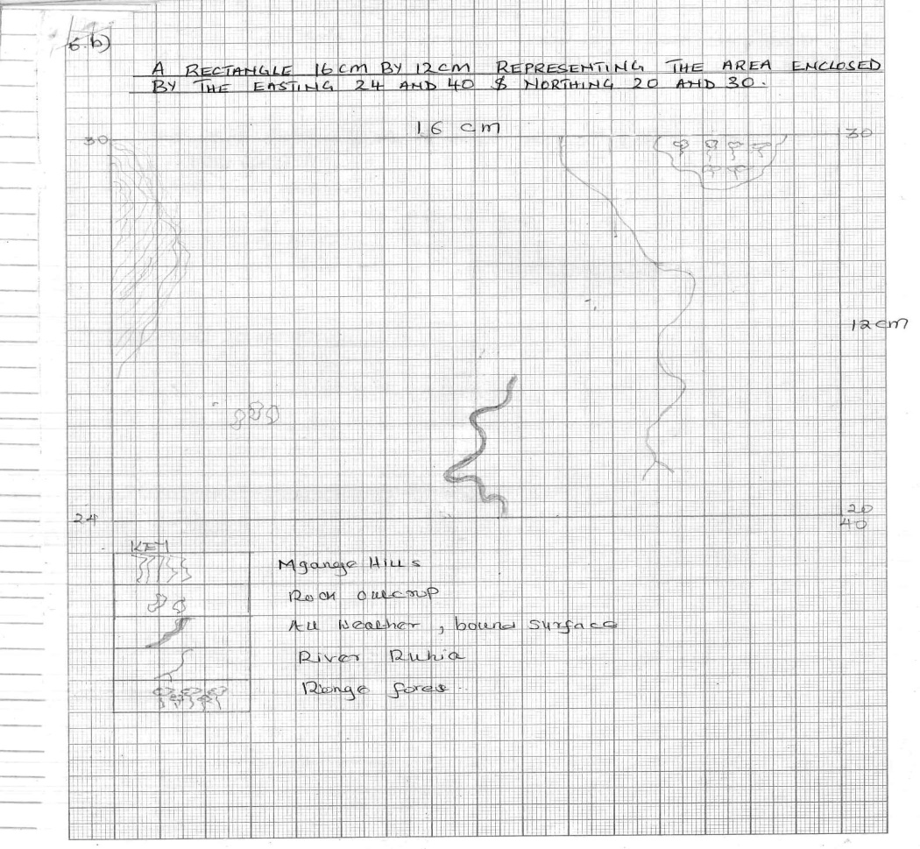
- Draw a rectangle measuring 16cm by 12 cm represent the area enclosed by the Easting 24 and 40 and Northings 20 and 30

On the rectangle, mark and name these features:
- Mganga hill (1mk)
- A rock outcrop (1mk)
- All weather road, bound surface (1mk)
- River Ruhia (1mk)
- Ronge forest (1mk)
- Using evidence from the map, explain three factors that may have favoured the establishment of the Teita Sisal estates in the southern part of the area covered by the map (6mks)
- presence of road network to provide transport facilities
- The are receives low rainfall as evidenced by scrub vegetation suitable for sisal growth
- The widely spaced contours indicate gentle slope facilitating mechanization.
- i) Describe settlement in the area covered by the map (5mks)
- Dense settlement along transport route.
- Dense settlement close to Teita sisal estates.
- Scattered settlement on the SE part/on the lower altitude part.
- No settlement on the slopping areas
- No settlement on the rock out crops.
ii) Citing evidence from the map, give two economic activities carried out in the area covered by the map other than sisal farming (4mks)
- Trading – shops
- Transport – roads & railway
- Agriculture - Sisal estates
- Ministry of Agriculture
- Farmers training centre

7. a) i) Factors influencing rate of river erosion (4mks)
- Nature of the slope
- Volume of water
- Nature and amount of the load
- Nature of the underlying rock

ii) Processes through which a river transports its load (6mks)
Suspension
Light fine and insoluble materials are lifted from the river bed and transported downstream while floating/suspended in water.
Solution
Soluble materials are dissolved and carried in solution form by the river’s water.
Saltation/Hydraulic lift
Involves transportation of medium sized materials downstream by water in form of series of short jumps/hops along the river
Traction
Involves rolling and dragging/pulling/sliding of large and heave materials along the river bed by the source of water.

b) Characteristics of a river in its youthful stage (4mks)
- The river flows fast/at high velocity
- The most dominant river action here is erosion with vertical erosion being more dominant compared to headward erosion
- Characteristic features include gorges, waterfalls, rapids, interlocking spurs, potholes and v-shaped valleys.
- Steep river gradient
- the river is swift/flows fast
- Vertical erosion is dominant
- Low volume of water
- Numerous tributaries and river confluences

c) Formation of a Braided channels (6mks)
- Forms when river is carrying heavy load
- The speed of the river/energy declines due to gentle gradient.
- This leads to deposition of heave materials on the river bed to form ridges/shoals
- Shoals grow into alluvial highlands
- The river sub-divides into channels/distributaries (called braided channels)
- This is referred to as braided channels

d)i) Preparations (3mks)
- Identify the area/place to conduct the study
- Seek permission from the administration.
- Conduct reconnaissance visit.
- Collect relevant tools/ equipment’s
- Divide in groups

ii) Methods (2mks)
- Administering questionnaire
- Interviewing
- Observation
- Taking measurements
- Content analysis

8.a) i) Differences (2mks)
- Plutonic rocks are formed from magma that cools and solidifies beneath the surface of the earth while volcanic rocks are formed from the cooling and solidification of lava on the earth’s surface.

ii) Sedimentary Rocks (5mks)
- Are formed from pre-existing rocks through the process of weathering and erosion.
- The sediments are deposited in layers/strata.
- Over a period of time they are consolidated into hard rock.

iii) Characteristics (3mks)
- Made up of layers known as strata/bedding planes.
- Are either mechanically/organically/chemically formed.
- some have fossils
b) i) Processes of metamorphism (6mks)
- Dynamic/kinetic metamorphism
- Occurs when pre-existing rocks are subjected to intense pressure.
Contact/thermal metamorphism
- Occurs when pre-existing rocks are subjected to intense heat.
Thermal dynamic metamorphism
- It occurs when pre-existing rocks are subjected to both heat and pressure.

ii) Sand stone – quartzite (1mk)
Limestone – marble (1mk)
Granite – gneiss (1mk)
Basalt – granulate (1mk)

c) Uses of rocks (5mks)
- Some rocks provide raw materials for industries e.g. trona.
- Some rocks are used for carvings that are sold to generate income.
- Some rocks like coal are sources of energy in industries.
- Some rocks contain minerals used in manufacturing of chemical e.g. sulphur.
- Some rock form spectacular sceneries which act as tourist attraction sites
- Some rocks act as water reservoirs & store a lot of underground water.

9. (i) Forces that cause faulting
- Compressional
- Tensional
- Tear / shear (3mks)

(ii) Features resulting from faulting
- Escarpment/fault scarp
- Fault steps
- Tilt block
- Rift Valley (3mks)

b) Horst Mountain
- Layers of crystal rocks are subjected to tensional forces.
- This results in development of parallel normal fault.
- Continued tensional forces lead to subsidence of the side blocks along the faults.
- As a result the side blocks leave the middle block standing as a horst mountain.
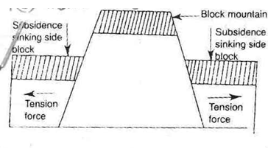

*Text (4mks) diagram (1mk)

c) i) Pre-visit
- Enables them to draw up study objectives/hypothesis.
- Enable them prepare work schedule/plan equipment.
- To identify suitable methods of data collection.
- To enable them prepare financially/estimate the cost of study.
- Enable them to prepare for the problems likely to be encountered. (2mks)

ii) Reasons for discussion (4mks)
- To identify type of data to be collected
- Decide on the suitability of the objectives and hypothesis
- Decide on methods of data recording.
- Decide on the tools/equipment required for the study.
- To prepare a questionnaire.

Effects of faulting to human activities (8mks)
- Mountains formed receive rainfall on their windward sides hence sources of rivers which provide water for domestic use/irrigation generation of HEP.
- Rainfall on the windward sides of mountains encourage growth of forests which provide timber for building and construction.
- Faulting results in formation of beautiful sceneries which attracts tourists.
- Cracks/faults formed on the earth’s surface during faulting are passages for hot water from the ground e.g. hot springs and geysers; such unique features form sites for tourist attraction.
- Hot steam from hot spring is tapped and used for geothermal power generation.
- Depression formed by faulting form lakes when water accumulate in them.
- These lakes form suitable fishing grounds.

10. i) Denudation
- Refers to the forces that shape/modify existing land forms by internal land forming processes/destruction and removal of rocks on the earth’s crust which are exposed to the earth’s surface. (2mks)

ii) Factors influencing the rate of weathering (3mks)
- nature of the rock
- climate
- plants
- human activities/animals
- time

b) Granular Disintegration cause weathering (5mks)
- Occurs in areas with large diurnal range of temperature
- It affects heterogeneous rock
- At day time when temperatures are high, different minerals in the rock are heated and expand at different rates.
- At night the minerals lose heat and contract at different rates.
- This expansion and contraction of the minerals in the rock at different rates causes stress within it.
- If this continues over a long time, it eventually causes the individual grains to break off from the rock into small granules

10. C(i) Name four processes of slow mass wasting
- Soil creep
- talus creep
- rock creep
- solifluction

ii) Factors that trigger rapid mass wasting (3mks)
- Collapse of a dam
- An earth’s tremor/earthquake
- Felling of trees from hill side
- Quarrying

- Effects of mass wasting on the environment (8mks)
- Formation of derelict land and this spoils the beauty of the land.
- Facilitate the loosening of the top soil thus increasing soil erosion.
- Materials from landslide may create a barrier across a river valley leading to the formation of a lake.
- Landslides may cause rivers to change their course/direction hence reducing the volume of water down stream.
- Cause damage to property when materials cover structures/farms/homes.
- Lead to loss of life when people/animals are buried
- Create sceneries that attract tourists.

