KIRENGA BOYS HIGH SCHOOL.
END OF TERM TWO EXAMINATION 2019
GEOGRAPHY PAPER 312/1
FORM FOUR
2 3/4 HOURS
QUESTION PAPER
SECTION A(Answer all questions in this section)
1a) State three proofs that the earth is spherical? (3mks)
b) Name three effects of the earth’s rotation. (3mks)
2(a) Name two types of the boundaries associated with the plate tectonic theory.(2mks)
b)Give three effects of the movement of tectonic plates.(3mks)
3 a) Differentiate between mass wasting and mass movement (2mks)
b) Give three factors influencing mass wasting (3mks)
4a) State two causes of submergence of coasts (2mks)
b) State two features that form as a result of submergence of coasts (2mks)
5a) Define a lake (2mks)
b) Give three reasons why some lakes are saline.(3mks)

SECTION B
Answer question 6 and any other two questions in section B
6. Study the Map of Oyugis provided and answer the following questions
a(i) Name two districts found in the area covered by the map.(2mks)
(ii) Give one marginal information used in the map.(1mk)
(iii) Measure the length of Kisii township in the eastern side of the map.Give your answer in Kilometers.(2mks)
(iv) Calculate the area covered by Kondera forest. Give your answer in Kilometers (3mks)
b(i) Name two physical features in grid reference 7636(2mk)
(ii) Describe the drainage of the area covered by the map(5mks)
c(i) Apart from education ,name three other social activities in the area covered by the map.(3mks)
(ii) Citing evidence from the map, give three reasons why the area covered by the map is suitable for agricultural activities.
7. The Map below shows some vegetation regions of the world .Use it to answer questions (a) and (b)
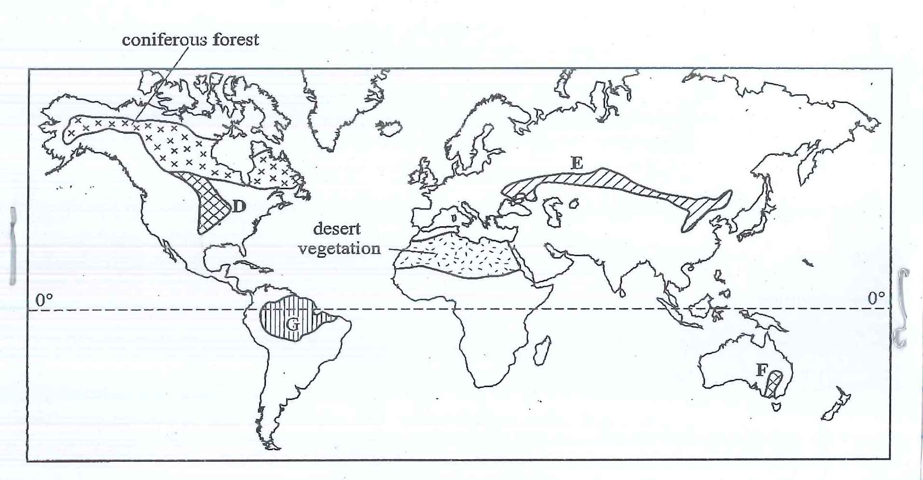
a. (i) Name the temperate grasslands market D,E,F.(3mks)
(ii) Describe the characteristics of the natural vegetation found in the shaded area marked G.(6mks)
b. Explain how climate has influenced the existence of the following types of vegetation shown on the map.
(i) Desert Vegetation (4mks)
(ii) Coniferous forests. (4mks)
c. You are required to carry out s field study of the natural vegetation within your local environment.
(i) Apart from identifying the different types of plants, state three other activities you would carry out during the field study.(3mks)
(ii)How would you identify the different types of plants? (3mks)
(iii) State two ways in which the information collected during the field study would be useful to the local community.(2mks)

8 (a) Describe plucking as a process in glacial erosion.(4mks)
(b) Explain three conditions that lead to glacial deposition.(6mks)
(c) The diagram below shows features resulting from glacial deposition on a lowland area.
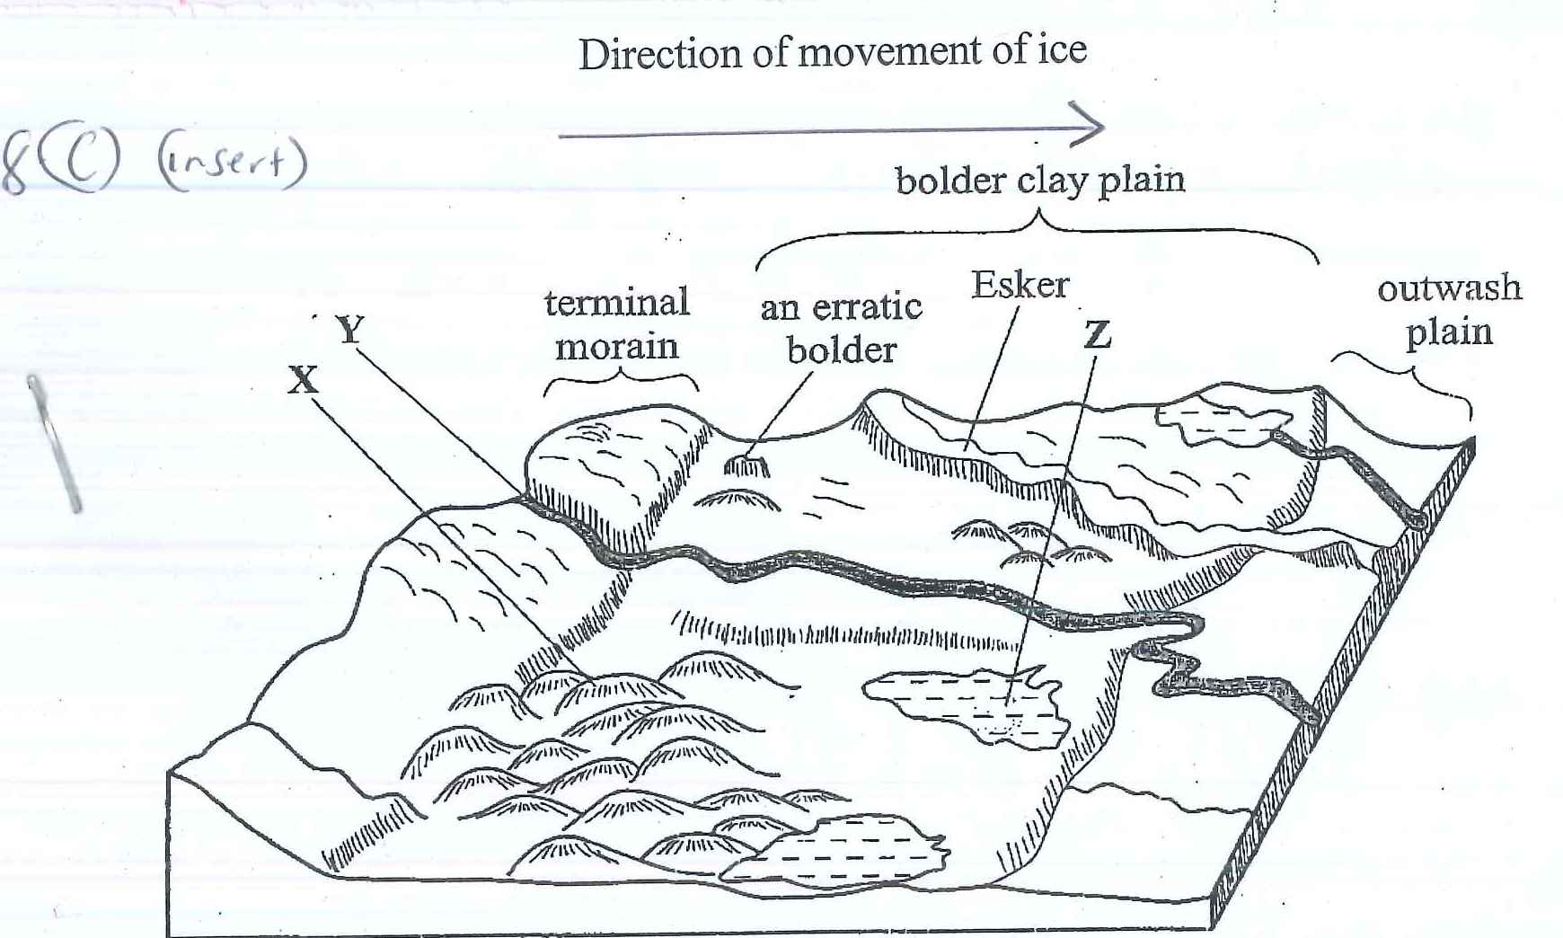
(i) Name the features marked X,Y,Z(3mks)
(ii)Describe how terminal moraine is formed.(4mks)
(d) Explain four positive effects of glaciation in lowland areas.(8mks)
9(a) Define a desert.(2mks)
b(i) Give three ways by which wind can transport its load in arid areas.(3mks)
(ii) Name three feature in arid regions associated with wind deposition.(3mks)
C) Using a well labeled diagram describe the formation of the following resultant feature of
Wind erosion
(i) Yardang (8mks)
d) You intend to carry out a field study on desert landforms.
(i) State two objectives and two hypothesis of your study.(4mks)
(ii) Give two methods you would use to present data.(2mks)
(iii) State any three challenges you are likely to encounter during your study.(3mks)

10. The diagram below represents underground features in a limestone area .Use it to answer question.(a)
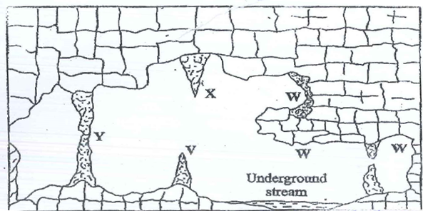
a(i) Name the features marked X,V and W
X-
V-
W- (3mks)
(ii) Describe how the feature marked Y is formed (6mks)
b(i) What is an artesian basin?(2mks)
(ii)Explain three factors which influence the formation of features in limestone areas.(6mks)
C. You are supposed to carry out a field study of a limestone covered area eroded by water.
(i) Give three reasons why you would need a map of the area of study. (3mks)
(ii) Name two erosional features you are likely to identify during the field study.(2mks)
(iii) State three recommendations that you would make from your study to assist the local community to rehabilitate the eroded area.(3mks)

GEOGRAPHY
PAPER 1
2 ¾ HRS
MARKING SCHEME
SECTION A
- (a) Proofs that the earth is spherical.
-Satellite photographs of earth taken from space show it to be spherical.
-During lunar eclipse the shadow of the earth which is cast on the moon appears spherical.
-Other planets are spherical, so it should also be.
-When a person circum-navigates he earth in a straight line, he/she will come back to the same position.
From a high altitude, the earth has a curvature.
-When a ship at sea approaching the shore, smoke is seen first followed by the mast and eventually by the whose ship. This shows that the ship is sailing over a curved surface.
Any 3X 1= 3mks
(b) Effects of the earth’s rotation.
-Deflection of ocean currents and winds.
-Causes day and night.
-Causes 1 hr difference in time between Meridian 15⁰ apart.
-Causes the rising and falling of ocean tide.
-Causes variation in the speed of air masses.
Any 3 X 1= 3mks
2(a) Boundaries associated with plate tectonic theory
-Extensional/Constructive boundaries
-Compressional/destructive boundaries
-Transform/Conservative boundaries.
Any 2 X 1=2mks
b) Effects of the movement of tectonic plates
-Folding
-Faulting
-Earthquakes/tremors
-Vulcanicity
Any 3 X 1
3a) Mass wasting Refers to the movement of weathered rock materials down a slope under the influence gravity while mass movement is the down slope movement of materials lubricated by rain water or melt water
b) Factors that influence mass wasting
-Nature and weight of the materials.
-Angle of slope
-Amount and nature of rainfall received.
-Vegetation
-Tectonic movements
-Human activities.
4(a) Causes of submergence of coasts.
-Rise in sea level
-Subsidence of land
-Flooding along the coast.
Any 2x 1=2mks
b) Features that may result due to submergence of coasts
-Rias
-Fjords(Fiords)
-Dalmatian coasts
Any 2X 1=2mks
5(a)A lake is an accumulation of water in a wide hollow or depression on the earth surface. (1x1 = 1mk)
b) Reasons why some lakes are saline
-Absence/lack of out-flowing rivers/ outlets to drain out excess salts .This leads to accumulation of salts in the water in the lake.
-Some lakes lack enough fresh rivers draining in to / emptying into the lakes
- Some lakes are locate in arid areas with very high rate of evaporation which leads to increased concentration and accumulation of dissolved minerals salts in the lake
-The bed of the lake may comprise of soluble rocks with minerals salts which dissolved in the lake water
- Surface run-off and rivers may dissolve a lot of salt from the rocks on which they flow .they eventually deposit this salt solution in the lake in to which they drain.
SECTION B
6a
i) District boarding oyugis
Kisii
South Nyanza (2x1)
ii) marginal information used in the map
key
index of adjoining sheet (2x1)

(iii)Length of Kisii Township Boundary
5.7km (+-0.1)
2x1= 2mks
(v)Area covered by Kodera forest
Full square = 0
Incomplete square = 15/2 = 7.5
Total area = 7.5km2 (+-1)
(3mks)
6A (i) Physical features of the grid7636 (2mks)
-hill
-slopes 2x1 2mks
b(ii) Drainage of the area catered by the map.
-There are numerous permanent rivers in the area counted by the map.
-Most of the rivers depict a dendritic paten
-The main rivers are Awash, Kaspul, Riana etc.
-There are seasonal swamps e.g. at grid ret 9336.
-Most rivers flow from southeast side to the northwest side of the map.
Some rivers are meandering e.g the lower course of R.Riana .N.B Any other relevant point.
Any 5x1

C (i) social service activities in the area covered by the map.
-Religion as indicated by the presence of churches
-Administration as indicated by the presence of chief’s office
-Health service as indicated by maternity, dispensary, health centers.
-Security as indicated by the police post.
(Any 3x1)

(ii)Reasons why the area covered by the map is suitable for agriculture.
-adequate rainfall as indicated by presence of permanent rivers.
-adequate labor and market as indicated by presence of dense settlement
-good transport network as indicated by the presence of the roads.
-gentle slopping land as indicated by relatively spaced contours which allows proper drainage of water.
Any 3x2
7. The map below shows some vegetation region of the world use it to answer question a & b
(Refer to question paper)
a(i)Name the temperate grasslands marked D, E,& F
D- Prairies
E- Steppes
F- Downs 3mks
ii) Describe the characteristics of the natural vegetation found in the shaded area marked G.
-The forest consists of mixed variety of tree species
-The trees shed their leaves at different times of the year/ Forests are ever green.
-The tress are tall with smooth trunks
-the tress have broad leaves /drip tipped leaves
-The tress takes long to mature.
-The tree species are only hardwood
-the tress grows close to each other
-The forest have little or no undergrowth
-The tress have numerous lianas/climbing plant/epiphytes
-Some of the tress have buttress roots
-The forests have canopies
-The forest grow from distinct layers
(9mks)
b) Explain how climate has influenced the existence of the following type of the vegetation shown on the map.
(i)Desert vegetation
-The area has scarce vegetation because it receives low rainfall/ experience drought.
-the long period of drought causes seeds to exist in a dormant state only to germinate on the short rains.
The higher rainfall along the margins of the region leads to more luxuriant vegetation in the areas.
Strong wind may uproot some of the plants leaving the ground bare /strong winds disperse seeds from one part of the region to another leading to establishment of the plant species far and wide in the region. Any -2x2=4mks
(ii) Coniferous forest
-The long cold winter and short summers make the vegetation/trees to grow at a slow rate.
-Due to long cold winters and short summers the vegetation. Types consist of a limited variety of species of plant.
-The low rain fall received in the area makes tress to be slender and thin. Permafrost subsoil makes trees develop shallow roots that spreads wide to utilize the moisture in top soils.
-Precipitation in the region is mainly in form of snow hence the cone shape of trees.
(2x2=4mks)
c) You are required to carry out a field study of the natural vegetation within your local environment.
(i)Apart from identifying the different types of the plant, state other three activities you would carry out during the field study.
-collecting samples of plants
-Measuring the distance
-Estimating the heights of the plants
-Drawing sketch/transact
-recording /taking note
-taking photographs of the plants
(Any 3x1=3mks)
(ii)How would you identify the different types of the plant?
by their
- Appearance
- Colour
- Leaf size/pattern/type
- Smell
- Texture of leaves
- Flowers

(Any 3x1=3mks)
(iii) State two ways in which the information collected during the field study would be useful to the local community.

-it can be used in conservation of the land and wildlife /soil/water
-it can be used for future reference
-it can be used in the rationalization of lands
It can be used to determine the economic use of the plant/herbal medicine.
Any 3=3mks

8(a) Describe plucking as a process in glacial erosion
-pressure from the ordering mass of the ice cause freeze & thaw action-Melting water fills the cracks /joints in the bed rocks.
-as water freezes it exerts pressure on the cracks enlarging them.
-the enlarged cracks lead to disintegration of rocks
The rocks debris are then pulled and caned away by the margin ice.
-as the ice moves it pulls out the embedded rock from the mother rock in a process called plucking.
b) Explain three conditions that lead to glacial deposition.
-Rising temperature leads to the melting of ice thereby causing the ice to deposit its loads.
-Change of gradient to relatively flat surface will reduce the velocity of the glacial movement which will subsequently lead to deposition of glacial material.
-Melting of ice which allow material embedded in the ice to be reserved & deposited
-Friction that occurs between moving ice and the surface causes heavy materials to be deposited.
-Stagnation /accumulation of glacial of glacial which in future leads to melting of the ice at the base.

Condition -1mk (Any 3x2)=6mks)
Explain -1mk
c) The diagram below shows features resulting from glacial on a lowland area
Refer to question paper

(i)Name the feature X, Y, Z.
X - Drumlins
Y - A river / melt water
Z - Kettle lake/ lake (3mks)
(ii)Explain how terminal moraine is formed.
-Moving ice carries solid materials.
-Moving ice stagnates.
-Melting ice releases its loads.
-Gradually the load piles in to a ridge,
-over time the ridge forms a horse shoe shape/block of solid materials called terminal moraines.
(4mks)
d) Explain four positive effects of glaciation in lowland areas
-Glacial hill provides fertile soils which are suitable for arable farming.
-Ice sheet in the scouring effect erode the surface which more expose the minerals making them easy to extract.
-Out wash plains combined of sand and gravel which are used as building materials,
-Glacial lakes found in low lands can be exported for various economic uses such as fishing and transportation.
-Glaciation forms features such as drumlins, eskers which are tourist’s attractions.
Glaciated low lands are generally flat and ideal for establishment of settlements/ development of transportation network.
(8mks)
9(a) Land that has insufficient moisture leading to little or completely no vegetation

b(i)-saltation
-Surface cheap
-Suspension
(ii) –Sand dunes/seif/barchans/transverse/wake dunes
-Loess
-Ripples
-Drass (any 3x1mk)
c (i)Yardang
-Formed from rock layers that lie parallel to the wind direction
-The wind by abrasion erodes the soft layers removing and transporting worn out particles by deflation
-This leads to formation of farrows in between hard layers
-Hard layers are left standing out as a small ridges called yardang

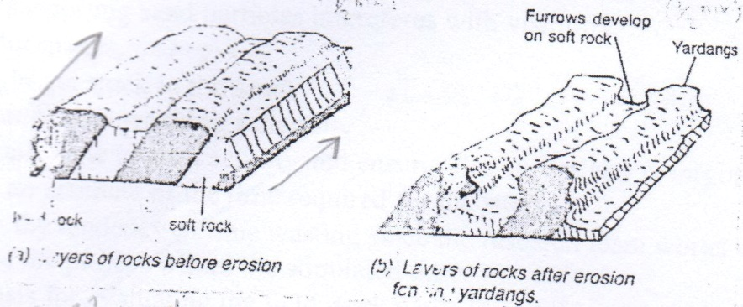
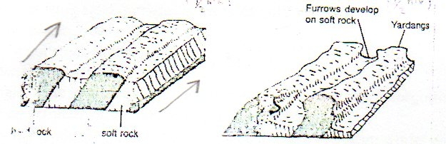

Text -4mks
Diagram –(2x2mks)
d) Objectives
- To establish the type of land forms formed through erosion.
- To identify the importance of desert land forms to the economy of the community.
- To identify how the wind transports its load
Any 2x1
Hypothesis
-the most dominant and land forms is the millet seed
-There is no relationship between desert landforms & the economic activity of the place.
-suspension is the most dominant way of wind transportation.
Any 2x1
ii) Follow up activities
-Displacing photographs
-Group discussion
-writing reports
-class presentation
iii) Challenges you are likely to encounter during the study.
-scorching sun
-Wind transporting particles interferes with visibility
-Attack by snakes and other wild animals.
-The bus might get stuck in the sand
-Loss of direction

10. The diagram below represents underground features in a limestone area use it to answer question
(See question paper)
a (i)Name the features marked X,V,W
x - Stalactite
V – Stalagmite
W – Cave
(ii)Describe how the feature marked Y is formed.
-solution of calcium carbonate trickles down slowly through the roof of care/carven
-Solution droplets hung on the roof of cave.
-Water evaporates and calcium carbonate is precipitated.
-The precipitated calcium carbonate gradually builds up downwards over a period of time as the solution continues to drip from the roof this forms stalactites
-The solution splashes on the floor and the water evaporates.
-The calcium carbonates in precipitates and gradually builds upward to form a stalagmite.
- Over time the stalactite & the stalagmite joins to form a pillar/column.
b (i) What is a artesian basin
- It is a saucer – shaped depression consisting layers of permeable socks lying between two layers of impermeable rocks, with pert of permeable rocks exposed to the surface along the edge of the basin.
(ii)Explain three factors which influence the formation of features in limestone areas.
-The surface rock must be thick limestone to allow solubility byRain water
-The rock should be hard &well jointed to allow water to percolate through the lines of weakness.
-The climate should be hot & humid to facilitate chemical reaction /weathering /carbonation
-The water able should be below the surface to allow for the formation of the feature
(Any 3x2=6)
c. you are supposed to carry out a field study of a limestone covered area eroded by water
(i)Give three reasons why you would need a map of the area of the study
-To show the extend /determine the area of the study
-To show the route to be followed during the study
-To show drainage features
-To be able to estimate the distance
-To show the general nature of the terrain
(ii)Name two erosion features you are likely to identify during the field study
-Exposed rocks
-Ridges
-gullies
- Pillars
(iii)State three recommendations that you would make from your study to assist the local community to rehabilitate the eroded are
- -building of gabions
- -constructing terraces
- -planting tress
- Adapting farming methods that allow conservation of soil.i.e planting of cover crops/mulching farming.
Any 3x1= 3mks

