PAPER 312/2
NOTE
QUESTION 6
PHOTOGRAPH SHOULD BE COLOURED

END OF TERM TWO EXAMINATION 2019
FORM 4
GEOGRAPHY 312/2

TIME 2 ¾hRS
SECTION A
Answer all the questions in this section

1a). Name two exotic species of trees planted in Kenya (2mks)
b.) State three reasons why it is necessary to carry out afforestation programmes in Kenya.
(3mks)
2a.) Outline three physical factors that favored the development of the seven forks hydro-electric power scheme. (3mks)
b.) State two problems facing hydro-electric power project in Kenya (2mks)
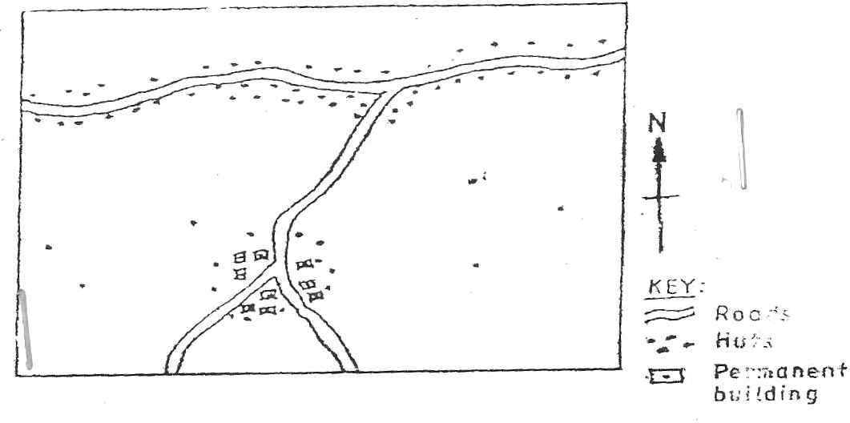
3.) Use the sketch map below to answer question a

a.)Name the main settlement pattern in
- The northern part of the area represented by the sketch map ( 1mk)
- The southern part of the area represented by the sketch map (1mk)
b.) state two ways in which government policy may influence the distribution of human settlement (2mks)
4a. Name three methods of underground mining (3mks)

b. Give the negative effects of open cast mining to the environment (3mks)
5a. Apart from windstorm name any two other environment hazards associated with climatic conditions (2mks)
b. State three problems caused by windstorms in Kenya (3mks)

SECTION B
Answer question 6 and any other two questions in this section
6. Study the photography and use it to answer question 6 a and b
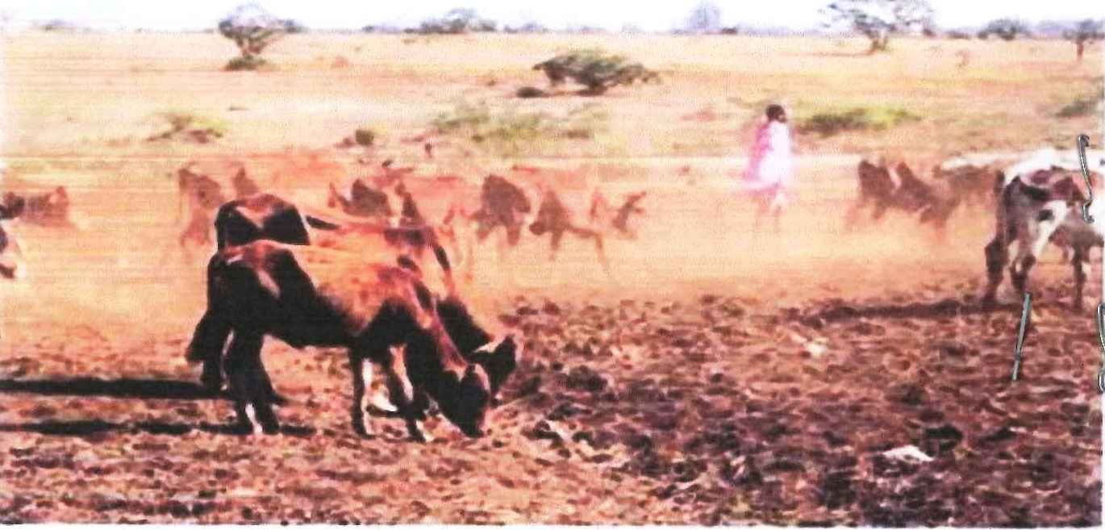
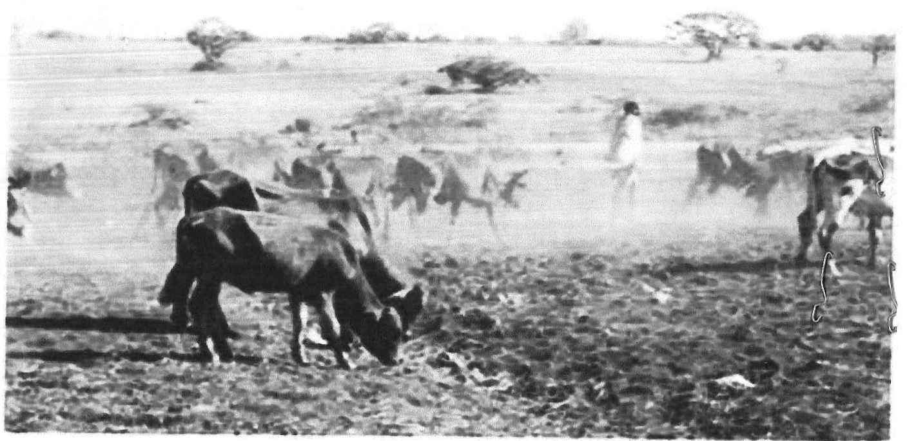

ai) Identify the type of photograph (1mk)
ii)Describe the features shown in the photograph (3mks)
iii).Name three counties where the photograph could have been taken. (3mks)

b)i)State two evidence that shows that the area was experiencing drought when the photograph was taken (2mks)
ii) Give four reasons why nomadic pastoralists keep large herds of livestock (4mks)

- Explain any three problems faced by nomadic pastoralists in Kenya (3mks)
- Name three examples of beef cattle kept by nomadic pastoralists in Kenya.
(3mks)
d. Explain three measures taken by the government of Kenya to improve beef cattle farming (6mks)
7 a. State three physical conditions that favor coffee growing in the central highlands of Kenya (3mks)
b. Describe the stages involved in coffee production from picking to marketing (8mks)
c. Explain four problems facing coffee farming in Brazil (8mks)
d.Your geography class carried out a field study on coffee farm.
- State four methods the class may have used to collect data (4mks)
- During the field study the class collected data quantities of coffee produced in the farm in the last five years
State two methods that the class may have used to present the data ( 2mks)
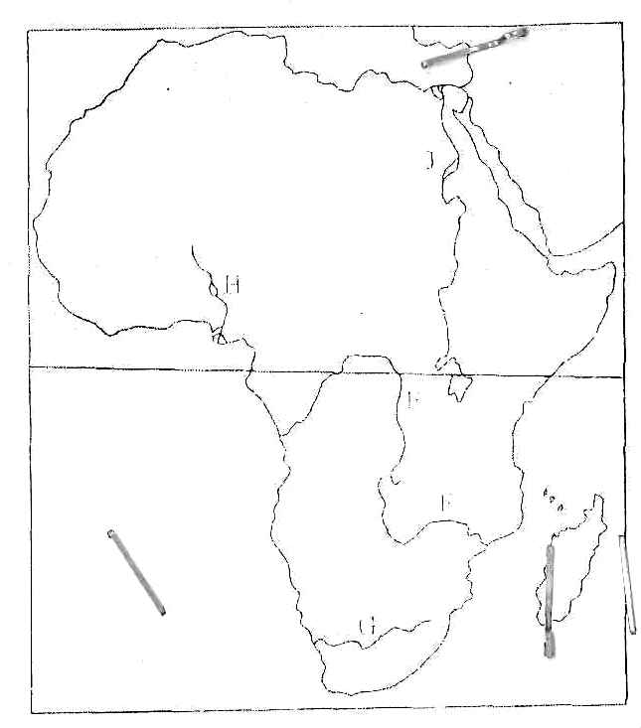
8. Use the map below to answer question a 1 and 2

- Name
- The rivers marked E,F,G (3mks)
- The human-made lakes marked H and J (2mks)
- Explain four measures which should be taken to improve inland water transport in Africa (4mks)
- State four ways in which communication contributes to economic development in Kenya.
(4mks)
- Explain four problems facing n railway transport in Africa (8mks)
9a i) Name three non-food –processing industries in Kenya (3mks)
- State four ways in which Kenya has benefited from the motor vehicle assembly industry (4mks)
b.) Explain three problems arising from industrialization in Kenya (6mks)
c.) Explain three factors which influenced the location of iron and steel industry in the Ruhr region in Germany in the 19th century (6mks)
d.) You intended to carry an out a field study of furniture –marking industry in the local market center
- State two reasons why it is necessary for you to visit he area of the study in advance
(2mks)
- For your field study you have prepared a work schedule.
State two items you would include in the schedule (2mks)
- Give two advantages of studying about furniture making through field work
(2mks)
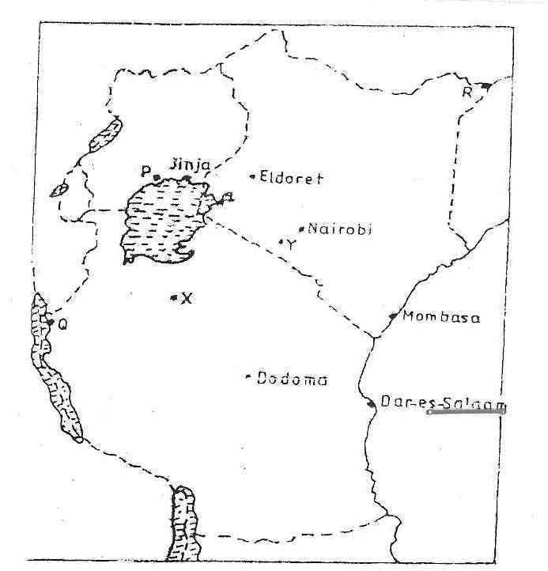
10. The map below shows the location of some urban centers in East Arica

a.i) Name the town marked P,Q.andR (3mks)
ii)Name the minerals that influenced the growth of the towns marked x and y
(2mks)
b. Explain four factors that have led to the grout of Eldoret town as a major town in Kenya
(8mks)
c. Compare the ports of Mombasa and Rotterdam under the following sub-headings
- Site (2mks)
- Transport links to the interior (2mks)
- The hinterland (2mks)
- Port facilities (2mks)
- Explain in which the urbanization negatively effects the surrounding agricultural areas (4mks)

END

GEOGRAPHY P2
312/2 FORM 4
MARKING SCHEME
SECTION A
1a) Name two exotic species of trees planted in Kenya (2mks)
- Pine - Kei apple
- Cypress - Jacaranda
- Blue gum/eucalyptus - Bombax
- Wattle - Grevilea

- State three reasons why it is necessary to carry out afforestation programmers in Kenya
(3mks)
- To protect water catchment areas
- To protect soil from soil erosion by water wind
- To ensure sustainable supply of forest products
- To put more land under forest cover
- To check the extinction of indigenous trees
- To regulate climate
2a)Outline three physical factors that favored the development of the seven forks hydro-electric power scheme
- Presence of hard basement rocks
- Presence of large volume of water from river Tana
- Presence of waterfall /rapids steep gradient
- Presence of narrow steep sided river valleys /deep gorges
- Presences of impervious rock/non porous
- Regular flow of water /constant of R.Tana
- State two problems facing hydro-electric power project in Kenya
- Seasonal fluctuation of water levels in rivers
- High cost of maintenance of machine
- High cost of transmission of power from remote site
- In adequate capital to expand the projects.
3. Use the sketch map below to answer question ( see given paper )
a. Name the main settlement pattern in
- The northern part of the area represented by the map
- Linear (1mk)
- The southern part of the area represented by the map
- Nucleated scattered (1mk)
b.)State two ways in which the government policy may influence the distribution of human settlement (2mks)
- The government may displace people in order to set up projects in an area/ project set up by the government attract settlement
- The government may set up settlement schemes to resettle the landless
- The government may gazette certain area as reserve thus controlling settlement
4a)Name the methods of underground mining (3mks)
- drift /adit method
- -drilling method
- shaft method
- solution method
b )Give three negative effects of open cast mining to the environment (3mks)
- Waste of agricultural land-mines associated tip heaps may occupy land otherwise suitable for farming
- Ugliness –people who live in areas where there is much derelict land have no pride in their towns as they have last their aesthetic values
- During mining toxic gases and dust may be omitted leading to air pollution
5 (a) apart from windstorms name two other environment hazards associated with climatic condition
- lightning
- Floods
- Drought/ desertification
- Landslides
- Heat waves (2mks*1)

b) State three problems caused by windstorms in Kenyan
- Windstorms destroy trees and crops
- They blow off roofs of houses
- They disrupts transport and communication lines
- They spread bush fires
- They cause strong sea storms
- Accelerate soil erosion (3mks *1)

SECTION B
6i)The type of photography is ground general view (1mk)
- The features shown in the paragraph (3mks)
- On the fore ground there is bare ground /short grass
- In the middle ground there is a herds man and some cattle on the move
- There is road on the middle ground
- At the background there are some patches of grass /some trees/shrubs/thickets
- Some part of the background are bare surface
- There are bushes on the middle ground
- Two counties where the photograph could have been taken from (2mks)
- Turkana - Kajiado
- Marsabit - Elgeiyo Marakwet
- Laikipia -West Pokot
- Narok - Isiolo
- Wajir - Baringo

b. i)Two evidence that shows that the area was experiencing drought when the photograph was taken
- Cloudless sky
- Malnourished/thin animal
- Dust raised by moving animals
- Bare ground /sparse vegetation /patches of vegetation

- Four reasons why the nomadic pastoralists keep large herd of animals
- A form of Insurance against natural calamities ,drought ,diseases
- Animal are kept for dowry payment
- Source of food in terms of blood, milk and meat
- Sore of income when sold
- Wealth/prestige
c.
- Three problems faced by nomadic pastoralists in Kenya
- There is shortage of water and pasture during the dry seasons leading to death of animals
- Diseases like anthrax east coast fever, foot and mouth which lead to death and low production
- Parasites like tick affect the animals and leading to death
- Most of the animals are poor quality which fetch low price thus frustrating the farmers
- There is in adequate security / cattle rustling leading to loss of animals
- Animals are at times killed by wild animals which is against loss of pastoralists
- Overstocking leads to overgrazing and lack of adequate pasture for the animal
- Three examples of beef cattle kept by nomadic pastoralists
- Zebu
- Borana
- Sahiwal

d. Explain three measures taken by the government of Kenya to improve beef cattle farming
- It has constructed cattle dips to control pest and diseases
- Has employed veterinary officers to treat animal diseases thereby improving the quality of beef animals
- It encourages research / cross breeding of traditional cattle breeds with exotic ones thus improving quality of the animals
- It has strengthen community education to teach beef cattle farmers better livestock management
- It has set up demonstrations ranches for farmers to learns new trends in livestock management
- It has constructed roads to make transport of animals to the market easier
- It has encouraged the replacement of course grass with nutritious pasture to improve the quality of the animal
- Has revised the Kenya meat commission for the farmers to sell their animals for slaughter
7. State three physical conditions that favor coffee growing in the central highlands of Kenya
- The highlands experience high rainfall about 1000-1500 m per year which is ideal for coffee
- The soils are deep volcanic fertile soil
- The area experience moderate to high temp (14-24⁰)
- The land has gentle slopes that allow good drainage/well drained soil
b. describe the stages involved in coffee production from picking to marketing
- The ripe deep berries are picked by hand
- The harvested berries are carried in baskets /sacks to the factory
- The berries are sorted out to remove the outer /diseased berries
- The different grades are weighed
- Berries go through a machine that removes the outer covering pulp
- The berries are fermented in tanks for sometime
- The berries are washed and sun dried for a week
- The husk are removed and berries winnowed
- The berries are sorted out and graded according to size and quality
- Ready coffee is then sold locally or exported

C. Explain four problems facing coffee farming in Brazil
- The wasteful technique of growing the crops leads to soil exhaustion which makes the coffee yield per hectare low /unregulated cultivation leads to soil exhaustion /low quality coffee
- Climatic hazards like frost destroy coffee plants reducing the yields
- Unplanned planting leads to overproductions surplus which lowers the price
- The fluctuation of coffee prices in world market sometimes leads to low profit
- Stiff competition from other coffee predicting countries reducers Brazil dominance in the world coffee market
d. Your geography class carried out field study on a coffee farm.
- State four methods the class may have used to collect data
- Administering questionnaire
- Interviewing/asking questions
- Taking photograph/video
- Observation
- Taking measurements
- Collecting sample
- Content analysis
ii) During the field study the class collected data on quantities of the coffee produced in the farm in the last five years ,state two methods the class may have used to present data
- Drawing charts
- Drawing tables
- Drawing graphs
8 a) Name the rivers marked E,E and G
- E- R. Congo
- F- R. Zambezi
- G- R. Orange
ii) Name the human made lakes named H and J
- H -kanji
- J - Aswan high dam
iii) Explain four measures which should be taken to improve inland water transport in Africa
- The waterways should be dredged regularly to control siltation /maintain constant depth of the river and lakes for easier navigation
- Dams/barrages should be constructed to control flooding hence allowing navigation
- Constructing canal /canalizing the rivers where waterfalls rapids /rock outcrops exist to bypass obstacles that hinder navigation
- Constant cleaning /controlling the growth of vegetation to allow free movement of vessels
- Using modern vessels /ports/equipment to improve the efficiency of handling cargo/passengers
- Removal of rock obstacles from the river bed to allow navigation

b.. State four ways in which communication contributes to economic development in Kenya
- Technology efficiently in communication makes business transitions easier / faster
- Modern communication network allow for the spread of ideas information for decision making which enhances economic development
communication promote development of related industries /business opportunity
- communication services provide employment opportunity
- communication connectively promotes mobility of labor
- communication derives revenue from communication services
- communication facilities marketing of products thus a wider market
- Explain four problems facing railways transport in Africa.
- Africa countries uses different railway gauges which make it difficult to have an integrated railway transport system/transportation of goods
- Construction of railway require large amount of capital that most countries lack to extend /maintain the existing lines
- Accident/ vandalism /uprooting of the railway line causes great losses /delay in transportation
- Tropical storm waters at time wash away vital section of the railway lines thereby disrupting transport /causing accident
- Railway transport faces stiff competing from move faster / flexible means of transport such as road and air
- Fueling maintenance of railways station and other related overhead costs are high thus reducing profit margin
9a ( i) Name three agricultural non-food processing industries in Kenya
- Tobacco processing
- Footwear marking
- Leather tanning
- Bees wax processing
- Sisal processing
- Pyrethrum processing
ii) State four ways in which Kenyan has benefited from the motor vehicle industry
- Kenya saves foreign exchange
- Kenya earns foreign exchange through exports
- The industries has created employment opportunities
- The industries has promoted transport sector by availing busses/lories vans/cars
b. Explain three factors arising from industrialization in Kenya
- Industrialization has led to rural –urban migrations which increased the urban population leading to congestion /shortages of houses /increase income
- Some industries emit toxic gasses which are harmful to people /wild life
- Industrial effluent pollutes water sources making the water unfit for human /animal use
- Fumes from chemicals corrode metallic roofs of building hence destroying them
- Congestion of infrastructures and social services in the industrial areas has led to the degradation of land
- Some industries has led to the displacement of people thus disrupting their social economic life
c. Explain the factors which influenced the location of iron and steel industry in Ruhr in Germany in the 19th centaury
- Availability of coal iron are as well a limestone from the Rhine valley provided raw materials needed in the industry
- River Rhine /Ruhr /lippie /wupper provided water required for cooling machine in the industry
- The region is served by navigable rivers e.g. Rhine Ruhr which offer cheap transport for the bulky raw materials and finished products
- Coal from Ruhr region /imported crude oil provided power required in the industry
- The local population had acquired skills on iron working /availability of local skilled labor and this formed the foundation of iron and steel industry
- Presence of rich families such as the Krupp family provided capital for the development of the industries
- The diverse and affluent population in ( central and western ) Europe/Germany provided ready market for iron and steel
- You need to carry out a field study of furniture making industry in the local market center
- State two reasons why it would be necessary for you to visit the area of study in advance
- To prepare a route map
- To determine the suitable of the area for the study
- To be able to formulate appropriate objective
- Preparation for a work schedule.
- To prepare appropriate data collection method
- Find out possible problems likely to be experienced during the field study
- To seek permission for the visit
- To determine the cost to be incurred during the study
- For your field study you have prepared a work schedule .state two items you would include in the schedule (2mks)
- Time for departure
- Time to spend in the field
- Time for lunch
- Time to end the activity
- Give two advantages of studying about furniture –making through field work (2mks)
- It enables one to get first head information
- It makes learning real
- It enables one to share the information
- It enables one to retain information learned
- It enables one apply skills acquired in class

10. The map below shows the locations of some urban centers in east Africa .use it to answer questions(see un the question paper
a. i). Name the towns marked P,Q and R (3mks)
P-Kampala
Q-Kigoma
R- Madera
ii)Name the minerals that influenced the growth of the towns marked x and y
x- Diamond (1mk)
Y-Trona /soda ash (1mk)
B. Explain four factors that influenced the growth of the Eldoret town as a major town in Kenya (8mks)
- Eldoret started a railway station on the Kenya- Uganda railway thus attracted settlement by people from around the town
- Land is extensive allowing large scale farming making Eldoret town a rich agricultural collection and processing center
- Eldoret is located in an area that experience a cool and wet climate ideal for settlement
- The terrain of the land is a plateau which allows expansion
- The modern infrastructure such as the Eldoret international airport have encouraged trade
- High population in the surrounding regions provide market for agricultural and processed goods
- The government policy of decentralization of industries led to setting up of some industries in Eldoret
- It is the county head quarter for Uasin Gishu county and this has attracted administrative services in the town
- Establishment of many educational institutes such as the university of Eldoret has attracted settlement
C .Compare the ports of Mombasa and Rotterdam under the following sub headings
- Site (2mks)
- Mombasa is located on the dreaded mouth of river Mwachi and Kombeni while Rotterdam is at the mouth of the river Rhine
- Transport link to the interior (2mks)
- Mombasa relies on road ,railway, air and pipeline to the interior while Rotterdam has in addition river Rhine and canal transportation
- The hinterland (2mks)

- Both ports have extensive hinterlands to DRC Congo while Rotterdam serves the continental Europe
- Port facilities (2mks)
- Both ports have containerized terminals .Rotterdam has very large ware house and more modernized /sophisticated port facilities
d. Explain two ways in which urbanization negatively affect the surrounding agricultural areas (4mks)
- Dumping
The nearby agricultural lands are sometimes used as dumping grounds for the waste generated in urban centers thus polluting the environment
- There is conflict in land use as urban centers expand into the land that would otherwise have been used for agriculture
- There is competition for labor as urban centers offer higher wages than agricultural areas.

End.

