FORM 4 GEOGRAPHY
PAPER 1 (312/1)
END OF TERM 2 2019
TIME: 2 ¾ HRS

INSTRUCTIONS TO CANDIDATES
- This paper consists of two sections A and B.
- Answer all questions in section A.
- In section B answer question 6 and any other two questions.

SECTION A

1. (a) Define revolution of the earth. (2mks)
(b) State four effects of the earth’s rotation. (4mks)
2. The diagram below represents some features formed in a karst landscape.

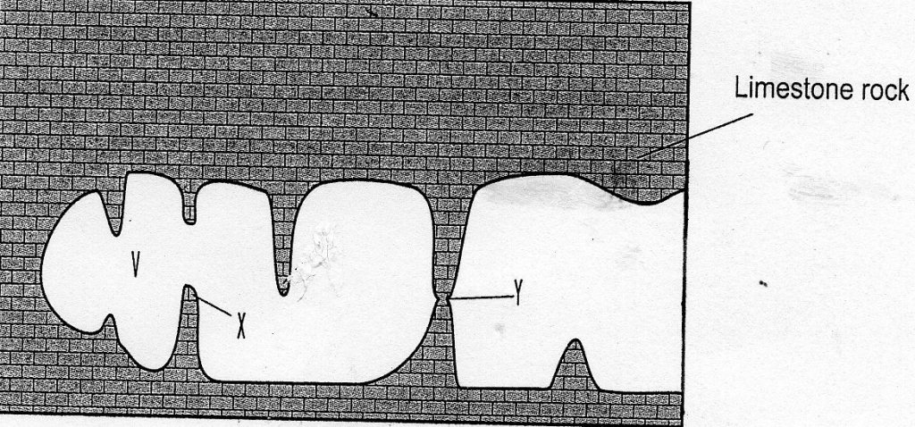

(a) Name the features marked V, X and Y (3mks)
(b) State three conditions necessary for the formation of a karst landscape. (3mks)
3. (a) Apart from carbonation, give three processes of chemical weathering. (3mks)
(b) Describe carbonation as a chemical weathering process. (3mks)
4. State three causes of earth movement. (3mks)
5. Describe how humidity is measured in a weather station. (4mks)

SECTION B

6. (a) (i) Name one human feature in grid reference 4127. (1mk)
(ii) Give two types of scales used in Taita Hills map. (2mks)
(b) (i) Give the six figure grid reference of the trigonometrical station point 2208. (2mks)
(ii) Calculate the length of the road classified D 535 from grid reference 405280 to
445283. Give your answer in kilometers. (2mks)
(c) Identify
(i) two types of natural vegetation in the area covered by the map. (2mks)
(ii) one planted vegetation in the area covered by the map. (1mk)
(d) (i) Identify two methods used to show relief in the area covered by the map. (2mks)
(ii) Describe the drainage of the area covered by the map. (6mks)
(e) (i) Describe the distribution of settlement in the area covered by the map. (5mks)
(ii) Give two social services in the area west of Easting 30. (2mks)

7. (a) Differentiate between weather and climate. (2mks)
(b) Describe how the following factors have influence climate
(i) Ocean currents (4mks)
(ii) Aspect (2mks)
(c) The map of Kenya below shows the climatic regions. Use it to answer the following
questions

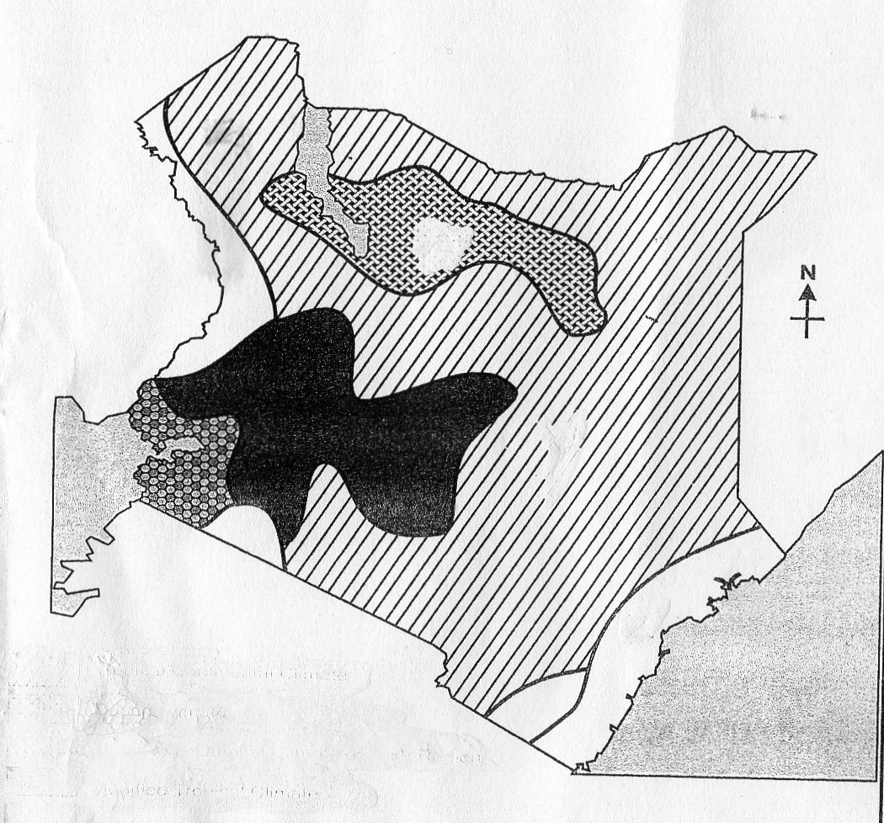
X
Y
Z

Modified tropical climate

(i) Name the climatic regions marked X,Y and Z. (3mks)
X -
Y -
Z -

(ii) Describe the climatic conditions of the modified tropical climate of Kenya.
(d) Form four students planned to conduct a field study on a weather station in the vicinity.
(i) State four reasons why a working schedule would be important. (4mks)
(ii) Give three features they would identify in the weather station during the field study.
(3mks)
8. (a) Define vegetation. (2mks)
(b) Use the map of Africa below and answer the questions that follow:

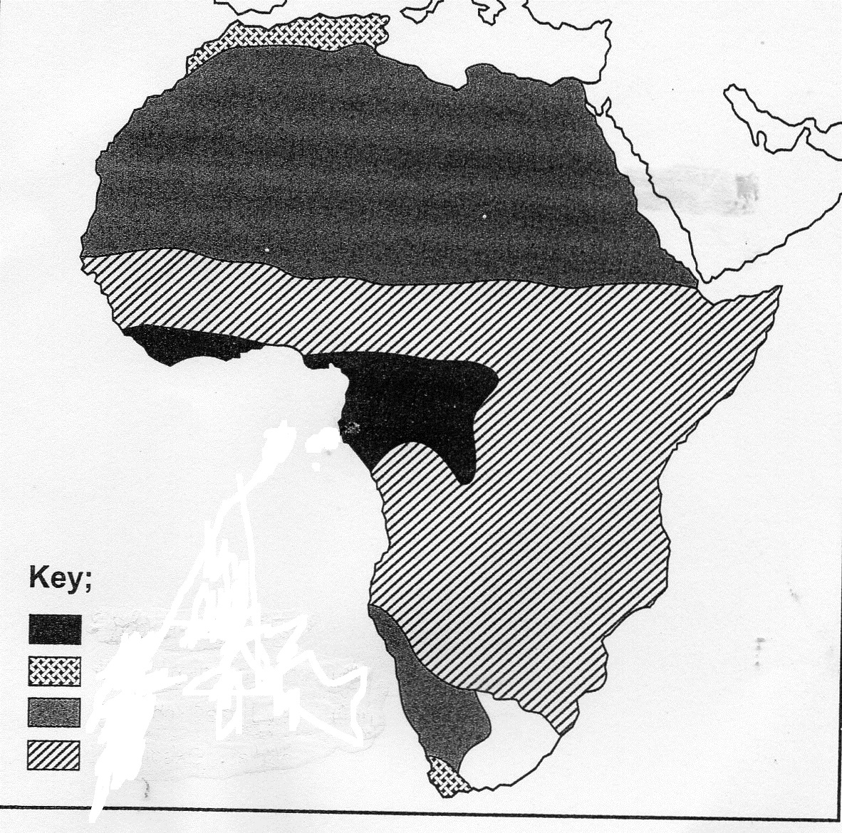

P
Q
M
N

(i) Name the vegetation region marked M, N and Q (3mks)
M -
N -
Q -
(ii) Describe the characteristics of the vegetation marked P (8mks)
(c) (i) Explain why polar regions are unable to support thick vegetation growth. (6mks)
(ii) Explain three factors that have led to a decline of natural grasslands in Kenya.
(6mks)
9. (a) Name four types of faults apart from normal faults (4mks)
(b) (i) Apart from block mountains give three other resultant features of faulting. (3mks)
(ii) With the help of well labeled diagrams describe how a block mountain is formed by
tensional forces. (8mks)
(c) Explain ways through which faulting has influenced human activities. (10mks)

10. (a) (i) Define soil (2mks)
(ii) Give four components of soil. (4mks)
(b) (i) What is soil catena? (2mks)
(ii) Draw a well labeled diagram of a developed soil profile. (5mks)
(c) (i) Define soil degeneration. (2mks)
(ii) Describe how the following cause soil degeneration
- Deforestation (2mks)
- Leaching (2mks)
- Monoculture (2mks)
(d) State four uses of soil (4mks)

