GEOGRAPHY
FORM 4 END OF TERM 2 2019
MARKING SCHEME
PAPER1 (312/1)

1. (a) Define revolution of the earth. (2mks)
- It refers to the movement of the earth on its orbit round the sun in an anticlockwise direction
(b) State four effects of the earth’s rotation. (4mks)
-It causes occurrence of day and night.
-It causes deflection of winds and ocean currents.
-It causes periodic rise and fall of ocean tides.
-It causes a time difference between longitudes.
-It causes variation of atmospheric pressure on the earth’s surface.
2. The diagram below represents some features formed in a karst landscape.

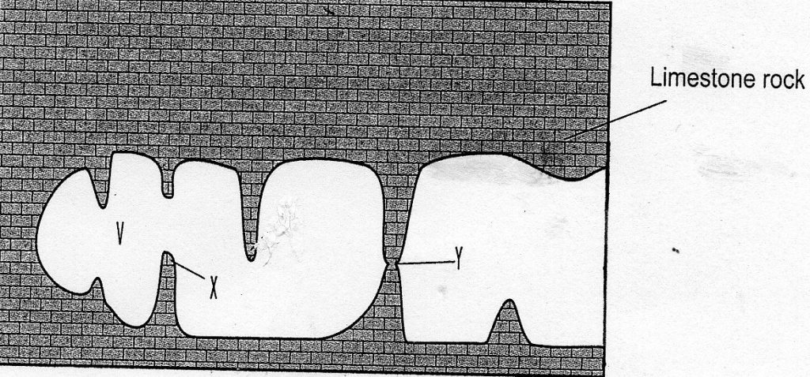

(a) Name the features marked V, X and Y (3mks)
V – Cave/cavern
X - Stalactite
Y – Limestone pillar
(b) State three conditions necessary for the formation of a karst landscape. (3mks)
-The area should be covered by thick limestone, dolomite or chalk.
-The water table should be deep below the surface.
-The rock should be hard and well jointed.
-The climate should be warm or hot.
-The area should have rainfall.
3. (a) Apart from carbonation, give three processes of chemical weathering. (3mks)
-Hydrolysis
-Oxidation
-Hydration
-Solution
(b) Describe carbonation as a chemical weathering process. (3mks)
-It occurs in thick limestone rocks
-Rainwater reacts with carbon (IV) oxide to from weak carbonic acid.
-The weak carbonic acid comes into contact with calcium carbonate mineral in limestone
rocks and reacts with it to form calcium bicarbonate which is soluble and it is lost in
solution.
4. State three causes of earth movement. (3mks)
-Magma movement within the crust
-Gravitative pressure
-Convectional currents in the mantle.
-Isostatic adjustment.
5. Describe how humidity is measured in a weather station. (4mks)
-Read and record dry bulb thermometer reading.
-Read and record wet bulb thermometer reading
-Calculate the difference between them
-Interpret the readings.

SECTION B
6. (a) (i) Name one human feature in grid reference 4127. (1mk)
- Bridge
- Dry weather road
- Telephone line
(ii) Give two types of scales used in Taita Hills map. (2mks)
-Linear scale
-Representative fraction scale or Ratio scale.
(b) (i) Give the six figure grid reference of the trigonometrical station point 2208. (2mks)
-212228
(ii) Calculate the length of the road classified D 535 from grid reference 405280 to
445283. Give your answer in kilometers. (2mks)
-4.4km± 0.1
(c) Identify :
(i) two types of natural vegetation in the area covered by the map. (2mks)
-Forest
-Scrub
-woodland
-Scattered trees
-Riverine trees
(ii) one planted vegetation in the area covered by the map
-Sisal
(d) (i) Identify two methods used to show relief in the area covered by the map.
-Use of contours
-Use of trigonometrical station
-Naming
(ii) Describe the drainage of the area covered by the map. (6mks)
-There are many permanent rivers
-The rivers generally flow from the highlands west of Easting 40 either to the north,
to the south and south eastern parts.
-The main river is River Voi(Goshi) which to flow the south eastern part.
-Most rivers form dendritic drainage pattern.
-There are dams/reservoirs in the north eastern part and the mid-west of the areas
covered by the map.
(e) (i) Describe the distribution of settlement in the area covered by the map. (5mks)
-There are nucleated settlements at Mwatunge in the far south and in markets.
-There are linear settlements along the major roads.
-The mid-west and western parts are densely settled.
-There are few settlements in the forests, while the thickets are not settled.
-Very steep slopes and hill tops are avoided, while moderately sloping areas are
settled.
-The eastern, northern and south eastern parts have few settlement.
(ii) Give two social services in the area west of Easting 30. (2mks)
-Education
-Health
-Administration
–Rehabilitation

7. (a) Differentiate between weather and climate. (2mks)
-Weather is the atmospheric condition of a place at a particular time, while climate is the
average weather condition of a place for along period of time. eg 30 years
(b) Describe how the following factors have influenced climate
(i) Ocean currents
-Onshore winds on crossing cold ocean currents are condensed prematurely causing
precipitation over the ocean and on reaching adjacent land they have a drying
effect/causes aridity.
-Onshore winds on crossing warm ocean currents, hold onto their moisture and
on reaching adjacent land they cause high precipitation/rainfall.
-Onshore winds on crossing cold ocean currents are cooled and on reaching land they
bring a cooling effect.
-Onshore winds on crossing warm ocean currents get warmed up and on reaching
adjacent coastland they bring a warming effect.
(ii) Aspect
-The windward slopes of highlands/mountains are warmer and wetter than the
leeward slopes, due to direct solar radiation and moist warm winds.
-In regions beyond the tropic , in the northern hemisphere the south facing slopes are
warmer than the polar sides due to direct solar radiation.

(c) The map of Kenya below shows the climatic regions. Use it to answer the following questions

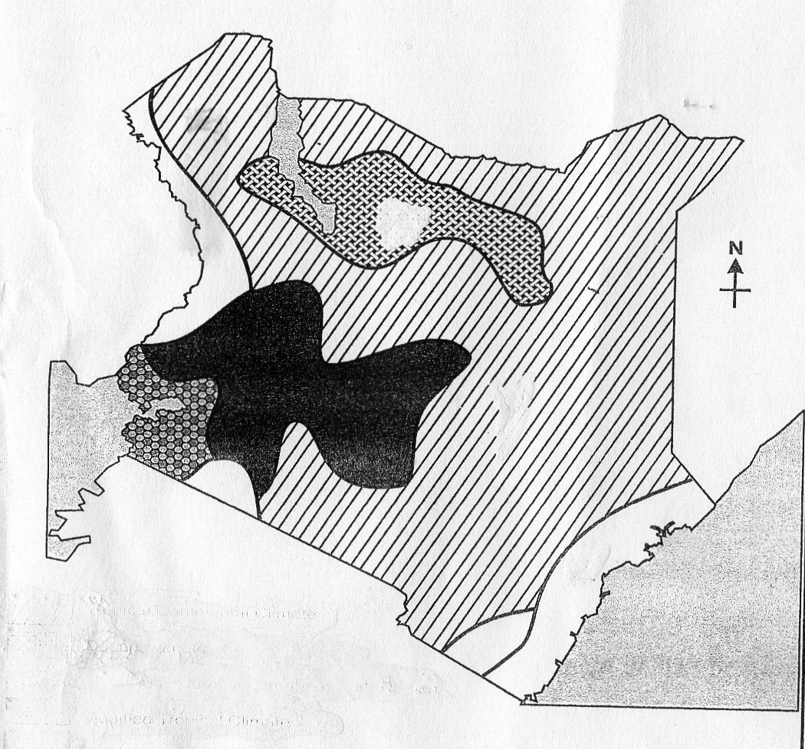
X
Y
Z

(i) Name the climatic regions marked X, Y and Z.
X - Desert
Y - Tropical continental
Z - Modified equatorial climate of the coastal region.
(ii) Describe the climatic conditions of the modified tropical climate of Kenya.(8mks)
-It receives rainfall throughout the year
-It receives double rainfall maxima, with the long rains received between March and
May and the short rains between September and December.
-It receives high rainfall between 1000mm and 1500mm/year.
-The windward slopes of the highlands receive more rainfall than the leeward sides.
-It receives mainly relief rainfall
-Temperatures are warm ranging between 17⁰C and 24⁰C.
-Annual range of temperature is small ranging between 3-5⁰C.
-The months of June to August are cool, while the rest of the year remains warm.
-The region experiences moderate humidity.
-Temperatures are warm during the day, while the nights are generally chilly.
-Low altitudes areas are warmer than high altitudes areas.
(d) Form four planned students to conducted a field study on a weather station in the vicinity.
(i) State four reasons why a working schedule would be important. (4mks)
-It gives ample time to each activity
-It reduces time wastage because student work within the allocated time.
-It provides an estimate of the overall time required for the study.
-It provides a basis for evaluating the field work exercise.
-It enables students to remain within the scope of the topic.
(ii) Give three features they would identify in the weather station during the field study. (3mks)
-Stevenson screen
-Wind vane
-Rain gauge
-Anemometer
-Campbell Stokes Sunshine recorder
8. (a) Define vegetation. (2mks)
-It refers to plant life growing in a given area.
(b) Use the map of Africa below and answer the questions that follow:
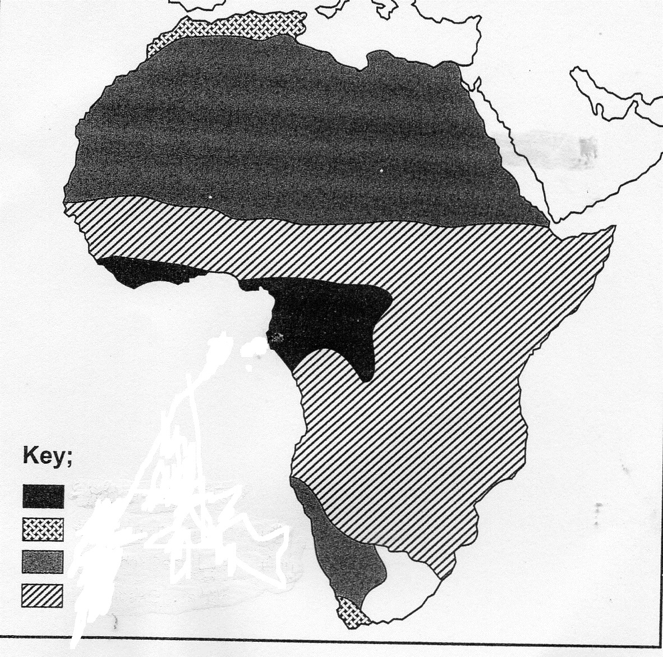
P
Q
M
N

(i) Name the vegetation region marked M, N and Q (3mks)
M -Desert vegetation
N -Savanna vegetation
Q -Mediterranean vegetation

(ii) Describe the characteristics of the vegetation marked P (8mks)
-Trees consists of three canopies
-The forest has little or no undergrowth
-The leaves of trees are broad and drip hipped
-The trees are mainly hardwood.
-Some trees have buttressed roots.
-The forest consists of climbers
-The forest consists of a mixed variety of tree species
(c) (i) Explain why polar regions are unable to support thick vegetation growth. (6mks)
-The soil is permanently frozen discouraging growth of vegetation
-The regions receive low rainfall which cannot support thick vegetation growth.
-The regions have very low temperatures which inhibit growth of plants.
-The areas have short growing seasons that limit the number of plant species.
(ii) Explain three factors that have led to a decline of natural grasslands in Kenya. (6mks)
-Wild and domestic animals overgraze the grass and stagnate their growth.
-Frequent outbreak of bush fires destroy the grass, thus retarding it’s regeneration.
-The increasing in the marking scheme.
9. (a) Name four types of faults apart from normal faults (4mks)
-Reverse faults
-Tear/shear faults
-Thrust faults
-Anticlinal faults.
(b) (i) Apart from block mountains give three other resultant features of faulting.(3mks)
-Fault scarps
-Tilt blocks
-Fault step
-Rift valleys
(ii) With the help of well labeled diagrams describe how a block mountain is formed by
tensional forces. (8mks)
-Layers of crustal rocks or a block of land is subjected to tensional forces.
-This leads to the development of normal faults.
-Continued tensional forces cause the two outer block of land to sink, leaving the
middle block standing out as a block mountain.
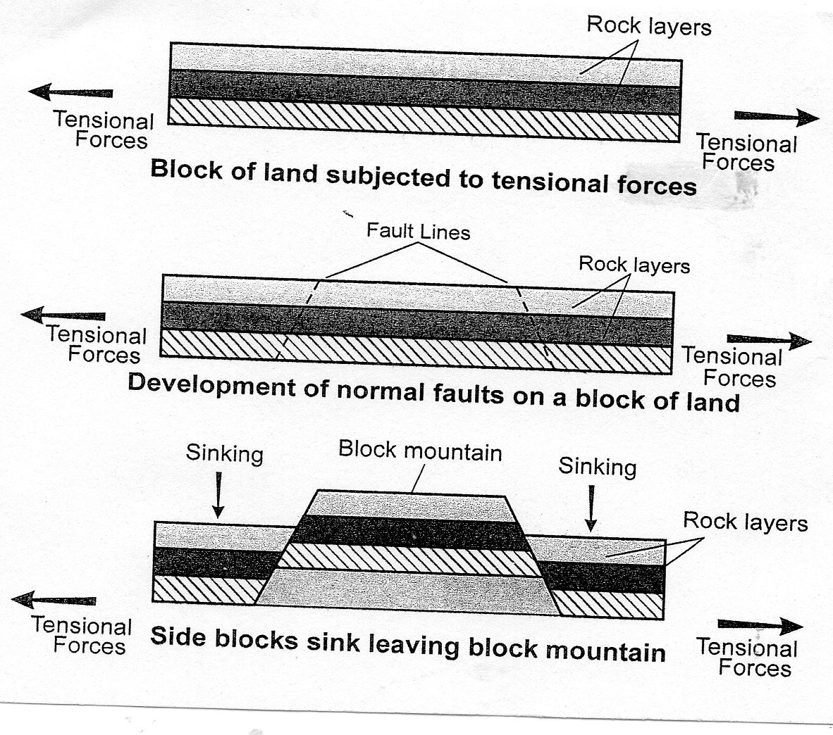

(c) Explain ways through which faulting has influenced human activities. (10mks)
-Features formed through faulting such as rift valley horst mountains and others are
tourist attraction.
-Deeply sunken sections of rift valley floor collect water to form lakes which provide
water for industrial, domestic or irrigation use.
-Some rift valley lakes like Lake Magadi, while others like Lake Tanganyika from
waterways as well as fishing grounds.
-Faulted landscape is rugged and may form barrier which prove difficult during the
construction of roads, railways and communication lines.
-Faulting has created deep faults which are passages for steam jets which may be utilized
for geothermal power generation.
-Springs formed at the base of scarp slopes provide fresh water which may attract
settlement.
-When faulting occurs across a river valley it may cause a river to disappear into the
ground through the fault line leading to lack of water downstream for the purpose of
industrial, domestic or irrigation.
-Vertical displacement across a river valley may lead to the formation of waterfalls which
can be harnessed to provide hydro-electric power.
10. (a) (i) Define soil (2mks)
-It is superficial layer of loose or unconsolidated materials overlying crustal rocks and
on which plants grow.
(ii) Give four components of soil. (4mks)
-water/moisture
-Air/gases
Organic matters/living organisms/Humus
-Inorganic matter/minerals

(b) (i) What is soil catena? (2mks)
-It refers to the sequence or arrangement of different soils along a slope from top to
bottom.
(ii) Draw a well labeled diagram of a developed soil profile. (5mks)

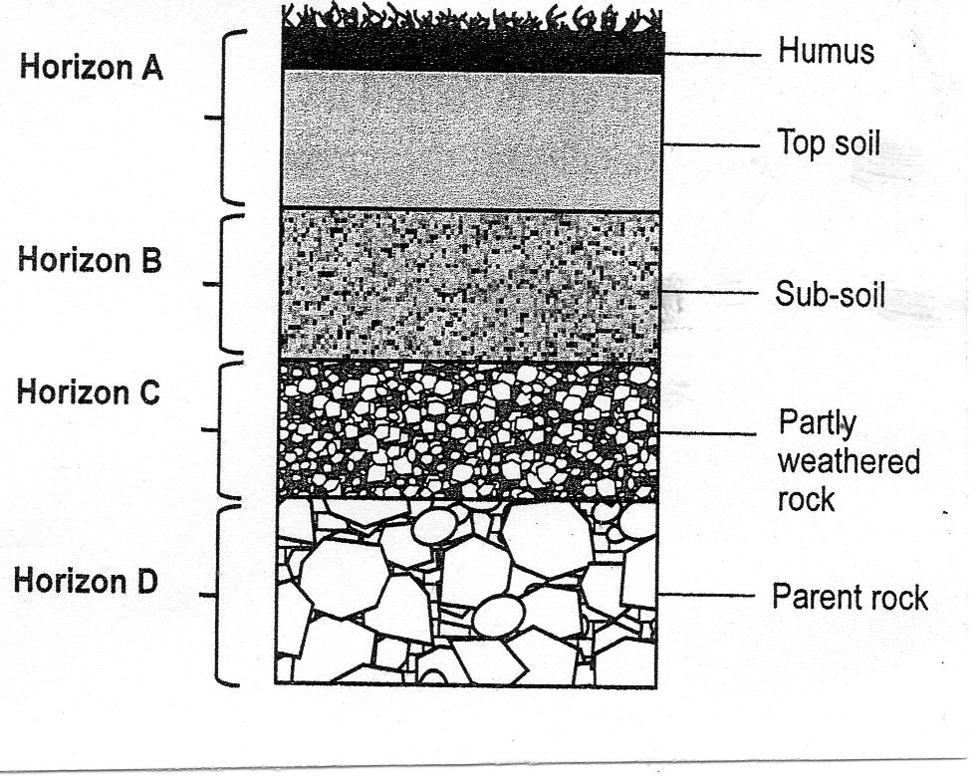

(c) (i) Define soil degeneration. (2mks)
-It is the process by which soil loses it’s mineral nutrients and humus due to
mismanagement or environmental effects.
(ii) Describe how the following cause soil degeneration
- Deforestation (2mks)
-Indiscriminate cutting down of trees exposes soil to erosional agents leaving
the soil bare and with low nutrient content.
- Leaching (2mks)
-High rainfall on well drained soil dissolves soluble minerals and carry them to
lower horizons where they are deposited leaving the top soil with very low
nutrient content or infertile.
- Monoculture (2mks)
-Growing of one type of crop on the same piece of land over along time period
of time causes the soil to loose a particular nutrient which is utilized by the
crop leading to low productivity of the land.
(d) State four uses of soil (4mks)
-Some soils are used for making building materials such as bricks and tiles.
-Soils support growth of crops which is a source of food for human beings and animals.
-Some soils are used for decoration.
-Some soils are mixed with herbs for medicinal purposes.
-Soils are source of valuable minerals.
-Fertile soils are suitable for agricultural activities.

