Kenya Certificate Of Secondary Education 2019
312/ 1 Geography Paper 1
END TERM 1 2019 -Time: 2 ¾ hours

Name …………………………………………….……… Index Number…………………………..
Candidate’s Signature ………………….…...……….. Date ……………………………………

Instructions To Students
- This paper has two sections A and B
- Answer ALL the questions in section A.
- answer questions 6 and any other TWO questions from section B
- The paper consist of 4 printed pages
- Candidates should check the question paper to ascertain that all pages are as printed and that no question are missing
- Candidates should answer the question in English
For examiners use only

GEOGRAPHY 1
2019

Section | Question | Maximum’s  Score | Candidate’s  Score
A | 1-5 | 25
B | 6 | 25
 | 7 | 25
 | 9 | 25
 | 10 | 25
100
Total

Turn over
SECTION A

Answer ALL the questions in this section.

- (a) State any two reasons why we study geography (2marks)
(b) Give three forces that are responsible for the spherical shape of the earth (3marks)
2. State three natural causes of earthquakes. (3 marks)
b) Give two effects of earthquakes in built up areas. (2 marks)
3. Draw a well-labelled diagram of a hydrological cycle (5 marks)
4. (a) List two elements of weather. (2marks)
(b) Name three processes through which the atmosphere is heated. (3marks)
- (a) What is desertification? (2marks)
(b) State three negative effects of desertification. (3marks

SECTION B
Answer question 6 and any other two questions from this section.

6. Study the map of KARATINA (1:50000), sheet 121/3 provided and answer the following questions
a. (i) Give the latitudinal and longitudinal extent of the area covered by the map. (2marks)
(ii) Calculate the area (in square kilometers) enclosed by the property boundary and the district boundary to the south Eastern part of the area shown. (2marks)
b. (i) Name the vegetation type in grid square 0045. (1mark)
(ii) Describe the drainage of the area covered by the map. Extract. (3marks)
c. (i) Using a vertical scale of 1cm to represent a 100 metres draw a cross-section from grid reference 830,500 up to
900,500 along northing 50. (4marks)
(ii) On the cross-section; mark and label
- River Rathithi (1mark)
- All weather road D451. (1mark)
- Dry weather Road E1710 (1mark)
(iii) Calculate the vertical exaggeration for the cross-section. (2marks)
d. Geography students from Ragati secondary school in grid square 9249 decided to carry out a field study in the area around Karatina Township.
- Name two means of transport they are likely to have used to travel to KaratinaTownship.(2marks)
(ii) State three social functions of Karatina Township that they identified. (4marks)
(iii) Identify the adjoining sheet and number to the south east of Karatina. (2marks
- a) i) What is folding. (2 marks)
ii) Differentiate between an overfold and a recumbent fold. (2 marks)
b) i) Apart from fold mountain, name three other features resulting from folding. (3 marks)
ii) With aid of well labelled diagrams, describe the formation of fold mountains. (8 marks)
c) The map below show the location of some fold mountains.

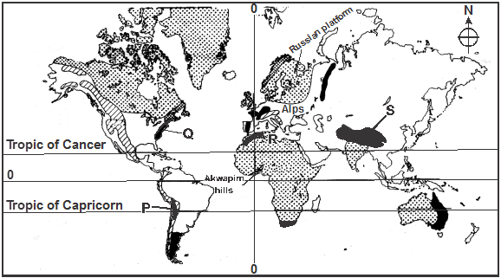

Name the mountain ranges marked P, Q, R and S. (4 marks)
d) Explain the significance of Fold Mountains to human activities. (6 marks)
8. a) i) What is a lake ? (2 marks)
ii) State three sources of water found in a lake. (3 marks)
b) Describe how the following lakes are formed
i) Tarn lakes (4 marks)
ii) Crater lakes (3 marks)
c) The map below shows some lakes formed by faulting.

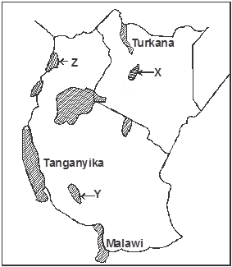

Name the lakes marked X, Y and Z. (3 marks)
d) i) Give four reasons why some Rift Valley lakes have fresh water. (4 marks)
ii) Explain three negative effects of human activities on lakes. (6 marks)
- a) i) State two days in a year when the length of day and night is equal. (2mks)
ii) Draw a well labelled diagram to show the eclipse of the moon (Lunar eclipse) (3mks)
b) i) Give four characteristics of planet Jupiter. (4 mks)
ii) Give three possible consequences of the revolution of the earth on lengths of days and nights. (3 mks)
c) i) Name three instruments found in a Stevenson screen. (3mks)
ii) State and explain four qualifications which makes Stevenson screen suitable four its work. (4mks)
d) With the help of a well labelled diagram, explain the formation of frontal /cyclonic rainfall. (6mks)

- a)(i) State three sources of underground water. (3marks)
(ii) Explain two ways through which water infiltrates into the ground. (2marks)
(iii) Using a well-labeled diagram, explain the formation of an artesian basin. (4marks)
b). With the aid of a well –labeled diagram, explain how the action of water leads to the formation of clints. (4marks)
c). You have been asked to carry out a field study on underground features in a karst region/scenery.
(i) Refine a working schedule. (1mark)
(ii) What is the importance of preparing a working schedule in field study? (3marks)
(iii) Name three underground features you are likely to study. (3marks)

