NYERI SUB COUNTY JOINT EXAMINATION

312/2
END OF TERM TWO EXAMINATION 2019
FORM FOUR GEOGRAPHY PAPER 2
TIME 2¾ HOURS

INSTRUCTIONS TO CANDIDATES
Answer all questions in section A. In section B answer questions 6 and any other two questions.

1.(a) What is a cottage industry. (2 mks)

(b) Give three reasons why the government of Kenya encourages the establishment of Jua Kali industries. (3 mks)

2.(a) State three factors that favour the growth of forest on Mt Kenya. (3 mks)

(b) Name two types of indeginous hard wood trees found in Kenyan forests. (2 mks)

3.(a) Define wildlife. (2 mks)

(b) State three reasons why it is necessary to conserve wildlife in Kenya. (3 mks)

4.(a) Give two uses of soda ash. (2 mks)

(b) State three ways in which mining derelicts can be rehabilitated. (3 mks)

5.(a) State two factors that lead to the development of nucleated settlement patterns.
(2 mks)

(b) Give three social functions of Kisumu town. (3 mks)

SECTION B
Answer question 6 and any other two questions from this section.

6. The table below shows Kenya’s horticultural produce in 2010 – 2014 in tonnes.

Commodity/year | 2010 | 2011 | 2012 | 2013 | 2014
Flowers | 200 | 240 | 250 | 280 | 285
Vegetables | 116 | 135 | 138 | 170 | 175
Fruits | 40 | 30 | 45 | 50 | 45

- Using a vertical scale of 1 cm represent 50 tonnes, draw a group line graph to represent the data above. (7 mks)
- State three advantages of using group line graph. (3 mks)

- Distinguish between market gardening and horticulture. (2 mks)

- Explain four factors that favour horticulture in Netherlands. (8 mks)

- State five factors that hinder development of horticulture in Kenya. (5 mks)

7. (a) Identify three sources of renewable energy. (3 mks)

(b) (i) Name three main Hydro Electric Power station along the River Tana. (3 mks)

(ii)Apart from providing electric power, state four other benefits of the dams along the River Tana. (4 mks)

(iii)Identify two problems that affect the production of power from the stations along River Tana. (2 mks)

(c) Explain four measures the government of Kenya has taken to conserve energy.
(8 mks)

(d) Some students carried out a field study on sources of energy by sampling the households around their school.

(i) Identify two sampling techniques the students may have used during the study.
(2 mks)

(ii) Give three advantages of sampling the households for the study. (3 mks)

8.(a)(i) Differentiate between transport and communication. (2 mks)

(ii) State three modern means of communication used in Kenya. (3 mks)

(b)(i) Explain four factors hindering the development of road transport in Kenya.
(8 mks)

(ii) Name two proposed major highways in Africa. (2 mks)

(c) Explain three ways in which the Great lakes and St. Lawrence sea way has contribured to the growth of industries in the region. (6 mks)

(d) Give four reasons why the government of Kenya is expanding pipeline transport.
(4 mks)

9.(a)(i) Define the term fisheries. (2 mks)

(ii) Name two countries in Southern Africa that are important for marine fish production. (2 mks)

(b)(i) State four problems experienced in marketing fish in Kenya. (4 mks)

(ii) Give four ways in which Kenya is promoting the fishing industry. (4 mks)

(c) The diagram below shows a fishing method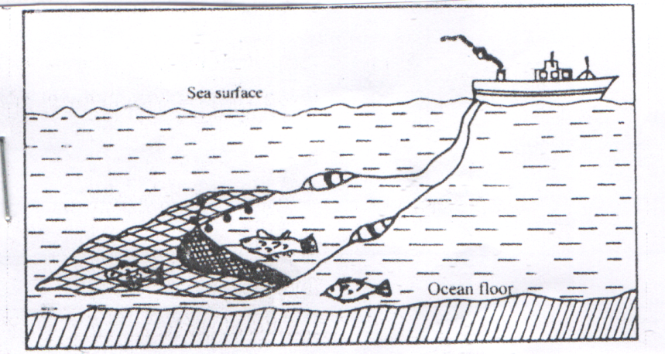

(i)What method is shown above. (1 mk)

(ii) Describe how the method is used in catching fish. (4 mks)

(d) Explain four factors that favour fishing industry in Japan. (8 mks)

10.(a)(i) State two causes of water pollution. (2 mks)

(ii) Give two effects of water pollution on the environment. (2 mks)

(b) Explain four methods used to control floods on rivers in Kenya. (8 mks)

(c)(i) Name two areas in Kenya that are prone to lightening. (2 mks)

(ii) State four problems caused by lightening. (4 mks)

(d) You intend to carry out a field study on pollution in the local open air market.

(i)State three reasons why it would be necessary for you to visit the market before the actual field day. (3 mks)

(ii) Give two methods that you would use to collect information on pollution.
(2 mks)

(iii) Give two follow-up activities ou would carry out after the field study. (2 mks)

