KASSU 2021
GEOGRAPHY PAPER 2
MARKING SCHEME
- a) What is Agroforestry? (2 marks)
- This is a practise that involves the cultivation of crops, planting of trees and keeping livestock on the same piece of land. OR
- Aland use system that involves planting of trees, cultivation of crops and rearing of livestock on the same unit of land.

b) Outline three exotic softwood tree species grown in Kenya. (3 marks)
- Cypress
- Pines
- Fir
- Wattle
- Eucalyptus/blue gum
- Spruce
(Any 3x1=3mks)

2. a) Distinguish between Land reclamation and Land rehabilitation. (2 marks)
- Land reclamation is the conversion of a wasteland into a productive land /the practice by which less productive/wasteland is converted into a more productive land for growing crops and keeping livestock while Land rehabilitation is the process of restoring misused land to its former productive state.

b) Identify three methods of Land reclamation used in Kenya. (3 marks)
- Irrigation of dry land
- Draining of swamps
- Controlling pests
- Introduction of drought resistant crops
- Afforestation and agroforestry/ Planting trees
- Controlling soil erosion
- Use of manure and fertilizers
(Any 3 x1 = 3mks)

3. a) What is Eco-tourism. (2 marks)
- Refers to development and management of tourism while conserving the environment OR
- A form of tourism where a tourist enjoys the environment with an aim of conserving nature.
(Any 1 x2 = 2mks)

b) State three benefits of Domestic tourism in Kenya. (3 marks)
- Offers opportunities for recreation.
- Creates employment to many citizens.
- Fosters utilisation of underutilized hotels/facilities during low season.
- Promotes circulation of money within the country.
- Enables many Kenyans to learn about their country hence promote patriotism
- Facilitates interaction between various communities thus enhancing national integration.
- Increases consumption of local products hence promoting more production leading to economic growth.
- Enables people to understand and appreciate the need to conserve wildlife.
- Enables students to learn more about wildlife.

(Any 3x1=3mks)

4. a) Define the term Trade. (2 marks)
- Trade is the activity of buying and selling of goods and services. OR
- The buying and selling/exchange of goods and services between people or countries.

b) Name three major imports of Kenya from the Middle East. (3 marks)
- Crude oil/refined petroleum
- Cars/vehicles/automobiles/car spares
- Medicines
- Wheat
- Iron
- Fruits
- Glass textiles
- Shoes
(Any 3x1=3mks)

5. a) Apart from road transport, give two other forms of Land transport. (2 marks)
- Railway
- Pipeline
- Human
- Animal poterage
(Any 2x1=2mks)
b) State three advantages of road transport. (3 marks)
- Is very flexible
- Cheapest means of transport
- Easy and relatively cheap to construct
- Is faster compared to water and railway transport
- Have variety of grades and sizes
- Can be used by various agents e.g. cars, bicycles, motorcycles. Pedestrians etc.
- Complements other means of transport
- Highly convenient since one can use at own convenient time.

(Any 3x1=3mks)
SECTION B
6. (a) The photograph below shows some mining activities. Study and use it to answer the questions that follow. 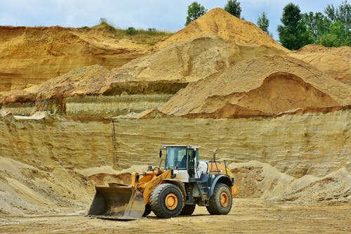
- Identify the type of photograph. (1 mark)
- Ground general view.
- Give reasons for your answer in (i) above. (3 marks)
- The camera was held horizontally to the ground.
- The size of the objects diminishes towards the background.
- It captures many objects.
- Draw a rectangle measuring 10cm by 12cm to represent the photograph. (1 marks)
- On it, mark and label four main features. (4 marks)
- Tractor.
- Forest.
- Sky.
- Heaps of mineral ore.
- State three negative effects of the mining method shown in the photograph to the physical environment. (3 marks)
- It leaves the land with many open pits and heaps of overburden which makes the site to look ugly thus interfering with the environmental beauty.
- The overburden hinders agriculture and other land uses thus creating barren land which is expensive to rehabilitate.
- It leads to heaping of overburden and destruction of vegetation leading to loss of biodiversity in the environment.
- Loose rock materials produced are easily eroded into the water bodies leading to water pollution and siltation of the water sources.
- It leads to downshifting of the water table leading to shortage of water which adversely affects life for both animals and plants.
(b) (i) Name two gold mining areas in South Africa. (2 marks)
- Johannesburg, Lydenberg, Odendaalrus, Welkon, Virginia, Allan ridge, Brackpan, Klerkdrop, Krugerdrop.
- Describe the process of gold processing. (6 marks)
- It is mined using the deep shaft mining method and then lifted to the surface for processing.
- The gold ore is crushed into powder.
- The powder is dissolved in a solution of sodium cyanide.
- Gold particles dissolve to form Gold-Cyanide solution with uranium impurities.
- The solution is mixed with zinc dust which precipitates gold.
- The solution containing uranium and other impurities is fed to tanks of sulfuric acid where uranium dissolves and then purified.
- Gold is then smelted and made into bars in Gemstone town.
- Some gold is sold locally and some exported.
- Explain three economic benefits of petroleum to the oil producing countries in the Middle East region. (6 marks)
- The country’s export petroleum which earns foreign exchange to develop other sectors of the economy.
- Petroleum is used as a raw material leading to the growth of petroleum related industries.
- Though exporting crude oil, the government earns revenue that enables the Middle East countries to invest heavily in the over sea countries.
- It has led to creation of employment opportunities for the local population raising their living standards.
- Income from petroleum is used to develop social amenities, transport and communication infrastructure.
- Income from petroleum has led to the growth of towns.

7. (a) (i) Define pastoral farming (2 marks)
This is the practice of keeping pasture dependent animals such as cattle, sheep and goats
(ii) Name three pastoral communities in Kenya (3 marks)
- Maasai
- Rendile
- Samburu
- Somali
- Borana
- Turkana
- Pokot

(b) (i) Identify two exotic beef cattle breeds kept in Kenya (2 marks)
- Aberdeen Angus
- Hereford
- Red angus
- Charolais
- Shorthorn
- Galloway
(ii) Outline three characteristics of nomadic pastoralism (3 marks)
- Seasonal movement of animals in search for water and pasture
- Many animals are kept
- A wide variety of animals are kept
- Indigenous species are kept e.g Boran and Zebu
- Animals are of poor quality
- There is uncontrolled breeding
(c) (i) Explain three factors favouring beef farming in Kenya. (6 marks)
- Gently sloping land/extensive flat lands for easy movement of animals
- Adequate water supply from rivers for cattle to drink
- Moderate rainfall/750 mm adequate for the growth of pastures
- Moderate temperatures/28C provide an ideal condition for growth of pastures
- Availability of good transport network to facilitate movement to the market
- Large tracts of land for establishment of large-scale ranches
(ii) State four similarities between beef farming in Kenya and Argentina (6 marks)
- Exotic cattle breeds are reared
- Beef cattle are mainly reared in ranches
- Cross breeding of beef cattle is common
- Beef cattle are mainly reared in areas of natural grazing
- Beef products are meant for both local and foreign consumption
(d) Your class carried a field study on tea processing.
(i) Outline any three stages of tea processing that the class may have observed.
(3 marks)
- Weighing of the tea leaves
- Drying of the tea leaves by passing hot air over them
- Fermenting the leaves
- Roasting the fermented leaves
- Roasting the fermented leaves
- Sieving the dried leaves
- Grading
- Packaging of tea leaves readily for marketing
(ii) State two methods that the class may have used to present data. (6 marks)
- Drawing charts
- Drawing tables
- Drawing graphs
- Report writing
- Displaying photographs /samples collected
- Publishing data in the internet

8. (a) The diagram below shows a fishing ground in the pacific ocean

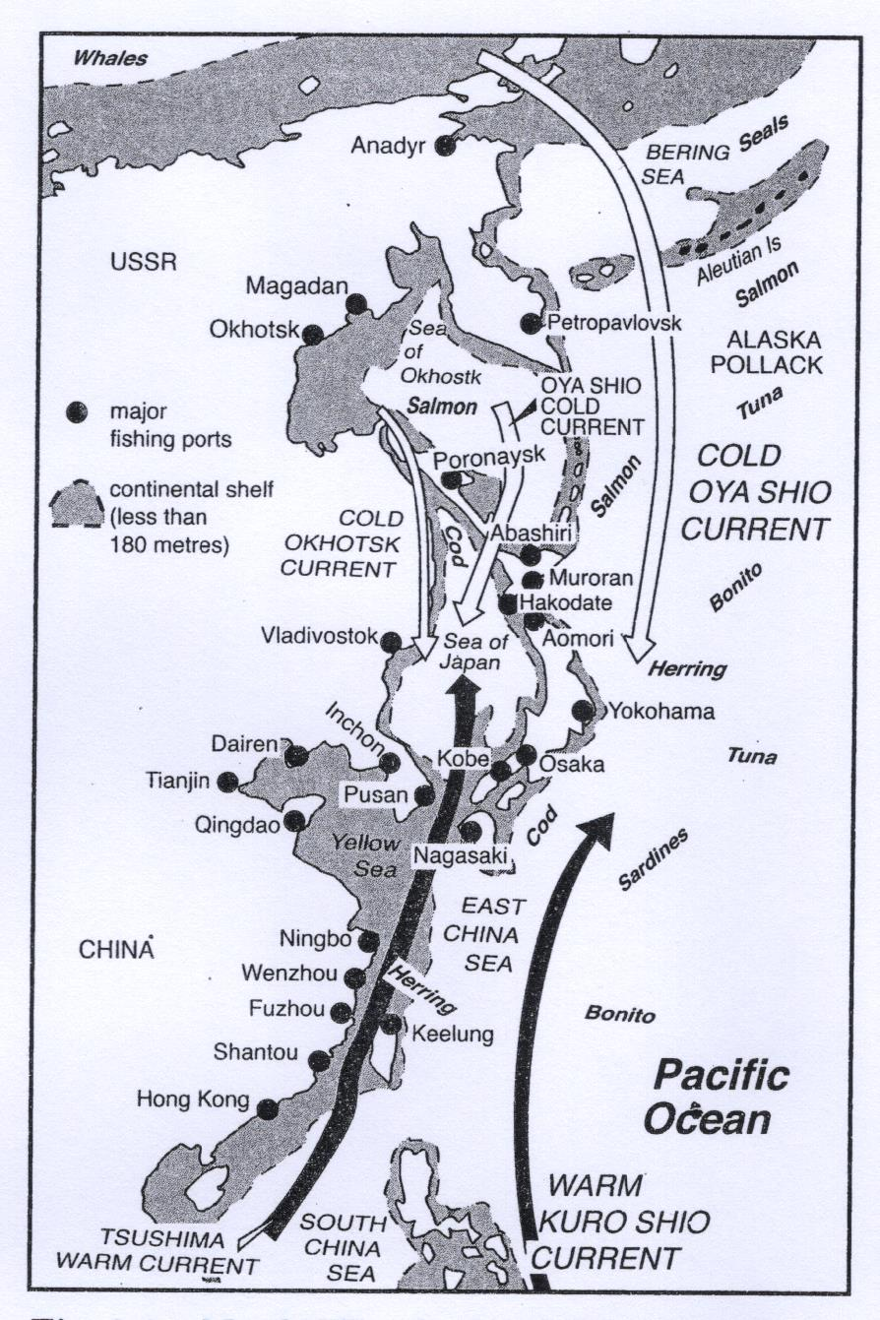

- Identify the fishing ground shown above (2mks)
- North west pacific fishing ground
- Name two types of fish species found in the fishing ground above (2mks)
- Salmon
- Mackerel
- Tuna bonito
- Sardine
- Cod
- Alaska Pollack
(b) (i) Differentiate between fishing and fisheries (2mks)
- Fishing is the extraction/exploitation of aquatic animals/fish, while fisheries is an area or place where fish are caught in large numbers
- Name two inland types of fisheries in Kenya (2mks)
- Lakes
- Rivers/streams
- Swamps
- Ponds

(c) (i)Describe the long lining fishing method (4mks)
- This involves long lines with many baited hooks sink to the floor of the ocean
- The line is suspended in water by floats at each end.
- The line is dragged along by a small boat called dory or by steam vessel the line are spread over a wide area.
- After enough fish is caught the hooks are drawn by a number of fishermen who unhook the fish and put them in containers.
- The bait the lines again and cast them back into the water for another catch.
- Explain three physical factors that have influenced the development of fishing in
Japan (6mks)
- The meeting of cold Oya-Siwo current and warm Kuro Siwo current result in cool conditions which favour plankton /oxygenated water/ice free water
- The broad shallow continental shelf favours growth of plankton leading to more fish
- The indented coastline with several islands in Japan/numerous bays and sheltered inlets favour fish breeding/provide good sites for development of ports.
- The mountains landscape of Japan hinders development of agriculture making fishing an alternative source of food
(d) (i) State four problems that face Marine fishing in Kenya (4mks)
- The natively warm waters of the tropics do not favour fish breeding of large number
- Narrow continental shelf limits the area over which plankton can grow
- Inadequate capital hampers the development of the industry for buying the equipment and preservation facilities
- Stiff competition from industrialized countries which have modern fishing equipment for deep sea fishing
- Simple fishing methods guarantees small catch because it hinders deep sea fishing
- South coast practices Agriculture hence sea fishing is minimal
- North Coast has a small pop hence small market yet the price of fish is also prohibitive.
(ii) Give three ways of conserving fresh water fisheries in Kenya (3mks)
- Restocking overfished waters to increase fish
- Special hatcheries have been set up for artificial fertilization of eggs to increase the fingerlings
- Prohibiting disposal of industrial domestic efficient into fisheries to avoid pollution and killing of fish through legislation
- Research is carried out to expand and improve fisheries by knowing their migratory and breeding habits
- Enacting laws against indiscriminate fishing /areas free for fishing
- Institutions have been set up to train personnel to manage fisheries

9. (a)(i) Define the term energy. (2 marks)
- It is the power required to run machines in order to perform various tasks in the production of goods and services.
(ii) Name two types of renewable energy. (2 marks)

- Water
- Wind
- Wood
- Biomass
- Solar
- Geothermal
- Tides/waves
- Draught animals

(b) Study the diagram of the seven forks dam power project provided below and use it to answer the questions that follow.
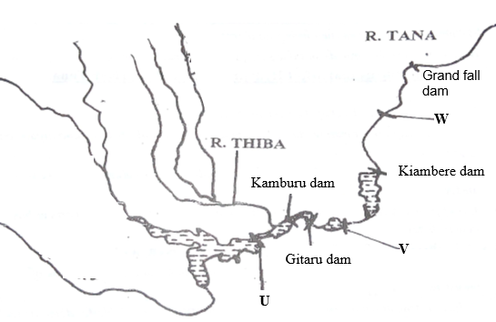
(i) Identify the dams labelled U and V. (2 marks)
U- masinga dam.
V- Kindaruma dam.
(ii) Explain three physical factors that favored the establishment of the seven forks power project. (6 marks
- Presence of a large catchment area which provides a continuous water supply to turn turbines.
- Presence of a hard basement rock which provides a firm foundation for construction of a dam.
- Presence of a hard non-porous basement rock to prevent water seepage in the reservoir.
- Presence of rapids to provide a steep gradient for water to run with force to turn turbines to generate power.
- Presence of a deep narrow valley to hold the reservoir and save on the cost of construction of the dam.
(iii) State three benefits of the seven forks power scheme. (3 marks)
- The reservoirs are used for generating electricity which is then used for industrial and domestic uses.
- The reservoirs provide water for domestic and industrial uses thus promoting industrialization and settlement.
- Some reservoirs provide water for irrigation thus improving agricultural production.
- The reservoirs provide fresh water for fishing grounds which supply fish to local people.
- The dams act as bridges across river Tana which has led to improvement of roads thus making the area accessible.
- The dams and reservoirs has led to control of floods in the lower parts of river tana thus reducing loss of life and destruction of properties.
- The reservoirs are tourist attraction sites which generates income for the country.
- The reservoirs modify climate making the surrounding areas suitable for settlements.
- The power generation activities have created employment opportunities for many Kenyans thus improvising their living standards.
(c) (i) What is energy crisis? (2 marks)
- It is a situation where the prices of fossil fuels rise uncontrollably as a result of short supply and high demand.

(ii) Explain four effects of the energy crisis to the economies. (8 marks)
- Increase in prices of crude oil makes Kenya spend a lot of foreign exchange to import oil leading to unfavorable balance of trade.
- Increase in oil prices lead to increase in prices of farm inputs which leads to reduced agricultural production causing food crises.
- Increase in oil prices cause increase in prices of commodities leading to inflation which results into low living standards.
- The high cost of fuels increases production cost thus slowing down the industrial growth.
- Oil crises case scarcity of oil byproducts leading to shortage of raw materials of certain industries leading to high prices of by-products and reduced industrial growth.
- Increase in fuel prices leads to increased transport costs which cause increase in prices of almost all the sectors of the economy.

10. (a) (i) Define industrial decentralization. (2 marks)
- The setting up of industries in rural areas away from areas of industrial
concentration.

(ii) State three causes of industrial inertia. (3 marks)
- Availability of experienced workers hence investors are reluctant to relocate,
- Availability of well-developed transport and communication system which is already in place.
- It is expensive to move to a new site.
- Industrial interdependence.
(b) Name three non-agricultural industries in Kenya. (2 marks)
- Cement processing,
- Glass making,
- Steel rolling,
- Water processing,
- Oil refining,
- Motor vehicle assembly.
(c) Explain four measures the government of Kenya is undertaking to promote
jua kali industry in Kenya. (8 marks)
- The government provides loans and technical assistance to the artisans through the Kenyan Industrial states used to buy raw materials,
- The government has constructed shades in the main towns so that the artisans can work from.
- The government funds research through the Kenya Industrial Research and Development institute to improve quality of the products.
- The Local authorities has set aside land where the artisans work from
- The government promotes marketing of products from the Juakali industries by organizing trade fairs.
- The government encourages juakali artisans to form cooperative societies to provide credit loans and facilities.

Study the map of Ruhr region below and use it to answer question (d).

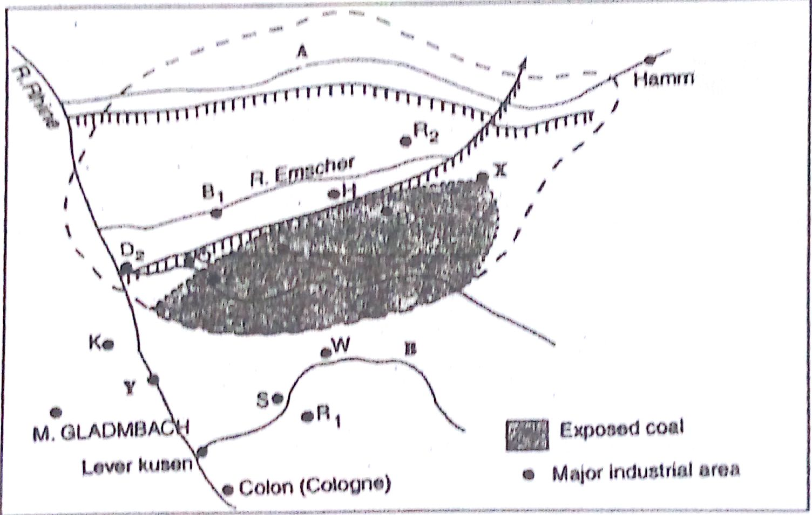

- (i) Identify
- the river marked A. - R. Lipe (1 mark)
- the canal marked H. - Rheine-Herne canal (1 mark)
- the town marked Y. - Dusseldof (1 mark)

(ii) Explain three human factors that led to the growth of Ruhr industrial
Region. (6 marks)

- The large local population had acquired skills on iron working / availability of local skilled labour formed the foundation of iron and steel industry.
- Presence of rich companies / Krupp families provided capital for the development of the industry.
- The dense / affluent population in central and Western Europe / Germany provided ready market for iron and steel.
- Industrial interdependence that developed that developed in the region provided industrial inertia.

