Name………………………………………………… Index No. …………………….

School ………………………………………………...

312/2
GEOGRAPHY
PAPER 2
2 ¾ HOURS

END TERM 1 2019

Kenya Certificate of Secondary Education (K.C.S.E)

INSTRUCTIONS TO CANDIDATES
- There are two sections A and B.
- Answer all questions in section A
- In section B answer question 6 and any other two from this section.
- All answers should be written in the answer booklet provided.

This paper consists of 4 printed pages.

Candidates should check the question paper to ensure that all pages are printed as indicated
and no questions are missing
SECTION A

Answer ALL questions from this section
1. a) State two human activities that lead to soil erosion. (2mks)
b) Give three problems experienced by sugarcane growing in Lake Victoria basin of Kenya.
(3mks)
2. a) What is agro-forestry? (2mks)
b) Give three reasons why afforestation is being encouraged in Kenya. (3mks)

3. a) State three ways in which a country benefits from urbanization. (3mks)
b) State two measures that have been taken in Kenya to reduce infant mortality. (2mks)

4. a)List two benefits Kenya derives from International trade. (2mks)
b) State three factors that influence external trade in Kenya. (3mks)

5. a) Apart from the sun, name two other renewable sources of energy. (2mks)
b) State three advantages of using hydro-electric power over other forms of energy. (3mks)

SECTION B
Answer question 6 and any other two from this section.
6. Study the photograph provided and answer the questions that follow.
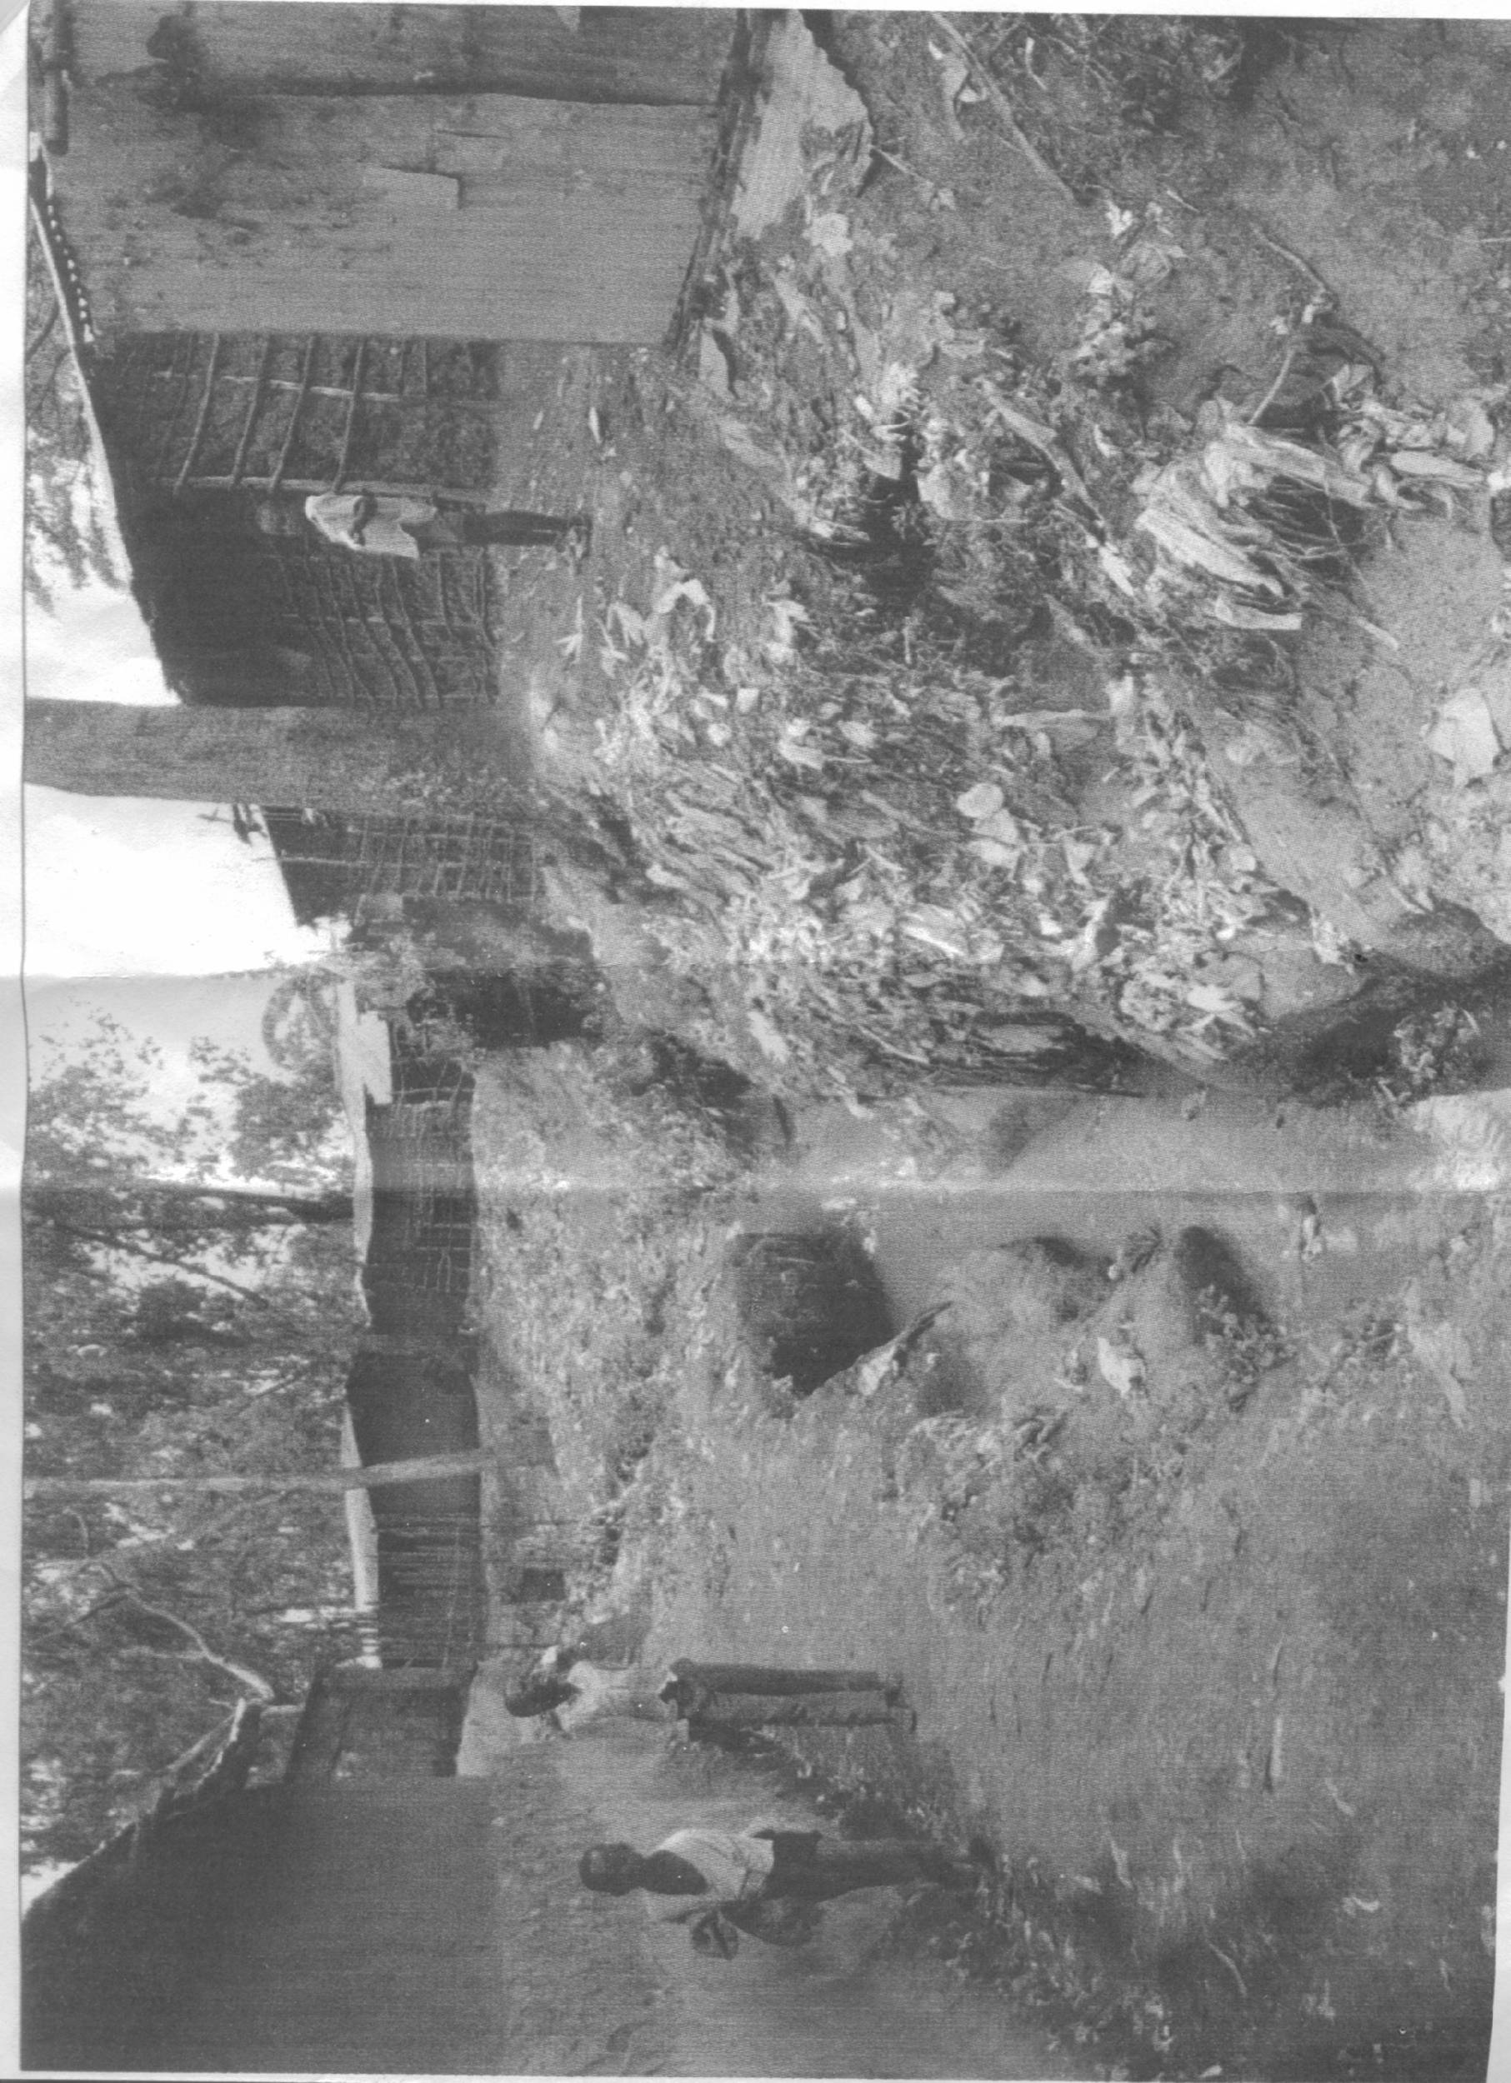

a) (i) Name the type of photograph shown. (1mk)
(ii) Describe the type of settlement found in this area. (6mks)
b) Explain four main problems which may be experienced in this area. (8mks)
(i) Explain four problems resulting from a high population growth rate in the East African Countries. (8mks)
(ii) State two problems created by the decline in population in developed countries such as Sweden. (2mks)
7. a) (i) Differentiate between secondary and tertiary industry. (2mks)
(ii) Give four reasons why Kenya should become an industrialized country. (4mks)
b) Explain why some Industries are located near sources of water. (6mks)
c) (i) Explain four factors which have favoured the development of electronics industry in Japan. (8mks)
(ii) State five ways in Which the government of Kenya encourages Jua Kali Industries.(5mks)
8. a) (i) Why is it necessary to conserve water. (2mks)
(ii) How does terracing help in water conservation. (2mks)
b) Explain three measures being taken by East African countries to manage wildlife. (6mks)
c) Explain how climate influences the distribution of wildlife in East Africa. (10mks)
d) State five effects of air pollution on the environment. (5mks)
9. The table below shows the 1979 population figures for central province in Kenya per district.
DISTRICT | POPULATION
Kiambu  Kirinyaga  Murang’a  Nyandarua  Nyeri | 686290  291431  648333  233302  486477
a) (i) Using a divided rectangle, represent the data given above. (5mks)
(ii) Besides a divided rectangle, name any three other methods of presenting the data.(3mks)
(iii) State three advantages of using divided rectangles to represent statistical data. (3mks)
b) Explain four ways in which communication contributes to the economic development of Africa. (8mks)
c) Explain three transport problems experienced in the great lakes and St. Lawrence Seaway. (6mks)
10. a) (i) What is land rehabilitation? (2mks)
(ii) List three social factors which influence agricultural activities in Kenya. (3mks)
b) Explain four physical conditions that favour the growing of oil palm in Nigeria. (8mks)
c) (i) Give four reasons why the growing of flowers in green houses is preferred in Kenya. (4mks)
(ii) Explain four benefits of dairy farming in Kenya. (8mks)

