MALIET MARKING SCHEME PAPER 1 FORM FOUR

1. (A) i Physical geography
ii Human geography
iii practical geography
(B) i in the process of cooling after breaking away from the sun the interior of the earth cooled at a slower rate than the outer part
ii The weight of the overlying burden or materials exerts pressure on the core,resulting into high temperatures.
iii Radioactivity-this is the process of breaking up of the nucleus of an atom.This is brought about by bombarding the nucleus with a stream of neutrons
2. (a) Natural vegetation is a plant cover that grows and spreads through natural means of seed dispersal without interference of external modifying influence.
(b) 1.Trees are tall
2.Trees have large trunks
3.Trees have broad leaves
4.Trees are evergreen
5.Trees have buttress roots
6.Trees are close to each other
3 (a) P-Batholith.
Q –Laccolith
R-Lopolith
(b) As a result of subsequent violent eruptions leaving an enlarged crater.Subsidence where the weight of the cone collapses into magma chamber.
4 (a) 1.close-ups
2.Ground general views
3 Ground oblique
(b) 1.Help in study of human and economic activities.+
2.They provide useful information on physical features.
3.Help to deduce the climate of an area
4.Useful in resource documentation/map making
5 (a) –It is the continous circulation of water from the earth surface to the atmosphere.
(b) –Evapotranspiration
-Condensation
-precipitation
-Run off
-Percolation/infiltration

SECTION B
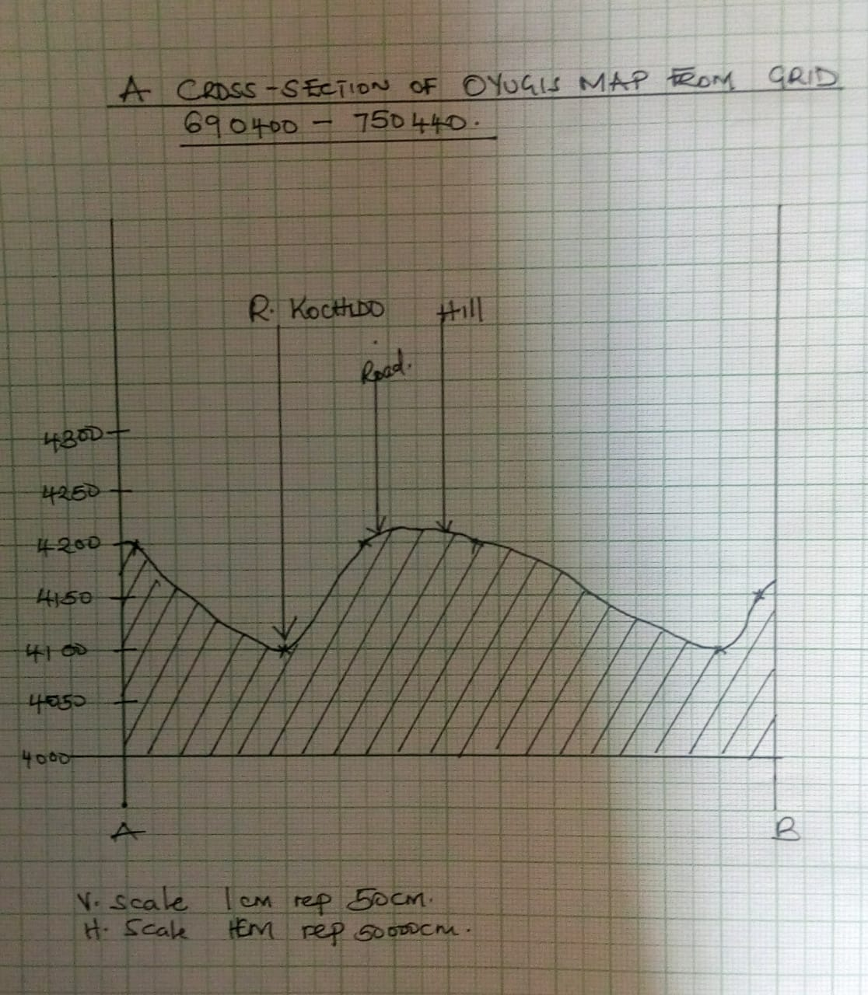
6 .A (i) 34º30’E to 34º45’E
(ii) 1:50,000
1cm to rep 50,000 cm
1cm to rep 500m
(iii) 8418 is Itumbe 5828 m
(iv) 6.7km+0.1
B (i) 326
+ 0°51’
326º51

Economic activities | Evidence
Agriculture | Cotton store
Transport | Bricks works
Commerce trade | Roads
Tourism | Market/shops lodges

ii.

iii. Source of water in the area covered in the map
-Rivers e.g R.Riana, Nyamaura, Mogusii
-WHO water holes
-Dams Hunga dam.
iv. Natural vegetation in the map.
-scrub
-woodland.
-forest
-Scattered trees

c. Calculate V.E= Vertical scale
Horizontal scale
=1:5000= 1 ÷ 1
1:50,00=5000 50000
=1 x 50000
5000 1
=10

7 a (i) Wind abrasion-it is a process where by weathered material is being transported by wing, it smoothens or scraps rocks surfaces it comes into contact with.
ii. Name two processes of wind transportation (2mks)
- Suspension
- Saltation
- Surface creep.
B i. Difference between a rock pedestal and a mushroom block (2mks)
-Rock pedestal-These are irregular pillars of rocks formed by wind erosion through a abrasion
-Mushroom block – is formed when a rock with uniform resistance is croded from the base smoothened & polished by varied rates of abrasion.
7.c i. Factors that makes wind an effective agent of erosion in arid areas (2mks)
i. Dunes- These are low ridges or hillocks of drifted sand resulting fro wind transportation and deposition.

ii. Drass- These are large desert features which are similar to self dunes and transverse dunes
iii .Loess- Are formed when the desert sand dust storms pick up loose dust materials and transport and deposit them in neighboring regions.

(ii) Characteristics of barchans . (3mks)
-Crescent/moon shaped
-smooth gentle windward slope
-Steep concave leeward slope
-Has 2 horns/curved edges
-Occurs individual or in groups

d. (i) Mesas- are extensive flat-topped residual tablelands which are generally capped with resistant rock –stratum in arid and semi-arid areas.
ii.Buttes- are small but prominent residual flat-topped hills usually capped with resistant rock- stratum which remain after denudation of a plateau in arid& semi arid areas.
E.(i). Preparation you would make before the study
(i) Choose the methods of data collection.
(ii) Prepare questionnaire with the help of the teachers.
(iii) Assembly the necessary tools
(iv) Prepare a working schedule.
(v) Divide the students into groups.
(ii) Problems encountered during the field study (3mks)
(i). Researcher may full sick during the study .
(ii) Respondent may become unco-operative or may fail to keep time.
(iii). Language barrier between the researcher & respondents hence may call for an interpreter finally flowing down the process of the study
(iv) Transport problem- vehicle which the researcher is travelling may break down.
8a.(i) How the following factors may influence the climate of an area
- Latitude (2mks)
1 .Areas near equator experiences higher temperatures than those farther away
2.It also influences the seasonal variation of rainfall i.e. North of topics requires rainfall from March-July
3.It also influences pressure i.e. pressure is higher at the pole equatorial region
(ii) Ocean currents
1.Climate is affected when the prevailing winds blow onshore
2.Prevailing winds are cooled by cold ocean currents as they blow inland
3.moist onshow winds blowing over warm ocean currents are warmed hence resulting into rainfall on land.

(iii) Distance from the sea
1.Temperature of places near the sea are modified by the sea
2.Winters in coastal regions are mild due to warming effect of the sea
3.Areas near the sea receive more rainfall than areas far away from the sea
B (i) A-warm temperature western margin climate
B-Equatorial climate
C-Desert climate
(ii) -Temperatures ranges 21°C in summer to 10ºC or less in winter
-During summer, trade winds blow off-shore hence the area is dry with clear skies.
-During winter, onshore trade winds results into cyclonic rainfall
-Rainfall amounts vary from 500mm to 900mm depending on location and altitude
-Hot and cold local winds i.e sirocco blows from Sahara towards Mediterranean.
C (I) –L.victoria
-Hills i.e Asego,Naya hills.
(II) –To study the effects of climate to this region
-To find out factor influencing climate of the region
-To study the relationship between climate and vegetation of the area
(III) –Increased rainfall
-Effect on agriculture
-Disruption of natural Ecosystem
Environment becoming hotter
- 9a (i) Define the term soil ( 2mks)
-Soil is the uppermost surface layer of unconsolidated material which liesd on the surface of the earth and in which plant grow.
(ii) Name two types of soil according to texture (2mks)
-Loam
-silt

-Sand gravel
b. (ii) Briefly explain how the following factors influence soil formation
(i) Climate (4mks)
-Rainfall affects the rate at which some land forming processes such as leaching can occer
-High temperature increase the rate of weathering and alson accelerate the rate of bacterial acticity whcich generates some organic matternin the soil
-Climate influence s the process of erosion by water, wind and ice.
ii.Living organism (4mks)
-The assist in braking down the rock through borrowing, ploughing and root penetration
-They influence the chemical composition by adding/removing organic acid solution/minerals.
-Borrowing/digging influence soil erosion
(i)Differentiate between soil profile and catena (2mks)
- Soil profile is vertical arrangement of different layers of soil from the surface to the bedrock which soil catena is the sequence of different soils down a slope on the surface of the land (2mks)
ii. List three processes which influence development of soil profile (3mks)
-salinization
-zolidization
-calcification
Ferrolization
Podzolization
D. Explain how the following human activities lead to soil erosion
(i) Continous ploughing (2mks)-This weakens the soli structure making it easy to the agent of erosion to carry it away.
ii. Cutting down trees (2mks)
-This exposes the soil to the agents of soil erosion, the ground is left bare.
e. Identify four consequences caused by severe soil erosion in an area (4mks)
(i)Soil water washed into water bodies contains agro-chemicals that are harmful to aquatic life
ii. eater reservoir gets reducing their capacity and affecting their efficiency in h.e.p production reducing the amount of water available for irrigation.

iii.When gullies are deepened to the water table underground water is is exposed. Some water flow s out as stream while the rest evaporates hence water is lowered leading to scarcity of water .
(iv)The productive top soil is lost for ever and only unproductive strongly soil is left behind this reduces agricultural productivity of the land.
10. (a) Name the first two planets of the solar system.
- Mercury (1 mark)
- Venus (1 mark)

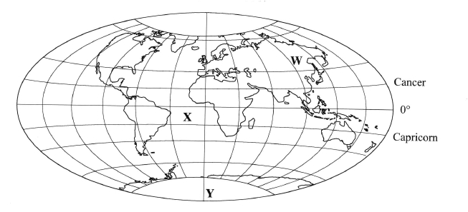
(b) Explain the origin of the earth according to the Nebula Cloud Theory. (8 marks)
- The explosion of the stars led to the formation of a huge cloud of gases
(hydrogen and helium), dust and ice particles.
- This cloud whirled, cooled and condensed to a disc shape.
- The gravitational attraction within the materials increased cause the particles to
compact. Some particles broke from the edge of the disc and whirled.
- The compacted particles swirled faster towards the centre of the disc in different
directions. As they whirled they cooled or solidified to form the planets.
- This swirling caused particles to collide losing a little energy at a time.
- The middle of the spinning disc condensed to form the sun while the material
spinning around condensed into large chunks of materials called planetoids.
- The planetoids collided and coalesced into large bodies called planets.
- The earth is one of the planets.
- The centre of the disc formed the sun.
4 x 2 = 8 marks
Use the map below to answer questions (c)(i)

(c) (i) Name:
the continent marked W - Asia.
the ocean marked X - Atlantic.
the line of longitude marked Y - Prime/Greenwich meridian. (3 marks)
(ii) Give two reasons why the earth has a spherical shape.
- The earth experiences the force of gravity pulling towards the centre which
creates a rounding effect on its shape.
- The North and South poles experience centripetal force which constantly pull

towards each other causing the flattening at the poles.
- At the equator the earth experiences the centrifugal force which causes the
bulge.
Force 1 x 2 = 2
Shape 1 x 2 = 2
NB: F can score on its own. “S’ must be tied to “F” to score.
(iii) State four effects of the rotation of the earth on its axis.
- It causes the occurrence of day and night /apparent movement of the sun from
East to West.
- It causes difference in time between places over the earth’s surface.
- It causes deflection of winds / ocean currents.
- It causes differences in atmospheric pressure on the surface of the earth.
- It causes ocean/sea tides
Any 4 x 1 = (4 marks)
(d) Describe the structure of the earth’s crust.
- It’s rocks are generally brittle/solid.
- The earth’s crust extends between 6 to 80 km.
- It is divided into two layers - sial (continental crust) and sima (oceanic crust).
- The sial rests on the sima
- The sial contains mainly silica and aluminium.
- The sima contains silica, magnesium and iron.
- The sial is lighter/has a density of 2.65 to 2.70 gm per cc.
- The sial has mainly granitic rocks.
- The sima has basaltic rocks.
- The sima is heavier/has a density of 2.7 to 3.0 g/cc
- The sima is fairly flexible
Any 4 x 1 = (4 marks)

