NAME:……………………………INDEX NO:……………………DATE:………………
312/1
GEOGRAPHY
Paper 1
MARCH/APRIL 2019
Time: 2¾ hours

MALIET JOINT EXAMINATION
Kenya Certificate of Secondary Education
312/1
GEOGRAPHY
Paper 1
Time: 2¾ hours
Instructions:
- This paper consists of two sections A and B.
- Answer all questions in section A.
- Answer question 6 and any other TWO questions from section B.
- All questions must be written in the answer sheets provided.
- Candidates must ensure that no question is missing.
For official use;
Question | Marks
Section A
6
7
8
9
10
TOTAL

SECTION A
- (a) List two main branches of geography (2mks)
(b)Give three reasons why the interior of the earth is still very hot. (3mks)
- (a)Define natural vegetation (1mk)
b.State four characteristics of natural vegetation found in tropical rain forests (4mks)
- The diagram below represents features of intrusive vulcanicity. (3mks)
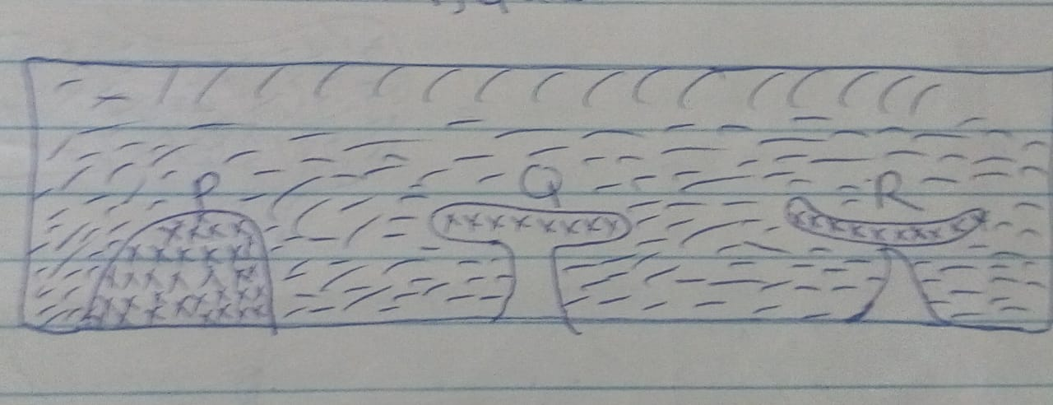
a. Name the features marked P,Q, and R (3mks)
b. How is caldera formed? (2mks)
- (a) Name two types of ground photographs (2mks)
(b) State three uses photographs (3mks)
- (a) Define the term hydrological cycle (1mk)
(b) Identify four process involved in the hydrological cycle (4mks)

SECTION B
- Study the map of Oyugis1:50,000 provided and answer the following questions.
- (i) Give the longitudinal extent of the area covered by the map (1mk)
(ii)Convert the scale of the map into a statement scale (2mks)
(iii).What is the approximate height of the hill on Grid squire 8418 (1mk)
iv. Measure the length of the loose surface road from River Nyangu bridge to the
mizori-Homa Bay junction in kilometers (2mks)
- i Calculate the magnetic bearing of Tunga Dam at Grid reference 705360 from
st. Vincent school at two economic activities taking place in the area converted in the map (2mks)
(ii) Citing evidence from the map, suggest two economic activities taking place in the area
Covered in the map (2mks)
(iii) Identify two sources of water in tshe area covered in the map (2mks)
(iv) Identify two natural vegetation found in the area covered in the map (2mks)
- Using a vertical scale of 1cm to rep 50cm
i.Draw a cross-section from grid reference 690400 grid Reference 750440 (2mks)
ii.On the cross, mark and name the following,
- River Kochido
- Road
- Hill
iii.Calculate the vertical exaggeration of the area covered by the map. (2mks)

- (a) (i) Define wind abrasion. (2mks)
(ii) Name two processes of wind transportation (2mks)
b.(i) Give one difference between a rock pedestal and a mushroom block (2mks)
c. (i) Give three characteristics of barchans. (3mks)
d. Using well illustrated diagrams, explain how Mesas and Buttes form. (8mks)
e. You are to carry out a field study in the arid north of Kenya
i. Mention three preparations you would make before the study. (3mks)
ii. Mention three problems you are likely to face during the field study. (3mks)

- a Explain how the following factors would influence the climate of an area
i.Latitude (2mks)
ii. Ocean currents (2mks)
iii. Distance from the sea (2mks)

b. The map below represents the climatic regions of Africa.
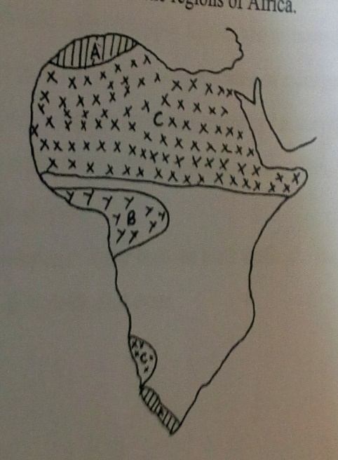

i.Name the regions marked A,B,C (3mks)
ii. Describe the climatic characteristics of the region marked A (5mks)
c.You have been asked to carry at a field study on the climate of l. Victoria Region (6mks)
i.Name two factors modifying the climate of the region. (2mks)
ii.Formulate three objectives for your study (3mks)
iii. Outline three effects of climate change in this region (6mks)

- a( i).Define the term soil (2mks)
(ii) Name two types of soil according to texture (2mks)
b.Briefly explain how the following factors influence soil formation
i climate (4mks)
ii.Living organisms (4mks)
c.i Differentiate between soil profile and soil catena (2mks)
ii. List three processes which influence the development of soil profile (3mks)
d. Explain the following human activities lead to soil erosion.
- Continuous ploughing (2mks)
- Cutting down trees (2mks)
e. Identify four consequences caused by severe soil erosion.
- (a) Name the first two planets of the solar system. (2 marks)
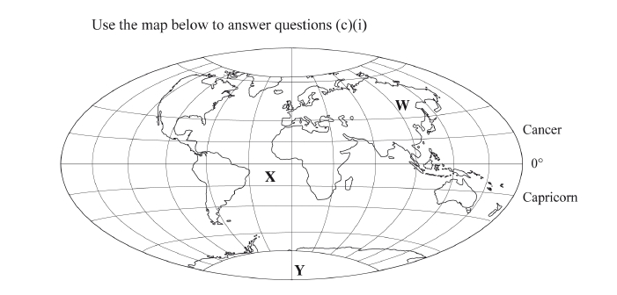
(b) Explain the origin of the earth according to the Nebula Cloud Theory. (8 marks)

(c) (i) Name:
I the continent marked W; (1 mark)
II the ocean marked X; (1 mark)
III the line of longitude marked Y. (1 mark)
(ii) Give two reasons why the earth has a spherical shape. (4 marks)
(iii) State four effects of the rotation of the earth on its axis. (4 marks)
(d)Describe the structure of the earth’s crust.(4 marks)

