312/2

NAME……………………………………………………….….……. INDEX NO………..…………………..
SIGNATURE……………………………….…….…………DATE………………….………………………..
ASUMBI GIRLS HIGH SCHOOL
POST -MOCK 1
AUGUST/SEPTEMBER
2022
AUGUST / SEPTEMBER - 2022

GEOGRAPHY
PAPER 2
TIME: 2³/₄ HRS
INSTRUCTIONS TO CANDIDATES.
- Write your name, class and admission number in the spaces provided above.
- Sign and write the date of the examination in the spaces provided above.
- This paper has two sections: A and B.
- Answer all the questions in sections A.
- Answer question 6 and any other two questions from Section B.
- All answers must be written in the answer booklet provided.
- This paper consists of 5 printed pages.
- Candidates should check the question paper to ascertain that all the pages are printed as indicated and that no questions are missing.
- Candidates should answer the questions in English.

For Examiner’s Use Only
Section | Questions | Maximum  Score | Candidate’s  Score
A | 1 – 5 | 25
 | 6 | 25
B |  | 25
 |  | 25
 |  | Total Score

SECTION A
Answer all questions in this section
- (a) Name two counties where floriculture is practiced in Kenya. (2 marks)
(b) State three characteristics of horticultural farming in Kenya. (3 marks)
- (a) Name two agricultural food processing industries in Kenya. (2 marks)
(b) State three problems facing Jua – Kali industries in Kenya. (3 marks)
- (a) The sketch map below shows Hydroelectric Power(H.E.P) along the River Tana. Use it to answer question (a)
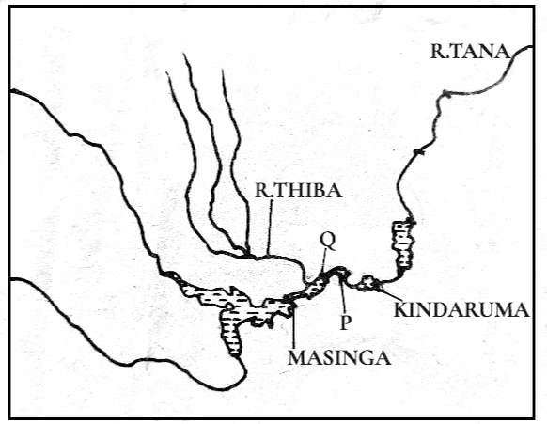
Name the Hydroelectric power (H.E.P) stations marked P and Q. (2 marks)
(b) State three reasons that limit the use of nuclear energy in Kenya. (3 marks)
- (a) Give two effects of the liberalization of the oil industry in Kenya. (2 marks)
(b) State three problems that have hindered the decentralization of industries in Kenya. (3 marks)
- (a) Apart from pastoral farming, name two other types of commercial livestock farming practiced in Kenya.
(2 marks)
(b) State three factors that favour pastoral farming in Kenya. (3 marks)

SECTION B
Answer question 6 and any other two questions from this section.
- Use the data provided to answer the questions that follow.

Kenya: Value by Foreign Trade between 1999 – 2007 in million Ksh.

YEAR | 1999 | 2000 | 2001 | 2002 | 2003 | 2004 | 2005 | 2006 | 2007
EXPORTS | 985 | 1.230 | 1,170 | 1,080 | 1,020 | 1,310 | 1,450 | 1,590 | 1,860
IMPORTS | 2,270 | 2,910 | 3,195 | 4,029 | 4,131 | 4,247 | 4,585 | 4,422 | 4,516

  - (i) Draw comparative line graphs to represent the data given.Use a scale of 1 cm to represent 500 million Ksh. on the vertical axis. (7 marks)
- Describe the trend of value of exports from 1999 to 2007. (3 marks)
- Describe the factors which may have led to the increased export earning from 2004. (6 marks)
  - Explain why Kenya experiences unfavorable balance of trade. (6 marks)
  - State three ways in which the Kenyan Government is promoting export trade. (3 marks)
- The diagram below represents a fishing method. Use it to answer question (a) below.
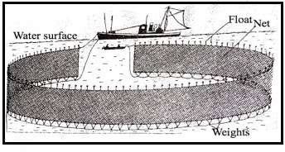
  - (i) Identify the method of fishing shown below. (1 mark)
- Describe how the above method is used in fishing. (5 marks)
- Give three examples of fish species caught by the above method. (3 marks)
  - Explain four factors that favour the fishing industry in Japan. (8 marks)
  - Explain four reasons why East Africa does not export large quantities of fish. (8 marks)

- (a) Identify three kinds of roads used in Africa. (3 marks)
- Name four major high ways in Africa. (4 marks)
- (i) Name four major world sea routes. (4 marks)
(ii)Explain two factors that make the major sea and ocean routes to be concentrate in the Northern Hemisphere.
(4 marks)
- (i) Give two forms of written communication. (2 marks)
(ii) Explain four human problems facing transport in Africa. (8 marks)
- The diagrams below shows the population structures of two countries A and B. Study it and answer the questions that follow.
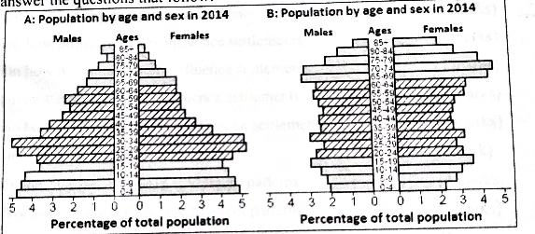
  - Identify the type of graph above. (1 mark)
  - (i) Which one belongs to Kenya. (1 mark)
(ii) Which one belongs to Sweden. (1 mark)
  - Describe five characteristics of population structure for country A. (5 marks)
  - (i) List two types of internal migration. (2 marks)
(ii) Give three ways in which government policy causes migration. (3 marks)
  - State any four problems resulting from high population growth rate. (4 marks)
  - Explain four factors that have contributed to high population growth in Kenya. (8 marks)
- (a) Identify two irrigation schemes in Kenya other than Mwea Tebere. (2 marks)
- Differentiate between land rehabilitation and land reclamation. (2 marks)
- Explain three factors that have led to the success of Mwea Tebere Irrigation Scheme. (6 marks)
- State four significance of irrigation farming in Kenya. (4 marks)
- Explain two methods that are used to rehabilitate land. (4 marks)
- Explain the steps followed in reclaiming land in Netherlands. (7 marks)

