MALIET PAPER 2 GEOGRAPHY F4 MARKING SCHEME
- (A) Forests-It is a continuous growth of trees covering a large track of land on the earth surface
Forestry-It is a science of developing or cultivating forests also referred to as tree farming
(b) -.pest and diseases
-.prolonged droughts
-drug growing
-biological conflicts
-.Forest fires.
-.Illegal logging
2.-fish farming occupies less space compared to other activities such as livestock keeping.
---Fish contributes immensely to the supply of animal protein
--The industry creates job opportunities for people involved in building$ management of the ponds
---Some of the fish from the ponds such as trout are exported to earn foreign exchange
--The activity can lead to the development of fish related industries.
3 (a) Horticulture---It is the process of cultivating fruits, vegetables and flowers for sale.
(b)--Land is intensively used in order to reap maximum produce
---Farms are generally small in size
-It is labour intensive
-Farms are located near good $ reliable transport routes that lead to the markets/export centers
4 (a) -ground close-up
-ground general view photographs
-ground oblique
(b)-Help to deduce the climate of an area
-Useful in resource documentation/map making
-Use to depict actual objects just as they appear.
-provides useful information on physical features,
-Help in study of human$ economic activities.
5.(a) -wood fuel
-water (hydroelectric)
-Geothermal Biomass
-wind.
(b) -exhaustion of coal mines
-High cost in production of coal
-The use of oil and electricity
-pollutes the environment
-low heat value compared to other sources

SECTION B
6(a) (i) 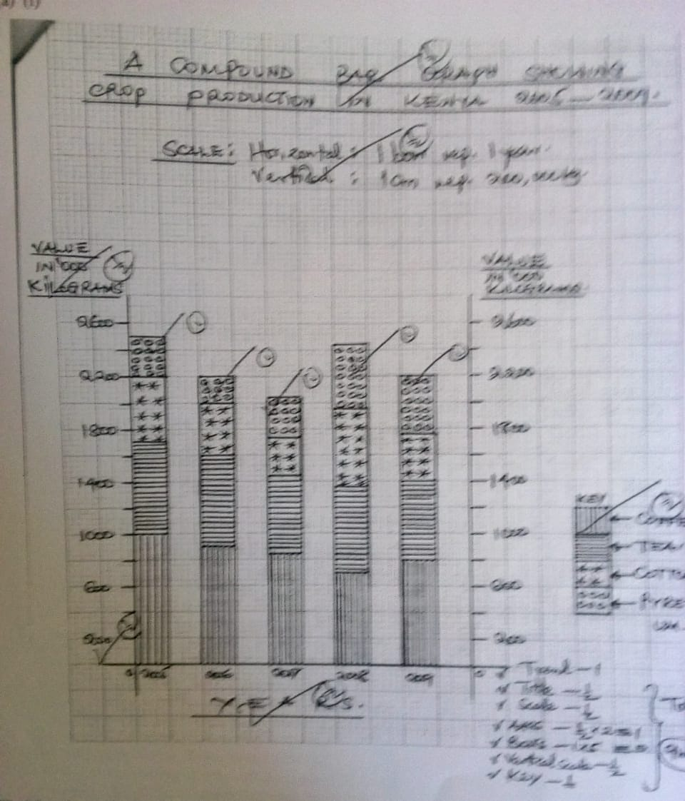

(ii) Advantages of using a compound bar graph to represent statical data (2mks)
-Facilitates comparison of data
-A number of variables can be represented in one bar
-changes/trend is easy to trace
- Good vision impression
b.(i)
-Nigeria
-Cote-de-vore
-cameroon
(ii)-High/well distributed rainfall exceeding 1200mm p.a
(ii) –High/well distributed rainfall, between 24º c-3oc
-High relative humility throughout the year
-deep
-low altitude below700ma.s.l.

(c).-Beans fermented for 5-6 days
-The fermented beans are washed/ cleaned
-Beans are roasted
-The roasted beans are then crushed to extract cocoa butter
-Cocoa is blended and mixed with sugar.
d)
-

7 (A) (i) Wildlife-Refers to the animals and plants existing in natural habitat
(ii) 1.Climate---Where there is abundant rainfall a variety of plant species grow most animals are found in the hot and warm parts. Areas with low temperatures have few species of animal plants.
2.Relief-Different vegetation species grow in different altitudes and intensity
3.Soil type-Different plant types grow in different soil
4.Vegetation-Different types of vegetation are habitants for different animals
5.Human activities-people greatly influence survival and distribution of wildlife.
(b)- (i) Tsavo
-(ii) Kipendo valley
-(iii) Serengeti.
(ii) -(i) There is less threat of animals interfering with human life and crop production
(ii)-Requires extensive land that is available only in these areas.
-population is low in there areas-reduces human –animal conflicts/resettling people who have been misplaced.
-It is the best economic use of land since agriculture is not viable in these areas.
C (I) (i) Fencing of parks to keep away human activities that would destroy wildlife
(ii) Banning of poaching $ human activities especially for endangered species.
(iii) Training $ Employing game rangers to guard the parks for destruction
(iv) Relocating the excess animals in order sufficient grazing ground
1. Well developed transport network e.g cable cars, electrified railway which enable tourist to reach all tourist sites.
2. It enjoys political stability & accommodations making people from all over the world to visit Switzerland at any time .
3. The swizz are known for their hospitality and friendliness
4. It has well developed hotels & accommodations making it offer excellent services
5. Diversity of language spoke eg French, Germany English.
8a(i) Onions
(ii) Chillis
(iii).Watermelons
(ii)1. To settle pastoralists as farmers
2.To utilize the detainees (maumau) labourers.
3. To develop land for agriculture and increase food production in Kenya.
B(i) The plateau/gentle sloping land which allows water to flow by gravity
- Presence of black cotton soil which is suitable for rice cultivation
- The warm climate condition experienced in the area promotes rice growing
- The area receives low amounts of rainfall (625mm) which is unreliable making irrigation necessary.
C.1. Pests e.g quelea birds which feed on rice& cause major losses & low yieds
2.Weeds growing in the canals& siltation interferes with the flow of water into the fields
3.The stagnant water encourages the breeding of n snails and mosquitoes which spread diseases to people e.g malaria and Bilhazia
4.Shortages of labour especially during the planting & harvesting seasons forcing farmers to hire labour.
5. Delayed payments which kill farmers morale
6.unsuitable soils some areas.
D.1. Earn foreign exchange when some of the crops are exported
2.Creation of employment opportunities in related fields
3. Increased food production due to increased food production due to increased farming land
4. Settlement of the landless e.g the Mwea & perkerra for the landless and detainees.
5. Industrialization crops are raw- materials for food industries.
6.Saves foreign exchange by producing food stuffs and agricultural products that could have imported.
9.a.(i) Technology
-Capital
- Transport coast
-Market
b.-if coal outcrops on hill slopes, boring instruments known as augers may be employed to remove it. These augers are very large with a diameter of 1.5metres and can reach as far as 105 metres below the ground . They drill out huge pieces of coal and bring them to the surface for transport by waiting trucks.
c.(i)-It earns the country foreign exchange which is used as a means for paying international debts
-Offers employment to many people raising their standards of living
-It has led to widespread urbanization contributing to the formation of the Witwatersrand’s conurbation
-It has formed a broad based market for other industrial operations.
-IT has led to development of modern infrastructure and amenities.

10.a.i Maasai
Ii Turkana
iii.Samburu
iv.Somali

ii.1.scarcity of pasture and water for the animals due to prolonged drought.
2.Trequent attack by pest &diseases lower the quality of the animals
3. poor quality breeds that take long to mature.
4.Overstocking the land results into soils erosion &scarcity of pasture
5. Cattle rustling reduces the stock of animals hence loses to the farmers.

b.(i)Encouraging group ranching to improve on the quality .
(ii) Providing extension officers to give advice to farmers.
(iii) Creation of anti.stock theft unit for security of animals

(iv) Building cattle’s dips and spraying animals to improve their health.
v. Sinking bore holes to provide water for livestock
ii
Argentina Kenya
1 | Has continuous pasture | 1 | Inadequate pasture of poor quality
2 | Refrigeration facilities enhances overseas export | 2 | Inadequate refrigeration limit the markets
3 | Advanced infrastructure, roads railway transport for the products | 3 | Poor transport by roads makes the ranches inaccessible
4 | Large domestic &external market increase production | 4 | Small domestic market hence low production.

C.1.Provides food as beef is a good source of proteins
2. Offers employment opportunities into large number of Kenyan
3. Earns the country foreign exchange when beef related products are exported
4. Makes the best economic use of marginal land that would otherwise be unsuitable fro arable farming

