**AGRICULTURE PAPER TWO 443/2 2019**

**SECTION 30 MARKS**

Answer all the questions

1. Name four breeds of beef cattle (2mks)
2. Name the sheep breed with a lambing percentage of 125 to 140 (1/2mk )
3. State four reasons for maintain farm tools and equipment (2mks)
4. Explain why it is advantageous to use adjustable spanner over ring spanner (1mks)
5. Give two examples of equipment that a livestock farmer can use in administering oral antihelmithes (1mk)
6. Name the camel breed that is adapted to cooler regions and a woolly body covering (1/2 mk)
7. State any two channels through which beef is marketed in Kenya (1mk)
8. State four factors that influence the variation of rate of respiration in various farm animals (2mks)
9. Give four examples of mineral imbalances or disorders in the farm animals (2mks)
10. State four reasons why farmers handle farm animals (2mks)
11. State two symptoms of tapeworm attack in livestock (1mks)
12. State four characteristics of succulent roughages (2mks)
13. Give two signs of heat in rabbits (1mk)
14. Differentiate between kidding down and kindling down (1mk)
15. Give two reasons for carrying out flushing in ewes (1mk)
16. State two uses of a crush in livestock production (1mk)
17. Give three reasons why timber is treated before construction (1 ½mks)
18. State the three parts of a building (1 ½ mks)
19. State four qualities of marketable eggs (2 mks)
20. Give two factors that inhibits milk let down (1mk)
21. Differentiate between dehorning and disbudding as used in livestock production (1mk)
22. Name the four strokes of a four stoke cycle engine in their correct order ( 2mks )

**SECTION B (20MKS)**

**Answer all the questions**

1. Below is an illustration of a farm structure. Study it carefully and answer the questions that follow.



1. Identify the parts labeled K,L,N and J (4mks)

K

L

N

J

1. State one use of part labeled N (1mk)
2. The diagram below shows a rearing practice in livestock production



1. Name the routine practice shown in the diagram above (1mk)
2. Give three reasons why the above practice is carried out in farm animals (3mks)
3. Name the tools being used in the above practice (1mk)
4. Study the diagram below and answers the questions that follow



1. Name the structure illustrated above (1mk)
2. Why should the structure be round and not rectangular or square shaped (1mk)
3. Describe the heat situation in the structure (1mk)
4. Give one reason to support your answer in C above (1mk)
5. Why is dust not suitable for use as litter in the structure (1mk)
6. Study the diagram below and answer the questions that follow.

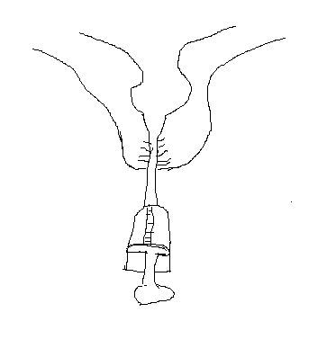

1. Name the above practice as carried out in livestock production (1mk)
2. State the reason why the above practice is carried out (1mk)
3. In which period of gestation is the above practice carried out (1mk)
4. Describe the procedure of carrying out the above practice (2mks)

SECTION C (40MARKS)

Answer any two questions

1. Describe the lifecycle of a three host tick (10mks)
2. Explain five reasons why culling is carried out in livestock production (5mks)
3. Explain five factors that influence water requirement in a farm animal (5mks)
4. Discuss Gumboro disease under the following sub heading
5. Animals affected (2mks)
6. Causative agent (1mks)
7. Symptoms (5mks)
8. Control measure (2mks)
9. Explain five factors considered when siting farm structures.(5mks)
10. Explain the advantages of embryo transplant as a method of services in livestock breeding (5mks)
11. Explain five advantages of farm mechanization (5mks)
12. Explain the practices observed in clean milk production (10mks)
13. Describe the disadvantages of animal drawn implements compared to tractor drawn implements (5mks)