Name……………………………………………….Adm No………..Class…….

Index No……………………….. Signature…………………………

121/1
MATHEMATICS ALT A
Paper 1

JULY 2019
2 ½ Hours

GATUNDU SUB-COUNTY EVALUATION EXAMINATION 2019

INSTRUCTIONS TO CANDIDATES
- Write your name and Admission number in the spaces provided at the top of this page.
  - This paper consists of two sections: Section I and Section II.
  - Answer ALL questions from section I and ANY FIVE from section II
  - All answers and workings must be written on the question paper in the spaces
provided below each question.
  - Show all the steps in your calculation, giving your answer at each stage in the spaces
below each question.
  - Non – Programmable silent electronic calculators and KNEC mathematical tables may be
used, except where stated otherwise.

FOR EXAMINERS USE ONLY

SECTION I
1 | 2 | 3 | 4 | 5 | 6 | 7 | 8 | 9 | 10 | 11 | 12 | 13 | 14 | 15 | 16 | TOTAL

SECTIONII
17 | 18 | 19 | 20 | 21 | 22 | 23 | 24 | TOTAL
Grand total

SECTION 1 (50MARKS)

Answer all the questions in this section in the spaces provided.
- Without using tables, evaluate $\frac{0.51 X 5700}{6.8 X 0.0095}$ giving the answer in standard form.(3mks)

- The sum of all the interior angles of a regular n-sided polygon is 2880⁰. Calculate the value of n and the size of the exterior angles of the polygon. (3mks)

- Find the equation of the line which passes through the point of intersection of the
lines y + 2x = 8 and 2y – x = 6 and the point ( 4, 3 ). (4mks)

- Express the inequalities $\frac{1}{3}$x 4 ≤ 7 + 2x ≤ 4 + ¼ x in the form p ≤ x ≤ q,
where p and q are real numbers. ( 3mks )

- A translation maps the point Q (5, -3) onto Q¹ (2, -5)
(a) Determine the translation vector. (1 mk )

(b) A point R¹ is the image of R (-2, -3) under the same translation. Find the length
of Q¹R¹. (2mks)

- George received 10,000 Euros from his brother who stays in France .He sent to his sister who stays in Japan 10,000 Yen .In addition George bought a car worth sh.200,000. Exchange rates :
Buying Selling
1 Euro 73.4226 73.52953
100 Japanese yen 62.8011 62.8822

How much was left in Kenya shillings. (3mks).

- Simplify the expression (3mks)
$\frac{×^{2}-{9y}^{2}}{{2x}^{2}- 7×y+ {3y}^{2}}$

- Kassim has a money box containing 100 mixed shs 5 and shs 10 coins with a total value of shs 600. How many of each type of coin does the box contain. (3mks)

- Use square roots, reciprocal and square tables to evaluate to 4 significant figures the expression; ( 4 mks)
$${\left(0.06458\right)}^{\frac{1}{2}}+ {\left(\frac{2}{0.4327}\right)}^{2}$$

- A boy walk directly from point Q towards the foot of a vertical flag post 200m away. After covering a distance of 140m, he observes the angle of elevation of the top of the flag post as 75$°$. Calculate the angle of depression of point Q from the top of the flag post. (3mks)

- Two similar blocks have masses of 729g and 216g respectively. If the surface area of the smaller block is 300cm², calculate the surface area of the larger block. (3mks)

- Evaluate (3 mks)

13.A two digit number is such that 4 times the units digit exceeds the tens digit by 1. If the digits are reversed, the number formed is decreased by 45. Find the number. (3mks)

14. Given that the column vectors
$$\underbrace{p}=\left(\begin{matrix}-3 \\ 4\end{matrix}\right), \underbrace{q}=\left(\begin{matrix}16 \\ -4\end{matrix}\right), \underbrace{r}=\left(\begin{matrix}9 \\ 6\end{matrix}\right)andthat\underbrace{a}=2\underbrace{p}-\frac{3}{4}\underbrace{q}+ \frac{2}{3}\underbrace{r}$$
Express as a column vector and hence calculate its magnitude (3mks)

15.A liquid spray of mass 384g is packed in a cylindrical container of internal radius 3.2 cm. Given that the density of the liquid is 0.6g/cm³, calculate to 2dp the height of the liquid in the container. (3 mks)

16.(a) Find the inverse of the matrix $\left(\begin{matrix}4 & 3 \\ 3 & 5\end{matrix}\right)$ ( 1 mk)

(b) Hence solve the simultaneous equation using the matrix method ( 2mks)
4x +3y = 6
3x + 5y = 5

SECTION II
Answer any Five Questions in this Section in the spaces provided
17. Three businessladiesWanjiku, Muthoni and Njoki decided to buy a lorry. The marked price of the lorry was 2.8million shillings. The dealer agreed that the ladies could pay a deposit of 60% of the marked price and the rest to be paid within a year.The ladies raised the deposit in the ratio of 3:2:5 respectively. At the end of the year the lorry had realized 2.08million shillings which the three shared in the ratio of their contribution. However, they were required to contribute for the balance of the lorry from these earnings again in the ratio of their original contributions.

- calculate amount to be paid as deposit (1mk)

- How much did each contribute to pay for the deposit? (3mk)

- How much did Njoki receive at the end of the year? (1mk)

- Calculate the total amount Muthoni and Njoki contributed to pay for the balance. (3mk)

- How much money did Wanjiku remain with after paying her share of the balance? (2mk)

18. a) A bus left Kisumu at 9.30 am towards Nairobi at an average speed of 81km/hr. A matatu left Nairobi for Kisumu at 10.10 a.m at an average speed of 72km/hr. The distance between Kisumu and Nairobi is 360km. Determine:
(i) The time taken before the two vehicles met. (3mks)

(ii) The distance between two vehicles 40 minutes after meeting. (2mks)

(iii) A car left Kisumu towards Nairobi at 9.50am at an average speed of 90km/hr. Determine the time the car caught up with the bus. (3mks)

(b) The figure below shows speed time graph of a journey. If total distance travelled in 80 seconds is 1000m. Find the distance travelled in the final 40 seconds. (3 mks)
16m/s
speed

- 15 60 80
time (seconds)

- The Figure shows a frustum of a right pyramid open container for storing water.
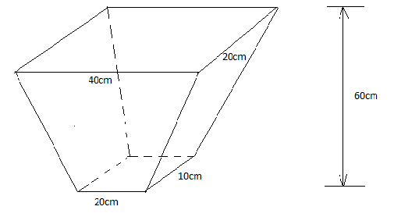
Calculate:
- The height of the pyramid from which the frustum was cut from. (2mks)

- The capacity of the frustum in litres (4mks)

- The surface area of the frustum (4mks)

- The table below represent marks in percentage scored by 50 students in a class
Marks | 40-44 | 45-49 | 50-54 | 55-59 | 60-64 | 65-69 | 70-74 | 75-79 | 80-84
Frequency | 6 | 4 | 7 | 6 | 12 | 4 | 5 | 3 | 3

- State the modal class (1mk)

- Estimate:
- The mean mark ( 4 mks)

- the median. (3mks)

- Calculate the percentage of students who scored between 50-64 marks (2 mks)

- In the figure below DA is a diameter of the circle ABCDE centre O. TCS is a tangent to the circle at C, AB = BC and angle DAC = 38⁰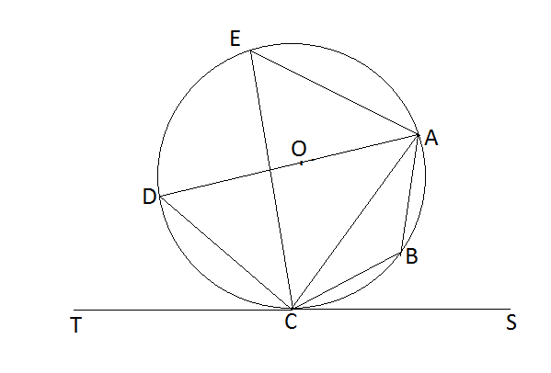
Giving reasons, determine the following angles:
(a) ˂ DCT (2 mks)

(b) ˂DEA (2 mks)

(c) ˂ACB (2 mks)

(d) ˂BDC (2 mks)

(e) ˂BOA (2 mks)
22. .(a) Complete the table below for the function y = -2x² – 7x + 4. (2 mks )

X | -5 | -4 | -3 | -2 | -1 | 0 | 1
Y = -2x² – 7x + 4

(d) Draw the graph of y = -2x² – 7x + 4 for -5 ≤ x ≤ 1 ( 3mks

(c ) Use your graph to solve

(i) -2x² – 7x + 4 = 0 (1 mk )

(ii) -2x² – 4x – 2 = 0 ( 2mks )

x
(iii) x² + ⁷/₂ – 1 = 0 (2mks)

23.(a) Complete the table below for the function y = x² + 3 (2mks)
x | 1 | 1.5 | 2 | 2.5 | 3 | 3.5 | 4 | 4.5 | 5 | 5.5 | 6
y | 4 |  | 7 |  |  | 15.25 | 19 |  | 27 |  | 39

(b) Use the mid-ordinate rule with five strips to estimate the area bounded by the curve, the line
x = 1 and the line x = 6. (2mks)

(c) Use integration to find the exact area in (b) above. (3mks)

(d) Calculate the percentage error arising from the use of mid-ordinate rule. (3mks)

24.Mwikali planned to spend sh. 16,800 to buy a number of bags of maize. When she went to the market, she discovered that the price of maize had increased by sh. 200 per bag. She could now afford to buy two bags less than she had planned to buy with the same amount of money.taking the original number of bags she intended to buy to be y:

- write an expression in terms of y for:
- original price per bag (1 mk)

- price per bag after the increase in price. (1 mk)

b) Determine the number of bags that she originally intended to buy. (4 mks)

c) She later sold the maize at sh. 1750 per bag. Find the percent profit she made. (4 mks )

