KUHS: HOMESCIENCE FORM TWO
MID TERM EXAM THIRD TERM 2011
TIME
- Give four functions for vitamin B1. (4 marks)
- (i)
(ii)
- (i)
(ii)

(4 marks)
- State factors to consider when chosing seams in garment cosntractionention two (2) sources of iron. (2 marks) 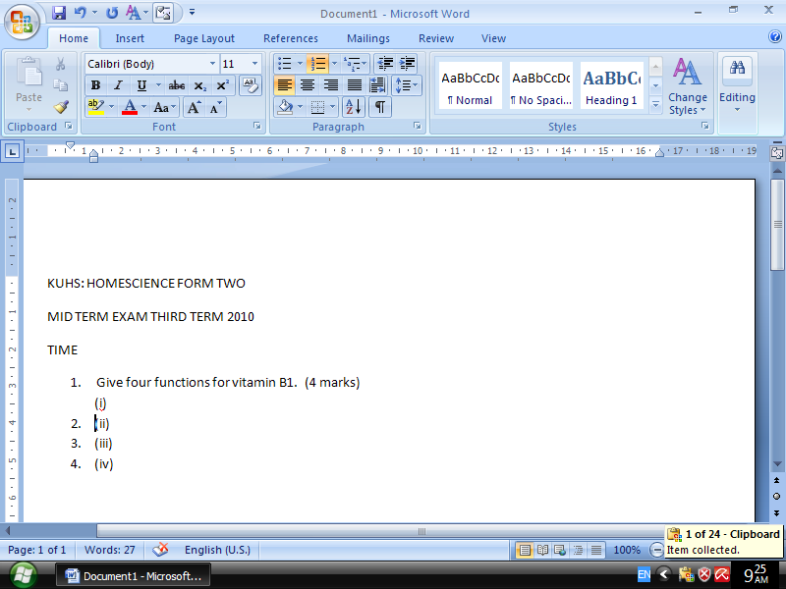
(i)
(ii)

