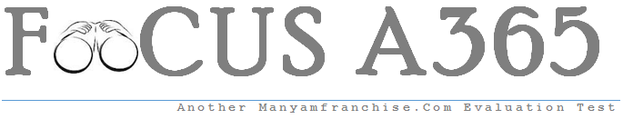

Gatitu Mixed Secondary School
Form 2 | Term 1 | 441 - Home Science | 08-Jan-16 | Opener
- Give two points to consider when buying a pair of shoes. (2 mks)

2. Suggest two measures to take immediately nose bleeding occurs. (2 mks)

3. Name four items in a First Aid kit that can be used to manage burns. (2 mks)

4. Give two reasons why wool is not suitable for underwears. (2 mks)

5. Identify two ways of making water safe for drinking. (2 mks)

6. Mention three uses of maize in the home. (3 mks)

7. Name the two categories of cooking methods and in each case give one example. (2 mks)

8. Why is hot water poured down a sink after cleaning. (1 mk)

9. State four situations that would require one to wash hands to prevent the spread of diseases. (4 mks)

10. Identify two waterborne diseases. (2 mks)

11. Identify two metals that are commonly used for ornaments. (2 mks)

12. State three safety precautions to observe when working in the kitchen. (3 mks)

13.A gourd is a kitchen equipment which grows from a creeping plant.Mention three ways in which it is used in the home. (3 mks)

14 .Mention any three advantages of traditional huts. (3 mks)

15. Outline four ways to enhance personal appearance. ( 4 mks)

16. State three points to consider when buying labour saving equipment. (3 mks)

