NAME……………………………………………………………CLASS………………

ADM…………………………..

GATITU MIXED SECONDARY SCHOOL
HOME SCIENCE
1ST TERM CAT 1-2015
FORM 3

TIME: 11/4HRS.

INSTRUCTIONS
Answer all questions.

1. Suggest four reasons why there should be a door leading to the outside of the house from the kitchen. (3mks)

2. Mention TWO reasons for airing clothes before storage (2 mks)

3. List THREE examples of separating tools in the kitchen (3 mks)

4. Identify TWO areas in which Home science is related to Geography (2 mks)

5. State three ways in which HIV/AIDS can be transmitted. (3mks)

6. State three causes of anaemia. (3mks)

7. Give three reasons why plastic basins are commonly used in homes today. (3mks)

8. Give three causes of needle breaking when the machine stitching. (3mks)

9. Identify the international care labels given below.
a)
………………………………………………………..(1mk)
b)
………………………………………………………(1mk)
c)
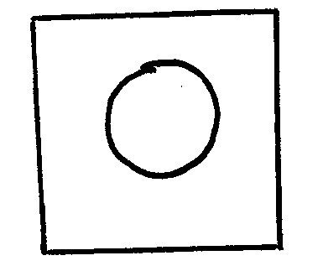 ……………………………………………………….. (1mk)

10. State two disadvantages of gas as a source of fuel. (2mks)

11. Mention two lifestyle diseases. (2 mks)

12. Outline how to clean your towel. (4mks)

13. Give two types of decorative stitches used in garments? (2mks)

x/35
WISHING YOU WELL

