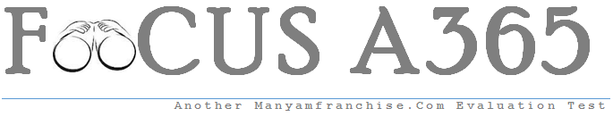

Gatitu Mixed Secondary School
Form 2 | Term 3 | 102 - Kiswahili | 03-Oct-15 | End Term
JIBU MASWALI YOTE
- Kamilisha jedwali lifutalo ala 25
kutenda | kutendesha | kutendatenda | kutendua
kuruka
 | kutumikisha |  | kufunua
 | kuwezesha | kuchorachora
 | kusomeka
 |  | kulimalima | kulimua
 | kukimbiza
 |  |  | kuzindua
kufanya

- Tambulisha kiwakilishi nafsi ala 7
- Wewe unaenda wapi?

- Mimi sitawasaidia wale.

- Nyinyi mtakuja?

- Sisi na wao tutafanya kazi.

- Yeye alitudhulumu.

- Kamilisha methali hizi al 10
- Mambo ni kangaja-------------------------------------------------

- Kwenda mbio --------------------------------------------------------

- Penye nia ------------------------------------------------------------------

- Kuishi kwingi ----------------------------------------------------------

- Mtaka nyingi nasaba --------------------------------------------------

- Tumia kivumishi mwafaka kukamilisha sentensi hizi: ala 5
- Ni mwanafunzi -----------------------------------aliyetoroka?
- Ni wanafunzi. -------------------------------------waliohitimu?
- Utatumia uzi -------------------------------------?
- Ni matunda ------------------------------yameliwa?
- Unataka kisu ---------------------------?
- Eleza maana ya misemo hii: ala 4
- Fanya kizungumkuti--------------------------------------------------------------

- Kujifunga kibwebwe ----------------------------------------------------------------

- Kupatikana mambo ------------------------------------------------------------------

- Tenda balaa ---------------------------------------------------------------------------

- Jaza nafasi iliyoachwa kwa kinyume kifaacho: ala 4
- Asiyeweza kuutumba ----------------------------- hawezi.
- Mama alipanga vitu, mtoto ------------------------------------------.
- Kupanda mchongoma ------------------------------------------------- ndiyo ngoma.
- Usione kwenda mbele ------------------------------------------ si kazi.
- Kanusha sentensi hizi: ala 5
- Mwangi alimwona daktari jana .

- Waafrika waliathirika sana wakati wa utumwa.

- Watoto hupenda kucheza.

- Mgonjwa alitaraji kupona.
- Karanja anakimbia.

- Tunga insha isiyozidi ukurasa mmoja wa kinafasi ya maswali kuhusu methali ya Kiswahili, “ mvumilivu hula mbivu” ala 15

