MTIHANI WA MWAKICAN
KIDATO CHA PILI
MUHULA WA KWANZA - 2016
JIBU MASWALI YOTE
SWALI | ALAMA
INSHA | 20
UFAHAMU | 15
UFUPISHO | 15
MATUMIZI YA LUGHA | 30
ISIMU JAMII | 10
FASIHI SIMULIZI | 10
JUMLA | 100

A INSHA (ALA.20)
“Wewe ni Mwalimu mkuu wa shule yako. Andika hotuba utakayo toa siku ya kutangaza matokeo ya mtihani mkuu wa K.C.SE ya shule yako.”

B. UFAHAMU
Soma ufahamu ufuatao kisha ujibu maswali uliyoulizwa
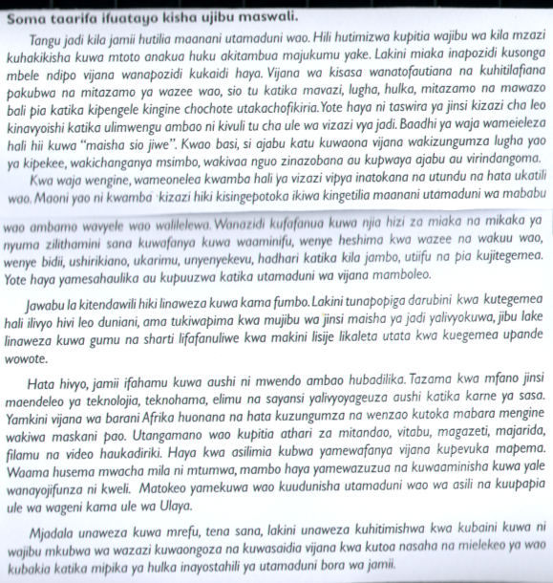
Toa kichwa mwafaka cha taarifa hii. (ala. 1)
_____________________________________________________________________________
_____________________________________________________________________________
b) Kulingana na taarifa uliyosoma, ni masharri gani amabayo mzazi anapaswa kutimiza kwa watoto wake? (ala, 2)
_____________________________________________________________________________
_____________________________________________________________________________
c) Utamaduni wa mababu ulitimiza vijana watimize mambo gani? (ala.3)
_____________________________________________________________________________
_____________________________________________________________________________
_____________________________________________________________________________
d) Eleza baadhi ya masuala yanayoathiri hulka za vijana mamboleo. (ala. 3)
_____________________________________________________________________________
_____________________________________________________________________________
_____________________________________________________________________________
e) Mwandishi anasema vijana wanbadilika vipi unavyo songa mbele? (ala. 3)
_____________________________________________________________________________
_____________________________________________________________________________
_____________________________________________________________________________
f) Eleza msimamo wa mwandiahi kuhusu hulika za vijana wa kisasa. (ala. 1)
_____________________________________________________________________________
_____________________________________________________________________________

g) Eleza msamiati ufuatao kama ulivyotumiwa katika makala.
i) Hulka . (ala. 1)
_____________________________________________________________________________
_____________________________________________________________________________

ii) Vizazi vipya. (ala. 1)
_____________________________________________________________________________
B. Soma makala yafuatayo kasha ujibu maswali uliyoulizwa.
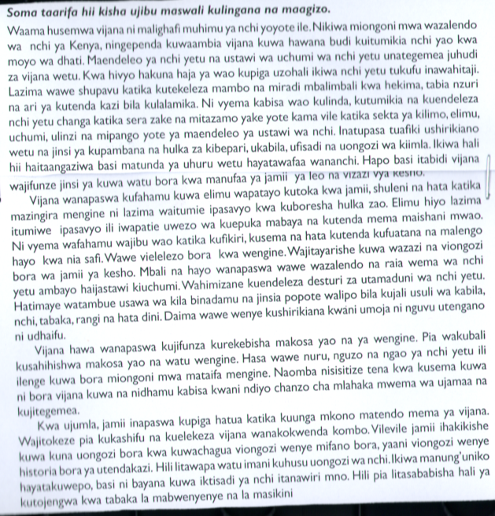
Maswali
Msimulizi ametoa mapendezo yepi ambayo vijana wanapaswa kuangazia kwa manufaa ya maendeleo ya nchi yao? Fupisho kwa maneno 90- 100)
Matayarisho

Jibu

- Eleza mchango wa jamii katika maendeleo ya taifa kulingana na mwandishi wa kifungu hiki Fupisha kwa maneno ( 30 – 40).
Matayarisho

Jibu

MATUMIZI YA LUGHA . (ALA 30)
- Taja kipasuo kimoja cha: (ala. 2)
i)ufizi__________________________________________________
ii) Kakaa gumu __________________________________________
b)Weka shadda katika maneno yafuatayo: (ala. 2)
i) kibaraka______________________________________________________
ii) Hawataupata__________________________________________________
c)Tofautisha baina ya vitate vifuatavyo kwa kutungia sentensi . Ala 3)
i) Vunja_____________________________________________________________
ii) Vuja______________________________________________________________
iii)Fuja_____________________________________________________________
d)Mofimu ni nini? (ala. 1)
_____________________________________________________________________________
_____________________________________________________________________________
e)Taja aina mbili za mofimu na utolee mfano mmjo mmoja. (ala. 2)

g) Bainisha aina ya vivumishi katika sentensi hii. (ala. 3)
_____________________________________________________________________________
_____________________________________________________________________________
_____________________________________________________________________________
g) Pambanua sentensi ifuatayo katika kielezo cha mstari. (ala 4)
Mama yangu atamletea zawadi nzuri.
_____________________________________________________________________________
_____________________________________________________________________________
_____________________________________________________________________________
h) Yakinisha sentensi ifuatayo ( ala 2)
Utingo hajapakia mieigo yote.
_____________________________________________________________________________
_____________________________________________________________________________
i)Onyesha vielezi katika sentensi ifuatayo. (ala.2)
Mwanafunzi mzuri sana alicheza jana.
_____________________________________________________________________________
_____________________________________________________________________________
j) Onyesha viambishi awali, mzizi na viambishi tamati katika neno lifuatalo. (ala.3)
Waliopigana.

k)Bainisha nomino mbalimbali katika sentensi zifuatazo. (ala.3)
i)Alichemsha maji yote.
_____________________________________________________________________________
ii)Kuogopa kwake kulimletea shida.
_____________________________________________________________________________
_____________________________________________________________________________
l) Eleza matumizi mawili ya ritifaa/kibainishi na utungie sentensi. (ala.2)
_____________________________________________________________________________
_____________________________________________________________________________
m) Unda nomino kutokana na maneno yafuatayo. (ala.1)
i)Shona ____________________________________________________________
ii)Shinda ___________________________________________________________
D. ISIMU JAMII. (ALA. 10)
i) Taja na ufafanue kaida masharti matano ya lugha. (ala.5)
_____________________________________________________________________________
_____________________________________________________________________________
_____________________________________________________________________________
_____________________________________________________________________________
_____________________________________________________________________________
_____________________________________________________________________________
ii) Eleza sifa tano za lugha ya kituo cha polisi. (ala.5)
_____________________________________________________________________________
_____________________________________________________________________________
_____________________________________________________________________________
_____________________________________________________________________________
_____________________________________________________________________________
_____________________________________________________________________________
_____________________________________________________________________________
_____________________________________________________________________________
_____________________________________________________________________________
_____________________________________________________________________________
E) FASIHI SIMULIZI. (ALA.10)
i) Taja vipera vine vikuu vya fasihi simulizi. (ala.4)
_____________________________________________________________________________
_____________________________________________________________________________
_____________________________________________________________________________
_____________________________________________________________________________
_____________________________________________________________________________
_____________________________________________________________________________
_____________________________________________________________________________
_____________________________________________________________________________
ii) Hizi ni aina zipi za ngano? (ala.3)
a) Kisasili ___________________________________________________________
b) Migani ________________________________________________________________
c) Hekaya _________________________________________________________________
iii) Taja aina tatu za nyimbo na ueleze kila wimbo. (ala.3)
_____________________________________________________________________________
_____________________________________________________________________________
_____________________________________________________________________________
_____________________________________________________________________________

