SECTION ONE
- Use logarithms, correct to 4 decimal places to evaluate 4 mks
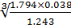
Number | Standard form | Log
1.794  0.038  1.243  0.3771 A1 | 1.794 x 10⁰  3.8 x 10⁻²  1.243 x10⁰  3.771 x10⁻¹ | 0.2439 +  2.5798 M1  (-2).8237 -  0.0945  (-2).7292 M1  (-3)+1.7292 M1  3  (-1).5764

- A straight line passes through points (-2,1) and (6,3). Find;
- The equation of the line in the form of y=mx +c 2mks

(2,1) and (6,3)
Grad = 3-1= 2/8 =1/4 M1
6+2
Equation =(6,3) (x,y) (grad =1/4)
y-3 =1/4
x-6
4y=x +6
Y=x/4 +3/2 A1

- The gradient of a line perpendicular to the line in (a) 1mk
Grad of L1= ¼
M1M2 =-1
4 x1/4 X M2 =-1x4
M2 =-4 A1
- Evaluate 2mks
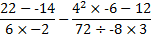
BODMAS
22+14 =36/12 =3
-12 M1
16 X-6-12 = -108/-27 =4
-9 X3
(-3)-(4) = -7 A1
- The interior angles of an octagon are 2x°, ½x°, (x+40)°, 110°, 135°, 160°, (2x+10)° and 185°. Find the value of x
Sum of int. angles of a polygon= 180(n-2) =180(8-2)
=180x 6=1080 M1
2X +1/X+ (X+40)° +110° +135° +160° + (2X+10)° +185° =1080
51/2X +640 =1080°
11/2X =440°
X =80 A1

- Find the value of m in the following equation 3mks
^{m}(81)⁻¹ =243

(1/3³) x 3⁻⁴ =3⁵ M1
3^{-3m} x3⁻⁴ =3⁵
-3m+-4 =5 M1
-3m =9
m= -3 A1
- Six cows and five sheep cost sh. 157000. Five cows and four sheep cost 265000. Find the cost of each. 3mks
4 x6c +5s =157500
5x5c +4s =131000
24c +20s =630000
25c +20s =655000 M1
1c =25000
6c+5s =157500
150000 +5s =157500 M1
5s =7500
S=1500
One cow =sh.25000
One sheep=sh.1500 A1

- In triangle ABC shown below, the bisector of angle A meets BC at D. DE is parallel to BA.
D
C
B
A
E
40
70

If angle B =40° and angle C=70°, find angle ADE 3mks
˂BEC =180 ° -40° -70° =70 °
˂DAC =70/2 =35° A1
˂AED =70+40 =110° A1
˂ADE =180- 110-145 =35° A1
8. If a=5, b=-4 and c=-3, find the value of : 3mks
(-4)²–(5X-3) –(-4X-3) –(-3) 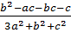
3(5)²+(-4)² +(-3)² M1
=16+15-12+3
75+16+9 M1
=22/100 A1

9.a) On the map of a certain district a forest reserve is represented by an area of 18 cm². Given that the actual area of the forest reserve is 28 800 hectares , calculate the scale of the map expressing it in the form of 1: n (3mks)
A.S.F =actual area
Area of map
=28800 x 10⁸
18 M1
=16 x10¹⁰
L.S.F=√A.S.F
√16 X10¹⁰ M1
=1:400000 A1

b)Two towns on this map are separated by a line 10.5 cm long .Find the distance between the two towns (1mk)

=10.5X400000
=4200000/100000
=42KM. A1

10)A shop keeper marked a suit at a price which.would give him 10%profit, but later sold the suit to a customer at 5%discounton the marked price.If the customer paid sh.1045, what was the cost price of the suit? 3mks
Cp=x
MP=1.1X M1
SP=0.95×1.1X M1
1.045X=1045
X=KSH.1000 A1

11) Evaluate 3mks
Numerator 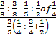
2/3x 8/3 -1/5 ÷1/8
=2/3 x 8/3 -1/5 x8/1
=16/9 -8/5
=80-72
45
=8/45 M1
Denominator
2/5(1/4 x4/3 +1/2)
=2/5(1/3+1/2)
=2/5 x5/6
=1/3 M1
=8/45/1÷1/3
=8/45 x3
=8/15 A1
12)Use reciprocal tables to determine 3mks
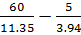
60(1/17.35) -5(1/3.94)
17.35=1.735 x10¹
=0.5764 x1/10

=(0.05764)60 M1

3.94 x10⁰
=0.2538
=5(0.2538) MI
=3.4584-1.269
=2.1894 A1
13)The wheel of a bicycle has a diameter of 70 cm and per makes 2 revolutions per second. Calculate to one decimal place the speed of the bicycle in km/h. (3mks)
Distance moved in one rev=∏d=22/7 x70cm
Distance moved in one second =22/7x 70x2 cm M1
Speed= distance moved in one hour =22/7 x70 x2 x60x60 =
22/7 x70x2x60x60 km/h M1
100 x1000
=15.8 km/h A1
14) Given that (a-b):(a+b)=4:5, find the value of a and b
2 mks
=5a-5b =4a+4b M1
a=9b
a/b=9/1
=a:b =9:1 A1

15)The figure below shows a net of a solid

Below is a part of the sketch of the solid whose net is shown above. Complete the sketch of the solid showing the hidden edges with broken lines 3mks

16)A Kenyan bank buys and sells foreign currencies at the exchange rates shown below;

 | Buying(ksh.) | Selling(ksh)
1 Euro | 147.56 | 148.00
1 Us Dollar | 74.22 | 74.50
An American arrived in Kenya with 20000 Euros. He converted all the Euros into Kenya shillings at the bank. He spent ksh. 2 510 200 while in Kenya and converted the remaining Kenya shillings to us dollars at the bank. Find the amount in dollars he received. 4 mks
Shs20000 x147.86
=sh.2957200 M1
To Us dollars=447000/74.5 M1
=6000
He received 6000 us dollars A1
. .
17) Express 0.2315 as a simplified fraction 3mks

R=0.23151515
10r=2.3151515 M1
100r=23.151515
1000r=231.5151515
10000r=2315.151515 M1
10000r=2315.1515-
100r=23.1515
=9900r=2292
r=2292/9900 A1

SECTION TWO

17)The table below shows measurements in meters made by a surveyor in his field book. Use the triangulation and offset technique to calculate the area in hectares of the field whose measurements are shown (10 mks)

 | G
 | 280
F 50 | 250
 | 200 | E 40
 | 150 | D 100
C 120 | 100
 | 40 | B 50
 | A

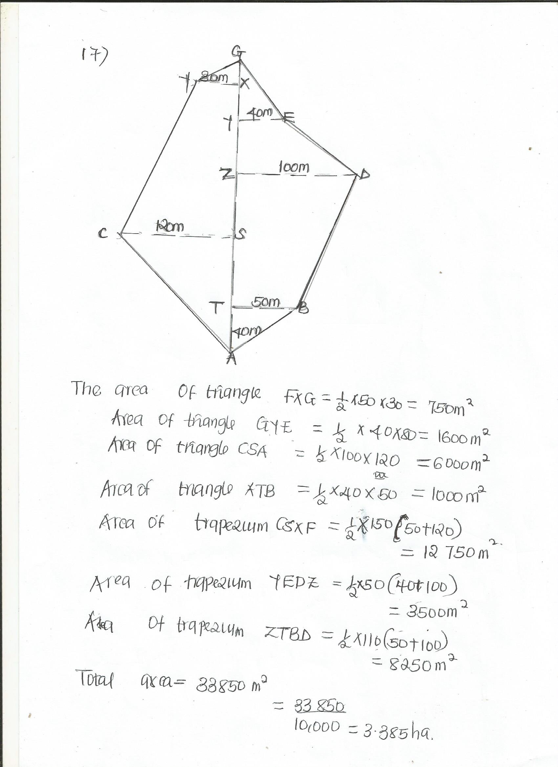

18. The boundaries of PQ, QR, RS and SP of a ranch are straight lines such that Q is 16 km on a bearing of 040° from P, R is directly south of Q and east of P and S is 12 km on a bearing of 120° from R.
a) Using a scale of 1cm represents 2 km, show the above information in a scale drawing (3mks)
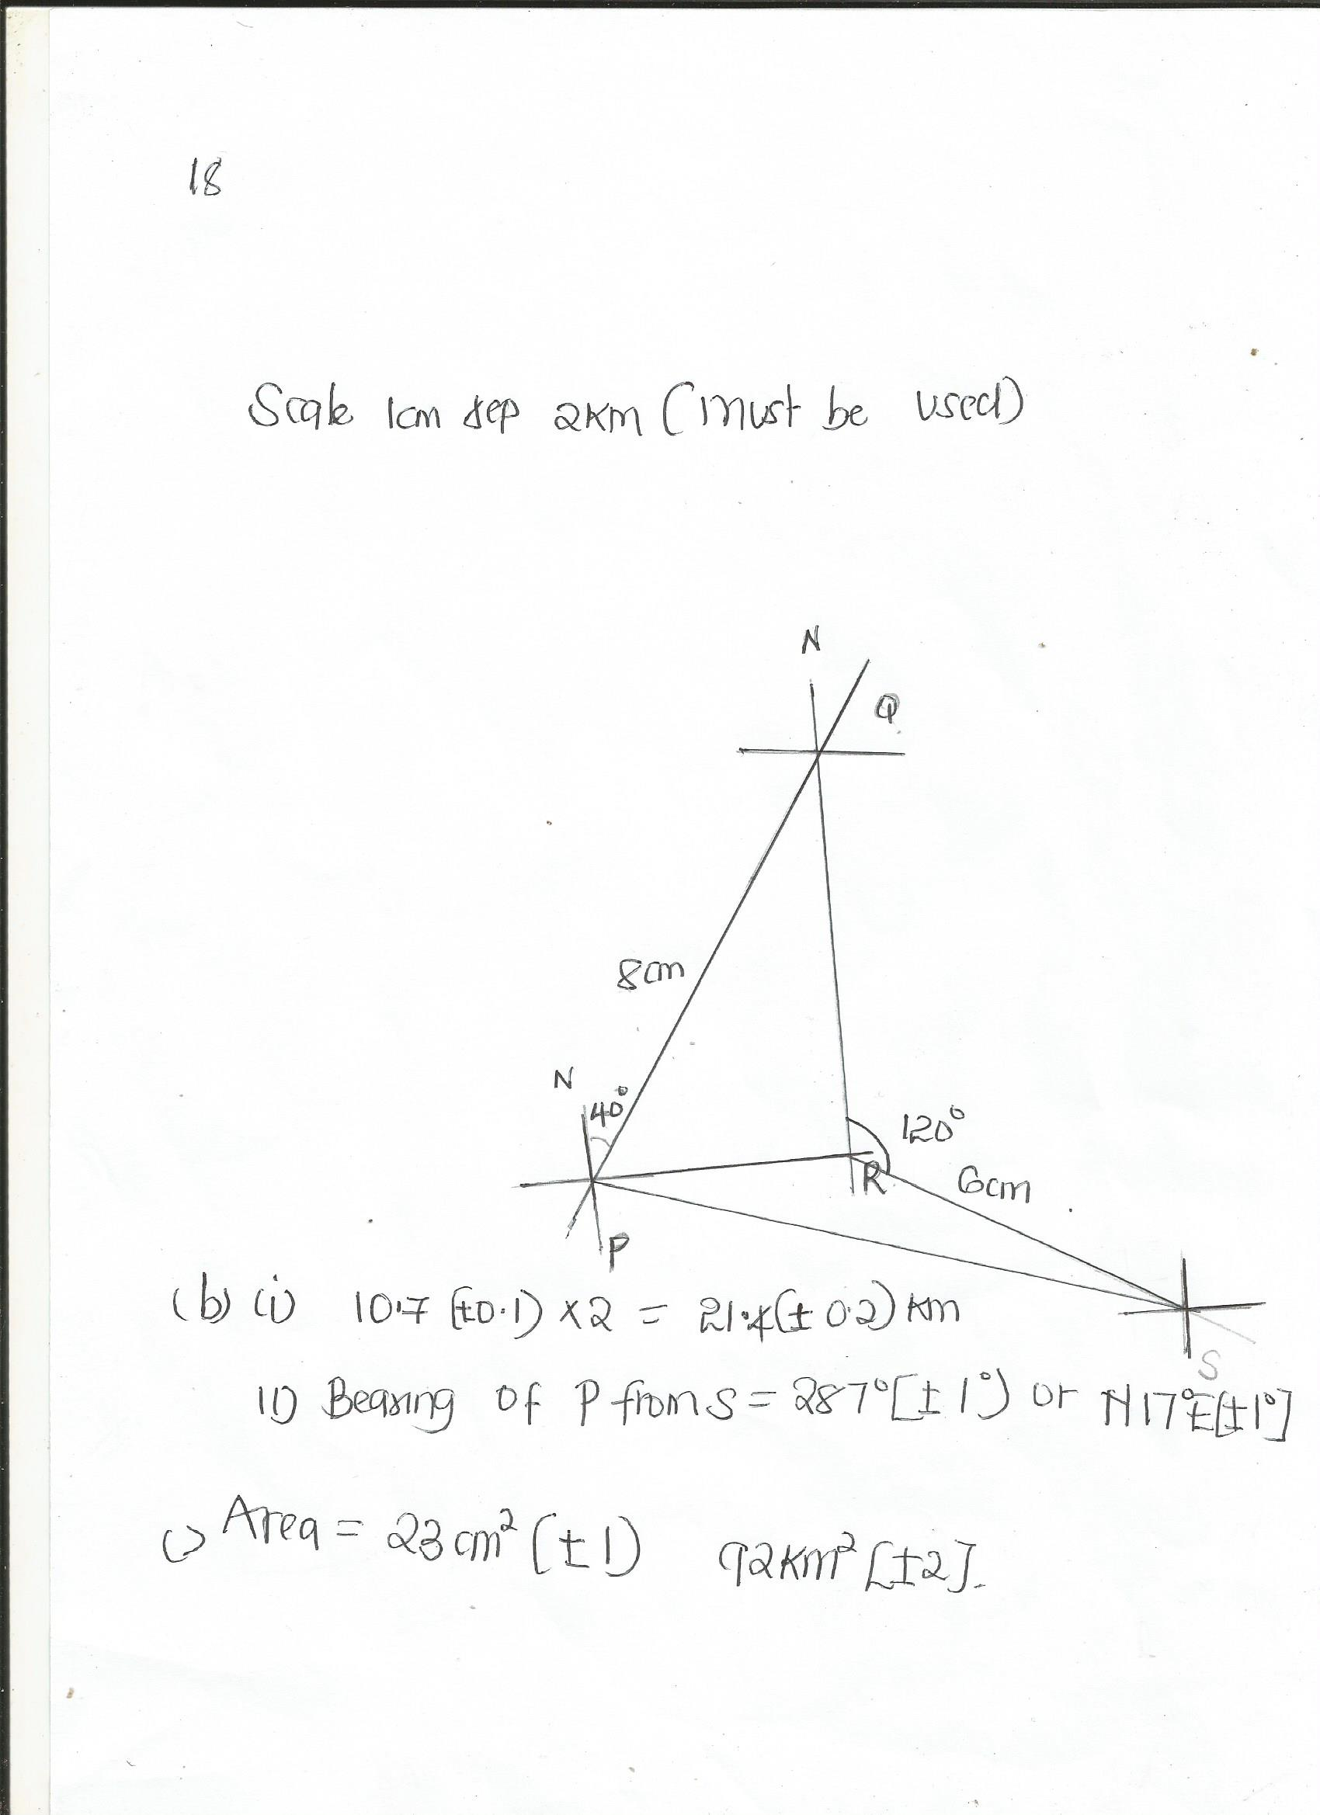

19 .a) The points A(2,6), B(1,1), C(3,4) and D(5,3) are vertices of a quadrilateral ABCD . Plot the points ABCD on the graph paper and join them to form quadrilateral ABCD (2 mks)
b) locate and write down the coordinates of points A’,B’,C’ and D’, the images of A,B,C and D respectively under a rotation of +90⁰ about the origin. On the same grid, draw the image of the quadrilateral A’ B ’C’ D’. (3 mks)
c) locate and write down the coordinates of the points A’’, B’’, C’’ and D’’ which are the images A’, B’, C’ and D’ respectively under a reflection on the x- axis. On the same grid, draw the second image quadrilateral A’’ B’’ C’’ D’’ (3 mks)
d) Quadrilateral A’’B’’C’’D’’ is the image of ABCD under a reflection. On your graph, mark the mirror line MN of the reflection and state its equation. (2 mks)
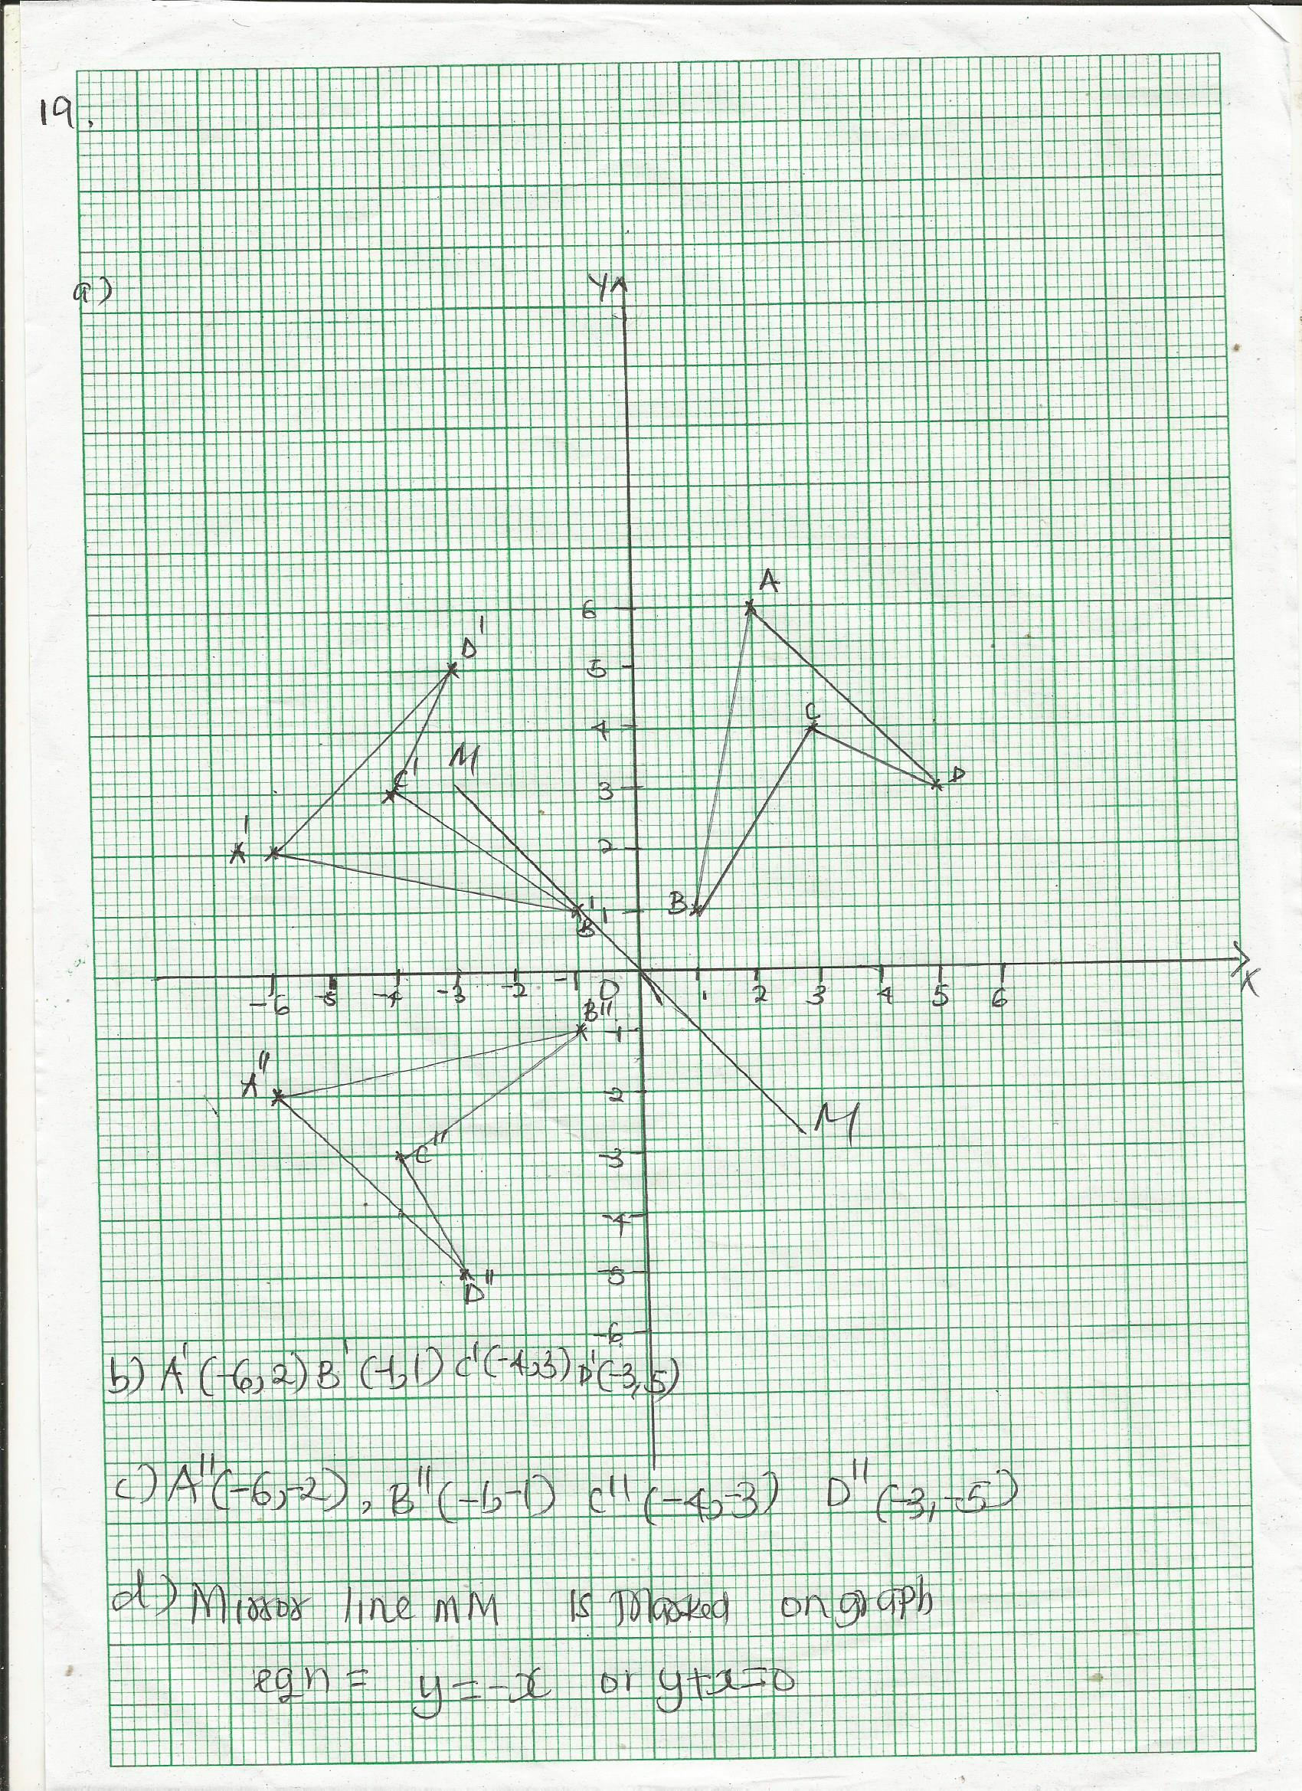
20. a) Use a ruler and compass to construct triangle XYZ with XY = 8cm, angle YXZ = 67 ¹_{/2}⁰ and XYZ = 45⁰ (4 mks)

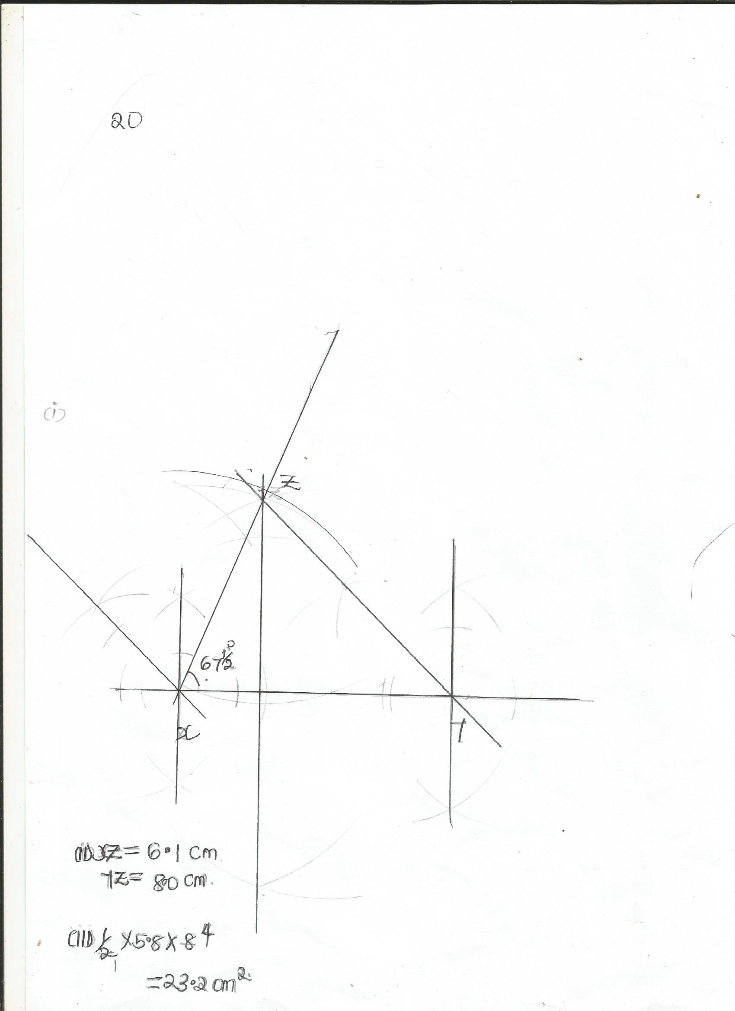

ii) Measure XZ and YZ (2 mks)

b)
By dropping a perpendicular from Z to XY, determine the area of the triangle (4 mks)

21. The external measurements of a closed wooden box are 1.5 m long , 0.8 m wide and 0.3 m high. The wood used in making the box is 1.0 cm thick and has a density of 0.75g/cm³. The box contains 30 packets of 12 similar tools each and each tool has a mass of 125 g.
Calculate
a)the volume of wood used in making the box (4mks)
a)external volume of box =150 x80 x30
=360 000 cm³
Internal measurements are 148 cm by 78 cm by 28 cm
Internal volume =148 x78 x28 =323 200 cm³
Volume of wood =360000-323200
=36 800 cm³

b)mass of wood =volume x density
=36800 x0.75 g
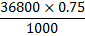
=27.6kg

c)mass of tools
=30x12x125
1000
=45 kg

Gross mass of box=27.6+45
=72.6 kg

