Name: ………………………………………… Index No………………………………..

School: ……………………………………. Stream………………………….ADM No………..

PHYSICS
Form Two
(Theory)
July 2015
Time: 2 Hours

FORM TWO 2015
Kenya Certificate of Secondary Education (K.C.S.E)
INSTRUCTIONS TO CANDIDATES
- The paper consists of TWO sections A and B.
- Answer all the questions in section A and B in the spaces provided
- All working MUST be clearly shown
- Non-programmable silent calculators and KNEC mathematical tables may be used.
FOR EXAMINER’S USE ONLY

Section | Question | Maximum Score | Candidate’s Score
A | 11-21 | 50
B | 22  23  24  25 | 12  15  11  12
TOTAL SCORE |  | 100

This paper consists of 13 printed pages. Candidates should check to ascertain that all pages are printed as indicated and that no questions are missing.

SECTION A ( 50 MARKS )
- Figure 1 shows the change in volume of water in a measuring cylinder when an irregular solid is immersed in it.
Given that the mass of the solid is 567g, determine the density of the solid in g/cm³. (Give your answer correct to 2 decimal places.) (3 marks)
volume = 110$-$40 cm³
density = $\frac{mass}{volume }$ = $\frac{567}{70 }$ =8$∙$10 cm⁻³

- State two properties of a liquid that is considered during the construction of a liquid – in – glass thermometer 2mks
i. Should have a wide range of temperature√
ii. Should expand and contract uniformly over a wide range of temperature
iii. Should be visible√ any 2
.

- Explain why steel is selected as a better material for reinforcement for a concrete wall 2mk

Concrete mixture and steel have approximately the same linear expansivity

4 (a) What is meant by the centre of gravity of an object? (2mk)
A central point of a body where its weight acts from

    - A uniform metre rule is in equilibrium on a knife-edge placed at 40cm mark as shown on figure 2 when a weight of 60N and 40N is placed at 10cm and 60cm mark respectively. Determine the weight of the metre rule. (3mks)
10cm 40cm 60cm

60N 40N

Clockwise moments = Anti-clockwise moments
60 N $× \frac{30}{100}$ m = W $× \frac{10}{100 }+$ 40 $N×\frac{20}{100}$ m 0$∙$1m w =10 Nm
18 Nm = 0$∙$1m W$+$ 8NmW = $\frac{10}{0∙1}$ = 100 N
18 Nm$-$ 8Nm = 0$∙$1m W

5. Explain why soft iron keepers are suitable for storing magnets (2mks)
Magnetism is easily induced in them. The dipoles of the keepers form a closed loop with those in the magnets hence protecting the magnets from being demagnetized

6. Fig 2 below shows a conductor carrying current placed in the magnetic field of two magnets. Complete the diagram by showing the field pattern and the direction of force F that acts on the conductor (2mks)

Figure 2
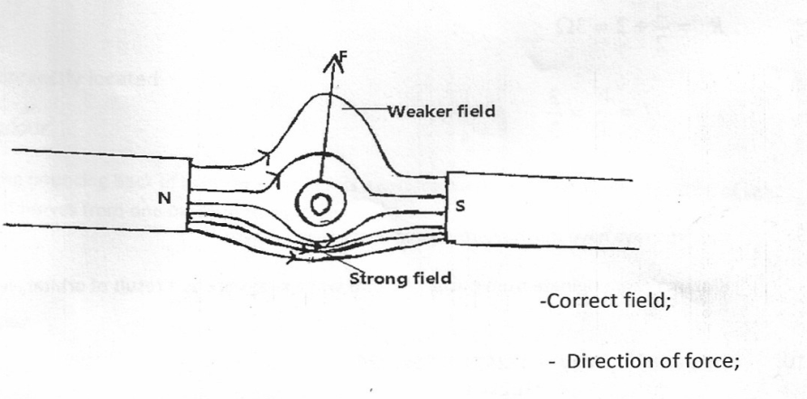

7. State two quantities that are used to determine whether accumulator require recharging or not (2mks)
i.Relative density of the acid;
ii.The voltage output

- A body is acted upon by a force of I0N towards the right hand side and 6N towards the left hand side. What is the resultant force? (2mks)

1 4N
Resultant force1 = (10 – 6)N = 4N1 towards the1 right hand side.

- The difference between the ice point and steam point on a liquid thermometer is 30cm. What temperature is recorded when the mercury thread is 12cm. (2mks)

ℓ₁₀₀ – ℓ₀ = 30cm

Ф = ℓ₀ – ℓ₀ = 12
100 ℓ₁₀₀ – ℓ₀ 30

Ф = 12 x 100⁰C1 = 40⁰C1
30

- A steel needle when placed carefully on water can be made to float. When a detergent is added to the water it sinks. Explain this observation. (2 marks)
the detergent weakens the surface tension

- When dust particles are suspended in water and observed through microscope, they are seen to move in random manner. Explain this observation. (2 marks)

dust particles move in random manner motion because of bombardment with liquid particles

- Explain why a glass container with thick walls is more likely to crack than one with a thin wallwhen a very hot liquid is poured into it (2mks)
Glass is a bad conductor1 of heat. The difference in temperature between the inside and he outside of the thick glass causes unequal expansion while for a thin glass there is equal distribution of heat thus 1equal expansion.

- The figure below shows a small toy boat floating in water in a basin. P and Q are two points near the toy.
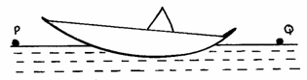

When a drop of kerosene is introduced in water at point Q, the toy is observed to move towards P. Explain this observation. (2mks)

Surface tension at Q reduces. ¹ The higher surface tension at P pulls the boat
in that direction. ¹

- The figure below shows the reading of micrometer screw gauge with a metal sphere of mass 1.75g placed between its jaws .The readings on the gauge when the jaws were fully closed without the sphere was 0.012cm. What is the volume of the sphere? (2marks)
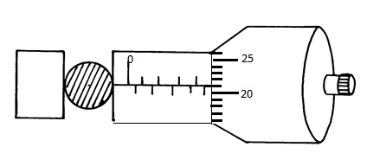
Reading = (4$∙$5$+0∙21$) $- 0∙12=4∙59 mm$
Volume = $\frac{4}{3}$πr³=$\frac{4}{3}×3∙142×( 2∙295×10$⁻³)³=50$∙6399 mm$³=5$∙$06399$×$10⁻⁹m³
- State two factors that reduce the stability of a vehicle while going round a banked road.
- marks)
- nature of the tyres
- nature of the road surface
- radius of the bend
- Which is easier to balance on a finger tip; a glass which is upright or a glass which is inverted with a finger inside? Given a reason. (2marks)
When the finger is inside- c.o.g is lowered hence very stable
- The figure 3 shows a ray of light incident on a mirror.

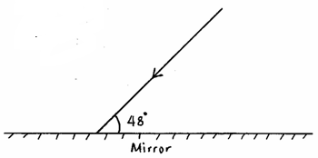
Fig.3

Determine the angle of reflection when the mirror is rotated 10° anticlockwise. (2mks)

38⁰
10⁰
90⁰ -38⁰=52⁰

- Explain why an increase in temperature increases Brownian motion (2mks)
Increase in temperature increases the kinetic energy of the particles

- Which glass among the two glasses in fig 3 is more stable. (1mk)

sand empty glass

(a) (b)

Fig 4
(i) Give reason for (i) above. (2mk)
Glass (a) because sand raises its c.o.g than in (b)
- Figure 5 shows two spherical materials one an insulator while the other a conductor. Negative charges are introduced at point A by contact method in each case.

conductor
insulator

Figure 5
A
A
On the same figure indicate the final position of the charges. Explain your answer. (4mk)

A
A

The conductor allows charge to be distributed while an insulator does not

- State any four differences between mass and weight (4mks)

Mass | weight
Measured using beam balance | Measured using spring balance
Constant everywhere | Varies from planet to planet
S.I Unit is kilogram | S.I Unit is Newton
Amount of matter in a body | Pull of gravity on a body

SECTION B ( 50 MARKS )
- A concave mirror and an illuminated object are used to produce a sharp image of the object on a screen. The object distance ( U ) and image distance ( V ) are given below
Object distance (cm) | 80 | 26.5 | 22.5 | 21.5 | 20
Image distance (cm) | 20 | 40 | 55 | 72 | 88
U⁻¹ | 0.0125 | 0.0377 | 0.0444 | 0.0465 | 0.050
V⁻¹ | 0.050 | 0.025 | 0.0182 | 0.0139 | 0.0114

(i) Fill in the gaps in the table above (2mks)

(ii)Plot a graph of $\frac{1}{u}$ against $\frac{1}{v}$ (4mks)
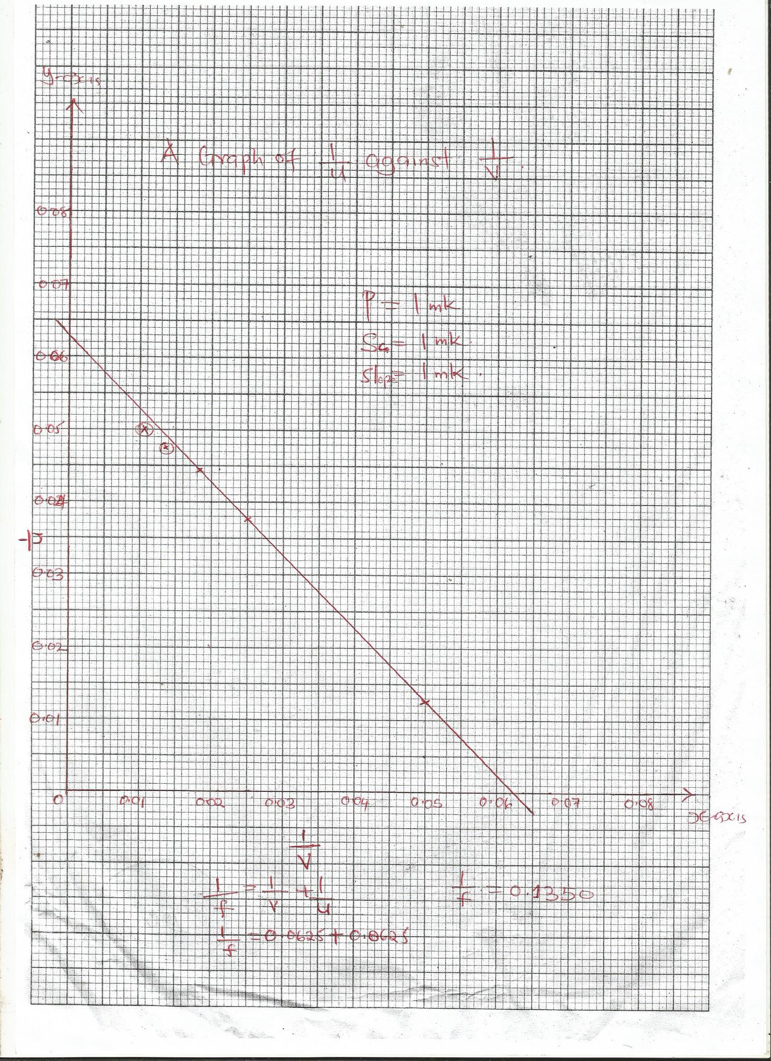
(iii) Determine the value of $\frac{1}{f}$ from the graph ( 2mks)

(iv) State any TWO properties of images formed by concave mirrors ( 2mks)
- real
- inverted
(v) State any two areas where concave mirror are used (2mk)
a. used as shaving mirrors
b .dentist examining teeth
c .solar concentrators
d.reflector behind a projector lamp
f.in telescopes
- a) State any TWOqualities of a liquid which can be used in an experiment to determine the size of a molecule. (2 marks)
- should float on water
- should not easily evaporate
- liquid should spread evenly in water
- should spread completely to form one molecule thick film
b) In an experiment to estimate the diameter of an oil molecule, an oil drop of diameter 0.05cm spreads overa circular patch whose diameter is 20cm:-
Determine the:-
- Volume of the oil drop. (2 marks)
volume =$\frac{4}{3}$πr³= $\frac{4}{3}×\frac{22}{7}×0$.0125$×$0.0125$×$0.0125
= 8$∙$185$×$10⁻⁶ cm³

- Area of the patch covered by the oil. (2 marks)
Area =πr²= $\frac{22}{7}×$10$×$10= 314$∙$286cm²
- Thickness of the oil molecule. (3 marks)

Thickness = $\frac{volume of oil drop}{area of oil patch}$ = $\frac{0∙00008185}{314∙286}$ = 2$∙$604$×$10⁻⁸ cm / 2.604 $×10$⁻¹⁰m

c) State:-
- Any two assumptions made in b(ii) above. (2 marks)
- the oil spreads completely
- the patch formed is one molecule thick
- the patch formed is circular
- spaces between the molecules are ignored
- Two possible sources of error in this experiment. (2 mks)
- the oil may not spread evenly
- the patch may not be circular in shape

d) State one reason why it is necessary to sprinkle chalk dust on to the water surface. to show the oil patch outline
- The following set up was used by a form 1 student to observe smoke particles in the smoke- cell experiment.

Microscope Eye piece Smoke cell

Spotlight

Figure 6

- State Brownian motion ( 2mk)
The random movement of gas particles due to collision of its particles
- State the observations made in the experiment. (2 mks)
a) Tiny bright specks √1 seen to move in random manner. √1
c) Explain the observations. (2 mks)
Bright specks are the smoke particles reflecting light √1, the random manner is as a result of repeated collisions between smoke particles and air particles. √1
(d) Explain therole of
i) The microscope (1 mk)
The microscope magnifies the tiny particles for ease of observation

ii) The spotlight (2 mk )
The spotlight provides bright light to illuminate the particles
iii) The smoke (2 mk )
The smoke provides the microscopic particles necessary for the motion to be observed.

- (i) State the law of electrostatic charges (2mk)
like charges repel, unlike charges attract
(iii) State the THREE methods of charging a conductor (3mks )
- separation
- induction
- contact

- In the diagram below shows a gold-leaf electroscope. Use it to answer the questions that follows

A

case E
FB
glass window D

- Name the parts labeled (3mks)
- Abrass cap
- B metal rod
- C gold leaf
- D earth wire
- E insulator
- F metal plate

- what is the function of the following parts (3mks)
A - Acquirescharges through induction or conduction and spreads it through the rod to the plate and leaf
C – Show the presence of charges by repelling the plate and can also show the absence of charges through divergence
Casing – protects the leaf from effect of draught, prevents charges from atmosphere from interfering with the leaf
(c ) Briefly explain how you can charge a conductor negatively by induction (3mk)
a positively charged glass rod or cellulose acetaterod is brought near a conductor but not touching it. This causes negative charges in the conductor to attracted on the side near the glass rod. The side of the conductor away from the glass rod is earthed by touching with a finger. This causes negative charges to flow from the earth through the body to the conductor. The electrons neutralizes the positive charges on the right part of the conductor. While holding the glass rod near the conductor the finger is withdrawn first then the glass rod. When the glass is withdrawn, negative charges on the conductor repel each other and spread all over each other. The conductor becomes negatively charged.

