NAME ………………………………………………………… ADM NO. ………………….
232/1
PHYSICS FORM 3
MARCH 2019
TIME: 2 HOURS
KENYA CERTIFICATE OF SECONDARY EDUCATION
INSTRUCTIONS TO CANDIDATES
- Write your name and Admission number in the spaces provided above.
- The paper consists of two sections A and B.
- Answer ALL questions in section A and section B in the spaces provided.
- All workings must be clearly shown in the spaces provided.
- None programmable silent electronic calculators and KNEC Mathematical tables may be used.
- Take: -
- g= 10m5⁻²
- Specific heat capacity of copper = 400J/kgk⁻¹
- Specific heat capacity of oil = 2400J/ kgk⁻¹
- Specific latent heat of fusion of ice = 336000J/kg
FOR EXAMINERS USE ONLY
Section | Question | Maximum score | Candidates score
A | 1-10 | 25
B | 11 | 15
 | 12 | 14
 | 13 | 12
 | 14 | 14
TOTAL |  | 80

SECTION A (25MKS)
- The figure below shows a spherical ball placed between 2 wooden blocks and a metre rule.

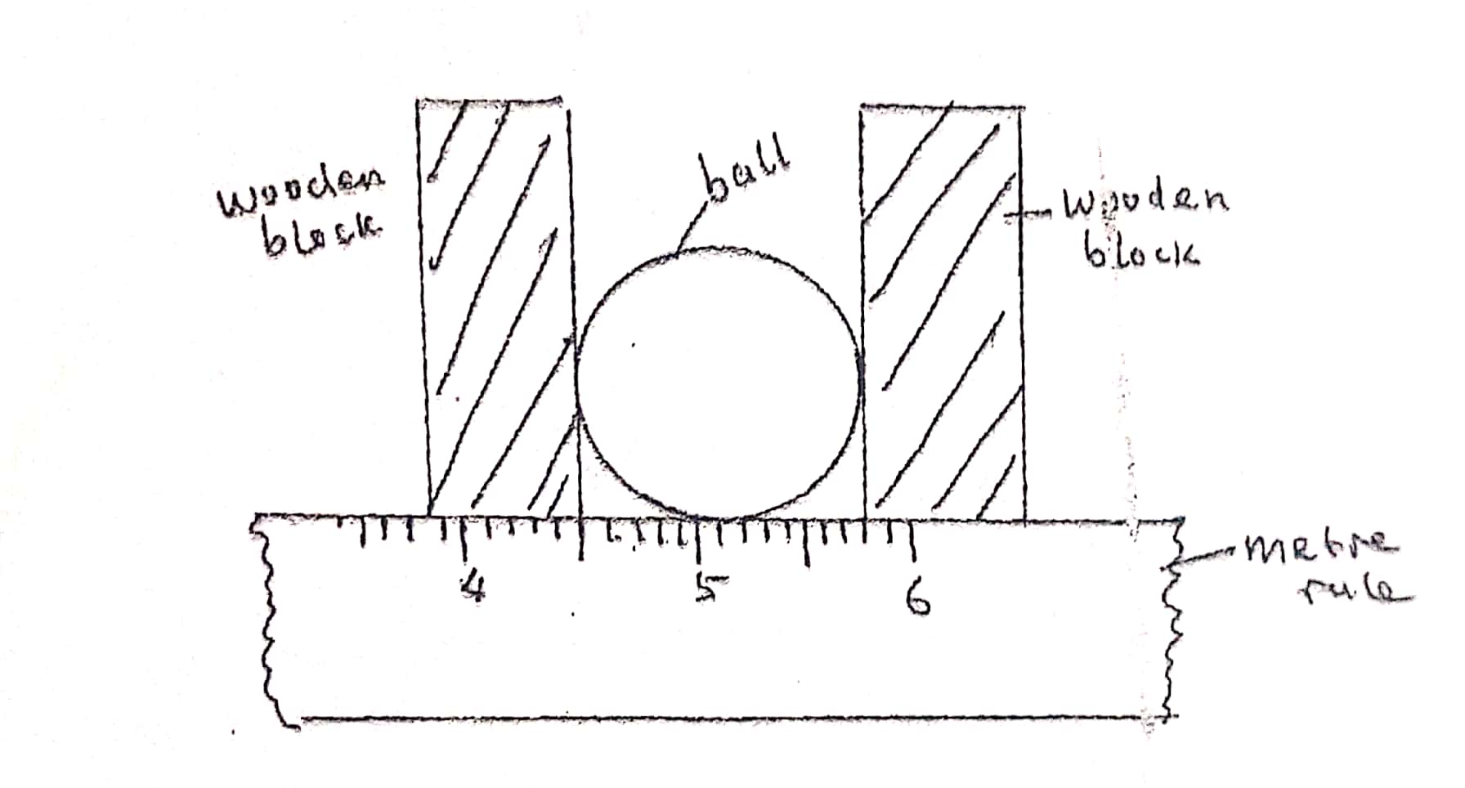
What is the volume of the ball? (3mks)

- A solid weighs 16.5N on the surface of the room. The force of gravity on the moon is 1.7N/kg. Determine the mass of the solid. (2mks)

- The figure below shows two cylinders containing a liquid and connected with a tight-fitting flexible tube. The cylinders are fitted with air- tight pistons A and B as shown.

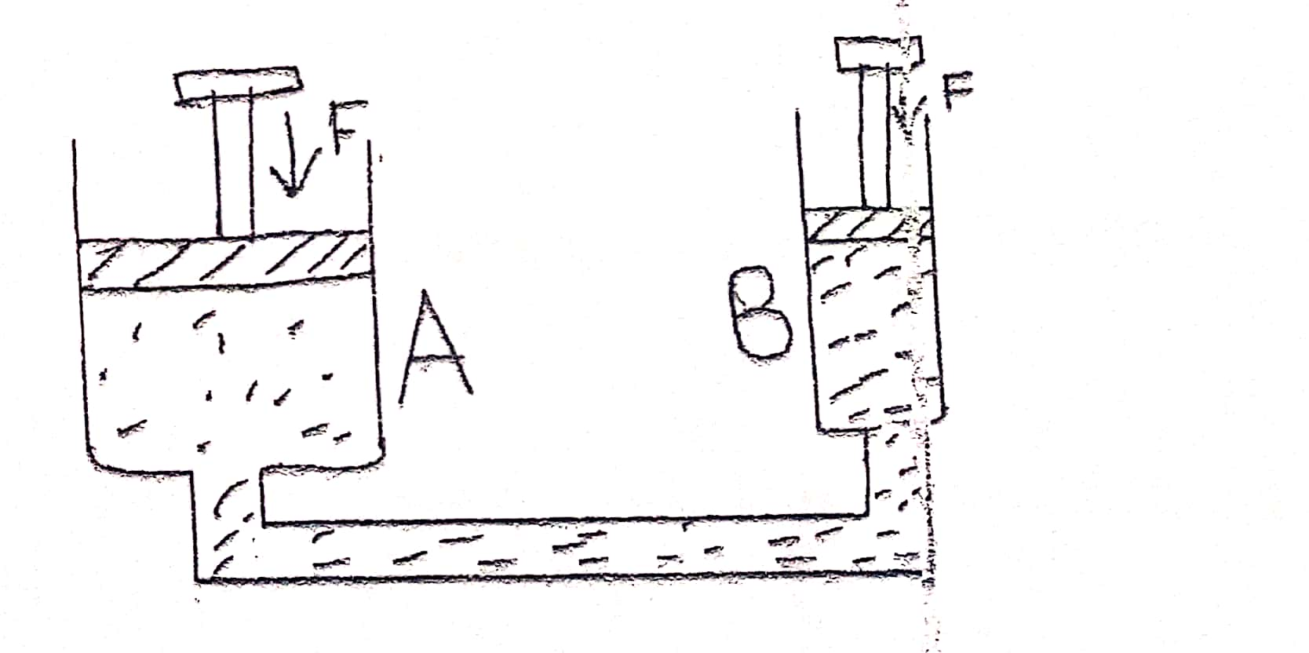
When equal forces, F are on the pistons as shown, what is observed. Explain the observation. (3mks)

- A bottle of soda stands on a bench. As the temperature of the surrounding rises the temperature of the bottle also rises. State and explain the effects of this on the stability of the bottle. (3mks)

- Explain how heat loss by:
- Radiation is minimized in a vacuum flask. (1mk)

- Conduction is minimized in a vacuum flask. (1mk)

- The figure below shows part of the main scale of vernier calipers.
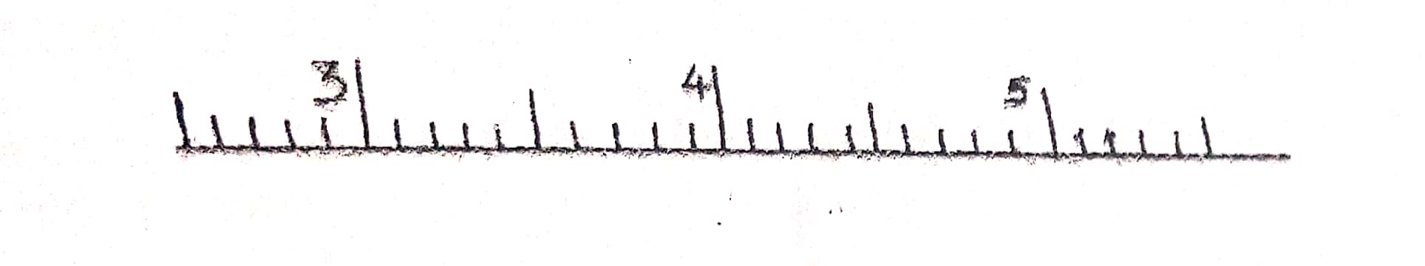
Insert the vanier scale to the main scale, to show a reading of 3.62cm. (1mk)

- A liquid flows into a pipe of varying cross sectional area. The inlet cross section is 10cm in diameter. If the liquid leaves the pipe at 0.5m³/s find the inlet velocity of the liquid. (3mks)

- The three springs shown below are identical and have negligible weight. The extension produced on the system of springs is 20cm. Determine the constant of each spring. (2mks) 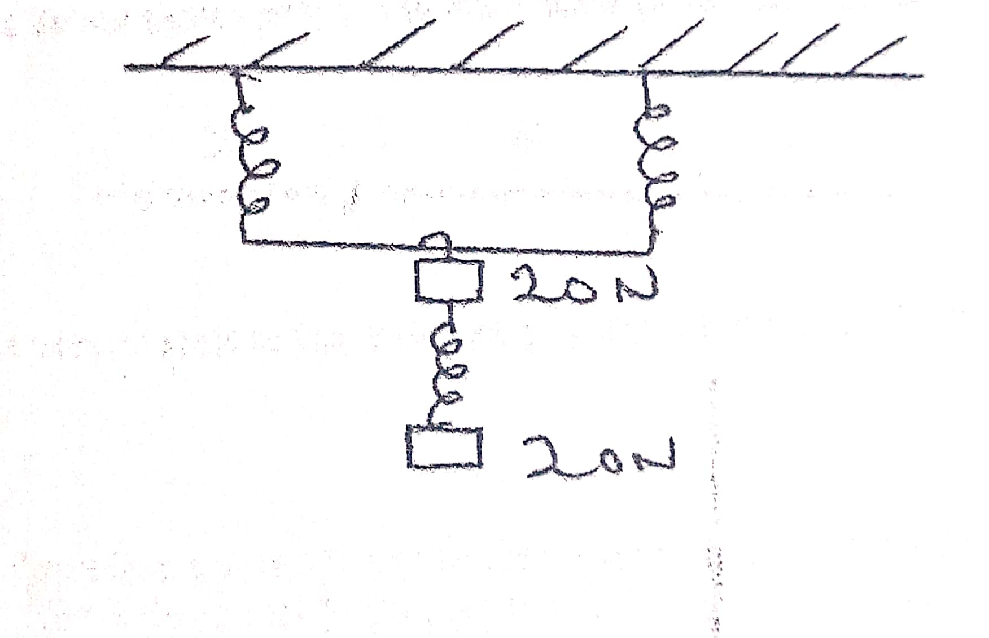
- The figure below shows a uniform metre rule of weight 1N with two weights 0.18N and 0.12N suspended from its ends.
- 100cm

0.18N 0.12N
Determine how far from the 0.18N weight a pivot should be placed in order to balance the metre rule. (3mks)

- An athlete runs at 4m/s from point A to point B and immediately turns and runs back from B to A with a speed of 8m/s. Calculate the average speed of the athlete. (3mks)

SECTION B (55MKS)
- (a) Distinguish between transverse waves and longitudinal waves. (2mks)

b) Plane water waves travels from deep end into a shallow end in a swimming pool at a velocity of 4m/s. If the wavelength of these waves in deep end is 6cm and in the shallow end is 1.5cm, determine the velocity of these waves in the shallow end. (3mks)

c) State one factor that effects the velocity of sound in a solid. (1mk)

d) A disc siren with 200 holes is rotated at constant speed making 0.5 revolutions per second. If air is blown towards the holes, calculate:
(i) The frequency of sound produced. (3mks)

- The wavelength of the sound produced if velocity of sound in air is 340ms⁻¹. (2mks)

e) The human ear can distinguish between two sounds as separate only if they reach atleast 0.1s apart. Determine the distance from the wall where one should be in order to hear an echo if the velocity of sound in air is 340m/s. (3mks)

f) How are echoes reduced in a room? (1mk)

- (a) In en experiment to estimate the diameter of an oil molecule, an oil drop of diameter 0.06cm spread over a circular patch whose diameter is 20cm. Determine:-
- The volume of the oil drop (2mks)

- The area of the patch covered by oil. (2mks)

- The diameter of the oil molecule. (3mks)

(b) State any assumption made in (ii) above. (1mk)

(c) The figure below shows parts A and B of a glass tube.
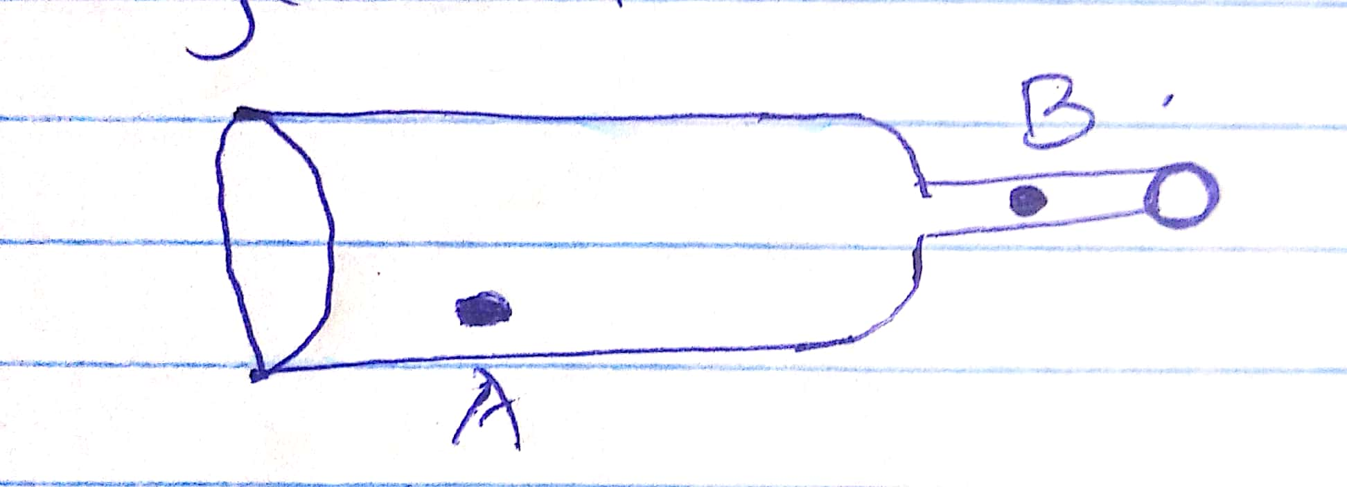
- State the part of the tube where the pressure will be lowest when air is blown through the tube. (1mk)

- What is the relationship between the velocity of air and its pressure at any point along the tube AB. (1mk)

(d) Water flows along a horizontal pipe of cross-section area 35cm² and constriction of cross-section 5cm², if the speed of water at the constriction is 2m/s:
(i) Continuity constant in SI unit. (2mks)
(ii) The speed in the wide section. (2mks)

- (a) State the principle of moments. (1mk)

(b) A uniform metal strip is 3.0cm wide 0.6cm thick and 100cm long. The density of the metal is 2.7 g/cm³.
- Determine the weight of the metal strip. (3mks)

- The strip is placed on a pivot and kept in equilibrium by forces as shown.

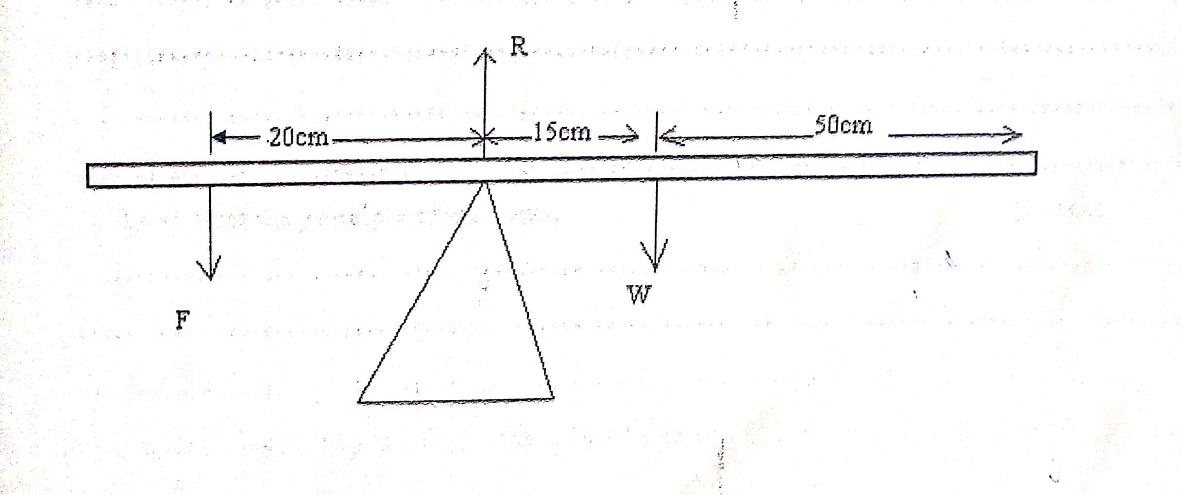
Determine the value of F and R. (3mks)

(c) (i) Define the centre of gravity of a body (1mk)

- State the factors that affect the stability of a body. (2mks)

- Give the three state of equilibrium. (2mks)

- An object of height 10mm is placed 50mm in front of a concave mirror of focal length 30mm. By scale drawing, determine: (5mks)
- Position of the image (2mks)

- Size of the image . (2mks)

- Nature of the image formed. (3mks)

- Calculate the magnification. (2mks)

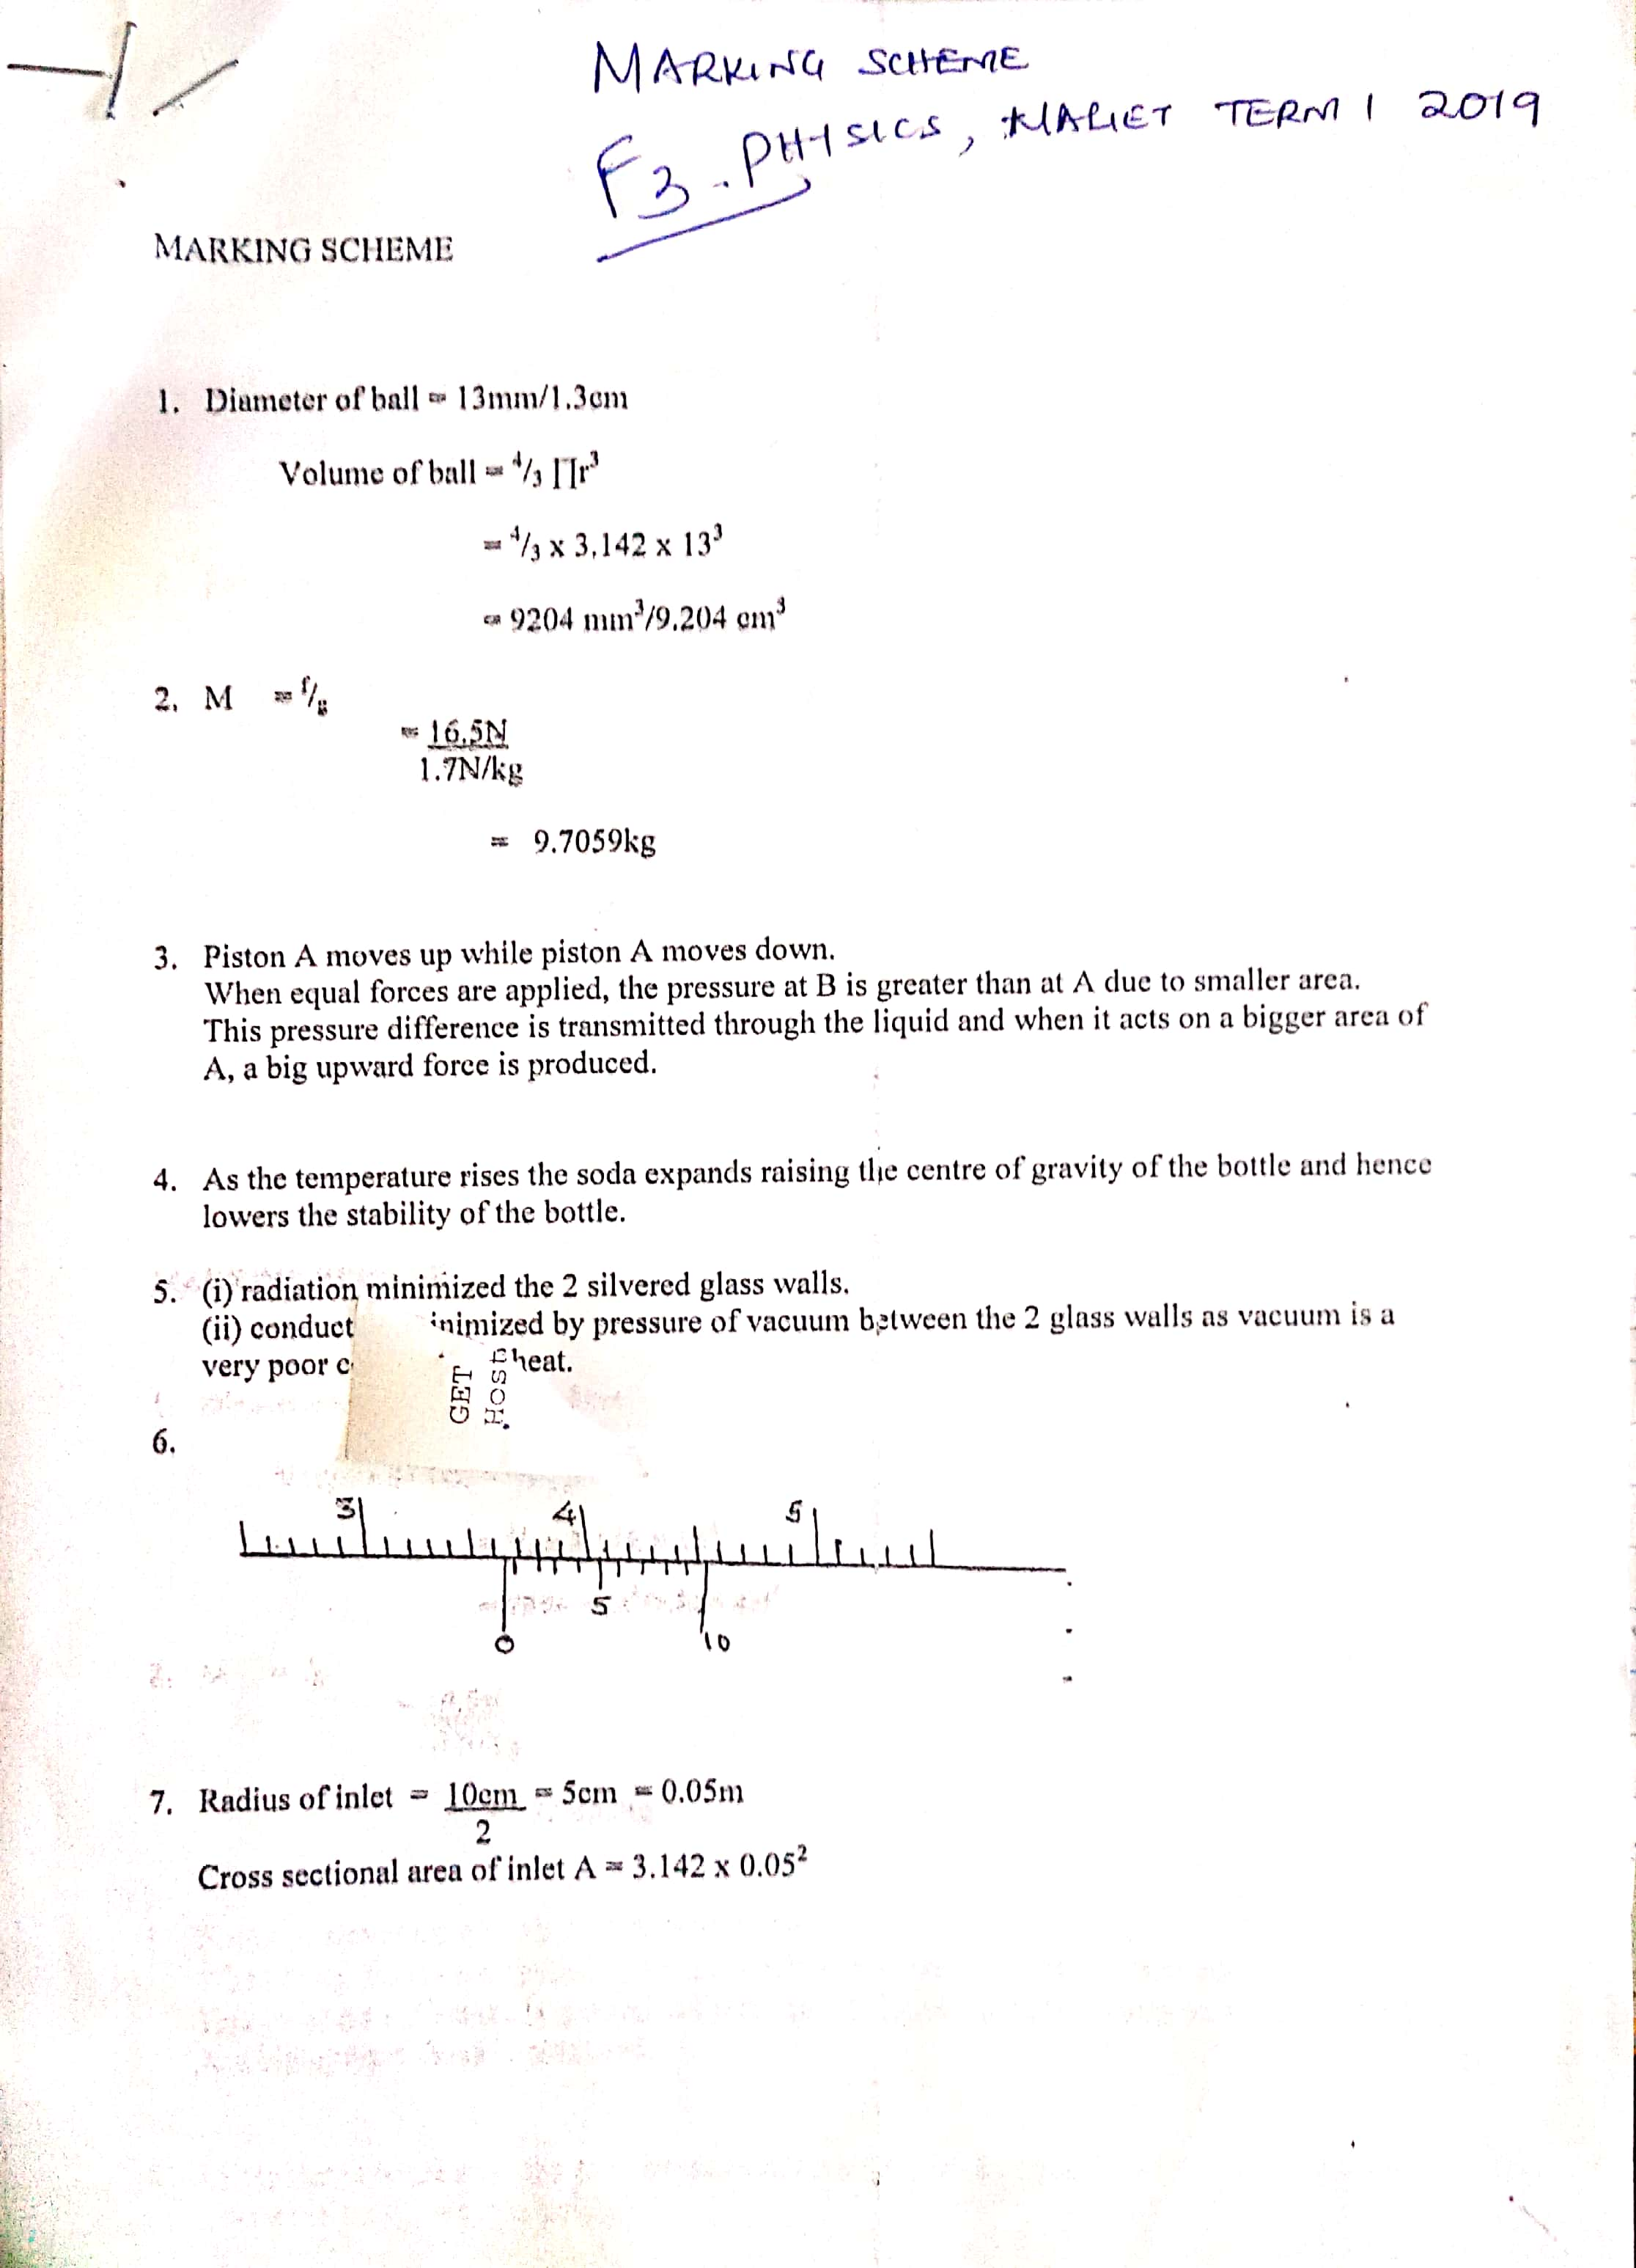
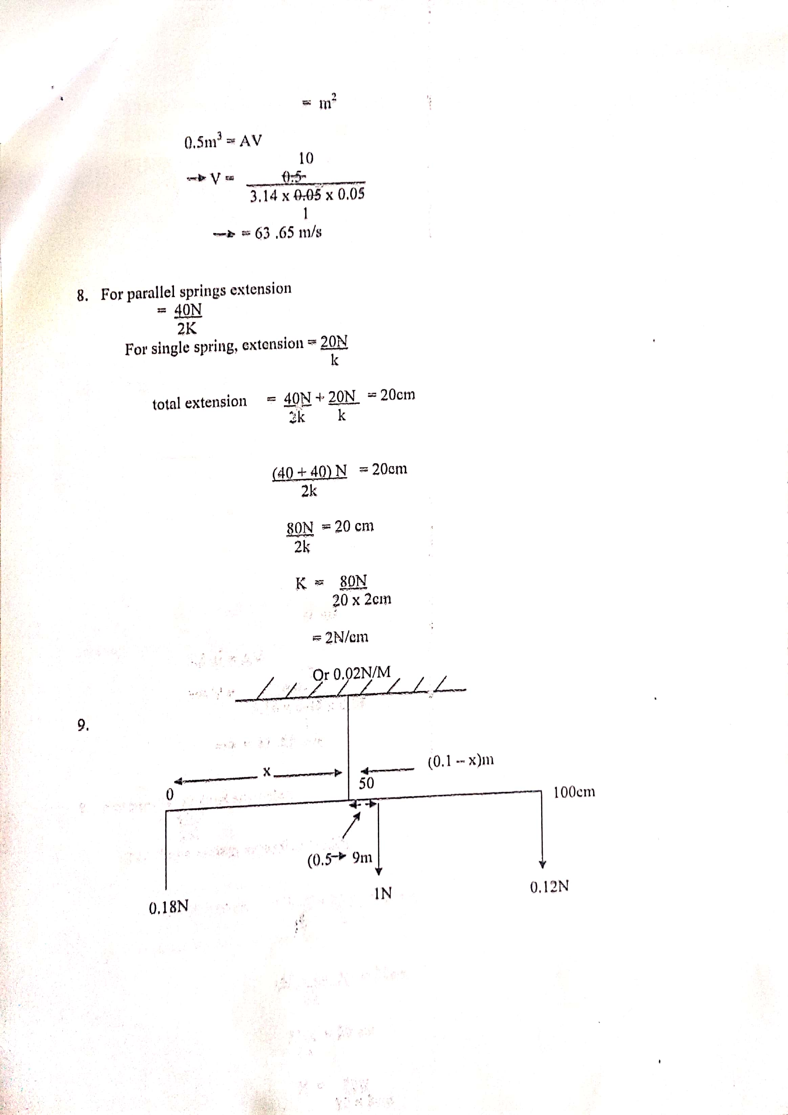
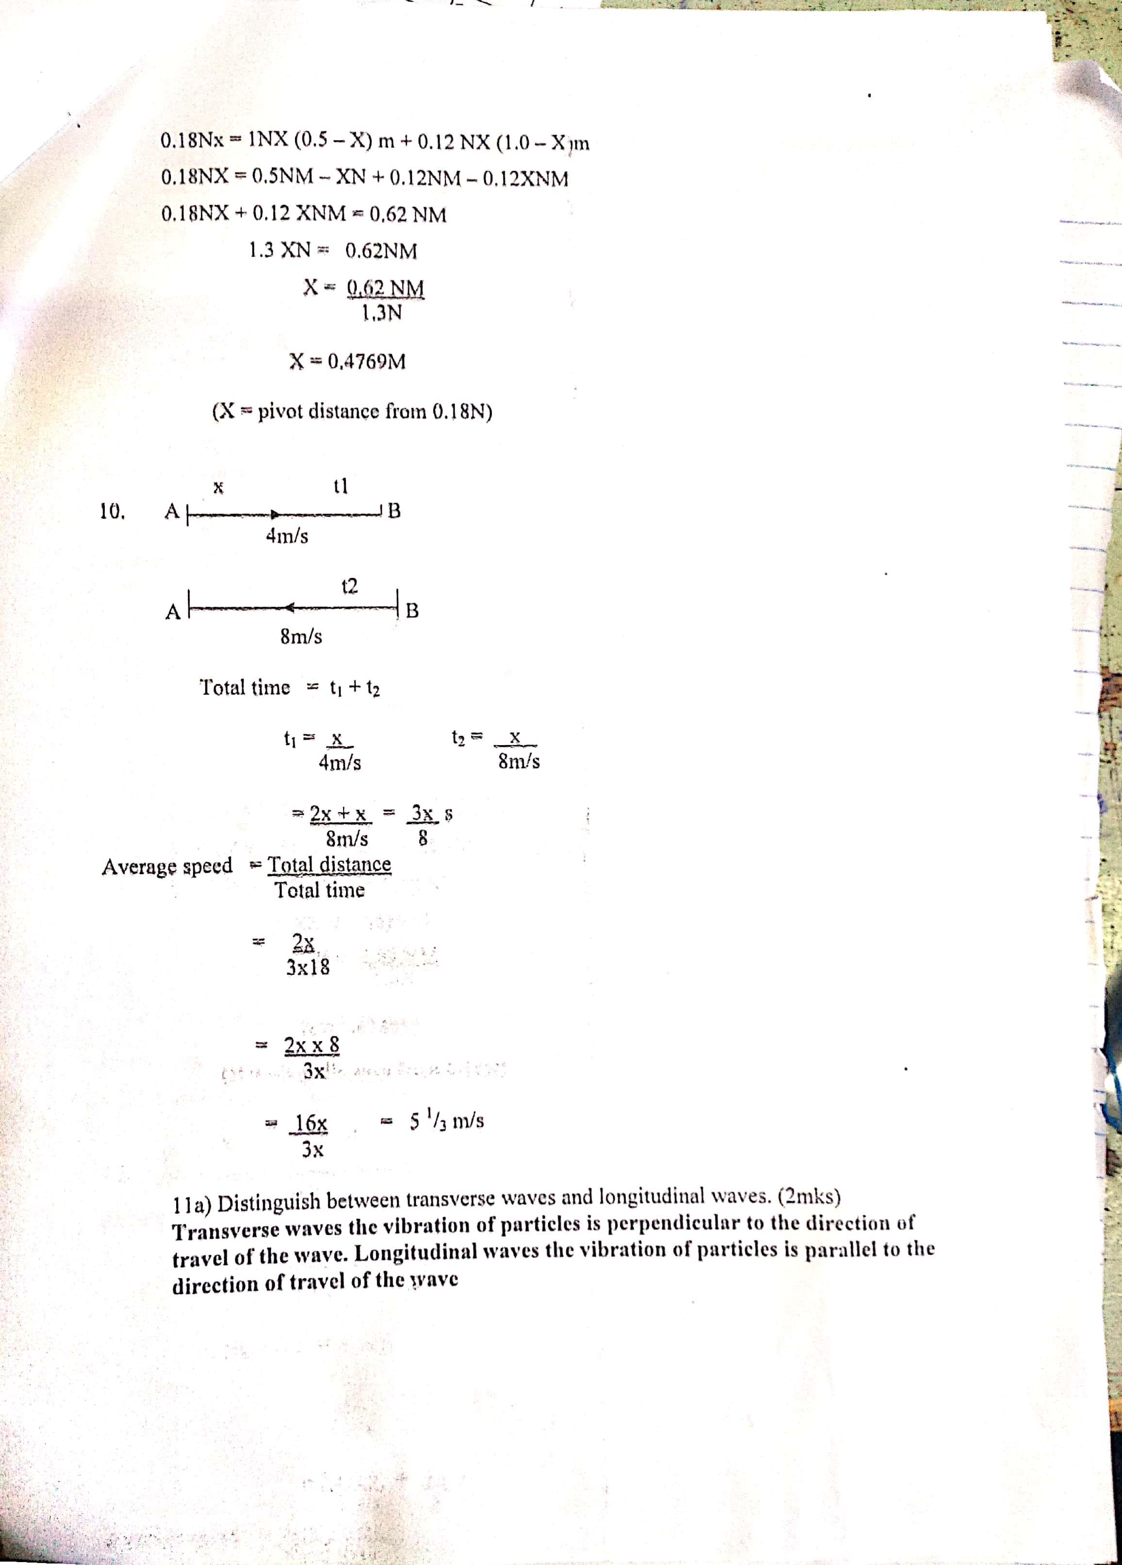
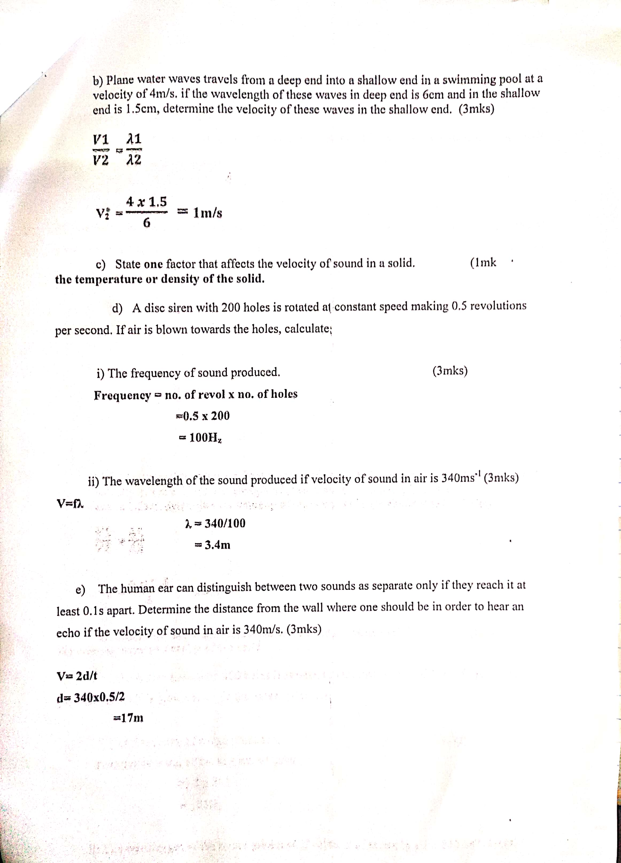
f) By covering seats, walls, the floor and the ceiling with soft sound absorbing materials heavy curtains and floor carpets.
12. (a) (i) V = $\frac{4}{3}$πr³
= $\frac{4}{3 }$ x 3.142 x (0.03)³
= 1.13112 x 10⁻⁴cm³
ii) A = πr²
= 3.142 x 10²
= 314cm²
- Volume of oil drop = volume of path
1.2322 x 10⁻⁴ = 314 x t
t= $\frac{{1.1311 x 10}^{-4}}{314}$
= 3.6023 x 10⁻⁷cm
(b) Oil drop is spherical.
(c) (i)Velocity of air at B is higher
(ii) Velocity is inversely proportional to pressure i.e. increase in velocity lower pressure
d) (i) A₁V₁ = A₂V₂ = constant
5 x 10⁻⁴ x 2 = 0.001m³/s
(ii) 0.001m³/s = 35 x 10-⁴ x V₂
V₂= $\frac{0.001}{{35x10}^{-4}}$
= 0.2857m/s
13. (a) When a body is in equilibrium, the sum of clockwise moments about the point is equal to the sum of anticlockwise moments about the same point.
(b) (i) Mass= density x volume
= 2.7gcm³ X 0.6 X 3 X 100cm³
= 486grams
Weight = $\frac{486 x 10}{1000}$ = 4086N
(ii) Taking moment about pivot,
F = $\frac{0.15 x 4.86}{0.2}$
F = 3.645N
Upward force = downward force
R = 3.645 + 4.86
R = 8.505N
(c) (i) The point of application of the resultant force due to the earth’s attraction on the body.
(ii) Position of c.o.g
Base area
iii)Stable
Unstable
Neutral
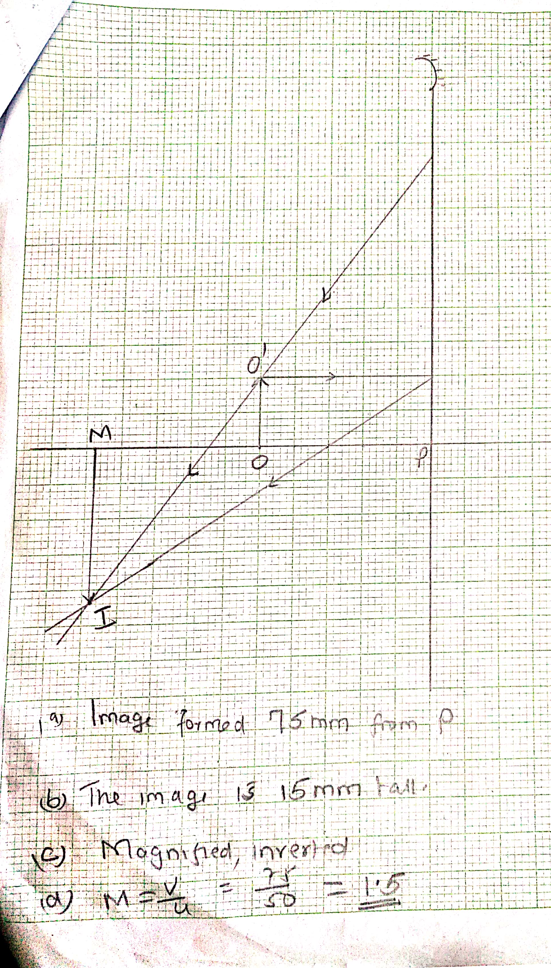 (b) The image is 15mm tall
(c) Magnified, inverted
(d) M =$\frac{v}{u}$ = $\frac{75}{50}$ = 1.5

