Name………………………………………………………………ADM NO…………………..
Candidate’s signature ………………………………………….. Date ……………………….
MALIET JOINT EXAMINATION

232/1
PHYSICS
PAPER ONE
MARCH 2019
2 HOURS

INSTRUCTIONS TO CANDIDATES
- Write your name, admission number in the spaces provided above.
- Sign and write the date of examination in the spaces provided above.
- This paper consists of TWO sections A and B.
- Answer ALL the questions in section A and B in the spaces provided.
- All workings MUST be clearly shown.
- Electronic calculators and mathematical tables may be used.
- ALL numerical answers must be expressed in decimal notation.
- This paper has 12 pages. It is the responsibility of the candidate to ascertain that all the pages are printed as indicated and that no questions are missing.
- Candidates should answer the questions in English.
For Examiners Use only
Section | Question | Maximum Score | Candidate’s Score
A | 1-12 | 25
B | 13 | 13
 | 14 | 10
 | 15 | 12
 | 16 | 13
 | 17 | 7
TOTAL |  | 80

SECTION A (25 MARKS)
- The figure below shows a micrometer screw gauge being used to measure the diameter of a ball bearing. A magnified portion of the scale is shown.

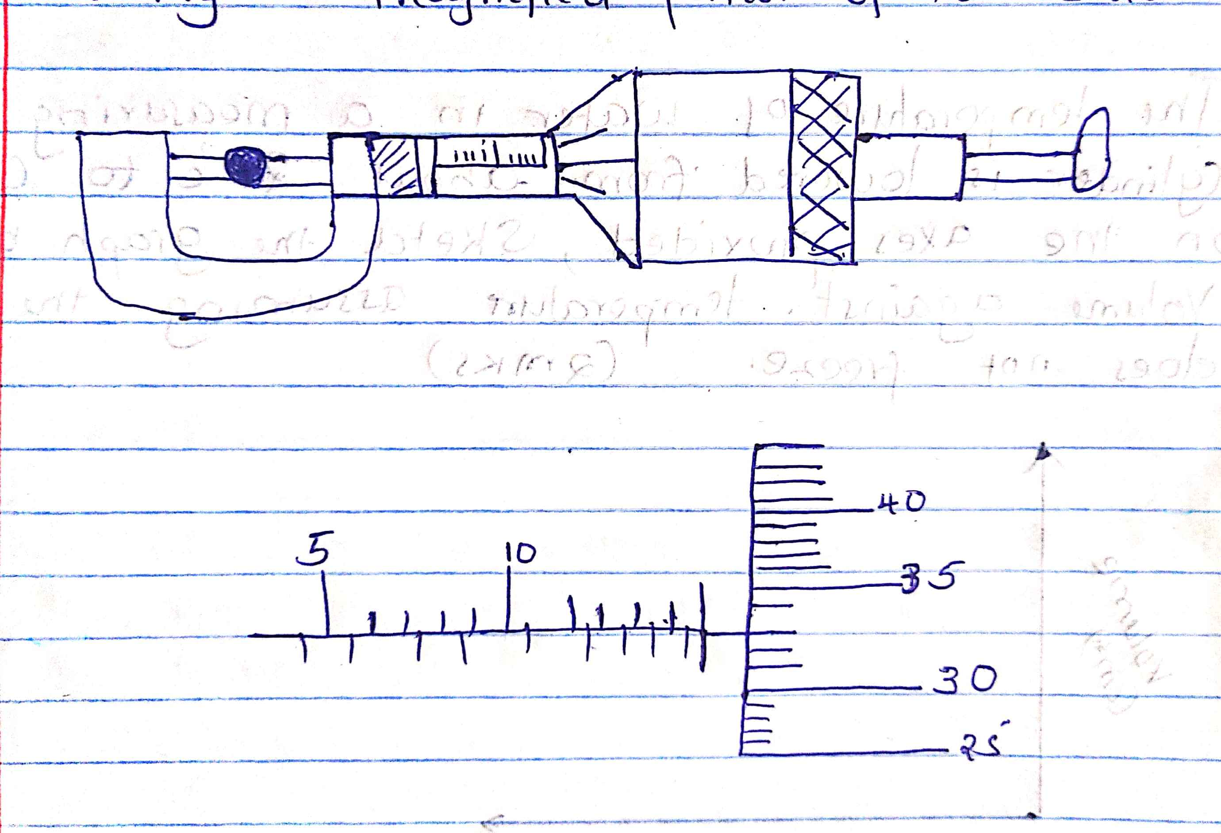
Record the diameter of the ball bearing. (2mks)

- The system in figure 2 is in equilibrium at room temperature. The system is taken outside where the temperature is 10ºC higher for sometime.

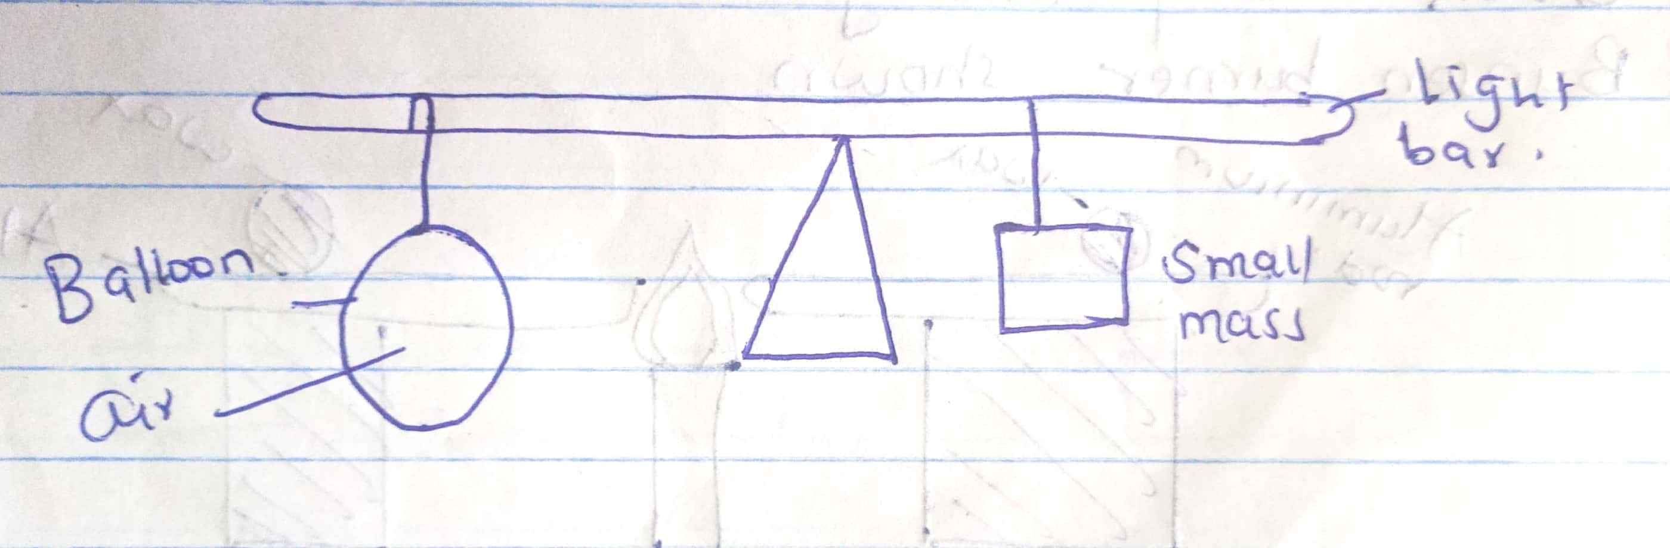
Explain why it tips to the right immediately it is returned to the room. (2mks)

- Give a reason why water is not suitable liquid for use in a barometer. (1mk)
________________________________________________________________________________________________________________________________________________________________________________________________________________________

- The temperature of water in a measuring cylinder is lowered from about 20ºCto 0ºC. On the axes provided, sketch the graph of the volume against temperature assuming the water does not freeze. (2mks)

Volume (cm³)

Temperature (ºC)

- Two identical aluminum rods are placed as shown in the figure below. One rests on a metal block and the other on the wooden block. The protruding ends are heated on a Bunsen burner as shown.
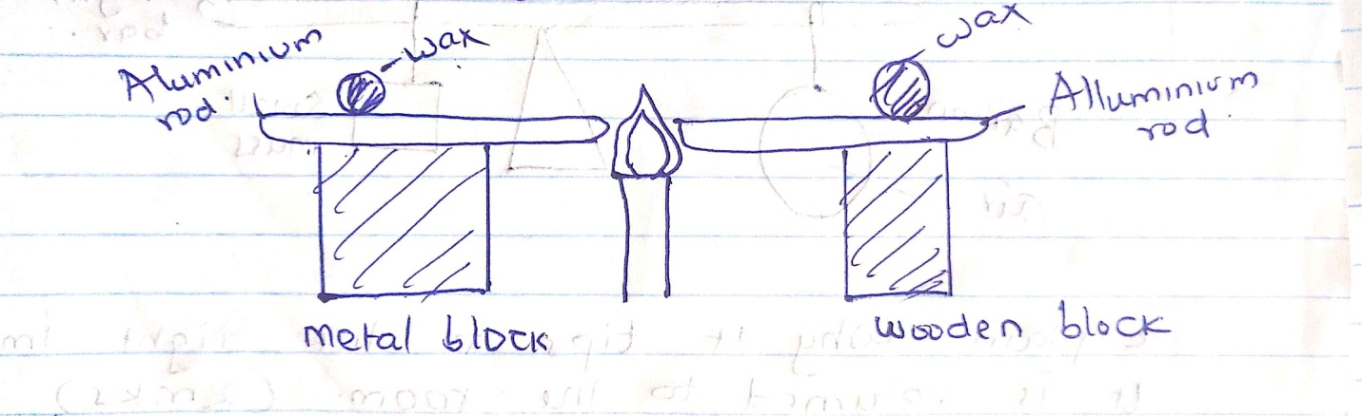
State with reason on which bar the wax is likely to melt. (2mks)
_______________________________________________________________________________________________________________________________________________________________________________________________________________________
- The figure below shows two mirrors inclined at an angle of 60º to each other. A ray of light is shown on one mirror as shown below.
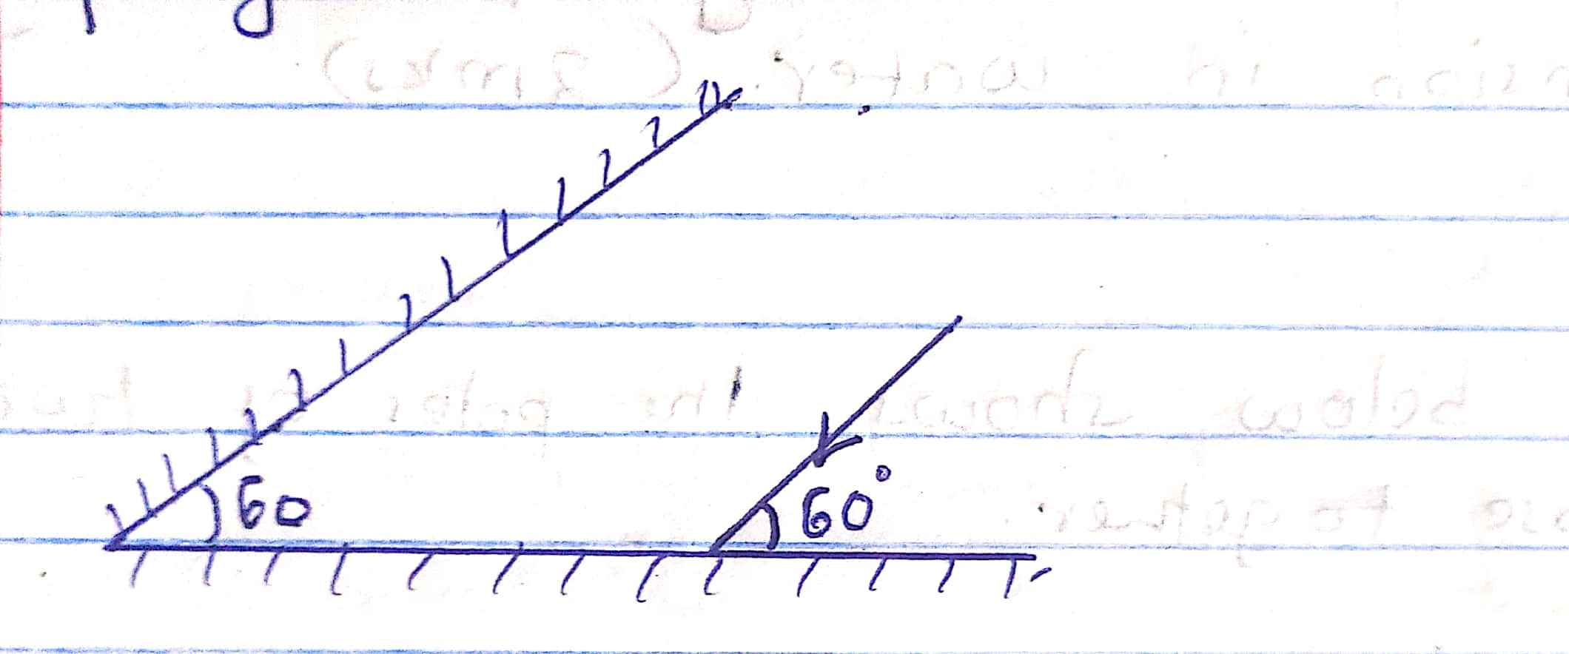
Sketch on the same diagram the path of the ray until it leaves the two mirrors. Indicate the angle at each reflection. (3mks)

- The figure below shows three spherical balls of the same size placed on insulating stands. Balls A and B are conductors while ball C is non conductor. Ball A was initially charged as shown. The quantity of charge is represented by the number of dashes.

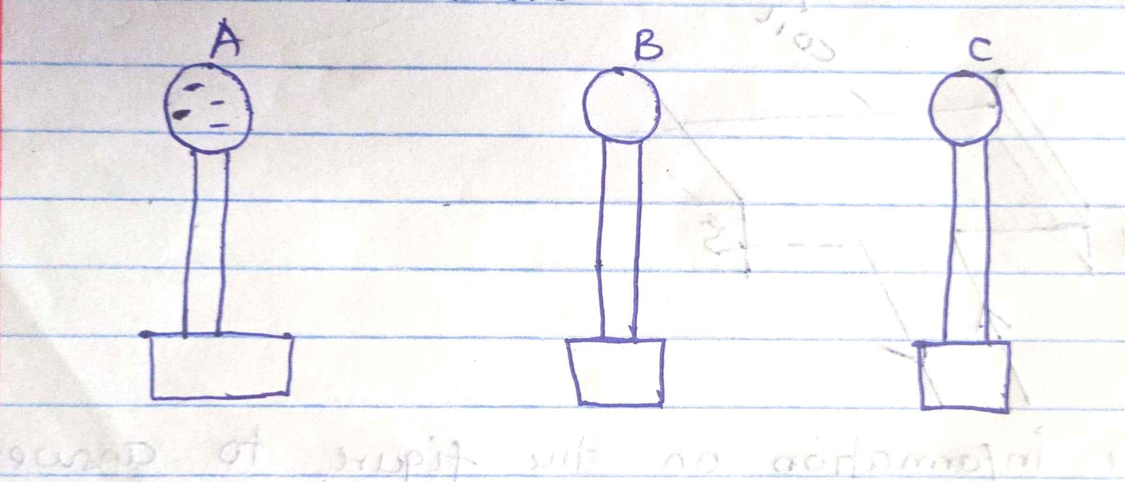
Ball A is made to touch B momentarily and then C. Show on the figure the final distribution of charge on the balls. (2mks)

- State the purpose of manganese dioxide in a dry cell. (1mk)
________________________________________________________________________________________________________________________________________________________________________________________________________________________
- State and explain one way of reducing surface tension in water. (2mks)
________________________________________________________________________________________________________________________________________________________________________________________________________________________
- The figure below shows the poles of two magnets close together.

N |  | N

Sketch the magnetic field pattern in the space between the poles. (1mk)

- The figure shows a current-carrying coil in a magnetic field.

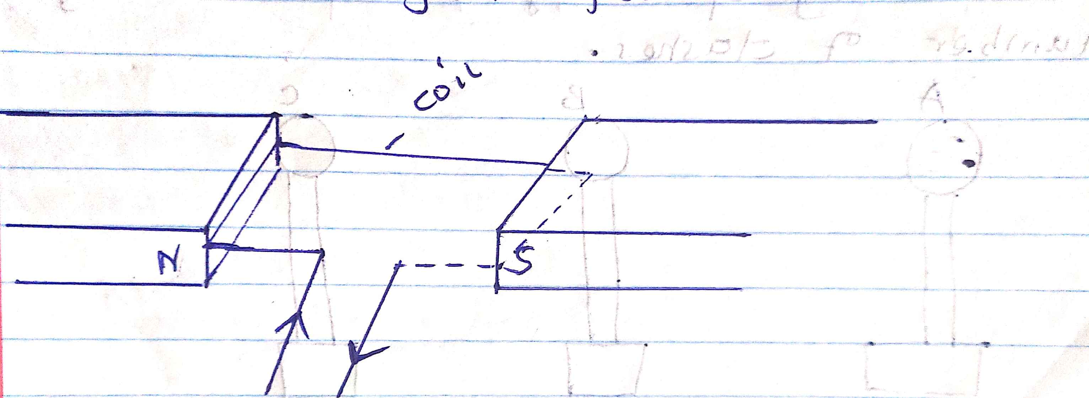

Use the information on the figure to answer the following questions.
- Mark on the figure the direction of the forces acting on the sides of the coil. (2mks)
- State two ways of increasing the force on the coil. (2mks)

- The figure below shows a system in equilibrium:
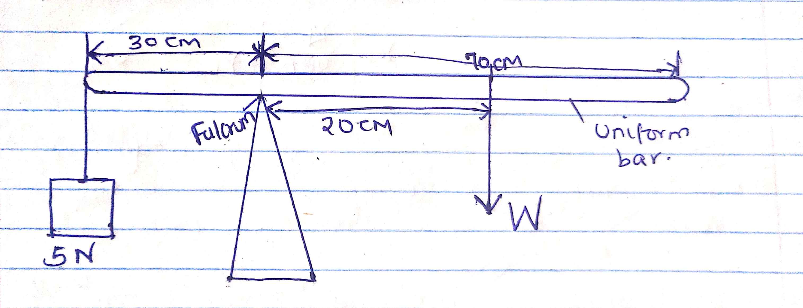

Determine the weight of the bar. (3mks)

SECTION B 55 MARKS
- (a) Define pressure and state its SI units. (2mks)

b) State Pascal’s principle. (1mk)

c) Give a reason why ink is most likely to ooze out of a pen when one is up an airplane. (1mk)

d) The figure below is a simple hydraulic machine used to raise heavy loads.
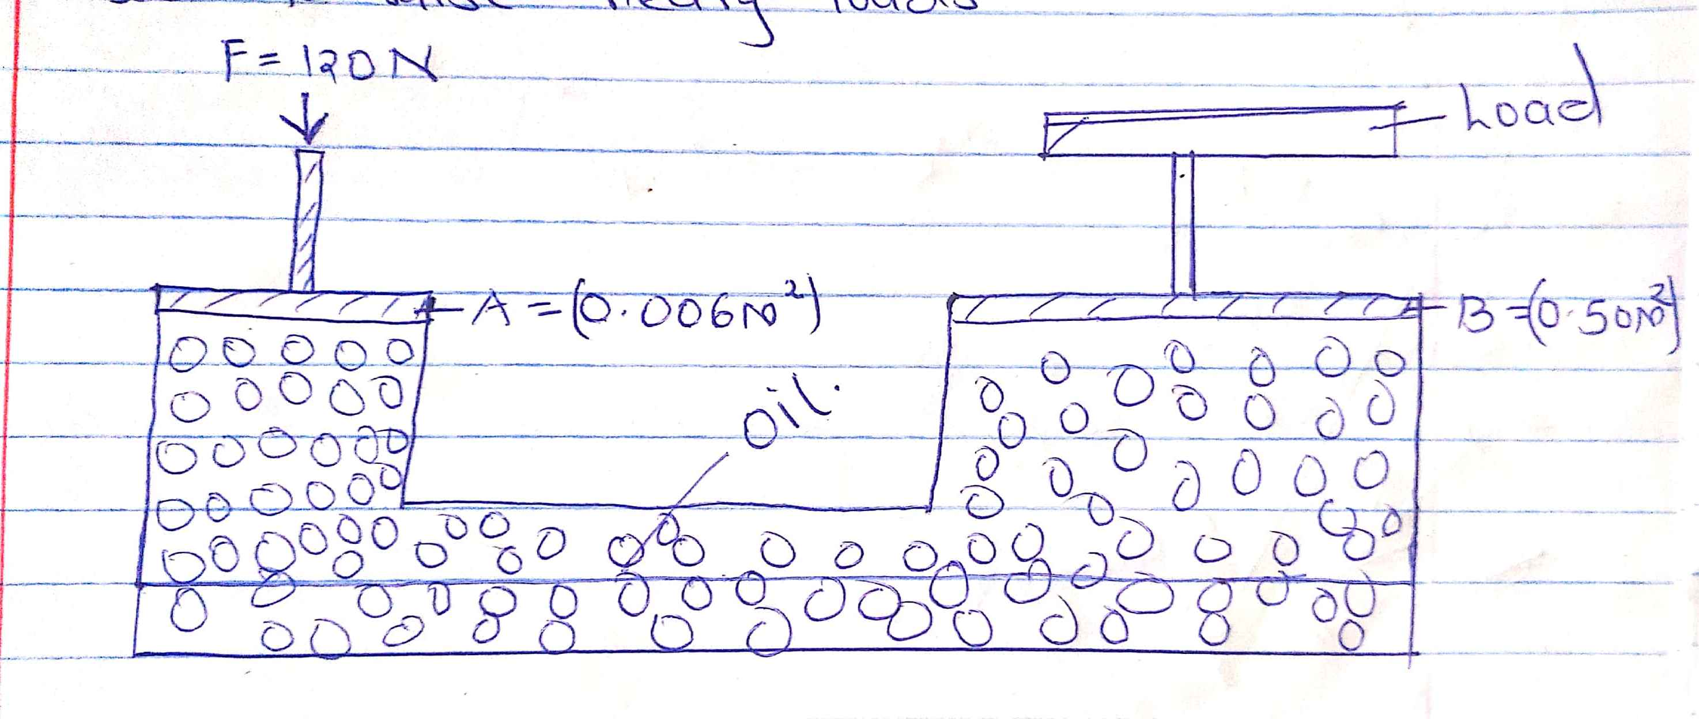

Calculate:-
- The pressure exerted on the oil by the force applied at A. (2mks)

- The load raised at B. (2mks)

- Give two properties which make the oil suitable for use in this machine. (2mks)

- The figure below shows a crate of mass 70kg being pushed by a man with a force of 150N along the plane. B
70kg

150N 2m

A C
- Show that V.R of the inclined plane is given by $\frac{1}{\sin{θ}}$ (2mks)

- Determine the work done:
- By the force of the man. (2mks)
- On the mass. (2mks)

- To overcome friction. (1mk)

- Determine the efficiency of the inclined plane. (2mks)

- Suggest one method of improving the efficiency of an inclined plane. (1mk)

- The following reading were obtained in an experiment to verify Hooke’s law using a spring.
Mass (g) | 0 | 25 | 50 | 75 | 100 | 125
Reading (cm) | 10.5 | 11.5 | 12.5 | 13.5 | 14.4 | 16.0
Force (N)
Extension (mm)

- Complete the table (2mks)
- Plot the graph of extension against force. (5mks)
- From the graph determine the:
- Elastic limit (1mk)

- Spring constant. (2mks)

- (a) The figure below shows an incomplete set up that can be used in an experiment to determine the specific heat capacity of a solid of mass m by electric method.
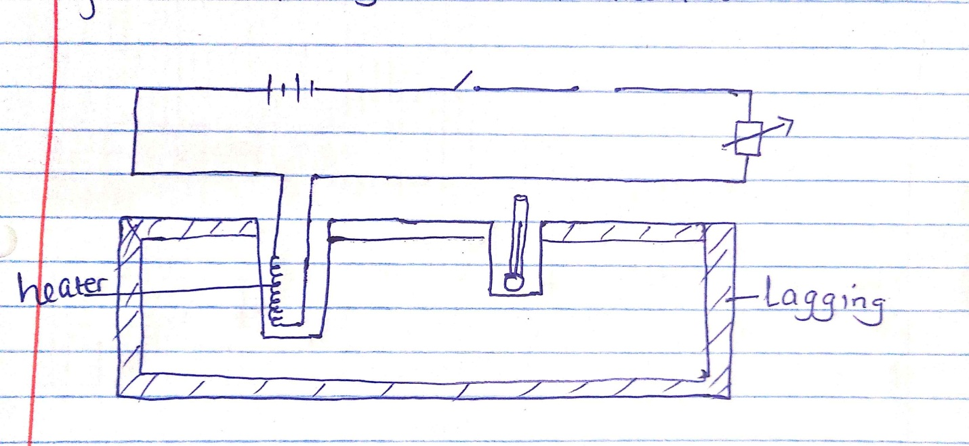
- Complete the diagram by inserting the missing component for the experiment to work. (2mks)
- State four measurements that should be taken. (2mks)

- The final temperature was recorded as $θ$. Write an expression that can be used to determine the specific heat capacity of the solid. (2mks)

(b) The figure below shows a graph of temperature against time for a 200g mass of ice at -14ºC slowly heated by an electric heater of power 30W.
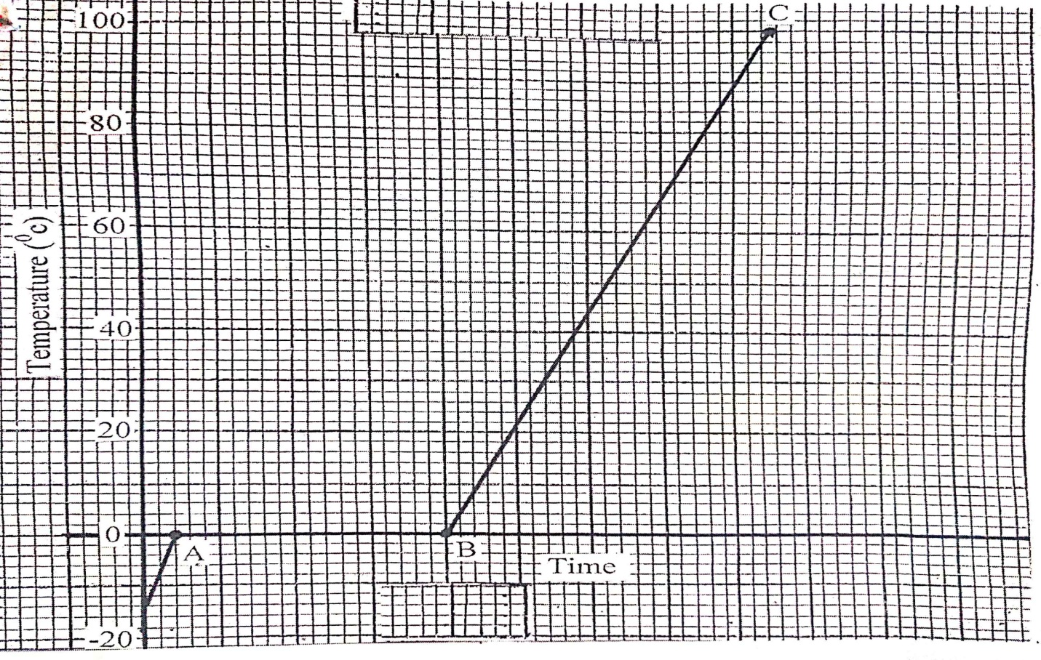

- Determine the:- (2mks)
- The time corresponding to the line AB. (2mks)

- The time corresponding to the line BC. (2mks)

- (i) State four differences between turbulent flow and streamline flow. (4mks)

- State the principle of continuity. (1mk)

- Water flows along a horizontal pipe of cross-section area 30cm². The velocity of the water is 4m/s but it reaches 7.5m/s in a constriction along the pipe. Calculate the cross-section area of the constriction. (2mks)

FORM 4 MALIET JOINT EXAMINATION
PAPER 1
MARKING SCHEME 232/1
SECTION A
- 15.50 + 0.33 = 15.83mm
= 1.583cm (2mks)
- Air in the balloon expands/ volume of balloon increases; displaces more air raising the upthrust of air.
- Density of water is low/ it will result to a very long barometer/ very long tube.

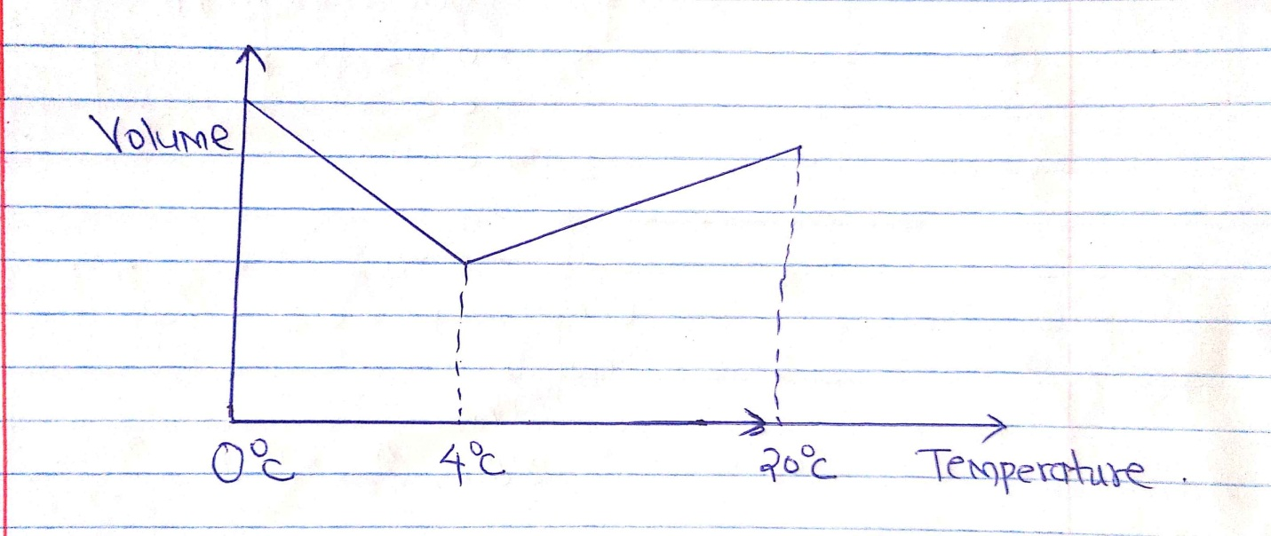

- Wooden block
Wooden block is a poor conductor of heat goes in melting the wax.
- Check correct rays with arrows.
At least one angle on each reflecting surfaces must be marked.

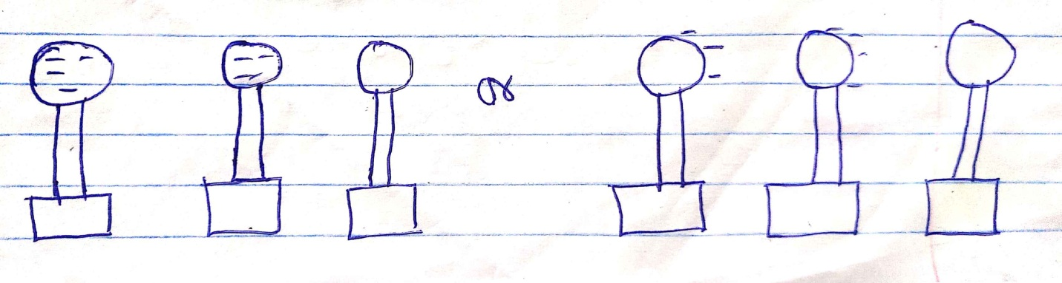
- To depolarize, oxidizer/ reduce polarization/ oxidizes H₂ to H₂O.
- Adding detergent/ impurities / increasing temperature/ heating (1mk)

- 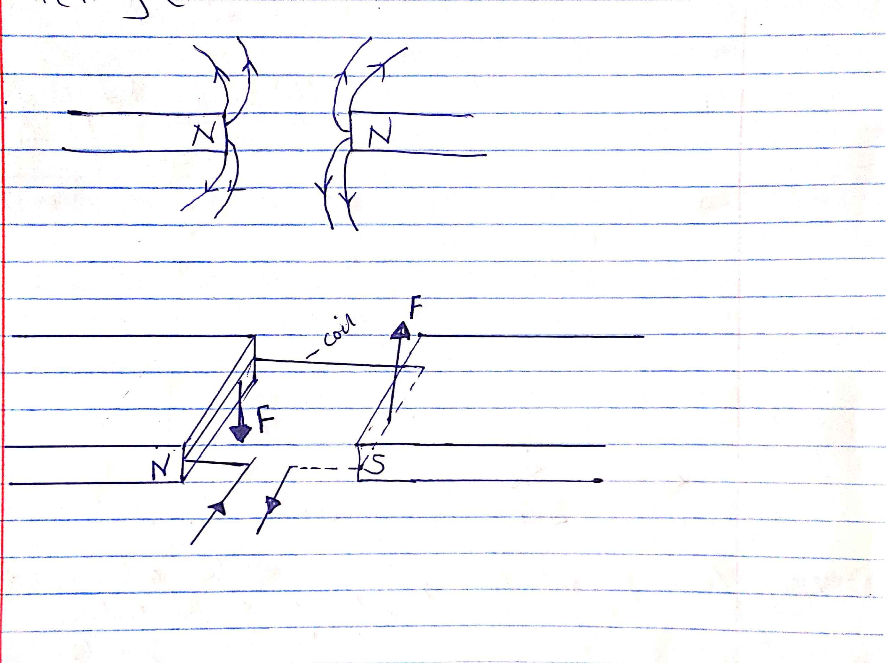

- Sum of clockwise moment = sum of anticlockwise moment
W x 20 = 30 x 5
$\frac{20W}{2}$ = $\frac{150}{20}$
W = 7.5N.

- (a) Pressure is a force acting normally or perpendicularly per unit area. SI unit N/M² or Pascals.
(b) Pressure applied at one part of a fluid is uniformly transmitted throughout the enclosed fluid.
(c) The pressure in the pen is higher than that outside the pen (atmospheric pressure). This causes the ink to flow outwards due to difference in pressure.
(b) (i) P = $\frac{F}{A}$ = $\frac{120}{0.006}$
= 20,000 NM⁻²
ii) F = P x A
20,000 x 0.50
10,000N
iii)Should be incompressible
Should be non-corrosive
Should have high boiling point and low melting point.
c) h₁e₁g = h₂e₂g
1360 x 1.25 = ($\frac{74-x}{100}$) x 13600
X = 61.5cm
- V.R = $\frac{12}{2}$ = 6
Sin $θ$ = $\frac{2}{12}$ = $\frac{1}{6}$
$\frac{1}{sinθ}$ = 6 = V.R

(b) (i) W = Fd
= 150 x 12 = 1800J
ii) W = mgh
70 x 10 x 2 = 1400J.

iii)1800 – 1400 = 400J
c) = $\frac{1400}{1800}$ x 100 = 7.78%
= 77.8%
d) Lubrication / use of rollers
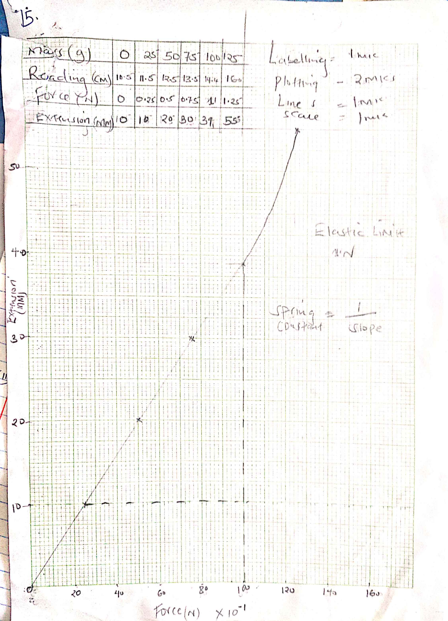
16(i) Ammeter, voltmeter
ii) Voltage
Current
Time
Temperature (initial)
iii)VIt = Mc($θ-θ) θ$- initial temperature
I (i) Pt = MLf
30t = 336000 x 0.2
t= $\frac{336000 x 0.2}{30}$
= 2240s
(ii) pt = MCD $θ$
30t = 0.2 x 4200 x 100
t= $\frac{0.2 x 4200 x 100}{300}$
= 2800s
III Small square = $\frac{2240}{18}$ = 124.4s
Pt = McD$θ$
30 x 124.4 x 2 = 0.2 x c x 14
C = $\frac{7464}{2.8}$
= 2666 J/kgk
17. (i)
Streamline | Turbulent
Flow is smooth | Flow is rough
Successive fluid particles through a point have same velocity | Successive particles through a point have different velocities
Pattern of streamline is regular streamline flow does not | Pattern for streamline is regular
Have a drag effect | Turbulent flow has a drug effect.

ii) For an incompressible fluid whose flow is steady, the flow rate (AV) is constant.
(iii A₁V₁ = A₂V₂
30 x 4 = 75 x A₂
A₂ = $\frac{30 x 4}{7.5}$
= 16cm²

