NAME …………………………………………………………………………………………
SCHOOL ……………………………………………………………………………………..
ADM NO …………………………… SIGNATURE …………….. DATE ………………..
Kenya Certificate of Secondary Education
FROM 4 PHYSICS
MARCH 2019
232/2
TIME: 2 HOURS
INSTRUCTIONS TO CANDIDATES
- Answer all the questions in the spaces provided.
- The paper consists of section A and B.
- All workings must be clearly shown.
- Mathematical tables and electronic calculators may be used.
FOR EXAMINER’S USE ONLY
SECTION | QUESTION | MAXIMUM SCORE | STUDENT’S SCORE
A | 1-10 | 25
B | 11 | 09
 | 12 | 8
 | 13 | 9
 | 14 | 16
 | 15 | 13
TOTAL SCORE |  | 80

SECTION A
- State the number of images formed when an object is placed between two plane mirror placed in parallel. (1mk)

- An un-magnetized steel rod is clamped facing North-south direction and then hammered repeatedly for sometime. When tested, it is found to be magnetized. Explain this observation. (2mks)

- The figure below shows how the displacement varies with time for a certain wave.

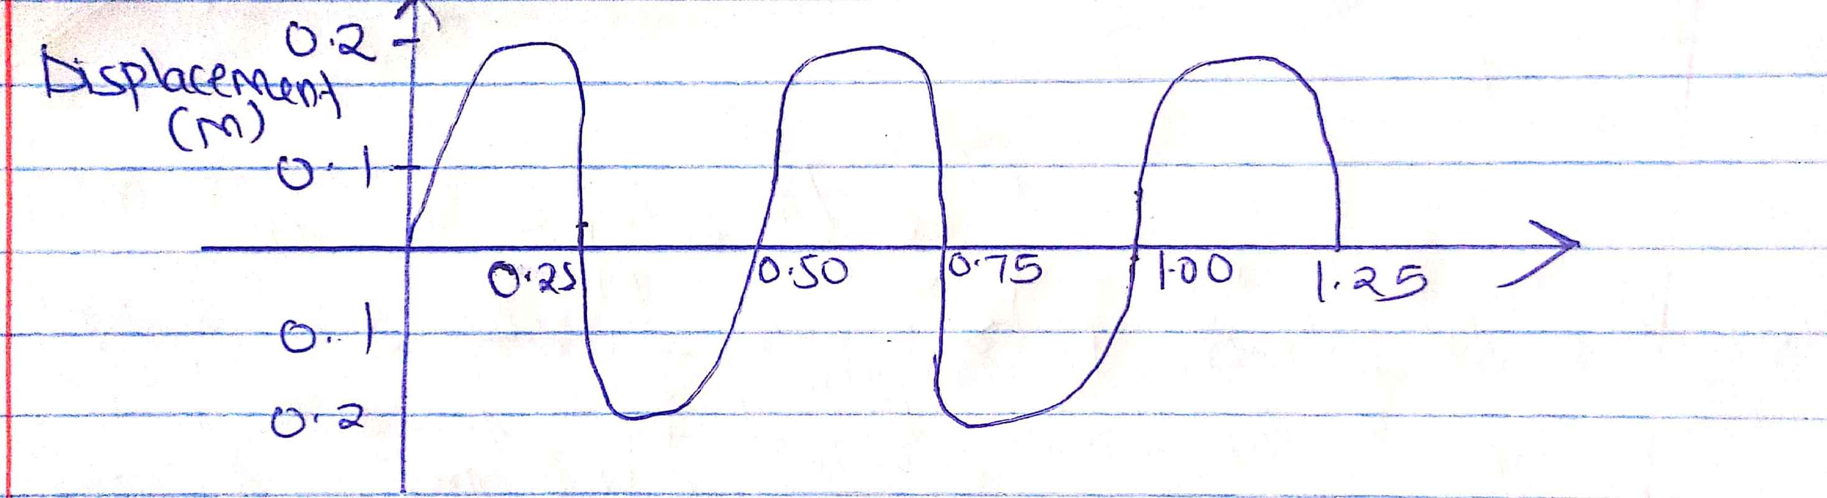

Determine the frequency of the wave. (3mks)

- The figure below shows an electric circuit. The current through 18Ω is 2A.
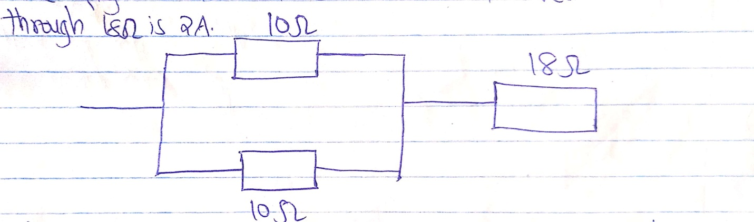
State the value of the current through each of the 10Ω resistors. (1mk)

- A heating coil is rated 100W, 240v. At what rate would it dissipate energy if it is connected to a 220V supply? (3mks)

- The figure below shows how rays from a distant and a near object are focused inside a human eye with a certain defect.
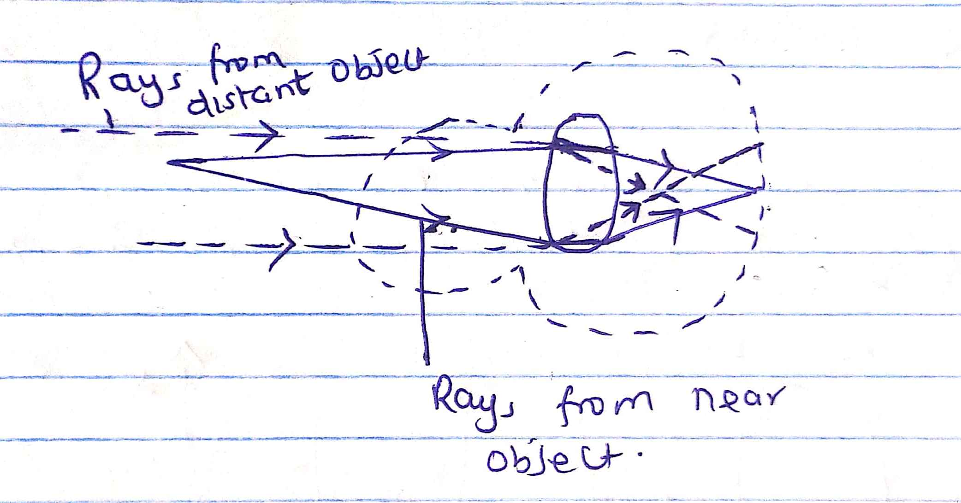
Name the defect and state the cause of this defect.
- Defect (1mk)

- Cause of defect. (1mk)

- A boy standing in front of a cliff blows a whistle and hears the echo after 0.5s. he then moves 17 metres further away from the cliff and blows the whistle again. He now hears the echo after 0.6s. Determine the speed of sound. (3mks)

- The distance between an object and its real image produced by a concave mirror is 20cm when the object is placed 10cm from the pole of the mirror. Determine the:
- Linear magnification of the image. (2mks)
- The focal length of the mirror. (2mks)

- Determine the speed of light in water given that the speed of light in air is 3.0 x 10⁸ m/s and the refractive index of water is 1.33. (3mks)

- Give a reason why it is necessary to leave the caps of the cells opened while charging an accumulator. (1mk)

SECTION B (55 MARKS)
Answer all the questions in this section in the spaces provided.
- (a) Figure 7 shows a pair of parallel plates of a capacitor connected to a batter the upper plates is displaced to the left.
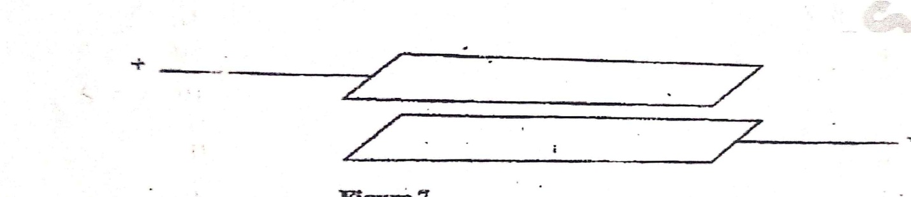
State with reason the effect of this movement of the capacitance. (2mks)

b) Figure 8 shows an electric circuit with three capacitors A, B and C of capacitance 4.0µF, 5.0µF and 3.0µF respectively connected to a 12V battery. Determine:

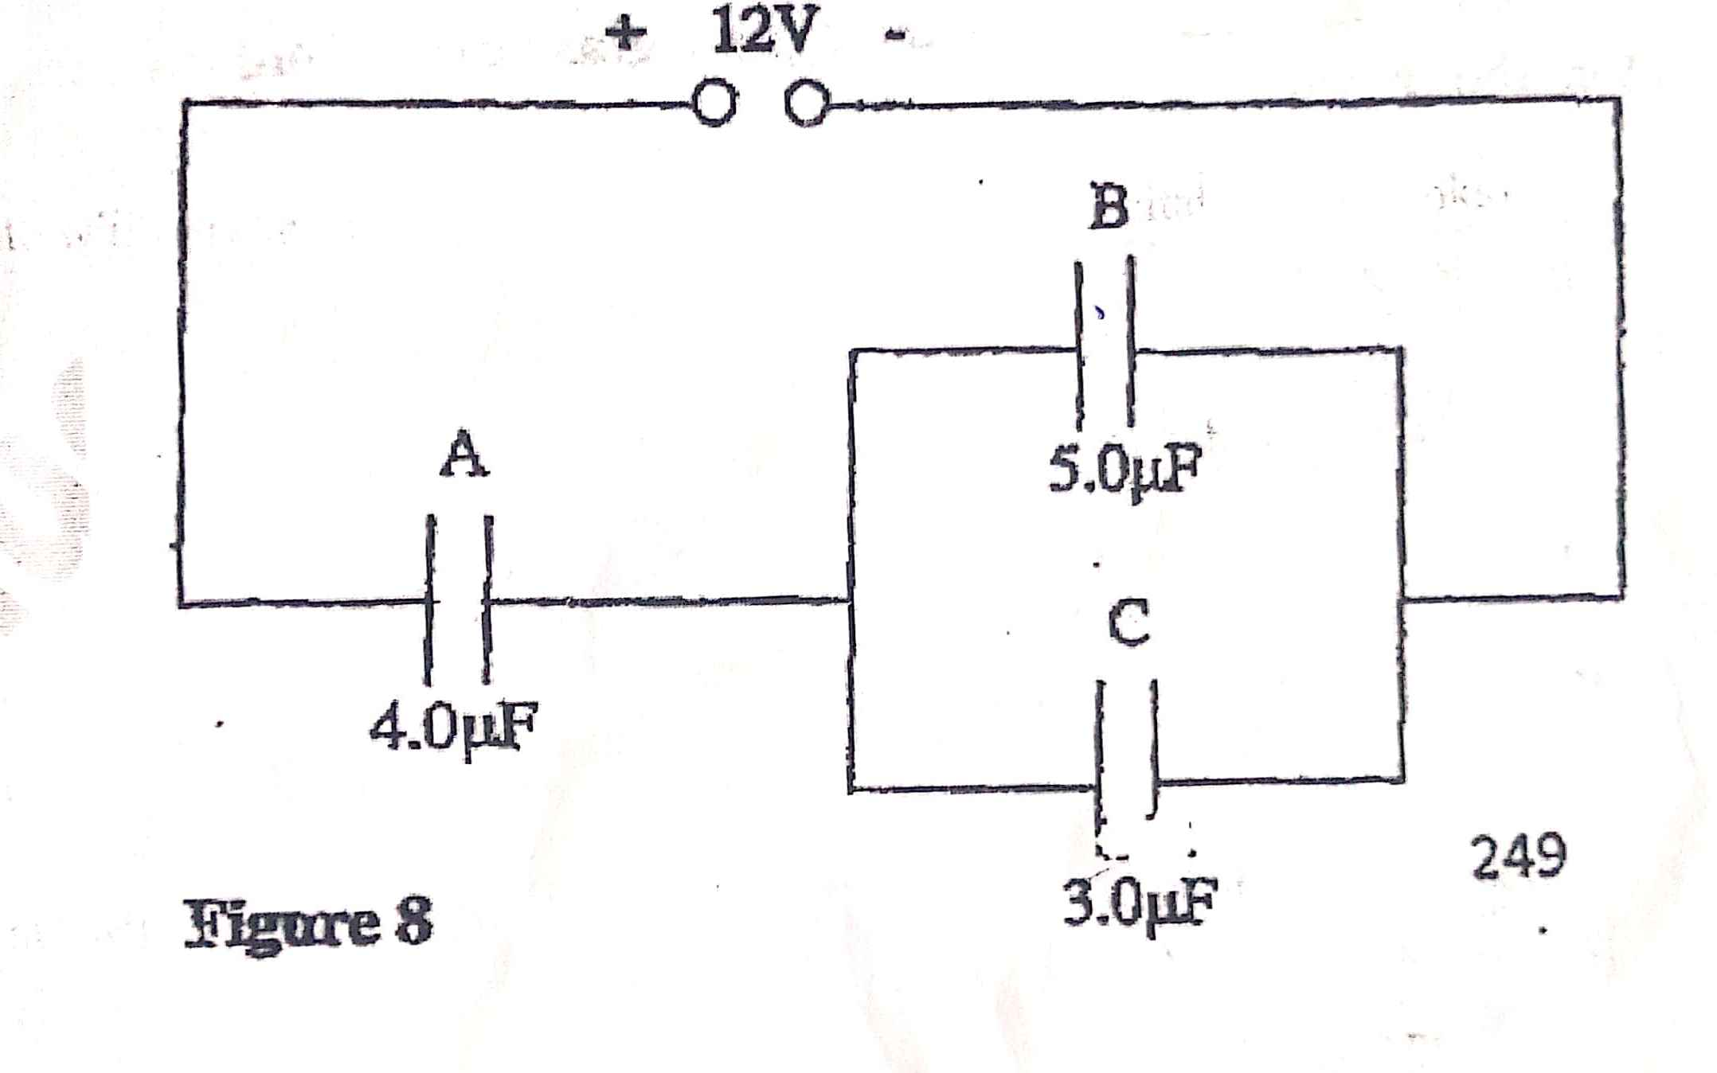
- The combined capacitance of the three capacitors. (3mks)
- The charge of the capacitor A (2mks)
- The potential difference across the capacitors B. (2mks)

- A bullet of mass 24g travelling in a horizontal path with a velocity of 450ms⁻¹ strikes a wooden block of wood of mass 976g resting on a rough horizontal surface. After impact, the bullet and the block move together for a distance of 7.5m before coming to rest.
- Name the type of collision which takes place above. (1mk)

- What’s the velocity of the two bodies when they start sliding. (2mks)

- Calculate the force which brings the two bodies to rest. (3mks)

- Determine the coefficient of friction between the block and the surface during this motion. (2mks)

- A stone is projected vertically upwards with a velocity of 30m/s from the ground. Calculate:
- The time it takes to reach the maximum height. (2mks)

- The time of flight. (2mks)

- The maximum height reached. (2mks)

- The velocity with which it lands on the ground (take g=10m/s²) (3mks)

- In an experiment to determine the refractive index of a transparent material in form of a rectangular block, the following results were obtained.
Angle of incidence (i) | Angle of refraction (r) | Sin i | Sin r
100º | 5.0 º
20 º | 9.8 º
30 º | 14.5 º
40 º | 18.7 º
50 º | 22.5 º
60 º | 25.7 º
- Complete the table. (4mks)
- Plot a graph of sin r (y-axis) against sin i and calculate the refractive index of the material from the graph. (7mks)
- Determine from the graph the angle of refraction for which the angle of incidence is 36 º. (2mks)

- Calculate the angle beyond which total internal refraction will occur for light travelling from the material to another one of refractive index 1.5 (3mks)

- (a) State Pressure Law. (1mk)

b) The following diagram shows a set up of apparatus used to verify Charles Law.
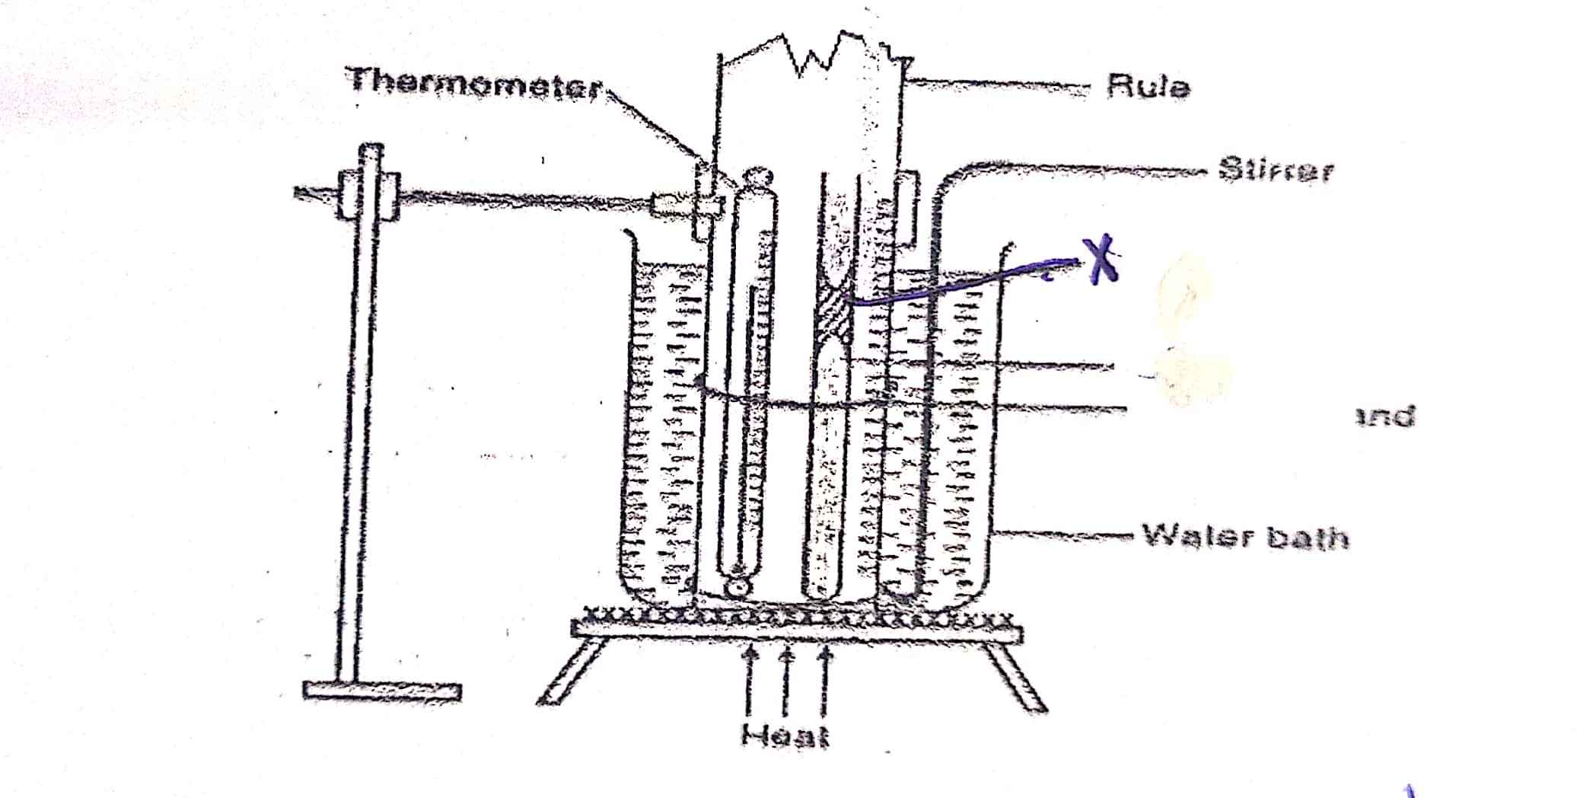
- Give the name of part labeled X and state Charles law. (2mks)

- What is the function of the part named in (i) above? (1mk)

- Briefly explain how to set up above is used to verify Charles Law. (4mks)

- A certain mass of hydrogen gas occupies a volume of 1.6m³ at a pressure of 1.5x10⁵Pa and a temperature of 12 ºC. Determine the volume when the temperature is 0 º C at a pressure of 1.0x10³Pa. (2mks)

- Differentiate between an ideal gas and real gas and define what absolute temperature is. (3mks)

FORM 4 PHYSICS MALIET JOINT EXAMINATIONS TERM I 2019
232/2
MARKING SCHEME
- Infinite
- Hammering causes the domain or dipoles to vibrate when settling, some domain align themselves in the N-S- direction due to the earths magnetic field causing magnetization.
- Period T = 0.5sec
F = $\frac{1}{T}$ = $\frac{1}{0.5}$ = 2H
- $\frac{2A}{2}$ = 1A
- $P$ = $\frac{V^{2}}{R}$
100 =$\frac{{220}^{2}}{{204}^{2}}$
R = $\frac{{240}^{2}}{100}$
E = 84J/S
- Short sightedness / myopia
Extended eyeball / lens has short focal length / eye ball too long
(any two)
- $\frac{2d}{0.5}$ = $\frac{2d}{0.6}$ + 34
D = $\frac{17}{2}$ = 85m
Speed = $\frac{2 x 85}{0.5}$
= 340 m/s or
V = $\frac{d}{t}$
$\frac{17 x 2}{0.1}$
= 340m/s
- (a) u = 10cm
V = 30cm
M =$\frac{v}{u}$ = $\frac{30}{10}$ = 3
(b) $\frac{1}{f}$ = $\frac{1}{v}$ + $\frac{1}{u}$
= $\frac{1}{30}$ + $\frac{1}{10}$
= $\frac{1+3}{30}$ = $\frac{4}{30}$
F = $\frac{30}{4}$
F = 7.5cm
- n=$\frac{speed of light in air}{speed of light in media}$
1.33 = $\frac{{3 x 10}^{8}}{v}$
V = $\frac{{3 x 10}^{8}}{1.33}$
= 2.26 x 10⁸ m/s
- To release gases
Release H₂ and O₂ produced at the electrodes.
SECTION B
- (a) Capacitance decreases
Area of the overlap decreases.
(b) (i) Parallel, cp = 5+3 = 8
Whole circuit $\frac{1}{4}$ + $\frac{1}{8}$ = $\frac{16}{6}$ = 2.6µf
C= 2.6 µf
- Q = cv
= 4 x 12 x 10⁻⁶
= 48 x 10⁻⁶c
- V = $\frac{Q}{C}$ = $\frac{{48 x 10}^{-6}}{{5 x 10}^{-6}}$
= 9.6^{v}
- (a) Inelastic collision
(b) m₁u₁ + m₂u₂ = (m₁m₂)v
$\frac{22}{1000}$ X 450 + $\frac{976}{1000}$ X 0 =( $\frac{976}{1000}$ + $\frac{26}{1000}$)v
V = 10.8ms⁻¹
(c) V² = u² + 2 a s
0 = 10.8² + 2 X a X 7.5
a= $\frac{{-10.8 }^{2}}{15}$
a= -7.776 ms⁻¹
F = ma = 1 x -7.776 ms⁻¹
F = -7.776N

(d)F = µR = µmg
= ma = µ x 1 x 10
µ= $\frac{1 x 7.776}{10}$
µ= 0.7776
- (a) T = $\frac{u}{g}$ = $\frac{30}{10}$ = 3 sec
(b) T = 2t
2 x 3 = 6 sec OR
$\frac{2u}{g}$ = $\frac{2 x 30}{10}$ = 6 sec
$(c)$ H = $\frac{u^{2}}{2g}$
$$\frac{30 x 30}{2 x 10}$$
= 45 m
(d)V² = u² – 2gs
S=O
V² = u²
= 30 x 30 = 900
V= $\sqrt{30 x 30}$
= 30 m/s

Sin i | Sin r
0.1736 | 0.0872
0.3420 | 0.1702
0.5 | 0.2504
0.6428 | 0.3206
0.7660 | 0.3827
0.866 | 0.4337
d) _{M1}N_{m2} = $\frac{\sin{c}}{\sin{90}}$
sin c = $\frac{1}{n}$
sin c = $\frac{1}{1.5}$
c = sin 1 $\frac{1}{1.5}$

- (a) The pressure of a fixed mass of gas is directly proportional to its absolute temperature provided volume is kept constant.
(b) (i) Sulphuric acid index.
(ii) – A drying agent
- Indicate the volume of gas
(iii)- The apparatus are set up as shown and the water bath heated.
- The temperature and volume/length of index is recorded at regular intervals of time.
- A graph of volume f versus absolute temperature is drawn and graph analysed.
- A straight line cutting the temperature axis at about -273k is obtained; hence volume is directly proportional to absolute temperature.
(c) P₁V_{1/}T₁ = P₂V_{2/}T₂
1.5 x 10⁵ X 1.6/ 285 = 1.0 X 10³ X V₂/273
V₂ = 1.5 x 10⁵ x 1.6 x 273 / (2.85 x 1.0 x 10³)
= 229.89m³

