NAME …………………………………………………………………………………………
SCHOOL ……………………………………………………………………………………..
ADM NO …………………………… SIGNATURE …………….. DATE ………………..
Kenya Certificate of Secondary Education
MALIET JOINT EXAM
FORM 4 PHYSICS
MARCH 2019
232/3
TIME: 2½ HOURS
INSTRUCTIONS TO CANDIDATES
- Write your name and index number in the spaces provided.
- Answer all questions in the spaces provided in the question paper.
- You are supposed to spend the first 15 minutes ½ hours allowed for this paper reading the whole paper carefully.
- Marks are given for a clear record of the observation actually made, their suitability, accuracy and the use made of them.
- Candidates are advised to record their observations as soon as they are made.
- Record your observations as soon as you make them.

- You are provided with:
- A resistance wire mounted on millimeter scale
- Two dry cells in a cell holder
- A voltmeter
- Four connecting wires, one with a crocodile clip at one end
Proceed as follows:-
- Set up the circuit as in the figure below and determine the total electromotive force E, of the cells. 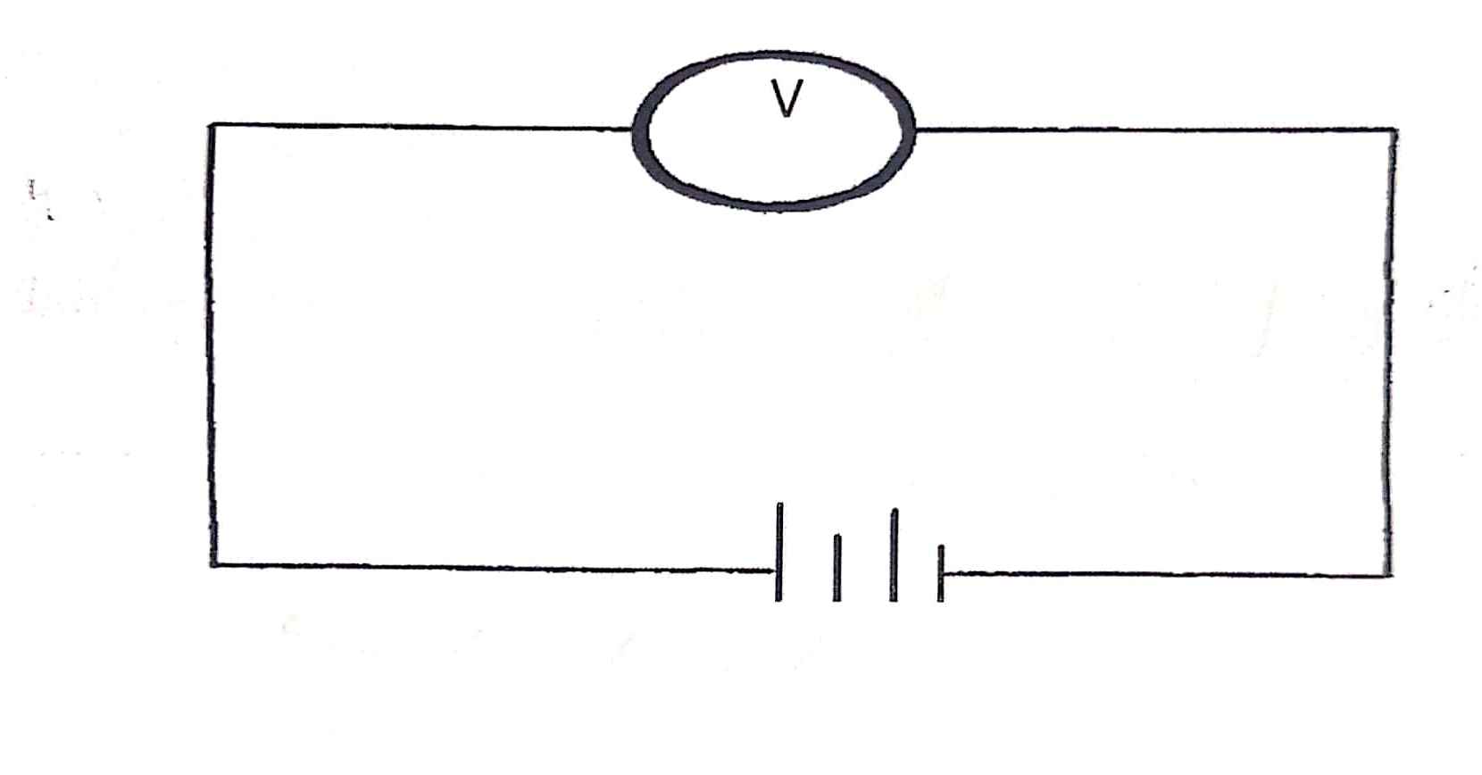
Electromotive force E, of the cells ……………………….. Volts

- Set up the circuit shown in the figure below, connect the wire with clip on the mounted wire at a length (L) of 10cm from the end marked A. Record the voltmeter reading in the table provided in part (c) below:

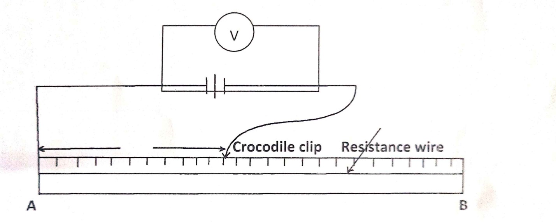

- Repeat the procedure in (b) above for the following values of length L: 20cm, 30cm, 40cm, 50cm, and 60cm and complete the table below: (5mks)
L(cm) | V(volts) | E-V(volts) | $$\frac{V}{E-V}$$
10
20
30
40
50
60

- Plot a graph of $\frac{V}{E-V}$ against L(cm. (5mks)
- Determine the slope of the graph. (3mks)

- Given the equation $\frac{V}{E-V}$ = K₁L₁ + K₂. Determine the values of K₁ and K₂. (3mks)

K₁……………………………………….. K₂…………………………………………..
- Given that 4K₂r = 10 where r is the internal resistance of the cells. Determine the value of r. (3mks)

- You are provided with the following apparatus.
- A candle
- A lens holder
- A convex lens
- A screen
- A metre rule
- An object
Proceed as follows
Using an object at infinity outside the room, focus its image on the screen provided. The image should be as sharp as possible and inverted. Measure the distance from the lens to the screen hcm. Repeat the same for three other values of H. Record your results and then calculate the average value of the three results, Hcm.
First reading of h…………………………………………………………………………. (1mk)
Second reading of h …………………………………………………………………… (1mk)
Third reading of h …………………………………………………………………….. (1mk)
The average value of h(H) …………………………………………………………….. (1mk)

Arrange the candle flame, the lens, and the screen as shown in the diagram below:
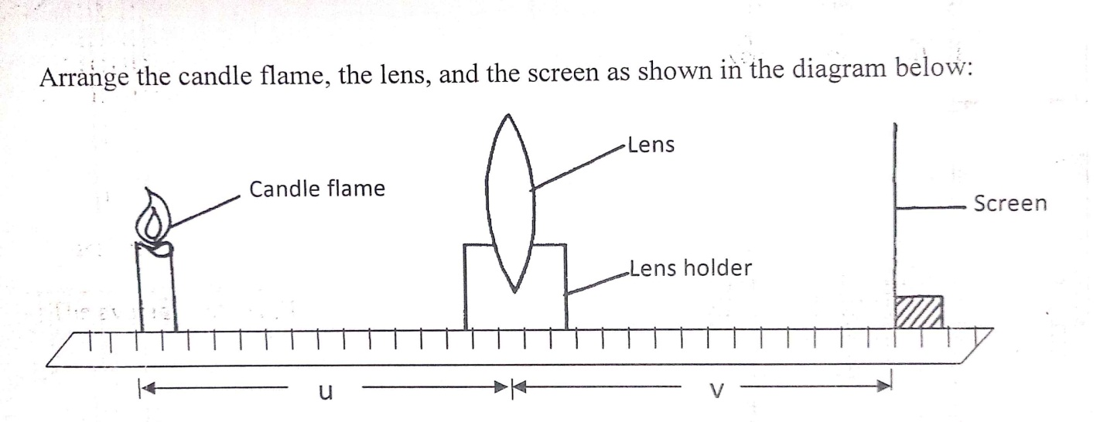
b) (i) For particular Value of u, adjust the position of the screen until a sharp image appears on the screen. Measure distance Vcm. Repeat the experiment for each of the other values of u, and enter the results in the table below: (7mks)
Distance L (cm) | Distance V (cm) | uv (cm²) | U + v (cm)
12
15
18
21
24
27
30

ii) Plot a graph of uv against u+u (5mks)
iii) From your graph, calculate the slope S. (2mks)

iv) Calculate the value of k given that kH=S. (2mks)

MALIET JOINT EXAM
FROM 4 PHYSICS
MARCH 2019
232/3 MARKING SCHEME
