MARANDA HIGH SCHOOL
Kenya Certificate of Secondary Education
MOCK EXAMINATIONS 2022

443/2 Agriculture Paper 2
September, 2022 Time: 2 Hours

Name: ………………………………………….…….…… Adm No: ………………
Class: ………………Candidate’s Signature: ………..…….. Date: 9th September, 2022.
Time: 2.00-4.00 PM

INSTRUCTIONS TO CANDIDATES
- Write your name, index number, admission number and class in the spaces provided.
- Sign and write the date in the spaces provided above.
- Answer all the questions in section A and B.
- Answer any two questions in section C.
- Answers should be written in the spaces provided.
- This paper consists of 10 printed pages.
- Candidates should check the question paper to ascertain that all the pages are printed as indicated and that no questions are missing.

FOR EXAMINERS USE ONLY

SECTIONS | QUESTIONS | MAXIMUM SCORE | CANDIDATES SCORE
A | 1-17 | 30
B | 18-21 | 20
C |  | 20
 |  | 20
TOTAL |  | 90
SECTION A (30 MARKS)
Answer ALL the questions in the spaces provided.

- State four reasons why rabbit rearing is gaining a lot of popularity in Kenya. (2 marks)

…………………………………………………………………………………………………………………………….………………………………………………………………………………………………………………………………………………………………………………………………………………………………………………………………………………………………………………………………..
- State the functions of the following tools.
- Claw bar. (1 mark)
……………………………………………………………………………………………………….
- Mortisegauge. (1 mark)
……………………………………………………………………………………………………….
- State four characteristics of merino sheep. (2 marks)
…………………………………………………………………………………………………………………………….………………………………………………………………………………………………………………………………………………………………………………………………………………………………………………………………………………………………………………………………..
- A Plumber was called to repair a water pipe that was leaking. List four tools that he would probably use.
(2 marks)
…………………………………………………………………………………………………………………………….………………………………………………………………………………………………………………………………………………………………………………………………………………………………………………………………………………………………………………………………..
- State four factors that influence the pulse rate in animals. (2 marks)
…………………………………………………………………………………………………………………………….………………………………………………………………………………………………………………………………………………………………………………………………………………………………………………………………………………………………………………………………..
- State four disorders that may result in animals due to mineral deficiency. (2 marks)
…………………………………………………………………………………………………………………………….………………………………………………………………………………………………………………………………………………………………………………………………………………………………………………………………………………………………………………………………..
- State four effects of keds in sheep (2 marks)
…………………………………………………………………………………………………………………………….………………………………………………………………………………………………………………………………………………………………………………………………………………………………………………………………………………………………………………………………..
- Mention four factors that determine the amount of water required by an animal (2 marks)
…………………………………………………………………………………………………………………………….………………………………………………………………………………………………………………………………………………………………………………………………………………………………………………………………………………………………………………………………..
- Mention four reasons for steaming up in cattle. (2 marks)
…………………………………………………………………………………………………………………………….………………………………………………………………………………………………………………………………………………………………………………………………………………………………………………………………………………………………………………………………..
- Differentiate between crutching and ringing in animals. (2 marks)
…………………………………………………………………………………………………………………………….………………………………………………………………………………………………………………………………………………………………………………………………………………………………………………………………………………………………………………………………..

- State four characteristics of a poor layer. (2 marks)
…………………………………………………………………………………………………………………………….………………………………………………………………………………………………………………………………………………………………………………………………………………………………………………………………………………………………………………………………..
- List two types of lambing management in sheep (1 mark) ……………………………………………………………………………………………………………………………………………………………………………………………………………………………..
- State four disadvantages of battery cage system of rearing birds. (2 marks)
…………………………………………………………………………………………………………………………….………………………………………………………………………………………………………………………………………………………………………………………………………………………………………………………………………………………………………………………………..
- State four advantages of the Kenya top bar hive (2 marks)
…………………………………………………………………………………………………………………………….………………………………………………………………………………………………………………………………………………………………………………………………………………………………………………………………………………………………………………………………..
- State two symptoms of black quarter on a carcass of cattle. (1 mark)
……………………………………………………………………………………………………………………………………………………………………………………………………………………………..
- Name two types of lubrication systems in a tractor. (1 mark)
……………………………………………………………………………………………………………………………………………………………………………………………………………………………..
- State two ways of controlling bloat in cattle. (1 mark)
………………………………………………………………………………………………………………..………………………………………………………………………………………………………………..
SECTION B (20 MARKS)
Answer ALL the questions in the spaces provided.
- Use the diagrams below to answer the questions that follow.
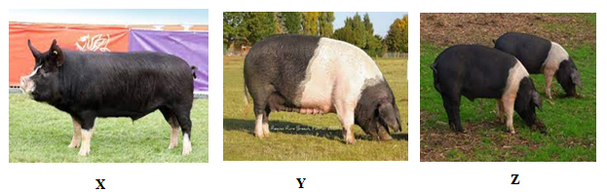
a) State the names of the pig breeds above: (3 marks)
X……………………………………………………………………………………………………………
Y……………………………………………………………………………………………………………
Z…………………………………………………………………………………………………………….
b) State two differences between large white and landrace breeds of pigs. (2 marks)
…………………………………………………………………………………………………………………………….………………………………………………………………………………………………………………………………………………………………………………………………………………………………………………………………………………………………………………………………..
- The diagram bellow shows the diagram of a fish pond. Use it to answer the questions that follow.
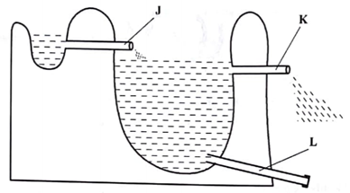
- Name the parts labelled J and L. (2 marks)

J …………………………………………………………………………………………………………
L …………………………………………………………………………………………………………
- State the function of part labelled K (1 mark)
………………………………………………………………………………………………………………..………………………………………………………………………………………………………………..
- Explain how fingerlings are introduced into a pond. (2 marks)
…………………………………………………………………………………………………………………………….………………………………………………………………………………………………………………………………………………………………………………………………………………………………………………………………………………………………………………………………..
- Use the diagrams below to answer the questions that follow.
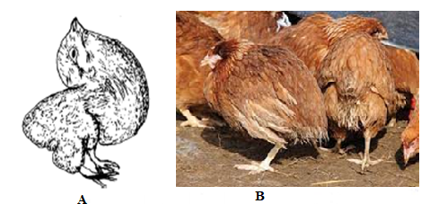
- State the nutrient that chick A may be lacking. (1 mark)
………………………………………………………………………………………………………………
- What other symptom can be shown by breeding birds lacking the nutrient name (a) above? (1 mark)
……………………………………………………………………………………………………………….
- Chick B is suffering from a viral infection, name the disease. (1 mark)
………………………………………………………………………………………………………………
- State two control measures of the disease indicated by chick B. (2 marks)
……………………………………………………………………………………………………………………………………………………………………………………………………………………………….
- The diagram below shows the udder of a cow. Use it to answer the questions that follow.
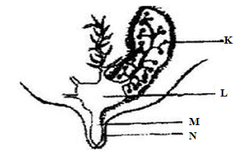
- Name parts L and M. (2 marks)
L …………………………………………………………………………………………………………….
M …………………………………………………………………………………………………………….
- State the hormone responsible for milk let down. (1 mark)
………………………………………………………………………………………………………………
- Define dry cow therapy. (1 mark)
………………………………………………………………………………………………………………...………………………………………………………………………………………………………………
- Why milking should be done quickly and evenly. (1 mark)
………………………………………………………………………………………………………………

SECTION C (20 MARKS)
Answer ANY TWO questions in the spaces provided after question 24.
- a) Explain five causes of livestock diseases. (5 marks)
b) Describe the life cycle of a beef tape worm. (10 marks)
c) Explain five reasons for inbreeding in livestock. (5 marks)
- a) Describe ten factors considered when selecting breeding stock. (10 marks)
b) Compare the digestion between ruminants and non-ruminants (5 marks)
c) Explain the procedure of establishing a barbed wire fence. (5 marks)
- a) Explain ten short service practices done on a tractor. (10 marks)
b) Describe the management of chicks in a brooder up to nine weeks. (10 marks) ……………………………………………………………………………………………………………………………………………………………………………………………………………………………………………………………………………………………………………………………………………………………………………………………………………………………………………………………………………………………………………………………………………………………………………………………………………………………………………………………………………………………………………………………………………………………………………………………………………………………………………………………………………………………………………………………………………………………………………………………………………………………………………………………………………………………………………………………………………………………………………………………………………………………………………………………………………………………………………………………………………………………………………………………………………………………………………………………………………………………………………………………………………………………………………………………………………………………………………………………………………………………………………………………………………………………………………………………………………………………………………………………………………………………………………………………………………………………………………………………………………………………………………………………………………………………………………………………………………………………………………………………………………………………………………………………………………………………………………………………………………………………………………………………………………………………………………………………………………………………………………………………………………………………………………………………………………………………………………………………………………………………………………………………………………………………………………………………………………………………………………………………………………………………………………………………………………………………………………………………………………………………………………………………………………………………………………………………………………………………………………………………………………………………………………………………………………………………………………………………………………………………………………………………………………………………………………………………………………………………………………………………………………………………………………………………………………………………………………………………………………………………………………………………………………………………………………………………………………………………………………………………………………………………………………………………………………………………………………………………………………………………………………………………………………………………………………………………………………………………………………………………………………………………………………………………………………………………………………………………………………………………………………………………………………………………………………………………………………………………………………………………………………………………………………………………………………………………………………………………………………………………………………………………………………………………………………………………………………………………………………………………………………………………………………………………………………………………………………………………………………………………………………………………………………………………………………………………………………………………………………………………………………………………………………………………………………………………………………………………………………………………………………………………………………………………………………………………………………………………………………………………………………………………………………………………………………………………………………………………………………………………………………………………………………………………………………………………………………………………………………………………………………………………………………………………………………………………………………………………………………………………………………………………………………………………………………………………………………………………………………………………………………………………………………………………………………………………………………………………………………………………………………………………………………………………………………………………………………………………………………………………………………………………………………………………………………………………………………………………………………………………………………………………………………………………………………………………………………………………………………………………………………………………………………………………………………………………………………………………………………………………………………………………………………………………………………………………………………………………………………………………………………………………………………………………………………………………………………………………………………………………………………………………………………………………………………………………………………………………………………………………………………………………………………………………………………………………………………………………………………………………………………………………………………………………………………………………………………………………………………………………………………………………………………………………………………………………………………………………………………………………………………………………………………………………………………………………………………………………………………………………………………………………………………………………………………………………………………………………………………………………………………………………………………………………………………………………………………………………………………………………………………………………………………………………………………………………………………………………………………………………………………………………………………………………………………………………………………………………………………………………………………………………………………………………………………………………………………………………………………………………………………………………………………………………………………………
THIS IS THE LAST PRINTED PAGE

