MARANDA HIGH SCHOOL
Kenya Certificate of Secondary Education
MOCK EXAMINATIONS 2022

231/2 Biology (Theory) Paper 2
September, 2022 Time: 2 Hours

Name: ………………………………………….…….…… Adm No: ………………
Class: ………………Candidate’s Signature: ………..…….. Date: 13th September, 2022
Time: 7.00-9.00 AM

Instructions to candidates
- Write all your details in the spaces provided above.
- This paper consists of two sections; A and B. Answer all the questions in section A in the spaces provided.
- In section B answer question 6 (compulsory) and either question 7 or 8 in the spaces provided after question 8.
- This paper consists of 11 Printed pages.
- Candidates should check the question paper to ensure that all the papers are printed as indicated and no questions are missing.

For Examiner’s Use only
Section | Question | Maximum Score | Candidate’s  Score
A | 1 | 8
 | 2 | 8
 | 3 | 8
 | 4 | 8
 | 5 | 8
B | 6 | 20
 | 7 | 20
 | 8 | 20
Total score |  | 80
      - The diagram below represents a plant tissue
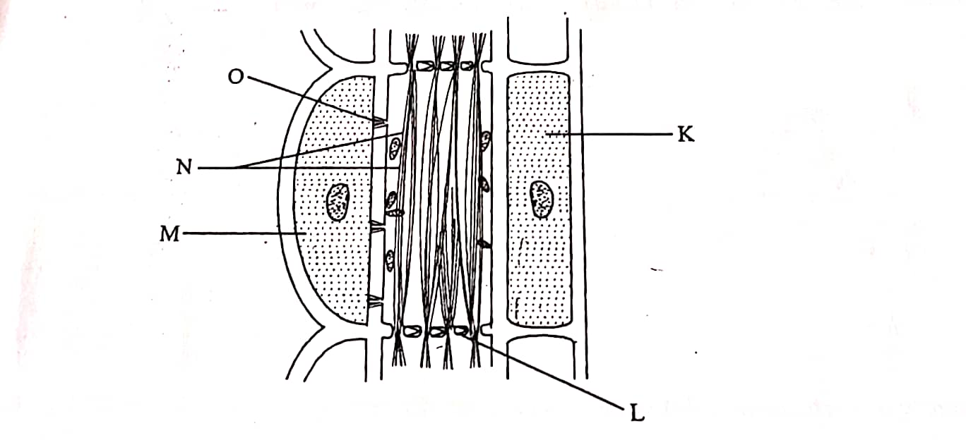
- Name the structures L and O. (2 marks)
L…………………………………………………………………………………………………………..
O…………………………………………………………………………………………..........................
- State the function of structure N and cell labelled M. (2marks)
N…………………………………………………………………………………………………………
M………………………………………………………………………………………………………….
- Give two structural differences between phloem tissue and xylem tissue. (2marks)
………………………………………………………………………………………………………………………………………………………………………………………………………………………………………………………………………………………………………………………………………………
- Distinguish between active and passive immunity. (2marks)
………………………………………………………………………………………………………………………………………………………………………………………………………………………………………………………………………………………………………………………………………………………………………………………………………………………………………………………………
      - he following figures represent the forelimb of a certain animal species. Study them and answer the questions that follow
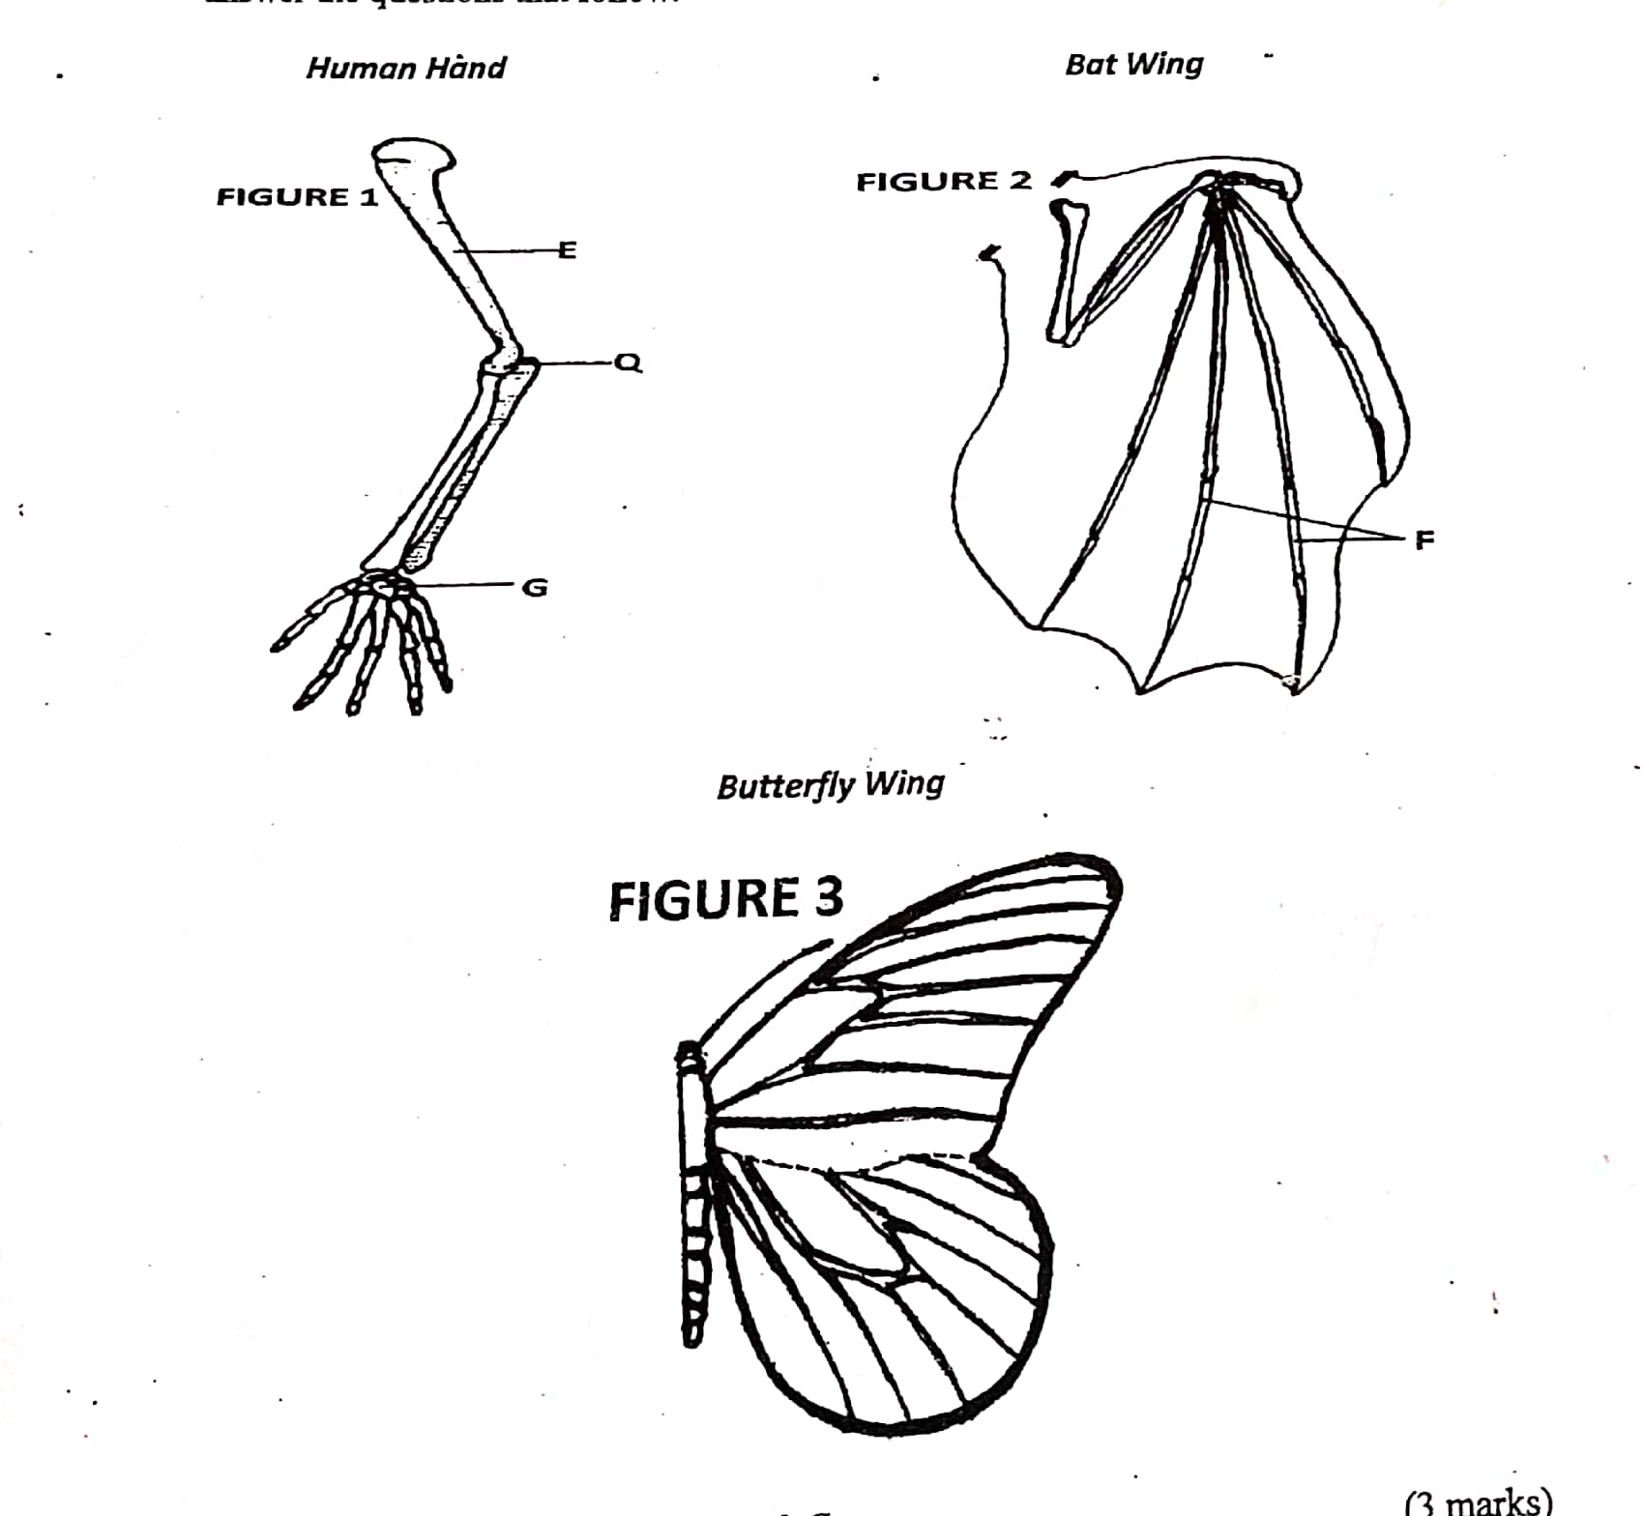

- Name the bones labelled E and G. (2marks)
E…………………………………………………………………………………………..........................
G………………………………………………………………………………..........................................
- State the type of skeleton represented by figure 1. (1mark)
………………………………………………………………………………………………..........................
- Name the type of joint at point Q. (1mark)
………………………………………………………………………………………………………………
- Which two figures represent analogous structures? (1mark)
………………………………………………………………………………………………………………………………………………………………………………………………………………………………………………………………………………………………………………………………………………
- Give adaptational differences between structures in figure 1 and 3. (3 marks)
………………………………………………………………………………………………………………………………………………………………………………………………………………………………………………………………………………………………………………………………………………
- Colour blindness is a disorder caused by gene mutation and it is controlled by a recessive gene. A man with normal colour vision marries a carrier woman:
- Using letter B to represent the gene for normal color vision, what is the chance that their son will be colour blind? Show your working. (4marks)

- Name another trait in humans inherited in the same way as colour blindness. (1mark)
………………………………………………………………………………………………………………
- Briefly describe inversion in gene mutation. (1mark)
………………………………………………………………………………………………………………………………………………………………………………………………………………………………………………………………………………………………………………………………………………..
- Distinguish between back cross and testcross. (2marks)
………………………………………………………………………………………………………………………………………………………………………………………………………………………………………………………………………………………………………………………………………………
- a) Nitrogen in the atmosphere cannot be directly utilized by plants. State two ways by which this nitrogen is made available for plant use. (2marks)
………………………………………………………………………………………………………………………………………………………………………………………………………………………………………………………………………………………………………………………………………………
- State the importance of saprophytic bacteria in the environment. (1mark)
………………………………………………………………………………………………………………………………………………………………………………………………………………………………
- Briefly explain the how excessive use of fertilizers affects the large water bodies. (3marks)
………………………………………………………………………………………………………………………………………………………………………………………………………………………………………………………………………………………………………………………………………………………………………………………………………………………………………………………………
- Explain how competition regulates the animal population in a habitat. (2marks)
………………………………………………………………………………………………………………………………………………………………………………………………………………………………………………………………………………………………………………………………………………

- The figure below shows the parts of the human digestive system. Study it and answer the questions that follow.

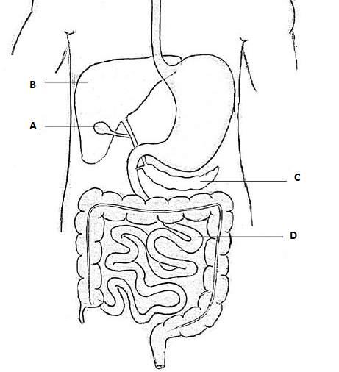

- Name the organs labelled A, B and D. (3marks)
A……………………………………………………………………………………………………………...
B……………………………………………………………………………………………………………...
D……………………………………………………………………………………………………………...
- State the role of part labelled C. (1mark)
………………………………………………………………………………………………………………………………………………………………………………………………………………………………………………………………………………………………………………………………………………
- Name the two salivary glands in human beings. (2marks)
………………………………………………………………………………………………………………………………………………………………………………………………………………………………………………………………………………………………………………………………………………..
- Give two adaptations of part labelled D to its function. (2marks)
………………………………………………………………………………………………………………………………………………………………………………………………………………………………………………………………………………………………………………………………………………..
- An experiment was carried out to investigate transpiration and absorption of water in sunflower plants in their natural environment with adequate supply of water. The amount of water was determined in a two hour intervals. The results are as shown in the table below.

TIME OF THE DAY | AMOUNT OF WATER IN GRAMMES
 | Transpiration | Absorption
11:00-13:00 | 33 | 20
13:00-15:00 | 45 | 30
15:00-17:00 | 52 | 42
17:00-19:00 | 46 | 46
19:00-21:00 | 25 | 32
21:00-23:00 | 16 | 20
23:00-01:00 | 8 | 15
01:00-03:00 | 4 | 11

- Using the same axes, plot graphs to show transpiration and absorption of water in grammes against time of the day. (7marks)

- At time of the day was the amount of water the same for transpiration and absorption? (1 mark)
………………………………………………………………………………………………………………..
- Account for the shape of the graph of :
- transpiration (3marks)
………………………………………………………………………………………………………………………………………………………………………………………………………………………………………………………………………………………………………………………………………………………………………………………………………………………………………………………………
- absorption (3marks)
………………………………………………………………………………………………………………………………………………………………………………………………………………………………………………………………………………………………………………………………………………………………………………………………………………………………………………………………
- What would happen to transpiration and absorption of water if the experiment was continued till 0500 hours? (2marks)
………………………………………………………………………………………………………………………………………………………………………………………………………………………………………………………………………………………………………………………………………………..
- Name two environmental factors that may affect rate of transpiration and absorption at any given time.
(2marks)
………………………………………………………………………………………………………………………………………………………………………………………………………………………………
- Explain how the factors you named in (e) above affect transpiration. (2marks)
………………………………………………………………………………………………………………………………………………………………………………………………………………………………………………………………………………………………………………………………………………………………………………………………………………………………………………………………………………………………………………………………………………………………………………
- a) Explain how blood sugar is regulated in the human body. (12marks)
- Explain the adaptation of the mammalian skin to thermoregulation. (8marks)

- a) Describe the factors that make the leaf of a terrestrial plant to absorb maximum light for photosynthesis. (12marks)
- Describe how support is achieved in herbaceous plants and shrubs. (8marks)
………………………………………………………………………………………………………………………………………………………………………………………………………………………………………………………………………………………………………………………………………………………………………………………………………………………………………………………………………………………………………………………………………………………………………………………………………………………………………………………………………………………………………………………………………………………………………………………………………………………………………………………………………………………………………………………………………………………………………………………………………………………………………………………………………………………………………………………………………………………………………………………………………………………………………………………………………………………………………………………………………………………………………………………………………………………………………………………………………………………………………………………………………………………………………………………………………………………………………………………………………………………………………………………………………………………………………………………………………………………………………………………………………………………………………………………………………………………………………………………………………………………………………………………………………………………………………………………………………………………………………………………………………………………………………………………………………………………………………………………………………………………………………………………………………………………………………………………………………………………………………………………………………………………………………………………………………………………………………………………………………………………………………………………………………………………………………………………………………………………………………………………………………………………………………………………………………………………………………………………………………………………………………………………………………………………………………………………………………………………………………………………………………………………………………………………………………………………………………………………………………………………………………………………………………………………………………………………………………………………………………………………………………………………………………………………………………………………………………………………………………………………………………………………………………………………………………………………………………………………………………………………………………………………………………………………………………………………………………………………………………………………………………………………………………………………………………………………………………………………………………………………………………………………………………………………………………………………………………………………………………………………………………………………………………………………………………………………………………………………………………………………………………………………………………………………………………………………………………………………………………………………………………………………………………………………………………………………………………………………………………………………………………………………………………………………………………………………………………………………………………………………………………………………………………………………………………………………………
THIS IS THE LAST PRINTED PAGE

