MARANDA HIGH SCHOOL
Kenya Certificate of Secondary Education
MOCK EXAMINATIONS 2022

231/3 Biology Practical Paper 3
September, 2022 Time: 1Hour 45 Mins

Name: ………………………………………….…….…… Adm No: ………………
Class: ………………Candidate’s Signature: ………..…….. Date: 12th September, 2022
Time: 11.00AM -12.45 PM
Instructions to candidates:
- Write your name and admission number in the spaces provided.
- Sign and write date of examination in the spaces provided above
- Answer all the questions in this paper.
- You are required to spend the first 15 minutes of the 1¾ hours allowed for this paper reading the whole paper carefully.
- This paper consists of 11 Printed pages.
- Candidates should check the question paper to ensure that all the papers are printed as indicated and no questions are missing.

For Examiner’s Use only

QUESTIONS | MAXIMUM SCORE | CANDIDATE’S SCORE
1 | 17
2 | 11
3 | 12
TOTAL | 40
- You are provided with Specimen K .Carefully cut a transverse section through specimen K using a scalpel provided.

- (i) By observing one of the two halves of specimen K, Give two reasons to prove that specimen K has axile placentation (2marks) ……………………………………………………………………………………………………………………………………………………………………………………………………………………
(ii) Squeeze some juice from specimen K into 100ml beaker provided and label it as juice K. Using a portion of juice K, carry out the food test using the reagents provided and complete the table below. (NB preserve the remaining portion of juice K for use in question 2 ) (8marks)

Food substance | Procedure | Observation | Conclusion

(iii) Name the deficiency disease that results from lack of the food substance present in juice K.
(1mark)
…………………………………………………………………………………………………………
(iv) Highlight two symptoms of the disease named in (a) (iii) above (2marks)
……………………………………………………………………………………………………………………………………………………………………………………………………………………
- Put 2cm³ of liquid labeled C into a test tube. Draw some of the juice from specimen K into a dropper. Add 4 drops of the juice into the test tube with solution C and shake.
(i) State your observation. (1mark)
……………………………………………………………………………………………………………………………………………………………………………………………………………………...
(ii) State the part of the human body where the process demonstrated above occurs and the enzyme that carries out the process.
Part of body…………..………………………………………………………………………. (1mark)
Enzyme…………...…………………………………………………………………………… (1mark) (iii) Which gland produces the enzyme stated in (a) (ii) above? (1mark)
………………………………………………………………………………………………………….
- (a) Take a small amount of substance B provided and add to it 2cm³ of sodium hydrogen carbonate solution.
(i) State your observations (1mark)
……………………………………………………………………………………………………………………………….………………………………………………………………………………………………………………………………………………………………………………………………
(ii) Which process in the body is illustrated above? (1mark)
…………………………………………………………………………………………………………
(iii) State the part of the body where the above process takes place (1mark)
…………………………………………………………………………………………………………
(iv) State two functions of substance B in the body (2marks)
……………..………………………………………………………………………………………………………………………..………………………………………………………………………………………………………………………..…………………………..…………………………………………………………………………………………………………..……………………………………
(v) Name two diseases of the circulatory system caused by excess cholesterol in food. (2marks)
……………………..………………………………………………………………………………………………………………..………………………………………………………………………………
- Study the photographs below depicting plants growing in different habitats. Use them to answer the questions that follow.
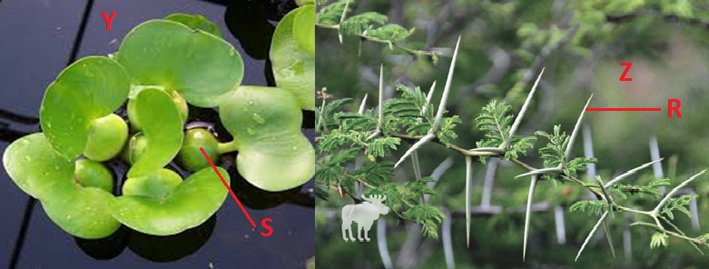
(i) Identify the habitats in which they are found (2marks)
Y ………………………………………………………………………………………………………
Z………………………………………………………………………………………………………
(ii) State the significance of the following structures found in the specimens shown above. (2marks)
R ………………………………………………………………………………………………………
S………………………………………………………………………………………………………..
- (a) Below are photographs of Venus flytrap (an insectivorous plant). Study them and answer the questions that follow.
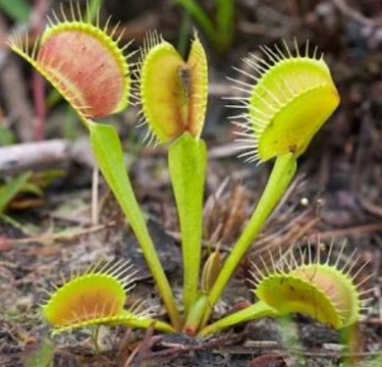
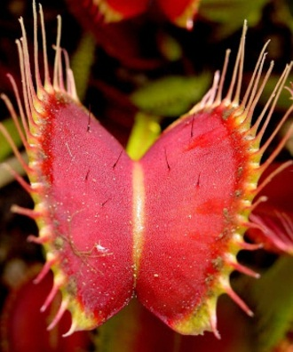
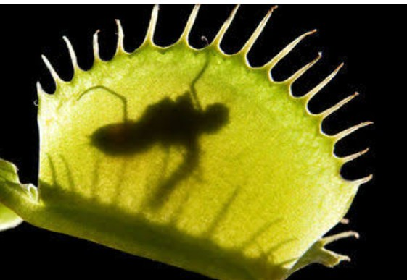
A B C

Sensitive hairs
Trapped insect
Spines

(i) Name one major nutrient that is deficient in the soil where the above plant grows. (1mark)
…………………………..………………………………………………………………………………
(ii) Name the type of response shown by photograph C (1mark)
…………………………..………………………………………………………………………………
(iii) Describe how the above plant traps the insect (4marks)
……………………..………………………………………………………………………………………………………………..……………………………………………………………………………………………………..………………………………………………………………………………………………………………..…………………………………………………………………………………………………………..………………………………………………………………………………
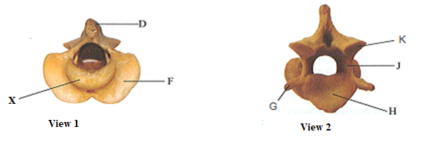
- The photographs below are of the same mammalian vertebra showing two views of the same bone. Examine them carefully.

(i) Identify the vertebra……………………………………………………………………….. (1mark)
(ii) Name the region from which the vertebra is obtained. (1mark)
…………………………………………………………………………………………………………
(ii) Name the part marked X (1mark) …………………………………………………………………………………………………………
(iv) State the function of part X (1mark)
…………………………………………………………………………………………………………
- State the functional difference between a tendon and a ligament (1mark)
……………………………………………………………………………………………………………………………………………………………………………………………………………………
- Name the bone that articulate with this vertebra at the distal end (1mark)
…………………………………………………………………………………………………………
THIS IS THE LAST PRINTED PAGE

