MARANDA HIGH SCHOOL
Kenya Certificate of Secondary Education
MOCK EXAMINATIONS 2022

232/1 Physics Paper 1
September, 2022 Time: 2 Hours

Name: ………………………………………….…….…… Adm No: ………………
Class: ………………Candidate’s Signature: ………..…….. Date: 7th September, 2022

Time: 10.45AM -1.45PM

Instructions to Candidates
- Write your name, admission number in the spaces provided above.This paper consists of TWO sections.
- Answer ALL the questions in sections A and B in the spaces provided.
- ALL working MUST be clearly shown.
- Non-programmable silent electronic calculators and KNEC mathematical tables may be used.
- Candidates should check the question paper to ascertain that all the 12 pages are printed as indicated and that no questions are missing.

For Examiner’s Use Only

Section | Question | Maximum Score | Candidate’s Score
A | 1 – 12 | 25
B | 13 | 12
 | 14 | 09
 | 15 | 12
 | 16 | 14
 | 17 | 08
 | Total Score | 80

SECTION A (25 MARKS)
Answer all questions in this section in the spaces provided:
- Figure 1 shows a section of an un-graduated vernier calipers.
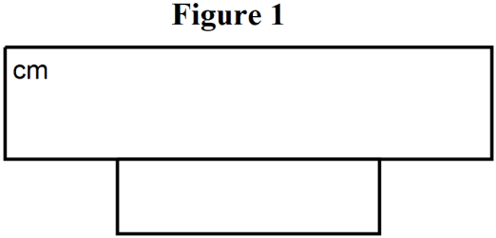

Insert division on the scales to represent a reading of 2.25cm (1mark)

- Explain why a person would jump higher on earth than on Jupiter. (2marks)
………………………………………………………………………………………………………………………………………………………………………………………………………………………………………………………………………………………………………………………………………………………
- A mercury thermometer with its fix points incorrectly marked has its reading at pure melting ice as -0.6⁰C and in steam at standard atmospheric pressure as 101.4⁰C.Calculate the correct temperature when it reads 60⁰C. (2marks)
…………………………………………………………………………………………………………………………………………………………………………………………………………………………………………………………………………………………………………………………………………………………………………………………………………………………………………………………………………
- State two ways of increasing the surface tension of a liquid. (2marks)
………………………………………………………………………………………………………………………………………………………………………………………………………………………………………………………………………………………………………………………………………………………
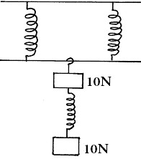
- Figure 2 shows three identical springs and have negligible weights. The extension produced on the system of the spring is 40cm.

Figure 2
Determine the spring constant of each spring. (2marks)
……………………………………………………………………………………………….……………………………………………………………………………………………….………………………………………………………………………………………………………………………………………………………………………………………………………………….……………………………………………………………………………………………………………………………………………………………….
- An oil drop of radius 0.35mm when placed in water spreads out to form a circle of radius 35cm.Using this information:
  - Estimate the size of the oil molecule. (2marks)
……………………………………………………………………………………………………………………………………………………………………………………………………………………………………………………………………………………………………………………………………………………………………………………………………………………………………………………………………………………………………………………………………………………………………………………………
  - State any one assumption you made in your calculation. (1mark)
……………………………………………………………………………………………….……………………………………………………………………………………………………………………………………………………………………………………………………………………………………………………
- Figure 3 shows a beam balance made of concrete and reinforced with steel.

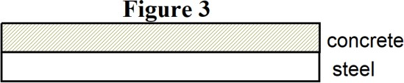

Using a diagram, show the shape of the beam when heated up. (1mark)

- a) State Newton’s second Law of motion. (1mark)
……………………………………………………………………………………………….………………………………………………………………………………………………………………………………………………………………………………………………………………………………………………………
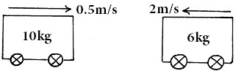
b) Figure 4 shows two trolleys one of mass 6kg moving with a velocity of 2m/s and the other of mass 10kg travelling at a velocity of 0.5m/s.

Figure 4

The trolleys were moving in the directions shown. Find their common velocity, if they moved together after collision. (3marks)
…………………………………………………………………………………………………………………………………………………………………………………………………………………………………………………………………………………………………………………………………………………………………………………………………………………………………………………………………………………….
- A student blew air into a horizontal straw in the direction shown in the figure 5.
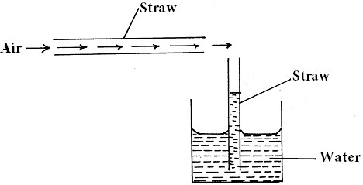

Figure 5

Explain what was observed in the vertical straw. (2marks)
………………………………………………………………………………………………………………………………………………………………………………………………………………………………………………………………………………………………………………………………………………………
- A form three student threw a stone vertically upwards. Sketch in the space below the velocity time graph for the body until it falls on the ground. (2marks)

- Figure 6 shows a uniform Meter rule of Weight 2N with two weights 0.36N and 0.24N suspended from its ends.
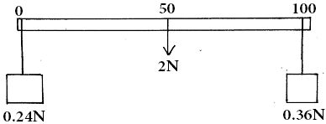

Figure 6

Determine how far from the 0.36N weight a pivot should be placed in order to balance the meter rule. (3marks)
…………………………………………………………………………………………………………………………………………………………………………………………………………………………………………………………………………………………………………………………………………………………………………………………………………………………………………………………………………
- Give a reason why water is not suitable as a barometric liquid. (1mark)

………………………………………………………………………………………………………………………………………………………………………………………………………………………………………………………………………………………………………………………………………………………

SECTION B: (55 MARKS)
Answer ALL questions in the spaces provided
- (a) Figure 7 shows a set-up that may be used to verify pressure law.
75 25
50
0
Pressure gauge
Stirrer
thermometer

Hot Water
Glass flask
Dry air

Figure 7

- State the measurements that should be taken in the experiment. (2marks)
………………………………………………………………………………………………….………………………………………………………………………………………………….………………………………………………………………………………………………….……………………………………………………………………………………………………………………………………………………………………………………………………………………………………………………………………….
- Explain how the measurements in (i) above may be used to verify pressure law. (3marks)
………………………………………………………………………………………………………………………………………………………………………………………………………………………………………………………………………………………………………………………………………………………………………………………………………………………………………………………………
- A column of air 26 cm long is trapped by mercury thread 5.0cm long as shown in the figure 8 (a) . When the tube is inverted as in figure 8(b) the air column becomes 30 cm long.
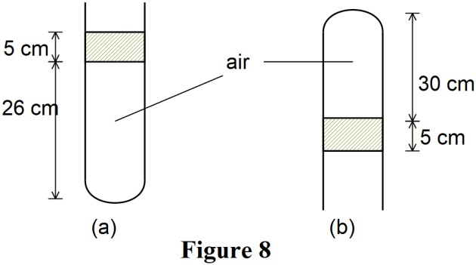
What is the value of atmospheric pressure? (3marks)
………………………………………………………………………………………………………………………………………………………………………………………………………………………………………………………………………………………………………………………………………………………………………………………………………………………………………………………………
- A steel cylinder of capacity 0.5m³ contains nitrogen at a pressure of 30,000Pa when the temperature is 27C. What will be the pressure of nitrogen if it is allowed to flow into another cylinder of capacity 9.5m³ with the temperature reduced to -23C? (3marks)
………………………………………………………………………………………………..………………………………………………………………………………………………..………………………………………………………………………………………………..…………………………………………………………………………………………………………………………………………………….
- State the difference between the temperature in Kelvin scale and Celcius scale. (1mark)
………………………………………………………………………………………………………………………………………………………………………………………………………………………………
- (a) Define the term specific heat capacity. (1mark)
………………………………………………………………………………………………………………………………………………………………………………………………………………………………
- A block of metal of mass 150g at 100C is dropped into a lagged calorimeter of heat capacity 40Jk⁻¹ containing 100g of water at 25C. The temperature of the resulting mixture is 34C. (Specific heat capacity of water = 4200Jkgˉ¹). Determine;
  - Heat gained by calorimeter. (2marks)
…………………………………………………………………………………………………………………………………………………………………………………………………………………………………
- Heat gained by water. (2marks)
………………………………………………………………………………………………………………………………………………………………………………………………………………………………………………………………………………………………………………………………………………
- Heat lost by the metal block. (1mark)

………………………………………………………………………………………………………………

- Specific heat capacity of the metal block. (3marks)

………………………………………………………………………………………….………………………………………………………………………………………….………………………………………………………………………………………………………………………………………………………….
- (a)The moon goes round the earth at a constant speed. Explain why it is true to say the moon is accelerating. (1mark)
………………………………………………………………………………………….…………………………………………………………………………………………………………………………………….
- Figure 9 shows a pail of water being swung in a vertical circle.
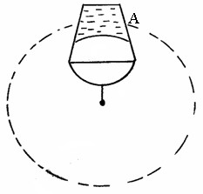

Figure 9
Explain why the water does not pour out when the pail is at position A. (1mark)
………………………………………………………………………………………………………………………………………………………………………………………………………………………………………………………………………………………………………………………………………………
- A string of negligible mass has a bucket tied at the end. The string is 60cm long and the bucket has a mass of 45g. The bucket is swung horizontally making 6 revolutions per second. Calculate:
  - the angular velocity. (2marks)
……………………………………………………………………………………………………………………………………………………………………………………………………………………………………
…………………………………………………………………………………………………………………
  - the angular acceleration. (3 marks)
………………………………………………………………………………………………………………………………………………………………………………………………………………………………………………………………………………………………………………………………………………………
  - the tension on the string. (3marks)
…………………………………………………………………………………………………………………………………………………………………………………….……………………………………………..…………………………………………………………………………………………………………………
  - the linear velocity. (2marks)
………………………………………………………………………………………….…………………….…………………………………………………………………………………………………………………
- (i) What is meant by perfectly inelastic collision. (1mark)
………………………………………………………………………………………….……………………...…………………………………………………………………………………………………………………
- A minibus of mass 1600kg travelling at a constant velocity of 20mls collides with a stationary car of mass 800kg. The impact takes 2 seconds before the two moves together and come to rest after 15 seconds. Determine.

  - The common velocity. (2marks)
……………………………………………………………………………………………………………………………………………………………………………………………………………………………………
  - The distance moved after the impact. (2marks)
………………………………………………………………………………………….……………………...………………………………………………………………………………………………………………….
  - The impulse force. (3marks)
………………………………………………………………………………………………………………………………………………………………………………………………………………………………………………………………………………………………………………………………………………………
- A man uses the inclined plane to lift a 50kg load through a vertical line height of 4.0m. The inclined plane makes an angle of 30 with the horizontal. If the efficiency of the inclined plane is 80%, determine.
  - The effort needed to move the load up the plane at a constant velocity. (3marks)
……………………………………………………………………………………………………………………………………………………………………………………………………………………………………………………………………………...……………………………………………………………………………………………………………………………………………………………………………………………………………………………………………………………………………………………………………
  - The work done against friction in raising the load through the height of 4.0m. (Take g = 10N/kg). (3marks)
………………………………………………………………………………….…………………………………………………………………………………..………………………………………………………………………………….……………………………………………………………………………………….
- i) State the law of floatation. (1mark)
…………………………………………………………………………………………………………………………………………………………………………………………………………………….………………………………………………………………………………………………………………….
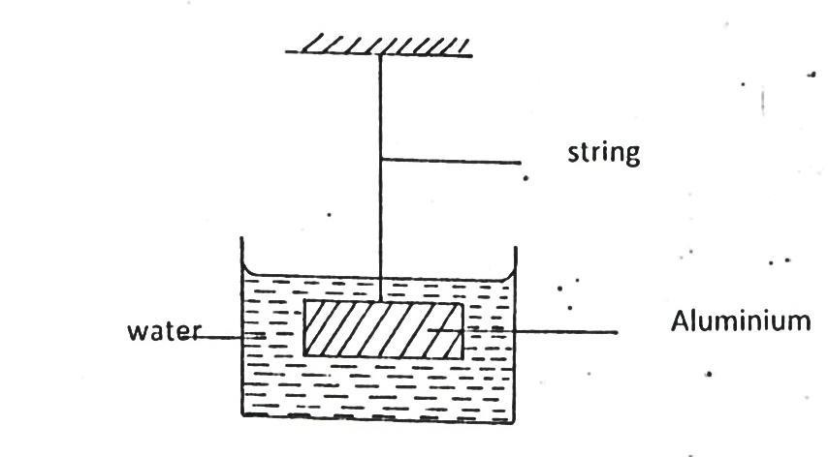
ii) Figure 10 shows a piece of aluminum suspended from a string and completely immersed in a container of water. The mass of the aluminium is 1kg and its density is 2.7 × 10³kg/m³
String
Water
Aluminium

Figure 10

Calculate the tension in the string. (3marks)
……………………………………………………………………………………………………………………………………………………………………………………………………………………………………………………………………………………………………………………………………………………………………………………………………………………..…………………………………………………
- Name any two forces acting on Aluminium block (2marks)
…………………………………………………………………………………………………………………………………………………………………………………………………………………………………………………………………………………………………………………………………………………………………………………………………………………………………………………………………………
- State and explain the change that would be made on tension when water is replaced with mercury
(2marks)
…………………………………………………………………………………………………………………………………………………………………………………………………………………………………………………………………………………………………………………………………………………………………………………………………………………………………………………………………………

THIS IS THE LAST PRINTED PAGE

