** MARANDA HIGH SCHOOL**

**Kenya Certificate of Secondary Education**

**MOCK EXAMINATIONS 2022**

**232/2 Physics (Theory) Paper 2**

**September, 2022 Time: 2 Hours**

**Name**: ………………………………………….…….…… **Adm** **No**: ………………

**Class**: ………………**Candidate’s** **Signature**: ………..…….. **Date: 9th September, 2022**

# Time: 7.00AM -9.00AM

# *Instructions to Candidates*

* *This paper consist of TWO sections; A and B. Answer ALL the questions in section A and B in the spaces provided.*
* *ALL working MUST be clearly shown. Mathematical tables, electronic calculators and slide rules may be used.*
* *Candidates should check the question paper to ensure that all the* ***12*** *pages are printed as indicated and that no questions are missing.*

*Take:*

**For Examiner’s Use Only**

|  |  |  |  |
| --- | --- | --- | --- |
| **SECTION** | **Question** | **Maximum**  **Score** | **Candidate’s**  **Score** |
| **A** | 1-12 | 25 |  |
| **B** | 13 | 14 |  |
| 14 | 13 |  |
| 15 | 14 |  |
| 16 | 14 |  |
| **TOTAL** | | **80** |  |

##### **SECTION A: 25 MARKS**

## *Answer ALL questions in the spaces provided.*

1. a) State one unique characteristic of a diode in relation to conduction of current (1 mark)

…………………………………………………………………………………………………………………

1. Figure 1 shows a simple circuit. Use it to answer the question that follows.

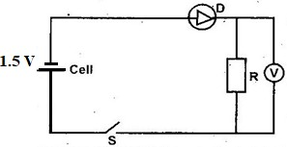 Figure 1

State and explain the voltmeter reading when switch S is closed (2 marks)

…………………………………………………………………………………………………………………

………………………………………………………………………………………………………...............

1. A sound vibrator produces sound waves inside the water. State and explain what would happen to its wavelength at the interface. (2 marks)

…………………………………………………………………………………………………………………

…………………………………………………………………………………………………………………

1. A radioactive carbon – 14 decays to nitrogen by beta emissions as shown.



Determine the values of X and Y in the equation

X=………………………………………………………………….. …………………….. (1mark)

Y = ……………………………………………………………………………………….. (1mark)

1. Give a reason why soft iron is used as a core of the coil of an electric bell. (1 mark)

…………………………………………………………………………………………………………………

1. An X-ray tube is set to produce X-rays to penetrate human tissues, what adjustment would be made for the X-rays to penetrate a metal slab. (1 mark)

…………………………………………………………………………………………………………………

…………………………………………………………………………………………………………………

1. **Figure 2** shows light travelling from more optically dense to less optically dense medium.

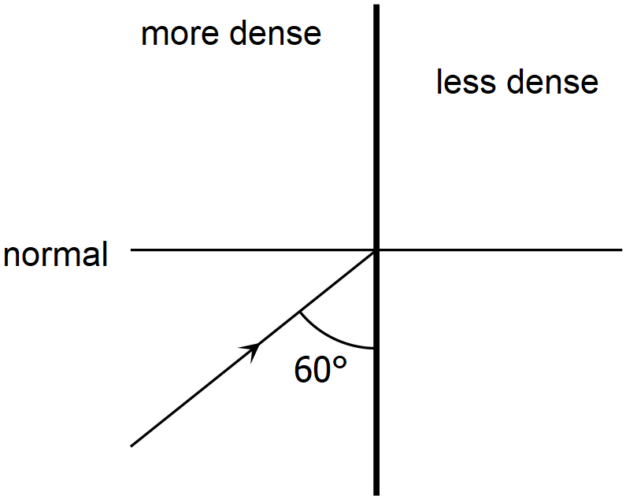

# Figure 2

* 1. Show the direction of the refracted ray. (1 mark)
  2. If the refractive index of the denser medium is 1.42, calculate the angle of refraction. (2 marks)

………………………………………………………………………………………………………………………………………………………………………………………………………………………………………………………………………………………………………………………………………………………

1. A building standing 200m from a pinhole camera produces on the screen of the camera an image 5.0cm behind the pinhole. Determine the actual height of the building. (3 marks)

…………………………………………………………………………………………………………………

…………………………………………………………………………………………………………………………………………………………………………………………………………………………………………………………………………………………………………………………………………………………………………………………………………………………………………………………………………

1. 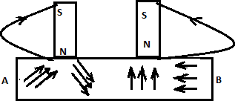**Figure 3** shows a method of magnetizing a material.

**Figure 3**

1. State the method of magnetization described below. (1 mark)

……………………………………………………………………………………………………………………

1. On the space provided, draw a diagram to show how the dipoles would appear after magnetization (1 mark)
2. State the polarity at A and B after magnetization (1mark)

……………………………………………………………………………………………………………………

1. Microwaves form part of the electromagnetic spectrum. State two uses of microwaves (2 marks)

……………………………………………………………………………………………………………………………………………………………………………………………………………………………………….....

1. **Figure 4** shows wave fronts approaching a concave surface.

**Figure 4**

Complete the diagram to show the wave fronts formed after striking the surface. Show how the focal point of the surface is located (2 marks)

1. 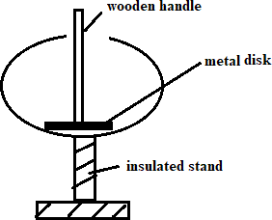**Figure 5** shows a hollow positively charged sphere with metal disk attached to an insulator placed inside.

**Figure 5**

State and explain what would happen to the leaf of an uncharged electroscope if the metal disk were brought near the cap of electroscope. (2 marks)

………………………………………………………………………………………………………………………………………………………………………………………………………………………………………………………………………………………………………………………………………………………

…………………………………………………………………………………………………………………

1. State **two** factor to be considered in constructing a paper capacitor. (2 marks)

…………………………………………………………………………………………………………………………………………………………………………………………………………………………………….…………………………………………………………………………………………………………………

# SECTION B: (55 MARKS)

## *Answer all the questions in this section in the spaces provided*

1. a) Battery of e.m.f. 12V supplies a current of 10A for 5 minutes. Determine the amount of electrical energy produced. (2 marks)

………………………………………………………………………………………………………………………………………………………………………………………………………………………………

………………………………………………………………………………………………………………

1. **Figure 6** shows a graph of resistance against reciprocal of current. Use it to answer the questions that follow.

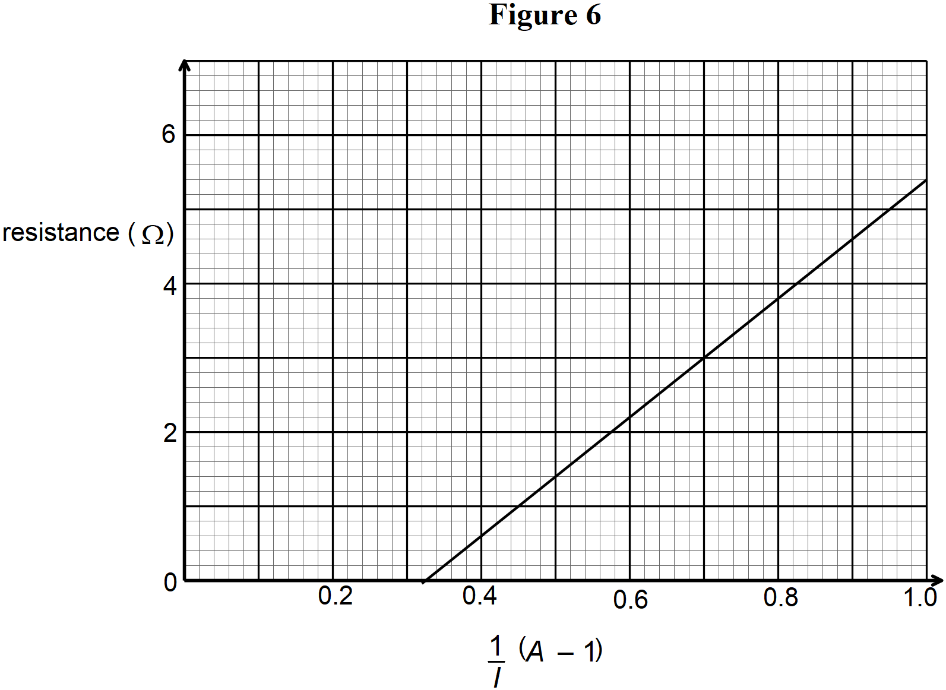

1. Find the internal resistance,  . (2 marks)

………………………………………………………………………………………………………………………………………………………………………………………………………………………………

………………………………………………………………………………………………………………

1. Determine the e.m.f, E of the cell. (2 marks)

…………………………………………………………………………………………………………………………………………………………………………………………………………………………………………………………………………………………………………………………………………….....

1. Draw a circuit diagram to show the set-up used to generate the above graph (2 marks)
2. Draw a circuit diagram to show how a 12V battery may be used to operate efficiently 3 head lamp bulbs each marked 6V, 24W. (2 marks)
3. Calculate the current supplied by the battery in (d) above. (2 marks)

……………………………………………………………………………………………………………………………………………………………………………………………………………………………………………………………………………………………………………………………………….

1. Calculate the total effective resistance of the bulbs in (d) above. (2 marks)

……………………………………………………………………………………………………………………………………………………………………………………………………………………………………………………………………………………………………………………………………….

1. **Figure 7** shows a graph of photoelectric current against frequency. Use it to answer questions that follow.

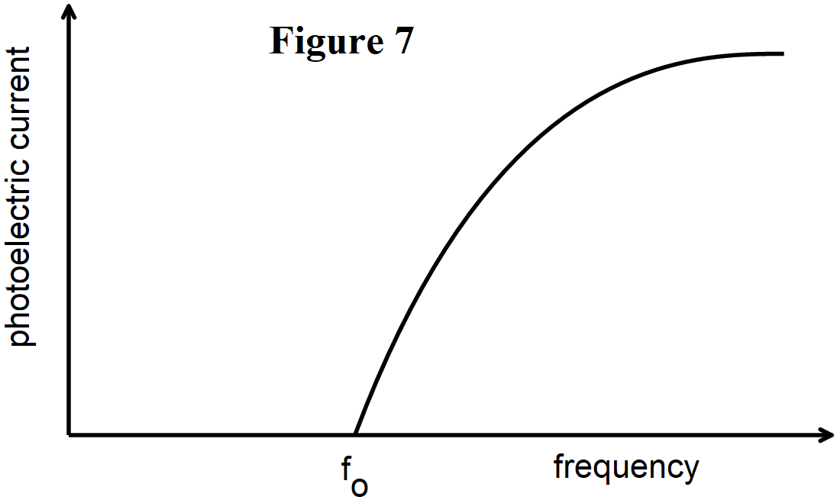

* 1. What does the term **fo** stand for in the graph above? (1 mark) ………………………………………………………………………………………………………………..
  2. Explain what the graph shows in terms of photoelectric emission. (2 marks)

………………………………………………………………………………………………………………………………………………………………………………………………………………………………………………………………………………………………………………………………………………

* 1. The work function of a metal is 

1. Explain what is meant by the term work function (1 mark)

……………………………………………………………………………………………………………………………………………………………………………………………………………………………………………………………………………………………………………………………………………….

1. Light with a frequency of  is shone onto the metal surface. Find out whether or not the photons of this light will cause the photoelectric effect to take place. (3 marks)

……………………………………………………………………………………………………………………………………………………………………………………………………………………………………………………………………………………………………………………………………………….

1. The light source is now replaced with a light source which produces light with a frequency of. The photons from this source contain more energy than is required to release electrons.
2. Determine the extra energy available after the electron has been released. (3 marks)

…………………………………………………………………………………………………………………………………………………………………………………………………………………………………………………………………………………………………………………………………………………………………………………………………………………………………………………….

1. What is the extra energy calculated above converted to? (1mark)

…………………………………………………………………………………………………………….

1. Draw a circuit diagram to illustrate how photoelectric effect can be installed in a door to alert you when a stranger gets into your house (2 marks)
2. a) i) Define the term mutual induction (1 mark)

…………………………………………………………………………………………………………………………………………………………………………………………………………………………

* 1. In mutual induction, the induced current is higher in the secondary coil when current in the primary coil is switched off. Explain (2 marks)

……………………………………………………………………………………………………………………………………………………………………………………………………………………………………………………………………………………………………………………………………...

* 1. State one application of mutual induction (1 mark)

…………………………………………………………………………………………………………...

b)  **Figure 8** shows a small magnet attached to a spring.

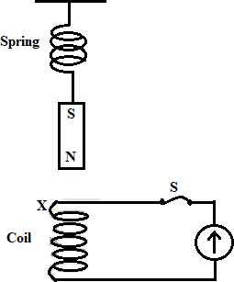 Figure 8

The magnet is set oscillating up and down.

1. State the polarity at X when the magnet is moving down. (1 mark)

…………………………………………………………………………………………………………….

1. Explain the cause of the deflection of the pointer of galvanometer (2 marks)

……………………………………………………………………………………………………………………………………………………………………………………………………………………………………………………………………………………………………………………………………….

1. If the switch at S is open, the magnet will take longer to come to rest. Explain (2 marks)

……………………………………………………………………………………………………………………………………………………………………………………………………………………………………………………………………………………………………………………………………………………………………………………………………………………………………………………

1. A power station has an output of 25kW at a potential difference of 5kV. A transformer with a primary coil of 1000 turns is used to step-up the voltage to 132kV for transmission along a grid. Assuming there are no power losses in the transformer. Calculate:
2. Current in the primary coil (2 marks)

……………………………………………………………………………………………………………………………………………………………………………………………………………………………………………………………………………………………………………………………………….

1. Number of turns of the secondary coil (2 marks)

……………………………………………………………………………………………………………………………………………………………………………………………………………………………………………………………………………………………………………………………………….

1. Explain why it is inefficient to use low voltage when transmitting electricity (1 mark)

……………………………………………………………………………………………………………

1. a) **Figure 9** shows a torch bulb placed at the principal focus of a parabolic reflector.

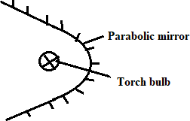

Figure 9

Using ray diagram show how the set up can be used a headlight (2 marks)

1. **Figure 10** shows a concave mirror with a wide aperture.

# Figure 10

Using a ray diagram show how spherical aberration occurs. (2 marks)

1. Using the mirror formula, show that  ,where  is magnification,  is the focal length and  is the image distance. (3 marks) ………………………………………………………………………………………………………………………………………………………………………………………………………………………………………………………………………………………………………………………………
2. The graph in **figure 11** shows the variation of magnification, M with image distance,  for a concave mirror.

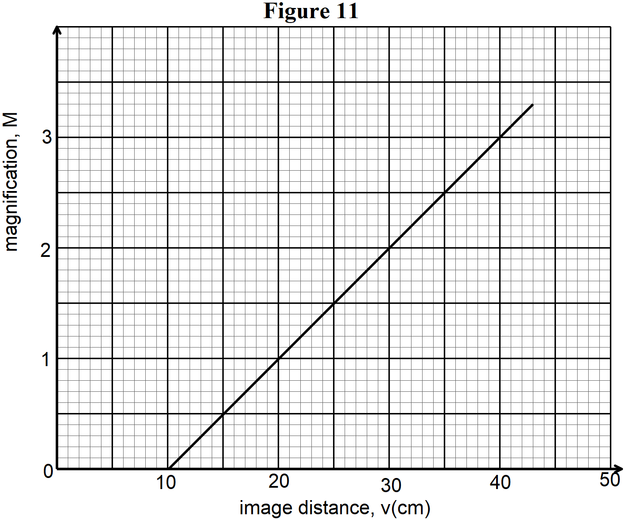

From the graph determine:

* 1. The object position when the image position is 45cm (2 marks)

………………………………………………………………………………………………………………………………………………………………………………………………………………………….

* 1. The focal length of the mirror. (2 marks)

…………………………………………………………………………………………………………………………………………………………………………………………………………………………

1. A 4.0 cm tall light bulb is placed a distance of 35.5 cm from a convex mirror having a focal length of 12.0 cm. Determine the image distance (3 marks)

………………………………………………………………………………………………………………………………………………………………………………………………………………………………………………………………………………………………………………………………………

**THIS IS THE LAST PRINTED PAGE**